

***Driv***ing Innovation in Crisis Management for ***E***uropean ***R***esilience

**UNITED KINGDOM**  
Policy, Legislation, Organisation, Procedures & Capabilities (PLOPC) in crisis management and disaster response

*Responsible Partner: CIES (Ben Hayes)*

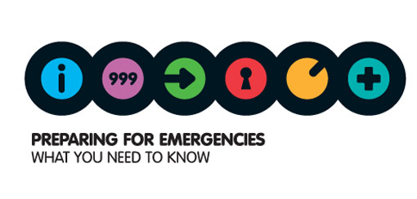

Scope and limitations

This study serves as supporting information for further work within DRIVER.

Only limited time and budget has been available for this first general survey, which needs to be considered in terms of scope and completeness of the respective studies.

The author/s of this study is/are responsible for its content and quality.

This report was revised at the end of 2015, reviewed internally by MSB and amended according to reviewer's comments and recommendations.

# Overview

Crisis management in the UK has grown and matured considerably over the last fifteen years, galvanised in part by the 9/11 terrorist attacks and 7 July 2005 London bombings which served to catapult the field up the political agenda.

The UK’s approach to crisis management is founded on Integrated Emergency Management (IEM), a holistic approach to preventing and managing emergencies that entails six key steps: anticipation; assessment; prevention; preparation; response; and recovery.

IEM advocates a bottom-up approach, with operations managed and decisions made at the lowest appropriate level. Preparation, response and recovery should be undertaken as an extension of a local responder‘s normal day-to-day activities.

This principle underpins the Civil Contingencies Act 2004, which overhauled existing legislation to provide a single framework for civil protection. It divides local responders involved in crisis management into two categories. Category 1 organisations are “first responders” (emergency services, local authorities, NHS bodies etc.) and have substantial civil protection responsibilities including risk assessment, emergency planning, and warning and informing the public. Category 2 organisations are “co-operating bodies” (transport providers, utility companies etc.) that are involved in planning for and responding to emergencies that affect their sector.

Most emergencies in the UK are dealt with at local level, but if necessary the government’s central response framework would be initiated. Cabinet Office Briefing Rooms (COBR) - comprised of ministers and senior officials from relevant UK government departments and agencies - would be activated to provide overall strategic planning. Overall crisis management is typically supervised by one Lead Government Department (LGD) which works closely with the Cabinet Office’s Civil Contingencies Secretariat, the principal governmental authority responsible for coordinating crisis management.

Crisis management in the UK is of a civilian nature with military involvement sought only in extreme cases. Volunteer organisations play an important role in augmenting capabilities and are involved in Category 1 responder training exercises. There is minimal evidence of significant private sector involvement in crisis management in the UK, with ad hoc agreements signed as necessary when emergencies occur.

It is difficult to calculate the amount of money allocated for crisis management in the UK because budget issues are not centrally managed by the government. Funding streams are often diverse and there is significant variation in resources between counties. What is clear is that funding has increased since the 7 July 2005 London bombings. Local authorities are generally responsible for financing emergency preparedness, though may apply to the government for financial support in bearing the costs of emergency response and recovery.

It is uncommon for the UK to cooperate bilaterally with other countries; instead the UK participates in intergovernmental organisations and a limited number of multilateral frames of cooperation in crisis management, such as the EU Civil Protection Mechanism. The UK rarely seeks help from other countries to manage internal emergencies, but is at the forefront of political initiatives in the EU context and is active in EU and NATO training and expert exchange programmes.

The Foreign and Commonwealth Office is responsible for managing the UK’s relationship with other countries through its network of embassies and High Commissions, as well as the UK’s overall relationship with international organisations such as the UN, NATO and the EU. However, the Civil Contingencies Secretariat is responsible for liaising with the civil emergency response and mutual aid systems of the EU and NATO. Government departments can also have bilateral relationships with specific international or multilateral institutions that will be used when appropriate.

# Table of Contents

UNITED KINGDOM Policy, Legislation, Organisation, Procedures & Capabilities (PLOPC) in crisis management and disaster response 1574

Overview 1575

Table of Contents 1577

List of Figures 1579

List of Tables 1579

List of Abbreviations 1580

1 Policy 1581

1.1 Risk Assessment 1581

1.2 Policy and Governance 1586

1.2.1 Strategy scope and focus 1590

1.2.2 Monitoring and analytical support to policy making; R&D 1590

1.2.3 Policy for Prevention 1593

1.2.4 Policy for Preparedness 1594

1.2.5 Policy for Response 1595

1.2.6 Policy for Relief and Recovery 1595

1.3 Financing 1597

1.3.1 Investing in preparedness 1597

1.3.2 Investing in consequence management 1599

1.4 Policy review, Evaluation & Organisational Learning 1599

1.5 Resilience 1603

1.6 Information sharing and data protection 1606

2 Legislation 1608

2.1 Crisis (emergency, disaster) management concept 1608

2.2 General crisis (emergency, disaster) management law 1608

2.3 Emergency rule 1610

2.4 Specific, department/agency-level legal arrangements and regulations on emergency and disaster management 1611

2.5 Specific to the regional and local authorities legal arrangements and regulations on emergency and disaster management 1612

2.6 Legal regulations on the involvement of volunteers and specialised NGOs 1615

2.7 Legal regulations for international engagements of first responders and crisis managers 1616

3 Organisation 1617

3.1 Organisational chart 1617

3.2 Organisational cooperation 1625

4 Procedures 1629

4.1 Standing Operating Procedures (SOPs) and Guidelines 1629

4.2 Operations planning 1629

4.3 Logistics support in crises 1630

4.4 Crisis communication to general public; Alert system; Public Information and Warnings 1632

5 Capabilities 1637

5.1 Human resources 1637

5.2 Materiel (non-financial) resources 1638

5.3 Training 1639

5.4 Procurement 1642

5.5 Niche capabilities 1643

Resources 1645

Legislative acts 1645

Official documents (white papers, strategies, etc.) 1645

Online resources (e.g. websites of key CM organizations) 1647

Publications 1648

## List of Figures

Figure 1: NRR Risk Matrix: Risks of terrorist and other malicious attacks 1583

Figure 2: NRR Risk Matrix: Other risks 1584

Figure 3: Integrated Emergency Management cycle 1588

Figure 4: Recovery structures and organisations 1596

Figure 5: the BCM lifecycle 1605

Figure 6: Linking local with central government 1617

Figure 7: Likely form of central government engagement based on the impact and geographic spread of an emergency in England 1621

Figure 8: Structure of Cabinet Office Briefing Rooms 1622

Figure 9: SAGE Governance structures 1624

Figure 10: Default SAGE, STAC interaction model 1625

Figure 11: Public communications timeline: what responders’ plans need to achieve 1634

## List of Tables

Table 1: Major civil security crises in the UK for the period 2000-2012 1585

Table 2: The role of scientific and technical advice in crisis management 1592

Table 3: Eurostat Indicators of government expenditures 2007-2011 1598

## List of Abbreviations

BCM Business Continuity Management

CCA Civil Contingencies Act 2004

COBR Cabinet Office Briefing Rooms

CPM Civil Protection Mechanism

CCS Civil Contingencies Secretariat

DCLG RED Department for Communities and Local Government Resilience and Emergencies Division

EU European Union

FCO Foreign and Commonwealth Office

G8 Group of Eight

IEM Integrated Emergency Management

LGD Lead Government Department

LRF Local Resilience Forum

MACA Military Aid to the Civil Authority

MoD Ministry of Defence

NATO North Atlantic Treaty Organisation

NCC News Co-ordination Centre

NGO Non-Governmental Organisation

NHS National Health Service

NOS National Occupation Standards

NRA National Risk Assessment

NRR National Risk Register

RCG Recovery Co-ordinating Group

SAG Scientific Advisory Group

SAGE Scientific Advisory Group for Emergencies

SARS Severe Acute Respiratory Syndrome

SCG Strategic Co-ordinating Group

STAC Science and Technical Advisory Cell

UK United Kingdom

UN United Nations

WCCC Wales Civil Contingencies Committee

# Policy

## Risk Assessment

Central government

The UK government conducts a National Risk Assessment (NRA) to monitor the most significant emergencies the UK could face in the next five years. This confidential assessment is conducted each year and utilises the expertise of a wide range of departments and agencies of government. It focuses on three broad categories of risk: natural events, major accidents and malicious attacks.

The National Risk Register (NRR) is the public version of the NRA. It was first published by the government in 2008, fulfilling a commitment made in the National Security Strategy, and last updated in July 2013. It was created to provide businesses and the public with information regarding how they should prepare for civil emergencies. Cabinet Office guidance published in February 2013 states that the government is conducting a review of the NRR in consultation with risk communication experts to improve these guidelines.[1]

The risks posed to national security and human welfare by longer-term trends, such as technological advances and climate change, is considered by the classified National Security Risk Assessment, which informs the UK’s National Security Strategy.

Local government

Different geographical areas of the UK face different risks. A person’s likelihood of exposure to emergencies such as coastal flooding, industrial accidents or terrorist attack is obviously heavily dependent on where in the country they live. For that reason the government provides guidance on how to interpret the NRA and NRR to Local Resilience Forums, the principal mechanism for local multi-agency cooperation (LRFs, see section 3.1), so that they can produce specific risk assessments that reflect the unique characteristics of their surrounding area.

The Civil Contingencies Act also requires emergency responders in England and Wales to maintain a public Community Risk Register. These are approved and published by LRFs and made available on local council websites.

Key risks and areas of concern

The NRA estimates the likelihood of different emergencies, typically using a mixture of data (including historical analysis and numeric modelling) and scientific expertise. The likelihood of terrorist or other malicious attacks is assessed more subjectively, with assessments focusing on the willingness and capabilities of those who might wish to carry out an attack, and the vulnerability of potential targets.

The NRR lists the highest priority risks (based on both likelihood and impact) facing the UK as: pandemic influenza, coastal flooding, catastrophic terrorist attacks, and severe effusive (gas-rich) volcanic eruptions abroad.

Other, less severe, risks include inland flooding, new and emerging infectious diseases, severe weather, severe space weather, wildfires, explosive volcanic eruption styles emitting mainly ash, animal diseases, major industrial and transport accidents, disruptive industrial action, malicious attacks and public disorder.

Pandemic Influenza

Pandemic influenza is considered by the government to be the most significant civil emergency risk facing the UK. The 2009 H1N1 influenza pandemic did not match the severity of the scenario the government plans for, and has no bearing on the probability of another, potentially more severe, pandemic occurring in the future. The three pandemics of the previous century (1918-19, 1957-58 and 1968-69) were all more deadly than the 2009 outbreak. The NRR anticipates that a severe pandemic could cause hundreds of thousands of deaths in the UK and would result in widespread social and economic disruption; significant threats to the continuity of essential services; lower production levels; shortages; and distribution difficulties.

Coastal flooding

The most severe example of coastal flooding occurred in 1953 – the last occasion a national emergency was formally declared in the UK – when a combination of high tides, a major tidal surge and onshore gale force winds devastated the east coast of England. While investment in coastal flood defences has reduced the risk of a similarly severe emergency occurring, the number of people living and working in east coast flood risk areas has increased, as has the range of critical infrastructure. The NRR warns that the impacts of overtopping and breaching of flood defences could be more serious than in 1953.

Catastrophic terrorist attacks

The NRR stresses that while major-impact terrorist attacks such as 9/11 are unlikely, they cannot be ruled out. The likelihood of terrorists obtaining effective mass impact biological agents or a functioning nuclear device is low, but not negligible. Accordingly, CONTEST, the Government’s counter­ terrorism strategy, is tasked both with stopping terrorists gaining access to the expertise and materials they need to deliver catastrophic attacks, and with preparing for the consequences should they succeed.

Severe effusive (gas-rich) volcanic eruptions abroad

The 2010 eruption of the Eyjafjallajökull volcano in Iceland highlighted the disruptive consequences of a volcanic eruption abroad. Ash-emitting eruptions of this type remain a concern, but the NRA and NRR are significantly more concerned by the prospect of a major effusive volcanic eruption, which could emit large volumes of gases into the atmosphere over months or years, and the widespread impact on health, agriculture and transport this would have. The 1783-84 Laki eruption from Grimsvötn volcano in Iceland is the best understood example of this type of eruption, in which significant levels of sulphur dioxide, chlorine and fluorine were released. The effect was visible pollution across the UK and Northern Europe, mass crop failure and excess deaths, with the mortality rate in England for summer 1783 10-20% above average.

Figure 51: NRR Risk Matrix: Risks of terrorist and other malicious attacks

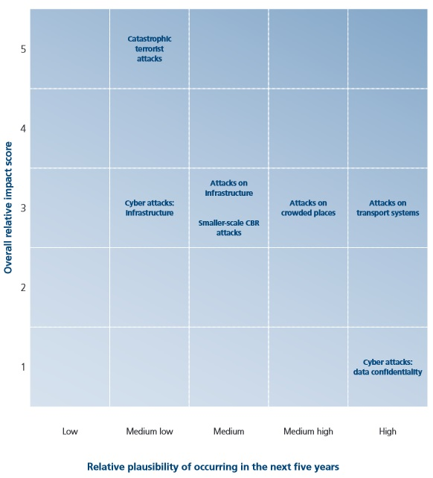

Source: National Risk Register of Civil Emergencies 2013 edition

Figure 52: NRR Risk Matrix: Other risks

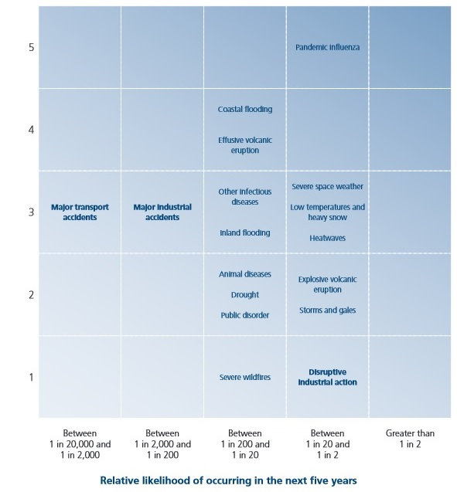Source: National Risk Register of Civil Emergencies 2013 edition

Table 35: Major civil security crises in the UK for the period 2000-2012

|  |  |  |  |  |  |
| --- | --- | --- | --- | --- | --- |
| Date | Crisis description | Crisis category | Persons Killed | Persons injured | Persons affected |
| October 2000 | Storm | Natural disaster | 12 |  | 19,504 |
| February 2001 | Foot-and-mouth disease | Pandemics/infectious diseases |  |  | Whole society |
| February 2001 | Transport accident | Industrial/transportation | 13 |  | 70 |
| July 2003 | Extreme temperature | Natural disaster | 301 |  |  |
| January 2004 | Miscellaneous accident | Industrial/transportation | 14 |  |  |
| November 2004 | Transport accident | Industrial/transportation |  |  | 150 |
| January 2005 | Storm | Natural disaster |  |  | 3,000 |
| December 2005 | Buncefield depot explosion | Industrial/transportation |  |  | Not easily estimated |
| July 2005 | London bombings | Terrorist attack | 56 | 770 |  |
| January 2007 | Storm | Natural disaster | 13 |  |  |
| April 2007 | Earthquake | Natural disaster |  |  | 4,501 |
| June 2007 | Flood | Natural disaster |  |  | 30,000 |
| July 2007 | Flood | Natural disaster |  |  | 340,000 |
| September 2008 | Flood | Natural disaster |  |  | 3,000 |
| April 2009 | Transport accident | Industrial/transportation | 16 |  |  |
| May 2009 | Swine Flu pandemic | Pandemics/infectious diseases | 362 |  |  |
| November 2009 | Flood | Natural disaster |  |  | 3,900 |
| April 2010 | Volcanic Ash Cloud | Natural disaster/Critical infrastructure failure |  |  | Whole society |

Source: ANVIL project country study: United Kingdom, February 2014

## Policy and Governance

The UK’s crisis management framework is premised on Integrated Emergency Management (IEM), a holistic approach to preventing and managing emergencies that entails six key steps: anticipation; assessment; prevention; preparation; response; and recovery. This section explains key terms, processes and principles.

Key terms

The terms ‘emergency’, ‘response’ and ‘recovery’ are used frequently in UK government guidance on crisis management. They are defined as follows:

Response

Response encompasses the decisions and actions taken to deal with the immediate effects of an emergency. It is the decisions and actions taken in accordance with the strategic, tactical and operational objectives defined by emergency responders. At a high level these will be to protect life, contain and mitigate the impacts of the emergency and create the conditions for a return to normality. In many scenarios it is likely to be relatively short and to last for a matter of hours or days – rapid implementation of arrangements for collaboration, co-ordination and communication are, therefore, vital. Response encompasses the effort to deal not only with the direct effects of the emergency itself (e.g. fighting fires, rescuing individuals) but also the indirect effects (e.g. disruption, media interest).[2]

Recovery

In contrast, recovery may take months or even years to complete, as it seeks to support affected communities in the reconstruction of the physical infrastructure and restoration of emotional, social and physical well-being. The process of rebuilding, restoring and rehabilitating the community following an emergency or disaster, continues until the disruption has been rectified, demands on services have been returned to normal levels, and the needs of those affected have been met. Recovery is defined as the process of rebuilding, restoring and rehabilitating the community following an emergency. Although distinct from the response phase, recovery should be an integral part of the response from the very beginning, as actions taken during the response phase can influence the longer-term outcomes for a community.[3]

Emergency

The Civil Contingencies Act 2004 establishes a coherent framework for civil security and civil protection in the UK. Part 1 defines an emergency as:

* an event or situation which threatens serious damage to human welfare in a place in the UK;
* an event or situation which threatens serious damage to the environment of a place in the UK; or
* war, or terrorism, which threatens serious damage to the security of the UK.[4]

The definition of ‘emergency’ is concerned with consequences, rather than the cause or source. Therefore, an emergency inside or outside the UK is covered by the definition, provided it has consequences inside UK territory (up to 12 nautical miles off the UK coast).

Government guidance uses the term emergency:

…to encompass all challenges that require the use of assets beyond the scope of normal operations and require a special deployment. The term “major incident” is commonly used by emergency services personnel to describe events or situations which would constitute an emergency as defined in the CCA regime; this is the threshold of event or situation that will initiate a response under their major incident plans. These terms refer to the same threshold and are essentially interchangeable.[5]

Integrated Emergency Management

The UK’s crisis management framework is founded on Integrated Emergency Management (IEM), a holistic approach to preventing and managing emergencies that entails six key steps: anticipation; assessment; prevention; preparation; response; and recovery.

Figure 53: Integrated Emergency Management cycle



The principles of IEM were agreed upon following a spate of emergencies in the late 1980s and early 1990s, which included the London King’s Cross underground station fire, terrorist bombings, air crashes, oil rig explosions, floods, the 1987 hurricane, the sinking of the Machioness pleasure boat and the 1989 Hillsborough stadium disaster.

Under IEM, the preparation for, response to, and recovery from emergencies focuses on the consequences and wider impacts of events rather than their causes. IEM emphasises the development of flexible emergency plans that enable organisations to deal effectively with an incident, whether foreseen or unforeseen.

Principles of effective emergency response and recovery

Accordingly, while the UK government has published a common set of underlying principles to govern emergency response and recovery in the UK at all levels (both local and national), it emphasises that arrangements must be flexible and that these guidelines are “not intended to be prescriptive or an operations manual as there is no single approach that will meet the needs of every area, nor is there one single set of organisational arrangements that will be appropriate to each and every type of emergency.”[6] Government guidance sets out eight principles to govern response and recovery efforts for every emergency in the UK:

Anticipation is crucial to both the pre-emergency and post-emergency phases. As with the first phase of the IEM process, it is important for organisations to actively ‘horizon-scan’ for risks and potential emergencies. During emergencies, it is important to anticipate the disparate direct and indirect impacts of emergencies may not be immediately apparent in high pressure, uncertain and demanding circumstances. Finally, an important aspect of anticipation is addressing recovery issues at the earliest possible opportunity, ensuring that the response and recovery effort is fully integrated.

Preparedness: All individuals and organisations that might play a part in the response and recovery effort should be appropriately prepared. They should have a clear understanding of their roles and responsibilities and how they fit into the wider, multi-agency picture.

Subsidiarity: The UK‘s approach to emergency response and recovery is founded on a bottom-up approach in which operations are managed and decisions are made at the lowest appropriate level. National and sub-national tiers often have little or no input and will become involved only when necessary.

Direction: During an emergency, those responsible for managing the response and recovery effort often face a plethora of competing demands and pressures. In some cases an array of organisations from across the public, private and voluntary sectors will be involved in responding to an emergency and their activities will need to be co-ordinated. It is therefore essential to establish clearly defined and unambiguous aims and objectives so as to create a shared set of priorities and focus resources. This is usually the responsibility of the Strategic Co-ordinating Group (SCG, see section 3.1).

Information: Maintaining the flow of information during an emergency (within organisations and also to partners and the general public) can be challenging but is crucially important to its successful resolution. The collation, assessment, verification, translation and dissemination of information should therefore be underpinned by appropriate information management systems. This will help decision-makers strike an appropriate balance between ensuring that decisions are well informed and acting swiftly and decisively. It will also help to furnish the public with appropriate advice, warnings and information to provide reassurance and a basis for any necessary action.

Integration: Responding and recovering from emergencies can involve multiple organisations and agencies from local, sub-national and national levels, each of which will have different roles and levels of involvement. It is therefore crucial that their contributions are integrated and clearly defined structures put in place to ensure that they combine and act as a coherent multi-agency group and are able to consult, agree and make decisions on key issues.

Co-operation: Emergency response and recovery brings together organisations with no formal or established relationship and it is therefore important to foster trust and understanding. Organisations must understand each other’s functions, ways of working, priorities and constraints. Decision making should be inclusive and information sharing and openness encouraged.

Continuity: Emergency response and recovery should be grounded in tried and tested arrangements and established structures should be preserved as much as possible. Organisations working on a day-to-day basis in the relevant field have a large role to play because their experience, expertise and resources are invaluable.

### Strategy scope and focus

The principles of IEM used to formulate the UK’s strategic approach to crisis management recognise the importance of emergency prevention, preparedness, response, and recovery. This is reflected in the Civil Contingencies Act, which obliges local responders to have emergency plans in place for each of these phases.

The government has been criticised, however, for focussing insufficiently on the prevention and preparedness phases of emergency planning. Britain’s level of participation in major EU and NATO exercises has been criticised in the past by the House of Lords European Union Select Committee as “unacceptably low” (see section 3.2). While in March 2011, the House of Commons Science and Technology Select Committee highlighted the volcanic ash emergency of April 2010 as “a clear example of how a lack of risk assessment and preparation can hamper the emergency response”.[7]

The May 2013 peer review of the UK’s implantation of the Hyogo Framework for Action - a ten-year guideline to reduce vulnerabilities to natural hazards - argued that the UK should strengthen both emergency prevention and preparedness: “A new momentum should enlarge the focus of the UK resilience approach from emergency preparedness and response towards more prevention and vulnerability reduction”[8](see section 1.2.3).

### Monitoring and analytical support to policy making; R&D

When conducting risk assessment the government may elect to seek scientific expertise, both from internal and external experts. A combination of this advice, expert judgement and historical and statistical data can then be used to estimate the approximate likelihood of an emergency occurring (see section 1.1). Local responders and LRFs can also use local experts to help meet their CCA responsibilities to conduct risk assessment.

In the emergency planning phase, LGDs and the Devolved Administrations can use Science Advisory Groups (departmental or national led scientific or technical advisory groups focused on or used to inform emergency management) to commission new research and draw on a range of experts to ensure that their preparation is informed by science. As of 2011, every individual government department has a departmental Chief Scientific Adviser. They sit on the Chief Scientific Adviser's Committee, along with the Government’s Chief Scientific Advisor (the personal adviser on science and technology-related activities and policies to the Prime Minister and the Cabinet; and head of the Government Office for Science).

SAGE can review and validate existing research and identify areas where new research should be commissioned. Cabinet Office *Enhanced Sage Guidance* states:

To ensure quality advice that can be provided in a timely fashion, the aim should be to avoid this situation by formulating scientific and technical advice during the planning phase. The commissioning of new research will need to be considered and authorised by the relevant department which will take in to account the provision of funds.[9]

The guidance also suggests that it is good practice for all scientific and technical advice to be frequently reviewed in order to reflect the latest evidence and lessons learned. “Where possible advice provided during an emergency should build - upon advice, evidence and research formulated during the risk assessment, planning and preparation phases and should be reviewed and incorporated into plans and guidance following the emergency.”[10]

However, the government has been criticised in recent years for failing to utilise scientific expertise in the preparation phase of emergencies. In March 2011, the House of Commons Science and Technology Select Committee published a report titled *Scientific advice and evidence in emergencies* which stated: “we are concerned that the Government's attitude to scientific advice is that it is something to reach for once an emergency happens, not a key factor for consideration from the start of the process. We conclude that scientific advice and an evidence-based approach must be better integrated into risk assessment and policy processes early on.”[11]

Table 36: The role of scientific and technical advice in crisis management

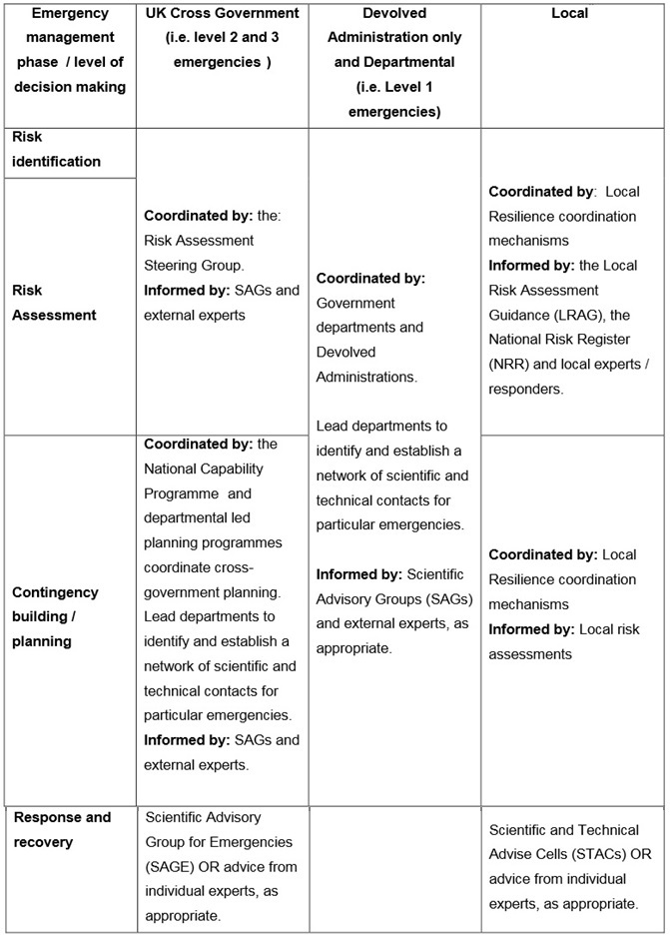

Source: Cabinet Office Enhanced SAGE Guidance, October 2012

In terms of scientific support for other Crisis Management policy areas, the UK Economic and Social Research Council has funded academic research into various topics related to emergency prevention, preparedness, response, and recovery. This includes topics such as “Detecting Terrorist activity”, “Enhancing resilience across all aspects of national infrastructure”, “Global Uncertainties” and “Ritual, community and conflict”.[12]

### Policy for Prevention

Like most facets of the UK’s crisis management framework, emergency prevention is grounded on the day-to-day work of local responder organisations. The CCA requires Category 1 responders to maintain plans for preventing emergencies. This refers primarily to the sort of prevention possible during the short period of time before an emergency occurs when it might be averted by prompt or decisive action. CCA statutory guidance states:

“Plans should be maintained for the purpose of ensuring that if an emergency is likely to occur, the organisation can perform its functions to prevent the emergency…emergencies under this aspect of the Act should be ‘nipped in the bud’ in the way that fire-fighters stop a fire from spreading.”[13]

The other form of prevention included in the CCA is that based on pre-emptive actions, such as the emergency services’ decision to mobilise proactively on New Year’s Eve to deal with potential incidents. Public health organisations immunising the public against the spread of influenza is cited as another example of emergency prevention. The CCA does not impose a duty on Category 1 responders to prevent all emergencies, nor does it oblige organisations to undertake remedial works which might prevent future emergencies.

The May 2013 peer review of the UK’s implantation of the Hyogo Framework for Action identified areas for improvement in the current crisis management framework’s capacity to prevent emergencies. The report advised that “additional dissemination of information to the public would help to strengthen not only preparedness but also prevention”[14] and proposed that:

*A new momentum should enlarge the focus of the UK resilience approach from emergency preparedness and response towards more prevention and vulnerability reduction. In particular, risks with potentially large impacts and high likelihoods, especially when these are growing, could be better managed through vulnerability reduction than through preparing and responding to the event. Floods and droughts are examples of the types of risks that may require more long-term, whole-of-society approaches to their reduction, as climate change may have an impact on those in the future.[15]*

### Policy for Preparedness

The UK’s crisis management framework emphasises local preparedness. Category 1 responders have comprehensive emergency planning duties under the CCA. They are required to: conduct risk assessment (through the Community Risk Register); formulate emergency plans and business continuity plans; regularly test the effectiveness of these plans through exercises; train key staff and the staff of appropriate voluntary organisations; and provide the public with information on the risks posed by emergencies. Local communities are also encouraged to make plans for emergencies that complement the role of the emergency services as part of community resilience.

The Cabinet Office’s Civil Contingencies Secretariat (CCS), the principal governmental authority responsible for coordinating crisis management, has overall responsibility for ensuring emergency preparedness at both national and local level and manages the National Resilience Capabilities Programme (see section 1.5). It is tasked with improving government systems “for identifying new challenges, for assessing risks, for anticipating, planning, preparing and exercising for crises, for building up our resilience to them, and for systematically applying the lessons learned from particular incidents.”[16] The core function of the CCS is to enhance UK resilience by bolstering the national capacity and capability to deal with emergencies. It works in close partnership with government departments to:

* *enable and protect their own decision takers;*
* *develop their own early warning systems;*
* *prepare plans against various eventualities and make sure those plans are properly integrated with those of other departments and agencies;*
* *identify the training and exercises needed to test the plans and enable continuous improvements;*
* *build up the necessary management and professional expertise to maintain and activate the plans and to know where to turn for reinforcement and augmentation;*
* *learn, and share their learning, with other departments.[17]*

Government departments also have individual responsibilities for emergency planning, staff training and exercising, and may be the LGD for a National Resilience Capabilities Programme workstream.

### Policy for Response

The UK’s approach to emergency response and recovery is bottom-up, with operations managed and decisions made at the lowest appropriate level. Government guidance emphasises that “local agencies are the building blocks of response and recovery operations” and indeed, most emergencies are dealt with at local level with little or no input from sub-national or national levels.

*The role of central government and the devolved administrations is to support and supplement the efforts of local responders through the provision of resources and co-ordination. The central and sub-national tiers will only become involved in emergency response and recovery efforts where it is necessary or helpful to do so.[18]*

See section 3 for detailed information on the organisational arrangements of emergency response.

### Policy for Relief and Recovery

**Guidance**

The CCS’s non-statutory guidance to the CCA, *Emergency Response and Recovery,* details the multi-agency structures and processes that can be used during the recovery phase of an emergency. It emphasises that recovery is a complex, long running and resource intensive process that requires the involvement of many more agencies and participants than the response phase. The recovery phase should be based on tried and tested structures and procedures and begins at the earliest possible opportunity, operating in tandem with the response phase to an emergency.

National Recovery Guidance aimed primarily at local responders was produced by the Cabinet Office’s National Recovery Working Group in 2007. Updated frequently with recent case studies and new best practice policy, the guidance is developed in accordance with the CCA and contains topic sheets on a wide range of recovery issues, a recovery plan guidance template, and over 100 case studies from incidents and exercises.

**Policy**

*Emergency Response and Recovery* identifies recovery support as an enabling and supportive process designed to assist affected communities towards management of their own recoveries. It is most effective when conducted at the local level with the active participation of the private sector, the voluntary sector and the wider community. The Cabinet Office outlines four interlinked categories of impact that individuals and communities will need to recover from: environmental; economic; infrastructure; and humanitarian assistance (including health needs). Recovery capability, planning and training, is built around these four key themes.

**Organisational roles and responsibilities at local level**

Local authorities are responsible for planning for the recovery of communities in the aftermath of emergencies. Government guidance recommends that a Recovery Co-ordinating Group (RCG) be set up by a local authority on the first day of an emergency to run in parallel with the SCG. The RCG is principally responsible for developing a recovery strategy and will report to the SCG. When the initial crisis response is complete, responsibility for coordinating the recovery phase will be passed from the SCG to the RCG at a formal meeting.

Local authorities are responsible for planning for the recovery of communities in the aftermath of emergencies. A local authority will usually chair and provide the secretariat for the RCG, coordinating the multi-agency response with help from Category 1 and 2 responders, voluntary organisations and any other relevant agencies via the LRF. Government guidance states that the size and organisation of an RCG varies according to the practicalities of each emergency, but suggests the structure shown in Figure 4.

Neighbouring local authorities are required to have organisational arrangements in place setting out how the recovery response will be coordinated for emergencies that cross local authority boundaries. Typically a single RCG will be created with a designated lead local authority acting as chair. Similarly, if an emergency crosses LRF boundaries guidance recommends that a Multi-LRF RCG be created to ensure “consistency of approach, reducing duplication of effort, minimising the burden on responders, and facilitating the sharing of information, support and mutual aid.”[19] As with all crisis management arrangements in the UK, the RCG would observe the principle of subsidiarity whereby all recovery related decisions would be taken at the lowest possible level.

Figure 54: Recovery structures and organisations

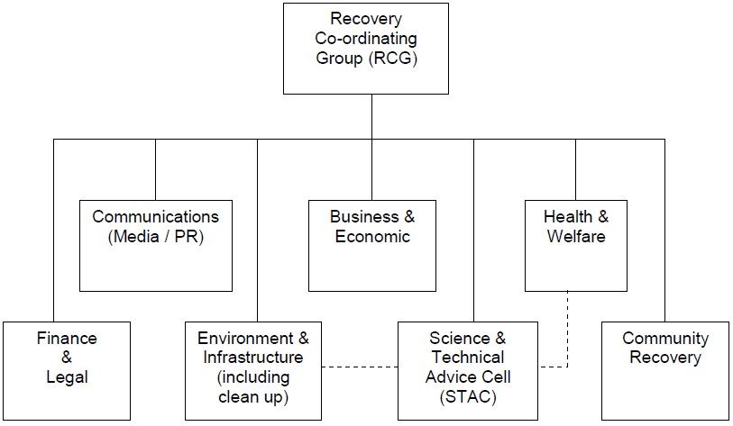

Source: *Emergency Response and Recovery*, non-statutory guidance accompanying the Civil Contingencies Act 2004

**Organisational roles and responsibilities at national level**

If the Cabinet Office agrees that ongoing national support is required, a formal handover will take place between the LGD for response and the LGD for recovery. The same department may retain responsibility for both phases, but often the evolving nature of the challenge, the different issues that arise and the expertise required mean that a different department is better situated to lead the recovery phase. In emergencies that effect wide geographical areas it is possible that response and recovery activity will be occurring simultaneously in different parts of the country under the leadership of two different LGDs. Consideration can also be given for the establishment of Ministerial cross-departmental Recovery Group. As with crisis response, a Department for Communities and Local Government‘s Resilience and Emergencies Division or LGD liaison officer(s) will act as the main point of contact between local responders and central government.

When an emergency has occurred in, or affected, a devolved administration and the UK government has retained responsibility for leading the emergency response, the Cabinet Office and the LGD will agree with the affected devolved administrations how the recovery process should be managed.

## Financing

### Investing in preparedness

The government operates The Bellwin Scheme of Emergency Financial Assistance to Local Authorities to provide financial assistance for the costs incurred during the response phase of an emergency. Any local authority can claim under the scheme if they incur expenditure in the course of responding to an emergency that involved the destruction of or danger to life and property.[20]Enhancements were made to the scheme in 2014 “to reflect the exceptional nature of recent storms and the role councils play as first responders”. Bellwin grants are now paid at 100 percent above threshold instead of 85 percent.[21]

The Bellwin scheme applies only to the response phase, with local authorities generally responsible for financing emergency preparedness themselves. The same is true for LRFs which are not fully staffed or supported by a secure funding stream, and in most cases must rely on a voluntary subscription scheme from its members if it is to appointment a full-time coordinator or manager (as CCA statutory guidance suggests).

With regard to total UK funding for emergency preparedness and response, the ANVIL study, an EU co-funded security research project, found that:

*British policy-makers certainly agree upon one thing: that it is extremely difficult to calculate the exact amount of money allocated for civil security in the UK. None of the interviewees of the present study has presented us with a clear answer on this matter. This is mainly because budget issues on civil security are not centrally managed by the government. In each county, there is a certain amount allocated by the local authorities for crisis management and risk assessment. Apart from that, each category 1 responder can have funds coming from the government department to which they belong (for instance the police can be aided by the Home Office). This also means that funds for civil security may not come exclusively from the Home Office; for example, the Ministry of Defence sponsors ‘Search and Rescue’ (SAR) operations, which can be conducted not only abroad but also in the homeland. Last but not least, emergency services at the local level may be distinct legal entities with the ability to impose local taxation, a portion of which can be dedicated to emergency preparedness and response. All these result in a rich variation of the available resources and of respective civil security capacities from county to county in the UK.[22]*

What is clear to the study is that after the 2005 London bombings, government counter-terrorism funding increased significantly, and that this spilled over to civil security issues. Increased funding led to the modernisation of civil security infrastructure, “always with a high emphasis on preventing a major civil crisis due to a terrorist attack”.

Although not providing a breakdown of how resources are allocated between government departments, the ANVIL study cites national statistics for total government expenditure (expressed in GDP percentages) in fields associated with civil security as an indicator of total financing.

Table 37: Eurostat Indicators of government expenditures 2007-2011

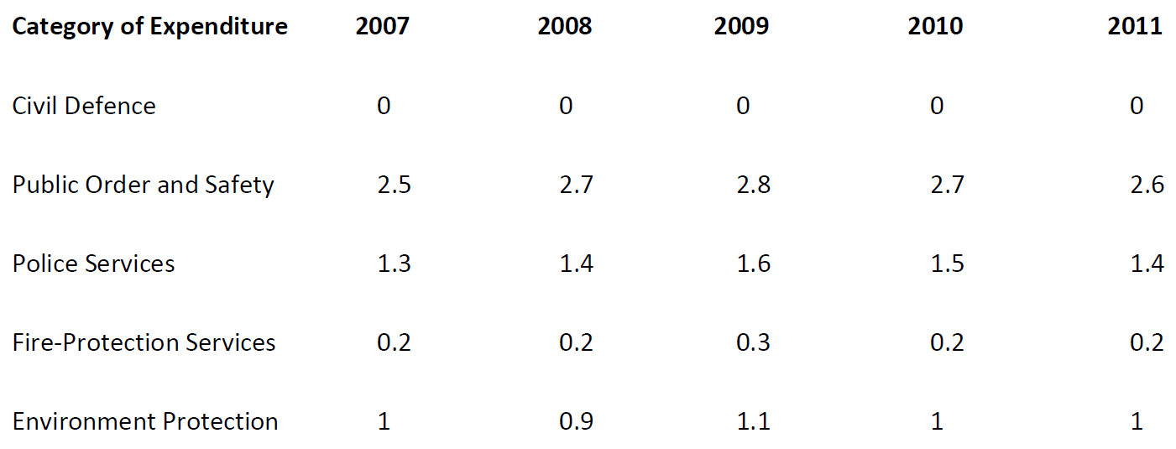

Source: ANVIL project country study: United Kingdom, February 2014

### Investing in consequence management

An independent review of 2007’s exceptionally severe flooding, chaired by Sir Michael Pitt, reaffirmed local authorities’ responsibility to make arrangements to bear the costs of the recovery phase in the majority of emergencies. Councils are responsible for conducting their own risk assessments and putting in place the right balance of insurance, self-insurance and reserves, to provide both security and value for money for their communities.

However, in response to the Pitt Review the government did put together, for the first time, a financial package to assist affected local authorities with the costs of recovery in the event of an “exceptional emergency”. In such circumstances, individual government departments (namely the Department for Communities and Local Government, the Department for Education, the Department for Environment, Food and Rural Affairs, and the Department for Transport) will consider at ministerial level whether to provide financial support for aspects of the recovery effort.

Recovery phase funding can also be applied for under the EU Solidarity Fund which was established in 2002 to provide financial assistance in the aftermath of major natural disasters. To be eligible for funding total direct damage caused by the disaster must exceed 3.2 billion euros or 0.6% of the country’s gross national income, whichever is the lower. The UK has benefitted from the fund once, when it was granted 162.3 million Euros to help with damage caused by the June 2007 floods.

If the armed forces are called on to support the response and/or recovery phases of an emergency, Treasury rules stipulate that the cost of this activity cannot come from the defence budget and instead must be recovered by the Ministry of Defence (MoD). The only exception is that where there is a direct threat to life, MoD Ministers may, at their discretion, decide it is in the national interest to waive part or all of the costs incurred for assistance provided in the response phase. When human life is not at risk, civil organisations will be required to meet all or some of the MoD’s costs. In some cases the MoD is only prepared to provide niche capabilities on the understanding that other departments or agencies are prepared to fund all or part of the costs (see section 4.3). Military assistance in the recovery phase will be charged for at rates determined by the MoD.

## Policy review, Evaluation & Organisational Learning

**Debriefing**

Cabinet Office CCA non-statutory guidance emphasises the importance of record-keeping during emergencies to facilitate operational debriefing and provide evidence to any enquiries that may later be held. Single-agency and inter-agency debriefing processes should therefore be in place to capture information while memories are fresh. All debriefs should be effectively chaired, preferably by someone who has not been involved in the emergency or exercise. A secretary should also be appointed to ensure a record of the discussion is produced.

There should also be a continual process for debriefs throughout the recovery phase to capture issues identified, recommendations to be implemented, and planning assumptions to be reviewed. It should identify issues from all partners involved in the recovery process and involve the local community (including businesses) at all stages. However, there is no specific guidance on how to carry out recovery debriefs. Instead the non-statutory guidance makes a series of general recommendations for good practice based on the experiences of recent emergencies. It suggests that internal debriefs within each organisations should be held first, with findings then brought together in a multi-agency debrief (at the RCG or LRF). A strategy for canvassing public opinion should be developed and agreed upon. This might include the use of questionnaires, focus groups, websites and existing networks (community groups and parish councils for example). Any documents produced should be held for five years and a recovery debrief report released into the public domain in a timely fashion.

**Lessons learned**

In January 2011, the Cabinet Office published the policy paper *Lessons identified from UK exercises and operations: a policy framework* to formalise existing arrangements for identifying, acting upon and implementing lessons learned from emergency operations and training exercises. How well these lessons are incorporated into civil contingency policy is uncertain and it is perhaps telling that government guidance generally refers to ‘lessons identified’ rather than ‘lessons learned’ (see below).

The policy framework reaffirms the CCA’s requirement of Category 1 responders to “capture and assess lessons emerging from exercises and emergencies” and recommends a formal role for LRFs “in reviewing on a regular basis lessons emerging from significant emergencies and exercises in their area.”[23] Accordingly, lessons learned from debriefing processes can be collated and distributed in a multi-agency environment at local and regional forums such as an LRF or Department for Communities and Local Government Resilience and Emergencies Division (DCLG RED). Lessons learned that are relevant at a national level can be passed by a DCLG RED to the CCS in the Cabinet Office where subsequent action by government departments can be coordinated.

Where lessons learned would be of interest to other LRFs or responders in other parts of the country, they can be flagged by the DCLG RED or relevant devolved administration authority and disseminated via their networks. The Cabinet Office policy framework suggests that “for emergencies of national significance, a lessons learned workshop or conference should be organised by either the local or regional resilience forum, as appropriate, in order to share learning with other responders.”

For emergencies that require intervention by central government, *The Central Government Arrangements for Responding to an Emergency - Concept of Operations* requires LGDs to “account to Parliament and lead in the submission of evidence to any subsequent Government-appointed or independent inquiry” and to “identify, learn and share the lessons” from the planning, response and recovery stages of an emergency. Following an emergency the LGD is required to produce a post-incident report within three months of the end of the response phase and should consider publishing a separate report on lessons learned from the recovery phase of the emergency.

Where lessons are identified, all government departments have a responsibility to consider how the defined areas of policy, planning and procedure for which they are responsible might be reviewed and revised accordingly.

The CCS has overall responsibility for lessons learned at government level and, according to the Cabinet Office policy framework, should facilitate an annual lessons learned seminar with national, regional and local stakeholders. The seminar is designed to “present key lessons from exercises and operations in an environment that will facilitate learning and ensure lessons identified are shared as widely as possible.”

The policy framework also requires the CCS to establish a system for collating “strategic or cross-cutting” lessons learned that have been submitted by individual government departments. The system should allocate responsibility to “act upon, investigate or clarify individual lessons” and ensure that it is implemented at national level (by amending LGD plans and procedures and the Central Government Concept of Operations for the response to an Emergency) and at local level (through informal guidance, amendment to statutory guidance and the revision of training courses).

**Examples of Lessons learned**

The Pitt Review of 2007’s exceptionally severe flooding published its final report in June 2008. In April 2010 the government passed the Flood and Water Management Act 2010, which implemented many of his recommendations including the introduction of a strategic overview role for the Environment Agency and a new leadership role for local authorities.[24] His recommendation of greater oversight of flood risk plans by scrutiny committees was incorporated via the Local Democracy, Economic Development and Construction Act 2009, and was reaffirmed in the Localism Act 2011. The review also prompted considerable scrutiny of flood management plans at the local level, for example in Devon in 2009[25], in South Staffordshire in 2010[26], and in Gloucestershire in 2011.[27] Each county produced their own review, the findings of which were implemented.

The Pitt Review also led, for the first time, to government financial aid to assist affected local authorities with the costs of recovering from emergencies (see section 1.3.2). Sector Resilience Plans for UK critical infrastructure were also introduced under Recommendation 51 of the Pitt Review (see section 1.5).

Lessons identified after the 7 July 2005 London bombings found that the effectiveness of emergency response had been undermined by the misinterpretation and overzealous application of the Data Protection Act 1998. Accordingly, in February 2007 the Cabinet Office published detailed non-statutory guidance titled *Data Protection and Sharing - Guidance for Emergency Planners and Responders* to complement the CCA regime’s existing statutory and non-statutory guidance for Category 1 and 2 responders.

**Criticism**

A November 2012 study by the National Institute for Health Research found flaws in the UK civil contingency system’s capacity to transfer knowledge and experience and to implement lessons identified by debriefing processes. The study talked to 17 experts working in the field and found that:

*“From the interviews, a common and recurrent theme was concern voiced with regards to whether the emergency planning community learnt from emergencies. For example, not all events were reviewed. Where some reviews are conducted following emergency events, some debriefing may occur and lessons are identified. However, these do not always translate into enduring organisational change.[28]*

Further, when lessons were considered to have been learned “there was little evidence of these lessons being revisited later to confirm changes in organisational or individual behaviour.”[29] An emergency planning academic and technical expert interviewed by the study said:

*“I was once interviewing an emergency planner as part of a panel for a job and he said, ‘Lessons learned - we’ve dealt with all of them.’ So I just looked at him and said, ‘What do you mean you’ve learned the lesson?’*

*‘Well we had an action plan.’*

*‘But how do you know it was learned?’*

*‘Well because we had an action plan.’*

*‘No, how do you know that learning was embedded? How do you know that meant changed behaviour, changed attitudes, changed culture?’*

*‘Ah well, erm’ is what you got from them. So I firmly believe if you talk about lessons learned you embed this feeling that you’ve actually learnt the lesson when actually all you’ve done is identify it.”[30]*

Explanations given for this lack of reflecting learning included lack of time, competing organisation pressures and attempts to avoid blame for operational failures. The report identifies the need for a “professional culture shift towards a much more evidence-based approach to emergency management” in which international evidence could be integrated to fill gaps in local knowledge. Currently there is a “tendency to disregard knowledge from sources outside the UK as irrelevant to the local context. This view ignores a substantial body of knowledge on emergency planning from around the world, and in particular the United States.”[31]

## Resilience

The government defines resilience as “the capacity of an individual, community or system to adapt in order to sustain an acceptable level of function, structure, and identity.”

The National Security Strategy states that one of the UK government’s key tasks is to improve the resilience of the infrastructure most critical to keeping the country running against attack, damage or destruction. Accordingly, Cabinet Office guidance promotes the building of a more resilient society that is better prepared for and more able to recover from emergencies. It emphasises the collective nature of this endeavour:

*“This responsibility needs to be shared between central and local government and the emergency services, the private sector (particularly those providing essential services to the public), civil society and communities. Our efforts to improve our ability to prepare for, respond to, and recover from emergencies therefore go beyond those organisations with legal obligations in this area.”[32]*

The National Resilience Capabilities Programme is the core framework through which the government seeks to build resilience across all parts of the UK. It identifies challenges and monitors current levels of capability in policy areas covered by 22 different workstreams. A LGD is responsible for each workstream, with the CCS responsible for the overall management of the programme and oversight coming from the National Resilience Capabilities Programme Board and, ultimately, from the Ministerial Sub-Committee on Resilience, which is chaired by the Prime Minister. Each LGD must gather information available at local and national levels and assess the level of workstream capability, before reporting their findings to government ministers.

**Infrastructure resilience**

The Infrastructure and Corporate Resilience Programme was established in March 2011 under the remit of the CCS to enable public and private sector organisations to develop the resilience of their infrastructure, supply and distribution systems to disruption from all risks.

In October 2011 it published the guide *Keeping the country running: natural hazards and infrastructure* “to support infrastructure owners and operators, emergency responders, industry groups, regulators, and government departments to work together to improve the resilience of critical infrastructure and essential services”.[33]

Since 2009, the LGD sponsoring each infrastructure sector has been required to produce an annual Sector Resilience Plan, setting out the resilience of the UK’s most important infrastructure to the relevant risks identified in the NRA. The plans are then placed before ministers to alert them to any perceived vulnerabilities along with an action plan for improving resilience where necessary. Sector Resilience Plans were introduced under Recommendation 51 of the Pitt Review and “are now a key driver within Government to support and enable the continuous improvement in the resilience of critical infrastructure.”[34] Individual plans are classified, but the Cabinet Office produces an annual summary of all departments’ plans into one overall sector resilience plan for critical infrastructure[35]:

* *In 2010, sector resilience plans focused on the resilience of the UK’s critical national infrastructure to flooding.*
* *In 2011, sector resilience plans extended the scope to allow assessment of other natural hazards and/or less critical assets.*
* *In 2012, sector resilience plans extended the scope to allow assessment of the sector’s most important infrastructure to all risks (hazards and threats)*

**Community resilience**

Community resilience involves “communities and individuals harnessing local resources and expertise to help themselves in an emergency, in a way that complements the response of the emergency services”. [36] Cabinet Office guidance proposes that by using local area risk assessments published by LRFs under the CCA to identify and plan for the risks posed by severe emergencies, communities can be better prepared, quicker to respond and in many cases better equipped to recover from an emergency. A community resilience programme has been in place since 2008 to support existing community initiatives, disseminate these successful activities in other areas and raise awareness and understanding of local emergency response capability.

The May 2013 peer review of the UK’s implantation of the Hyogo Framework for Action found that:

*Despite efforts by the Government to educate and provide detailed information, changing people’s behaviour and making individuals personally responsible remains a challenge: the culture of prevention and risk awareness is still seen as low (reportedly around 12 per cent among the general population).[37]*

**Business Continuity Management**

Business Continuity Management (BCM) involves identifying a business’s main products and services, along with the critical activities necessary to produce them, and devising strategies to ensure continuity of service in the event of disruption caused by an emergency, and for effective recovery afterwards. Guidance emphasises the vital role businesses play in assisting the public during and after an emergency.

The government aims for all businesses to have a clear understanding of how they can become more resilient under BCM and has produced a BCM Toolkit[38] and a *Business Continuity Guide for Dummies*, in partnership with the Business Continuity Institute and Emergency Planning Society.*[39]* A Business Continuity Plan should be devised, frequently reviewed, and tested through regular exercises. The CCS’s Corporate Resilience Strategy promotes effective but inexpensive ways for smaller businesses to implement BCM.

The CCA requires Category 1 responders to have Business Continuity Plans in place to ensure that they can continue to exercise all functions - not just those that relate to emergency planning - in the event of an emergency, so far as is reasonably practicable. The Act also requires local authorities to provide advice and assistance to businesses and voluntary organisations in relation to business continuity management - an integral part of the Act’s wider contribution to building resilience in the UK.

The Business Continuity Management standard ISO 22301:2012 (*Societal security - Business continuity management systems - Requirements*) is widely acknowledged as industry best practice and provides a generic framework that is applicable across the public, private and voluntary sectors. It is supported by ISO 22313:2012 (*Societal security - Business continuity management systems – Guidance*) which provides pragmatic guidance concerning the implementation of BCM. The standards, or their equivalent in the water industry, the Security and Emergency Measures Direction (SEMD), establish the process, principles and terminology of BCM.

Figure 55: the BCM lifecycle

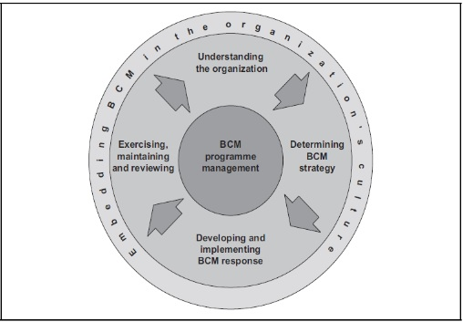

Source: Cabinet Office website

## Information sharing and data protection

Category 1 and 2 responders have a duty under the CCA and Contingency Planning Regulations to share information with each other in order to aid emergency planning, response and recovery. CCA statutory guidance considers information sharing to be “a crucial element of civil protection work, underpinning all forms of co-operation.”[40]

*Information sharing is necessary so that Category 1 and 2 responders are able to make the right judgements. If Category 1 and 2 responders have access to all the information they need, they can make the right decisions about how to plan and what to plan for. If they do not have access to all the information, their planning will be weakened.[41]*

Guidance states that “the initial presumption is that all information should be shared”, but that Category 1 and 2 responders must, at all times, have regard for their responsibilities under relevant legislation, such as the Freedom of Information Act 2000 and the Data Protection Act 1998. This includes understanding what information should be controlled, how to obtain consent, how to categorise information, and what the limits of its disclosure are.

An appropriate level of understanding of these obligations was deemed to be lacking in the aftermath of the 7 July 2005 London bombings. The government’s lessons learned programme found that in some parts of the emergency response the requirements of the Data Protection Act were either “misinterpreted or over-zealously applied”.[42] Accordingly, in February 2007 the Cabinet Office published detailed non-statutory guidance titled *Data Protection and Sharing - Guidance for Emergency Planners and Responders* to complement the CCA regime’s existing statutory and non-statutory guidance for Category 1 and 2 responders.

During any emergency, Category 1 and 2 responders must balance the potential damage to the individual against the public interest in sharing the information. Inevitably the balance struck will depend on the specific nature of the emergency in question, and guidance notes that “in emergencies, the public interest consideration will generally be more significant than during day-to-day business.”[43]

The only circumstances in which the provisions of the Data Protection Act could be disregarded entirely would be through emergency regulations made under Part 2 of the CCA.

**Social media**

Social media plays an increasingly prominent role in emergency response, both as a means of warning and advising the public (see section 4.4) but also to “help responders gain a more accurate picture.”[44] In policing terms this means using “monitoring tools currently available on the market …to track online conversations, identify emerging issues and monitor the online communities most influential to the police.”[45] National Police Improvement Agency guidance *Engage: Digital and Social Media Engagement for the Police Service* claims:

“*These tools continue to help us to understand the policing issues that people are talking about online and how we can best engage with these communities to impact upon confidence in the police.”[46]*

# Legislation

## Crisis (emergency, disaster) management concept

The principle legal instrument in the field of crisis management is the *Civil Contingencies Act 2004.* This is supplemented by the *Emergency Response and Recovery Non statutory guidance accompanying the Civil Contingencies Act 2004,* published by the CCS. As explained in the previous section, the Central Government’s *Concept of Operations* sets out crisis management principles and arrangements in the UK for responding to and recovering from emergencies.

## General crisis (emergency, disaster) management law

**Background to the Civil Contingencies Act (CCA) 2004**

Following a series of emergencies in 2000-2001 (the fuel crisis and severe flooding in late 2000 and the outbreak of Foot and Mouth Disease in 2001) the government initiated a review of emergency planning regulations. It concluded that existing legislation no longer provided an adequate framework for modern civil protection efforts and that new legislation was required.

Following public consultation on a draft Bill from June to September 2003, the Civil Contingencies Bill was introduced to Parliament on 7 January 2004. The Bill received Royal Assent on 18 November 2004 and henceforth became known as the Civil Contingencies Act 2004.

**Statutory basis of the CCA regime**

The Civil Contingencies Act 2004 provides a single framework for civil protection in the UK. It sets out the relationship between the central, regional and local tiers within England, as well as covering the relationship between UK central government and the devolved administrations in Scotland, Wales and Northern Ireland.

Accompanying Regulations flesh out the detail of the Act, and it is also supported by statutory guidance *Emergency Preparedness*,published by the CCS and revised in 2012, which sets out how the CCA’s duties and supporting regulations should be implemented. The Act, regulations and guidance are together referred to as the CCA regime.

The CCS has also published *Emergency Response and Recovery non-statutory guidance* “to establish good practice based on lessons identified from responding to and recovering from emergencies, both in the UK and internationally.” The Cabinet Office has published many more official documents on crisis management and civil security stakeholders often create their own guidance relevant to their particular field. For example, the London Emergency Services Liaison Panel has published eight editions of a Major Incident Procedure Manual to summarise the responses and responsibilities of each of the emergency services at a major incident in London.

To keep the CCA updated, the government created The Civil Contingencies Act Enhancement Programme. It assesses whether there are aspects of the Act where original intentions are not being met, whether the Act needs updating, how to reflect best practice in the Act and supporting guidance and whether the scope of the Act should be broadened. This has led on several occasions to *Emergency Preparedness Guidance* being updated.

**Specialised legislation**

Severe specialised risks are covered by Regulations that pre-date the CCA. These Regulations have established multi-agency emergency planning regimes in place. To avoid duplication, CCA Regulations stipulate that that the duty to maintain plans under the Act does not apply to emergencies which are dealt with by these pieces of legislation.

* Control of Major Accident Hazards Regulations 1999 (as amended 2005 and 2008) impose requirements with respect to the control of major accident hazards involving dangerous substances. They implement Council Directive 96/82/EC on the control of major accident hazards involving dangerous substances (except Article 12 which relates to land use planning). Site operators are required to produce on-site emergency plans for establishments where a dangerous substance is stored.
* The Pipelines Safety Regulations 1996 are enforced by the Health and Safety Executive to ensure that Major Accident Hazard Pipelines are designed, constructed and operated safely. The Regulations task local authorities with the production of emergency plans or the modification of existing plans, to cover certain major accident hazard pipelines within their area.
* Radiation Emergency Preparedness and Public Information Regulations 2001 implement in Great Britain the articles on intervention in cases of radiation emergency in Council Directive 96/29/Euratom, except where they apply to transport by road, rail, air, sea or inland waterway. The Regulations also partly implement Council Directive 89/618/Euratom on informing the general public about health protection measures to be applied and steps to be taken in the event of a radiation emergency. The Regulations establish a framework of emergency preparedness measures to ensure that members of the public are properly informed and prepared, in advance, about what to do in the unlikely event of a radiation emergency occurring, and provided with information if a radiation emergency actually occurs.

The Energy Act 1976 also contains emergency power provisions which allows for the regulation or prohibition of the production, supply, acquisition or use of fuel during an emergency affecting fuel supplies.

Other legislation regarding industrial emergency planning and safety at sports grounds and events includes:

* Nuclear Installations Act 1965
* The Ionising Radiations Regulations
* The Energy Act (Carbon Capture and Storage) 2008
* Safety of Sports Grounds Act 1975
* Fire Safety and Safety of Places of Sport Act 1987
* The Health and Safety at Work Act 1974
* The Flood and Water Management Act 2010

## Emergency rule

Part 2 of the CCA repeals the Emergency Powers Act 1920 and sets out the government’s generic emergency powers legislation. It allows the government to create temporary special legislation (emergency regulations) as a last resort in the most serious of emergencies when both the CCA regime’s legislative framework and the emergency provisions of other existing legislation are judged to be insufficient to respond to an emergency in the most effective way.[47]

Emergency regulations can make any provision that could be made by an Act of Parliament or by exercise of the Royal Prerogative and can extend to the whole of the UK including devolved territories. The only Act of Parliament which may not be amended by emergency regulations is the Human Rights Act 1998. This means that, in theory, emergency powers could be used to suspend core constitutional legislation such as the Habeas Corpus Act 1816 and the Parliament Act 1911 (which restricts a parliament to five year terms). This concerned the House of Lords which in 2004 proposed without success an amendment to exempt important legislation from the CCA’s emergency power provisions.

Section 22 of the CCA states that “emergency regulations may make any provision which the person making the regulations is satisfied is appropriate for the purpose of preventing, controlling or mitigating an aspect or effect of the emergency.” However, the Act’s non-statutory guidance emphasises that: “all those powers listed in Section 22 of the CCA will not be collectively available in any specific emergency; the powers actually used must be tailored to the emergency if they are to meet the robust legal tests and safeguards set out in the CCA”.

Responsibility for proposing the introduction of emergency regulations and drafting their content falls to the LGD in collaboration with other government departments. The government must then satisfy itself that the conditions of the CCA are being met. The Act stipulates that emergency regulations can only be introduced if the UK or a devolved territory faces serious damage to human welfare, serious damage to the environment or a threat to security from war or terrorism. If these criteria are met the emergency must then satisfy the Act’s two additional safeguards which state that emergency powers can only be considered if:

* it is necessary to make provision urgently in order to prevent, control or mitigate an aspect or effect of the emergency when existing powers are insufficient and it is not possible to bring forward a Bill in the usual way and there is a need to make the provision by other means;
* and emergency regulations must be proportionate to the aspect or effect of the emergency they are directed at.[48]

Emergency Regulations are made by the Queen by Order in Council on the advice of her ministers. If this is not possible without serious delay, a senior minister may make the regulations by Order. A regulation must be presented to parliament and approved (with or without amendment) within seven days or it will be considered invalid and cease to have effect. If approved, a regulation stays in force for 30 days but can be renewed for a further 30 days at any point if it is considered necessary and proportionate to do so.

CCA guidance emphasises that the timescale for introducing emergency regulations is likely to vary dramatically depending on the scale of the emergency and the number of regulations it requires. In some cases complex legal issues surrounding liability, human rights protection and devolution may be raised, all of which would need to be resolved before emergency regulations could be made. For this reason guidance advises:

*It should be assumed that it will take a minimum of six hours to bring the regulations into effect, or, more likely, a number of days. This must be borne in mind when considering whether it is appropriate to request the use of the powers - if the effects of an incident are expected to be felt in a matter of minutes or to be over in just a few hours, it is extremely unlikely that emergency regulations could be put in place quickly enough to be of any use. In these situations existing “normal” powers, or the Royal Prerogative, can provide legal cover for any action taken.[49]*

When emergency regulations are introduced, the CCA stipulates that the government must appoint a Regional Nominated Coordinator for each region in England to which the regulations relate, and an Emergency Coordinator for each of the relevant devolved administrations. Their primary role would be to facilitate coordination under the emergency regulations, although Coordinators could also be afforded special powers of direction over organisations and the general population and be allowed to requisition property. A body may need to be created to support them in the exercising of their duties.

## Specific, department/agency-level legal arrangements and regulations on emergency and disaster management

As described in Section 3.1, the UK operates a Lead Government Department principle for emergencies that require intervention by central government. One department typically assumes overall responsibility for crisis management; assessing the circumstances of the emergency, ensuring that its ministers and other relevant ministers are briefed, handling media and parliamentary interest, and providing co-ordinated policy and other support as necessary to local responders. Other government departments, agencies and, if appropriate, the devolved administrations, provide support to the LGD as necessary to ensure a co-ordinated response. The LGD collaborates particularly closely with the Cabinet Office, and the News Co-ordination Centre when activated (see section 4.4).

Often the LGD for recovery is different to the LGD for response. In such cases government guidance emphasises that they would need to work closely from the outset to ensure a smooth transition of responsibilities and that objectives are shared. The LGD for recovery may call on other government departments for support, both for specialist technical and policy advice as well as local knowledge of the area and key contacts to augment their resources. During the transition from response to recovery, DCLG REDs – which advise the LGD, cabinet office and other relevant government departments and provide a liaison function on crisis management and resilience issues below the national level (see section 3.1) – play an important role in ensuring a smooth handover of information, contacts and ongoing actions.

## Specific to the regional and local authorities legal arrangements and regulations on emergency and disaster management

While the principles of emergency response and recovery are the same throughout the UK, the management of emergencies that occur in Scotland, Wales or Northern Ireland varies according to the terms of each country’s devolution settlement and local administrative arrangements. Consequence management and recovery is generally devolved to the relevant administration in the aftermath of all emergencies.

Each devolved administration has its own emergency planning and lead organisation arrangements including protocols for local responders and systems for coordinating a multi-agency response. Accordingly, even when the UK government reserves competency over an emergency they will typically liaise closely with the relevant devolved administration.

Part 1 of the CCA operates in Scotland and Wales much as it does in England, while in Northern Ireland the Act applies only to a limited number of organisations. Were emergency powers ever to be introduced under Part 2 of the Act, the UK government would be required to appoint an Emergency Coordinator for each of the relevant devolved administrations to facilitate coordination of emergency regulations (see section 2.3).

**Scotland**

Responsibility for civil protection is largely devolved in Scotland with responsibility resting with the Scottish Resilience Division of the Scottish government. If an emergency relates to an area of devolved responsibility (such as law and order or the environment), the Scottish government will lead the response, liaising as appropriate with the UK government. If the emergency relates to an area of reserved responsibility (such as national security or nuclear energy) the UK government’s lead department will head the response, working closely with the Scottish government.

Even in cases relating to reserved matters, such as terrorism, the Scottish administration will play a full role in response and recovery because a range of devolved matters, such as the emergency services and the NHS, remain the responsibility of Scottish Ministers, and the prosecution of crime is a devolved responsibility of Scotland’s Lord Advocate.

At local level, responder organisations coordinate under the auspices of eight SCGs, each formed on the basis of a Scottish Police Force area. They play a similar role to LRFs in England and Wales with responsibility for risk assessment, steering emergency planning initiatives, engaging with the community, running training exercises and overseeing the response to an emergency.

At government level, in the event of an emergency the Scottish Government Resilience Room would be established to inform decision making, ensure cross government coordination of the response and support responders as necessary. If the emergency is UK-wide the Resilience Room would coordinate closely with COBR.

**Wales**

Responsibility for civil protection is largely non-devolved in Wales, remaining primarily the responsibility of UK government departments. However, the Welsh government has functional responsibility for a number of policy areas (such as health, the environment and fire and rescue) and is primarily responsible for a number of Category 1 and 2 responders. There is a dedicated Welsh government team for handling multi-agency cooperation and engaging with the UK government on issues of emergency planning and response.

The objectives and arrangements for response at the local level in Wales match those in England but take into account devolved functions. LRFs remain the principle mechanism for multi-agency co-operation on civil protection issues.

At government level, Welsh government officials liaise with their UK government counterparts and act as the main point of contact with local responders and SCGs. This structure is set out in the Pan-Wales Response Plan.

When an emergency with a Level 1 impact has occurred or is likely to occur in Wales, the Welsh government will convene the Civil Contingencies Group to provide strategic leadership to emergency response, linking into both the local and national levels as appropriate. The group is chaired by a senior Welsh Government official and comprised of Welsh Government department officials and representatives from organisations relevant to the emergency.

In the event of a Level 2 emergency, or if the Civil Contingencies Group decides that the emergency should be escalated to Level 2, the group will be re-constituted as the Wales Civil Contingencies Committee (WCCC). The WCCC is an advisory body comprising senior government officials and senior experts from Category 1 and 2 responders. Its functions include maintaining a strategic picture of the evolving situation within Wales, supporting the Government Liaison Team that by this time will have been deployed, and assessing and advising on issues that cannot be resolved at local level. The Welsh Government may also activate the Emergency Co-ordinate Centre (Wales) to link with SCGs and provide briefing and advice to the WCCC, LGD and any other Welsh or UK government department involved in the emergency.

The Welsh Resilience Forum - a non-statutory advisory body - provides a national forum for multi-agency strategic advice on civil protection and emergency planning. The forum meets quarterly and is chaired by the First Minister or the Minister for Social Justice and Regeneration. It provides collective strategic direction to the Wales Capabilities Programme and individual member leadership to the various capabilities sub-groups co-ordinated through a Wales Resilience Partnership Team. It also oversees the Wales Risk Assessment Group which undertakes risk assessment at a pan-Wales level.

A number of other groups provide forums for discussion and the co-ordination of emergency preparedness and response procedures in Wales, including: the Joint Emergency Services Group; the Welsh Borders Resilience Group; the Welsh Government Emergencies Branch and the Wales Media Emergency Forum.

**Northern Ireland**

Civil protection is largely devolved in Northern Ireland. Responsibility for the strategic coordination and management of most emergencies rests with Northern Ireland government departments (following the LGD principle – see section 3.1) and overall policy and strategy co-ordination lies with the Office of the First Minister and Deputy First Minister. This excludes emergencies relating to terrorism, policing, criminal justice and security, which remain the responsibility of the UK government’s Northern Ireland Office. In emergencies of this nature the Northern Ireland Office would activate its Northern Ireland Office Briefing Room arrangements, although the Northern Ireland executive would also activate its own crisis management arrangements because many of the responses required in such emergencies fall within devolved responsibilities.

Emergencies in Northern Ireland are first dealt with locally by the emergency services, district councils and other public services organisations. If an emergency cannot be managed effectively at local level and requires cross-departmental strategic coordination, the Northern Ireland Crisis Management Arrangements will be invoked.

The Crisis Management Group is responsible for setting the overarching strategy of the Northern Ireland government’s response to an emergency and has the power to direct the response and commit the resources of the Northern Ireland civil service. It is normally chaired by the First Minister and deputy First Minister acting jointly, and is comprised of other Executive Ministers and departmental senior officials.

The strategic direction set by the Crisis Management Group is supported by the Civil Contingencies Group (Northern Ireland), a pan-Northern Ireland multi-agency forum comprised of senior representatives from Northern Ireland government departments, the Northern Ireland Office, emergency services, district councils and other organisations relevant to the emergency. The group’s functions also include periodically reviewing, researching and briefing member organisations on civil protection policy.

The Crisis Management Group and Civil Contingencies Group (Northern Ireland) are supported by a range of administrative and advisory groups, including a Central Operations Room, a scientific and technical advisory group and liaison arrangements with other co-ordination groups.

These strategic crisis management arrangements, together with provisions for emergency preparedness, are maintained by the Civil Contingencies Policy Branch, located in the Office of the First Minister and Deputy First Minister. The Branch also represents Northern Ireland in policy discussion at UK and international levels.

**London**

London’s patterns of public service provision and government mean that some aspects of civil protection are organised differently. One pan-London LRF covers the whole city, incorporating the Metropolitan Police and City of London Police areas. Each London borough is represented on the LRF by a Borough Resilience Forum which facilitate co-operation and information sharing at the operational level between local authorities and the emergency services. Local authorities are supported in exercising their duties by the London Fire and Emergency Planning Authority which, among other things, helps to develop, maintain and exercise emergency plans for category 1 responders and trains their staff.

## Legal regulations on the involvement of volunteers and specialised NGOs

A wide range of voluntary organisations and NGOs, both at local and national level, support the statutory services in the planning, response and recovery phases of most emergencies. These arrangements are generally ad hoc, although their role was clarified by Part 1 of the CCA which requires category 1 responders “to have regard to the activities of bodies whose activities are not carried on for profit” in the course of carrying out their emergency and business continuity planning duties.[50] CCA guidance states:

*Statutory responders should be aware of the capabilities and capacity of local voluntary organisations and the means of accessing their services, whether as individual volunteers or as members of local or national volunteer organisations. Statutory responders should develop and implement agreed processes for activating call-out mechanisms, and systems for organising, managing, briefing and debriefing volunteers. The voluntary sector should also be included in post-response review and evaluation activity.[51]*

Category 1 responders are obliged to consider how the voluntary sector can be involved at every stage, including training and exercising for emergency preparedness. Cabinet office guidance emphasises that advance planning is essential if the voluntary sector’s diverse array of skills and expertise is to be effectively integrated and utilised during the response phase of an emergency. *Emergency Preparedness* guidance states:

*Sound co-operation through the Local Resilience Forum (LRF) processes and directly with individual Category 1 responders should be based on an agreed framework. This structure needs to suit local circumstances, be understood by all concerned and have clearly identified points of contact. These contact arrangements must be kept up to date by regular formal and informal dialogue between each of the participants at local level.[52]*

Statutory agencies that use volunteers may become responsible for their health and safety, and as such CCA guidance states that “volunteers should be appropriately equipped, trained, supervised and supported by their own organisations.”[53] Agencies can use Service Level Agreements, Memorandum of Understanding or other forms of protocol to establish arrangements to identify the level of insurance cover provided by voluntary organisations, the training provided to voluntary sector personnel, or the use of Personal Protective Equipment. When involved in emergency response, the activities of voluntary organisations and NGOs will be subsidised by category 1 responders. *Emergency Preparedness* guidance states that a Memorandum of Understanding should be in place to describe financial arrangements.

The CCS and the British Red Cross established the Voluntary Sector Civil Protection Forum to identify and maximise the voluntary sector’s contribution to UK civil protection arrangements and to provide a framework for engagement between the government, emergency services, local authorities and voluntary organisations. The Voluntary Sector Civil Protection Forum is made up of representatives from the voluntary sector, central and local government, devolved administrations, statutory authorities and professional organisations.

## Legal regulations for international engagements of first responders and crisis managers

There are no statutory regulations for deploying first responders and crisis managers overseas. The 2010 Strategic Defence and Security Review commits the UK to working “to ensure that EU civil protection arrangements focus on shared risk assessment and prevention, coordination of mutual assistance, and maximised awareness of critical infrastructure dependencies” (see further section 3.2).[54] In the event that UK civil servants or civilian experts are committed to overseas missions they are usually seconded, either directly to the governmental agencies of the country in which the programme is being carried out or to international organizations involved in the programme.

# Organisation

England consists of 34 two-tier counties, 32 London boroughs and 1 City of London or Greater London, 36 metropolitan counties and 46 unitary authorities. Northern Ireland consists of 26 district council areas and Scotland and Wales has 32 and 22 unitary authorities respectively.

England is subdivided into nine administrative regions. Greater London has an elected Assembly and Mayor, but the other regions have a minor role, with unelected regional assemblies and Regional Development Agencies. Below the regional level and excluding London, England has two different patterns of local government in use. In some areas, there is a county council responsible for services such as education, waste management and strategic planning within a county, with several district councils responsible for services such as housing, waste collection and local planning. These councils are elected in separate elections. Some areas have only one level of local government, and these are dubbed unitary authorities. The City of London and the Isles of Scilly are sui generis authorities, predating recent reforms of local government.

## Organisational chart

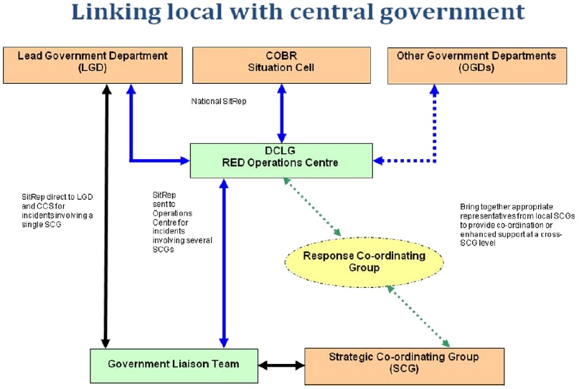

Figure 56: Linking local with central government

Source: Department for Communities and Local Government

**Local arrangements for civil protection**

Part 1 of the CCA, together with supporting regulations and statutory guidance, establish a clear set of roles and responsibilities for those organisations involved in emergency preparation and response at the local level. The Act divides local responders into two categories and imposes a different set of duties on each.

Category 1 responders are organisations that collectively form the core of the response to most emergencies. They include:

* Emergency services: police forces including the British transport police; fire services; ambulance services; HM coastguard
* Local authorities: all principal local authorities (i.e. metropolitan districts, shire counties, shire districts, shire unitaries)
* NHS bodies: primary care trusts; hospital trusts; foundation trusts (and Welsh equivalents); Health Protection Agency
* Government agencies: Environment Agency; Scottish Environment Agency

Given their front-line role, category 1 responders are subject to the full set of civil protection duties under the CCA. They are required to:

* assess the risk of emergencies occurring and use this to inform contingency planning;
* put in place emergency plans;
* put in place Business Continuity Management arrangements;
* put in place arrangements to make information available to the public about civil protection matters and maintain arrangements to warn, inform and advise the public in the event of an emergency;
* share information with other local responders to enhance co-ordination;
* co-operate with other local responders to enhance co-ordination and efficiency; and
* provide advice and assistance to businesses and voluntary organisations about business continuity management (Local Authorities only).[55]

Category 1 responders are excluded from these CCA responsibilities in cases of severe specialised risks and emergencies that are covered by other legislation (for example, the Control of Major Accident Hazards Regulations 1999, the Pipelines Safety Regulations 1996 and the Radiation Regulations 2001), although their help could still be required if appropriate.

Category 2 responders are less likely to be involved in front-line response and planning work, but may be heavily involved in emergencies that affect their sector. They include:

* Utilities: electricity distributors and transmitters; gas distributors; water and sewerage undertakers; telephone service providers (fixed and mobile)
* Transport: Network Rail; train operating companies (passenger and freight); London Underground; Transport for London; Highways Agency; harbour authorities; Airport operators
* Health: NHS strategic health authorities; Health and Safety Executive

The CCA imposes two responsibilities on these responders: cooperation and information sharing with other category 1 and 2 responders.

The intention is to foster cooperation and understanding and cement local-level partnerships and accordingly senior representatives of category 1 and 2 organisations also come together to form Local Resilience Forums (LRFs), the principal mechanism for local multi-agency cooperation under the CCA. LRFs have no legal personality or powers to direct their members, but are obliged to meet at least once every six months and are expected to ensure effective delivery of CCA duties. They also provide specific risk assessments for their geographical area (see section 1.1).

**The local response to an emergency**

As outlined in Section 1.2, emergency management and response in the UK is founded on a bottom-up approach in which operations are managed and decisions are made at the lowest appropriate level. Local organisations are always the first responders and act as the “essential building block” for the response to an emergency.[56] Indeed, the Cabinet Office emphasises that:

*Most incidents are handled at a local level by the emergency services and by the appropriate local authority or authorities with no direct involvement by central government (though government departments with a potential interest would keep themselves informed on developing events and the handling of the media).[57]*

Category 1 responders are required by the CCA to have procedures in place for determining whether an emergency has occurred. Once identified, if the scale and nature of an emergency is deemed to require strategic guidance, an SCG will be formed to coordinate the local multi-agency response. It is located in the Strategic Co-ordination Centre and comprised of senior representatives with executive authority from each of the key organisations involved in the local response. The chair of the group, typically a senior police officer but occasionally a Local Authority Chief Executive, is known as the Strategic Coordinating Group Chair (although this role is often colloquially referred to as a ‘Gold Commander’). The SCG will take strategic decisions on managing the emergency locally. The command structures of individual agencies operate alongside but separate from the SCG.

Three levels of command at single agency level operate below the SCG: operational (Bronze), tactical (Silver) and strategic (Gold). They can often be implemented without the need for multi-agency co-ordination through the SCG, with any necessary co-ordination taking place at silver or bronze level. Incidents are normally handled at the operational level, moving to the tactical or strategic level if required depending on the scale or nature of the incident.

**The Central response framework**

While most emergencies are managed at the local level, the government has identified three types of emergency that might necessitate the involvement of the sub-national tier in England, a devolved administration, or UK central government:

* *Significant emergency (Level 1) has a wider focus and requires central government involvement or support, primarily from a lead government department (LGD) or a devolved administration, alongside the work of the emergency services, local authorities and other organisations. There is however no actual or potential requirement for fast, inter-departmental/agency, decision making which might necessitate the activation of the collective central government response, although in a few cases there may be value in using the COBR complex to facilitate the briefing of senior officials and ministers on the emergency and its management.*

*Examples of emergencies on this scale include most severe weather-related problems. In addition, most consular emergencies overseas fall into this category with the FCO providing advice and support to those affected alongside the authorities in the country affected.*

* *Serious emergency (Level 2) is one which has, or threatens, a wide and/or prolonged impact requiring sustained central government co-ordination and support from a number of departments and agencies, usually including the regional tier in England and where appropriate, the devolved administrations. The central government response to such an emergency would be co-ordinated from the Cabinet Office Briefing Rooms (COBR), under the leadership of the lead government department. Examples of an emergency at this level could be a terrorist attack, widespread urban flooding, widespread and prolonged loss of essential services, a serious outbreak of animal disease, or a major emergency overseas with a significant affect on UK nationals or interests.*

*Examples of emergencies on this scale, include the H1N1 Swine Flu pandemic, the 2007 summer floods, and the response to the 7th July bombings in London.*

* *Catastrophic emergency (Level 3) is one which has an exceptionally high and potentially widespread impact and requires immediate central government direction and support, such as a major natural disaster, or a Chernobyl-scale industrial accident. Characteristics might include a top-down response in circumstances where the local response had been overwhelmed, or the use of emergency powers were required to direct the response or requisition assets and resources. The Prime Minister would lead the national response. Fortunately, the UK has had no recent experience of a Level 3 emergency, but it is important to be prepared for such an event should the need arise.[58]*

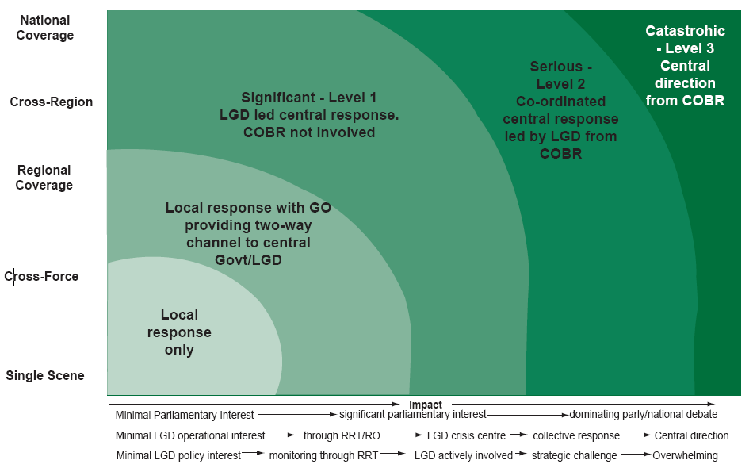

Figure 57: Likely form of central government engagement based on the impact and geographic spread of an emergency in England

Source: Responding to Emergencies: UK Central Government Concept of Operations

In the event of a Level 2 or 3 emergency, the government’s central response framework would be initiated. This would involve the activation of central government’s crisis management facilities - the Cabinet Office Briefing Rooms (COBR). COBR is comprised of ministers and senior officials from relevant UK government departments and agencies along with representatives from other organisations as necessary. COBR is responsible for overall strategic planning and its activation is intended to facilitate rapid co-ordination of the central government response and effective decision-making. It also provides an authoritative source of advice for local responders.

COBR is designed to be flexible to adapt to the specific circumstances of an emergency. Within COBR, a senior decision making body oversees the government’s response and is supported as necessary by a number of separate cells and supporting blocks of activities. These can be grouped into five broad areas and are supported by sources of specialist advice as required. There is often no need for all of the supporting structures to be activated; a full activation is likely only in the most complex emergencies, particularly where there is a need to manage a mix of highly and unclassified material or there are potentially wide ranging consequences flowing from the initial event (some terrorist scenarios, for example). On many occasions, the senior decision making body is likely to meet with only the Situation Cell for support with operational response considerations the responsibility of the Lead Government Department (see below).

Examples of COBR being initiated within the last year include a series of meetings throughout February 2014, chaired by Prime Minister David Cameron, on the government’s response to severe weather and flooding. COBR also met to discuss the threat posed by the Ebola virus to the UK in July and October 2014.

Figure 58: Structure of Cabinet Office Briefing Rooms

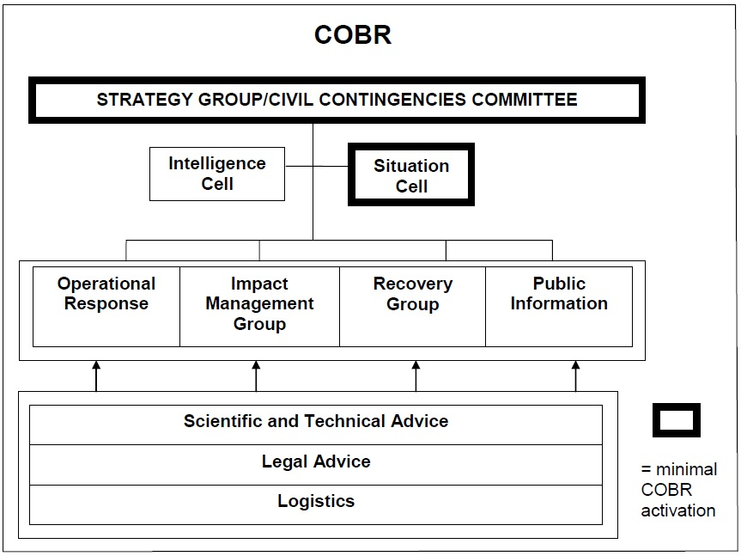

Source: Responding to Emergencies: UK Central Government’s Concept of Operations

Overall crisis management is typically supervised by one government department: the Lead Government Department. The LGD takes overall responsibility for assessing the situation, ensuring that its ministers and other relevant ministers are briefed, handling media and parliamentary interest, and providing co-ordinated policy and other support as necessary to local responders. Other government departments provide support to the LGD to ensure a co-ordinated response.

The Cabinet Office publishes a list of pre-nominated lead departments for as many potential emergency situations as possible to ensure clarity in times of crisis.[59] In England, Scotland and Wales, the Home Office is the LGD responsible for terrorist related emergencies and assumes responsibility for all emergencies where the cause is uncertain or until such a time when terrorist activity can reasonably be ruled out.

The LGD is responsible for alerting the CCS as soon as it considers any incident (or potential incident) to likely require collective consideration by a range of departments. The CCS was created in July 2001 and is the cabinet office department responsible for emergency planning. It works under the leadership of the Civil Contingencies Committee, a cabinet office committee chaired by the Home Secretary, and in the event of an emergency its role is to provide central focus for cross-departmental and cross-agency commitment, coordination and cooperation (see section 1.2.4 for the CCS’s role in orchestrating emergency preparedness).

When it is unclear which government department should take the lead, the CCS will take the immediate lead until the Prime Minister has endorsed its selection of LGD.

**Liaison between local responders and central government**

When an emergency requires central government intervention, a Government Liaison Officer is dispatched to act as the primary liaison between government departments and the SCG. The Government Liaison Officer is normally from the relevant government office or the LGD, and is supported when necessary by a Government Liaison Team.

If local responders are overwhelmed or an emergency affects a wide geographical area and would benefit from greater coordination, a multi-SCG Response Co-ordinating Group (RCG) may be convened to bring together representatives from different SCGs. Both SCGs and, when formed, the RCG, report to their local Department for Communities and Local Government Resilience and Emergencies Division (DCLG RED – England is divided into four REDs whose seats are in London, Birmingham, Bristol and Leeds) which acts as conduit for communications between central government and the local level.

REDs are responsible for supporting local response and recovery efforts, and ensuring that there is an accurate picture of the situation in their area (see Figure 6). They advise the LGD, cabinet office and other relevant government departments on what support is likely to be required by local responders to recover from an emergency. REDs are also responsible for liaising with government in emergencies below the national level that don’t require intervention by central government and are the first point of contact between government and all LRFs in England.

**Scientific support during emergencies**

The effective management of most emergencies requires access to specialist scientific and technical advice, for example regarding the public health and environmental implications of a flood or the spread of a disease.

At local level, the SGC is advised to establish a Science and Technical Advice Cell (STAC) at an early point of the response phase to provide a common and coordinated source of scientific and technical advice. The STAC’s designated lead usually comes from the health community and will work with the SCG to select the cell’s core membership, typically from government agencies.

At national level, COBR and government departments receive advice from the Scientific Advisory Group for Emergencies (SAGE) which is responsible for coordinating and peer reviewing scientific and technical advice to inform evidence-based ministerial decision making. SAGE can be scaled up or down in size depending on the nature of the emergency (similarly to COBR) and is usually chaired by the Government’s Chief Scientific Advisor.

SAGE representatives report to the ministerial and official groups within COBR. The Government’s Chief Scientific Advisor usually represents SAGE at ministerial meetings. A SAGE committee oversees the work of SAGE’s sub-groups - which can be many depending on the nature and scale of the emergency - established to focus on specific issues. A SAGE secretariat, typically provided by the LGD, has the role of activating and deactivating SAGE and supporting its functions.

To ensure consistency, SAGE will liaise with STAC(s). Interaction arrangements are defined by the LGD in consultation with the Cabinet Office and the Government Office for Science, and can vary depending on the nature of the emergency. The standard interaction model, designed to embed scientific advice provision into both local and central government decision-making is outlined in Figure 9.

Most recently, SAGE was activated during the 2009 H1N1 influenza pandemic, during the 2010 volcanic ash disruptions and the Fukushima nuclear incident in 2011. STACs have been activated for a number of events, including the 2008 Cumbrian flooding.

Figure 59: SAGE Governance structures

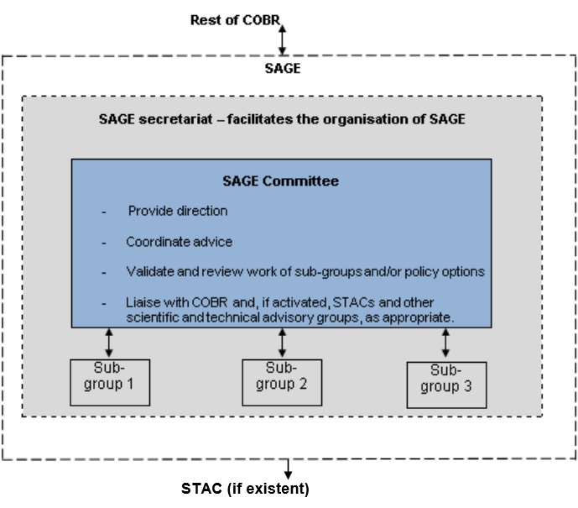   
Source: Cabinet Office Enhanced SAGE Guidance, October 2012

Figure 60: Default SAGE, STAC interaction model

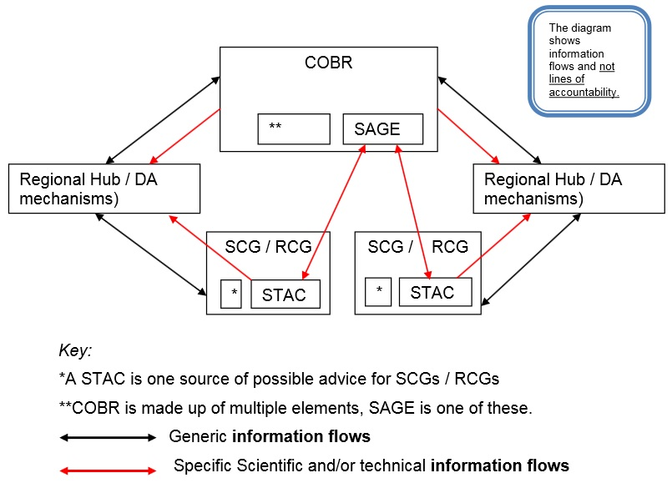

Source: Cabinet Office Enhanced SAGE Guidance, October 2012

## Organisational cooperation

**Operational cooperation within the EU**

The UK can cooperate with other countries bilaterally, although this happens very rarely. The ANVIL study found that “the UK has not invoked a bilateral agreement with regard to crisis management in the period 2000-2012.”

More commonly, the UK participates in intergovernmental organisations and a limited number of multilateral frames of cooperation in crisis management. This includes facilitating mutual aid between countries in the event of an emergency, and sharing good practice and training to better prevent or mitigate the consequences. The UK participates in the EU Civil Protection Mechanism (CPM) which, since its creation in 2001, has functioned as an institutional framework for all ad hoc agreements with other European countries following the occurrence of an emergency. The UK is also:

*…a member of the ‘Bonn Agreement’ which, among other issues, engages with pollution as a maritime disaster; within the EU Civil Protection Mechanism, it participates in a working group of 6 member states discussing key aspects of the Mechanism; it also has membership in the ‘Regional Environmental Centre for Central and Eastern Europe’, in the ‘International Organisation of Fire & Rescue Service’, and in the ‘Regional Coordination Council for South Eastern Europe’.[60]*

However, it remains a very rare phenomenon for the UK to seek help from other countries to manage emergencies. This can be attributed both to the self-sufficiency of the UK’s crisis management system and the fact that, in the UK, crisis management is tied closely to the sensitive subject of national sovereignty. There is a general reluctance among UK practitioners to engage in operational collaboration with EU countries and institutions on internal emergencies. An interviewee told the ANVIL study: “‘EU institutions do not really play a role in emergency response internally in the UK’.”

The ANVIL study identified only two instances for the period 2000-2012 when the UK considered and accepted external assistance: the Buncefield fire at the Hertfordshire Oil Storage Terminal in December 2005 and the severe snowfalls of winter 2009, during which the government referred to the EU Monitoring Information Centre, for the first and only time, to request grit-salt through the EU Civil Protection Mechanism.[61] The UK is more willing to offer assistance, having contributed to requests for assistance on 13 occasions as of February 2014.

The ANVIL study found that while “the euroscepticism of British policy-makers extends to civil security issues”, at the level of political initiatives the UK has not lagged behind in the EU context. The UK is active in the CPM and is a member of an informal working group that discusses main aspects of EU civil protection. The ANVIL study interviewed a member of the CCS who affirmed UK support for the coordination of prevention measures: “The UK supports the general thrust to encourage risk assessment across member states and the sharing of best practice and expertise in this area.”[62] The British government has also proposed the introduction of a common EU Counter-terrorism strategy, adopted in 2007, and a Civil Contingencies Strategy.

Britain’s level of participation in major EU and NATO exercises has been criticised in the past by the House of Lords European Union Select Committee as “unacceptably low.” In 2009, the Committee found that “the United Kingdom has participated in only 11 of 31 EU or NATO exercises between 2000 and 2008” and often only as an observer. The Committee argued that “using the NATO criterion, ‘participated in the exercise by deploying teams’, it seems that the United Kingdom has participated in none of the annual NATO exercises, and in only one of the EU exercises.”[63] However, the UK appears to have become more active in recent years. It hosted the EU exercise Orion in September 2010, an earthquake scenario simulation, and participated in exercises in Greece in May 2010, Estonia in May 2011 and most recently a Denmark-Germany joint hosted exercise in October 2013.[64]

The ANVIL study cites enthusiasm among British civil servants to participate in CPM training programmes and emphasises the fact that training on how to coordinate collaboration under the CPM is offered in Britain:

*The UK’s Emergency Planning College offers a unique, intensive seminar called ‘Community Mechanism Introduction’, with instructors from different European countries covering a variety of issues from basic knowledge of EU activities on civil protection to brief tabletop exercises. We were able to follow part of the training in November-December 2012 and can confirm the attendance of students/emergency planners from different European partners and their willingness to learn from each other, create networks and get accustomed to cooperation in case they have to operate together.*

The UK is active in the CPM’s Exchange of Experts in Civil Protection programme, having most recently sent CCS officials to Iceland in April 2014 to improve the UK’s understanding of, and preparation for, an effusive volcanic eruption.[65] Cabinet Office guidance also cites NATO Civil Emergency Planning as an example of the UK working internationally on emergencies.

The UK is also a member of the European Forum for Disaster Risk Reduction and is a signatory to the Hyogo Framework for Action 2005 to 2015, which it signed, along with 100 other countries, at the World Conference on Disaster Reduction in January 2005. The Framework “is the first plan to explain, describe and detail the work that is required from all different sectors and actors to reduce disaster losses” and commits signatories to reduce vulnerabilities to natural hazards. The UK was the first country to have its implementation of the framework peer reviewed in May 2013 and, although scope for improvement was identified, the UK was deemed to have “achieved a high level of preparedness.”[66]

**Transboundary crises**

Unlike other European countries, the UK’s crisis management system has not been tested by severe transboundary crises (and of course is less likely to be given the UK shares a land border with just one other EU Member State, Ireland). Nonetheless, the ANVIL study advises greater interaction with the civil security mechanisms of other European countries, and asks:

*How well would the British civil security system have reacted if the bombings in 2005 had taken place in the Channel Tunnel instead of the London underground? Our estimation is that in such cases the value-added of EU assistance can be significant and has not been sufficiently assessed by the British practitioners.[67]*

**UK Organisational arrangements**

The Foreign and Commonwealth Office (FCO) is responsible for managing the UK’s relationship with other countries through its network of embassies and High Commissions, as well as the UK’s overall relationship with international organisations such as the UN, NATO and the EU.

However, the CCS in the Cabinet Office is responsible for liaising with the civil emergency response and mutual aid systems of the EU (the CPM including the Monitoring and Information Centre, and the Community Emergency Communication and Information System) and NATO (the Euro-Atlantic Disaster Response Co-ordination Centre, which coordinates emergency planning).

Government departments can have bilateral relationships with specific international or multilateral institutions that will be used when appropriate. For instance, during a pandemic flu, the Department of Health would be best place to engage with the World Health Organisation as part of the UK response.

When an emergency occurs in the UK, the FCO representative in COBR is responsible for handling any requests of support from the UK government. They are also responsible for advising COBR on the concerns and handling of other governments. The FCO is responsible for ensuring that bilateral and multilateral obligations to identify neighbouring countries and/or partners of the emergency have been met, although another government department may have responsibility for making the notification.

For emergencies that occur overseas such as bombings or kidnappings, the FCO is the LGD and will chair COBR unless the emergency has significant direct consequence in the UK (for example the fallout from a nuclear accident or a pandemic) in which case the appropriate government department will lead. If an emergency necessitates the return or repatriation of British citizens the FCO will always be the LGD, although it may relinquish lead status once this process has been completed.

# Procedures

## Standing Operating Procedures (SOPs) and Guidelines

There is no single document setting out Standard Operating Procedures for crisis management in the UK, nor any compendium of the SOPs applicable to different agencies. Key procedures and guidelines have been set out in previous sections.

## Operations planning

In the UK, emergency planning is predominantly carried out at the local level, in keeping with the country’s bottom-up approach to crisis management. The police, local authorities, and all other Category 1 responders, have specific legal duties under the CCA to plan for civil emergencies in their geographical area, such as flooding, industrial accidents, severe weather etc. This also includes putting in place business continuity management arrangements to ensure continuity of service in the event of disruption caused by an emergency, and for effective recovery afterwards. This also applies to industrial action, where it is important for the emergency services in particular to maintain business continuity. All of these plans must be tested regularly through training and exercises.

For example, in London, the London Resilience Forum directs the work of the London Resilience Partnership, which is comprised of more than 170 organisations from Category 1 and 2 responders, the Greater London Authority, central government, the military and business representatives. The Partnership works to assess risks in London and prepare for major emergencies. It has plans and protocols in place outlining how different emergencies would be responded to and conducts multi-agency exercises to test these arrangements. Operational plans exist to cover flooding, pandemic influenza, mass casualties, mass fatalities, excess deaths, structural collapse, adverse weather, mass evacuations, mass shelter, and disease outbreaks.

At national level, the government and relevant government departments plan for specific risks.

Pandemic influenza: the government aims to stockpile enough antivirals to treat 50% of the population and has advanced purchase agreements for the supply of pandemic-specific vaccines. The UK Influenza Pandemic Preparedness Strategy 2011 provides UK-wide guidance on responding to an influenza pandemic.

New and infectious diseases: Public Health England, an executive agency of the Department of Health that was established in 2013, has plans in place for dealing with an outbreak of a new or emerging infection, whether arising abroad or in the UK. It would coordinate the investigation and management of any such outbreak and advise the government on public health risks and necessary preventative and control measures. Existing Department of Health SARS and pandemic influenza contingency plans would form the basis for dealing with any future outbreaks should either of these diseases re-emerge. Government departments also have plans in place to manage the potential influx of British nationals that may occur in the event of this type of emergency.

Flooding: The government has a programme of flood risk management, which aims to reduce the likelihood and consequences of flooding. The Environment Agency works with the Met Office and the Flood Forecasting Centre to anticipate the risk of flooding and to provide early warning to the areas most likely to be impacted.

Major industrial accidents: Comprehensive plans are in place for handling shortages, or complete outages, of oil, gas and electricity (see section 5.2). Under the Security and Emergency Measures (Water and Sewerage Undertakers) Direction 1998, all water companies must have plans in place to provide alternative water supplies. The Maritime and Coastguard Agency plans for major and minor pollution incidents. A National Response Plan is also in place to deal with the effects an overseas nuclear accident would have on the UK population and infrastructure.

Malicious attacks: Long-standing and regularly activated major incident plans and structures are in place across government to respond to malicious attacks in both crowded places and on infrastructure. All transport sector operators are required to have plans in place to cover a range of malicious attack scenarios.

The government also plans, to varying extents, for all of the other risks identified in the National Risk Register. They include: volcanic hazards, severe weather, severe space weather, severe wildfires, animal diseases, major transport accidents, public disorder, and cyber-attacks.

## Logistics support in crises

**Private logistics providers**

Private logistics providers likely to have an important role in emergency response and recovery are designated by the CCA as Category 2 responders. They have responsibilities under the Act to cooperate and share information with other Category 1 and 2 responders, and Category 1 responders must take into account how category 2 responders can be involved in crisis management whilst conducting emergency planning (see section 3.1). Both category 1 responders and central government can also sign ad hocagreements with private companies if an emergency occurs (see section 5.1). During emergency response, privatised utility companies will often be recruited by local authorities.

**Military logistics support**

The armed forces’ national structure, organisation, skills, equipment and training can be of benefit to the civil authorities in managing the response to and recovery from emergencies. Support is governed by Military Aid to the Civil Authority (MACA) arrangements, with detailed rules and procedures governing the employment of armed forces on MACA operations set out by the MoD in *Operations in the UK: The Defence Contribution to Resilience*. Reserves, if available, can be deployed alongside regular personnel in most scenarios.

CCA statutory guidance emphasises that assistance is provided on the basis of availability and as such responding agencies should not formulate plans for specific emergencies on the assumption that the armed forces will be able to intervene. In general, the armed forces will intervene only when the scale of an emergency exceeds the capabilities of local responders or when the nature of the emergency requires obvious military intervention, for example in the event of a bioterrorist attack or an accident involving hazardous material.

Deployment

In most circumstances the provision of armed forces support must be requested by a government department and approved by a Defence Minister. The exception is when there is a requirement to save lives, alleviate distress or protect property in which case a commander can decide to provide urgent assistance without government approval. A local authority can also contact central government and request military involvement under the provision of Military Aid to the Civil Community. This happened during the 2009 floods in Cumbria but in general is a very uncommon occurrence. Part 2 of the CCA could also be used to enable the Defence Council to deploy armed forces under emergency regulations.

Organisational

The MoD’s Standing Joint Command (United Kingdom) is the operational lead for the armed forces. It responds to MACA requests from government departments and provides advice through army regional brigades. Each brigade has a Joint Regional Liaison Officer who liaises with local responders and acts as their first point of contact. Military units and personnel remain under the MOD chain of command at all times and are not subordinated to the command of civil authorities.

Role

The armed forces can support civil authorities in two ways: by augmenting the capabilities of responders through regular and reserve forces, and by providing niche capabilities. In the case of the latter, Defence Minister may decide to devote specific armed forces and MoD assets to specific emergency response and recovery operations. These include:

* *a UK-based and UK-focussed Command and Control structure*
* *a UK focused Defence communications capability*
* *an Explosive Ordnance Disposal and Chemical Biological Radiological and Nuclear make-safe capability*
* *an air surveillance, policing and defence system*
* *Fishery Protection vessels*
* *a Special Forces capability*
* *a Search and Rescue capability*

A small number of armed forces personnel are available to brief COBR, and logistics specialists could also be deployed to other levels of command, although they are not held at readiness for such tasks. Logistics support could be provided in multiple areas:

Transport: the armed forces use commercial contractors, but may have a small number of helicopters and portable boats available in the UK which could be used to move limited amounts of stores or small numbers of personnel.

Engineering: armed forces engineering equipment is held centrally and amounts to about that typically available in a medium sized town. Relevant engineering expertise on subjects such as power generation, bridging or temporary flood protection, may be available depending on the situation.

Estate: military bases could be available during operational responses or for non-operational support, such as accommodation or training facilities.

Fuel: the armed forces hold sufficient fuel reserves to support military activities and a small number of fuel tankers in the UK.

Telecommunications: the military has its own resilient communications for use by the armed forces and may have some small scale capacity to augment civil capability with specialist engineers and communications staff if required.

## Crisis communication to general public; Alert system; Public Information and Warnings

In the UK, responsibility for warning and informing the public depends on the nature of the emergency. Raising awareness on counter-terrorism, for example, is largely a task for central government. Other risks are addressed at both local and national level. In the event of a pandemic, local health authorities would inform and advise the public but information would also be available through the News Centre of the Health Protection Agency. If the Environment Agency issues warnings of coastal or inland flooding, local authorities are depended on to help warn and prepare the public.

**Informing the public – traditional and social media**

When an emergency occurs, local responders have immediate responsibility for alerting the public. Methods of information delivery available to them are extremely varied, but may include:

* *mobilising officers to go round on foot and knock on doors*
* *from car or helicopter, by loudhailer or other amplified means*
* *media announcements*
* *electronic/variable message boards, eg at the roadside or on motorways*
* *direct radio broadcasts to shipping (in maritime incidents)*
* *PA announcements in public buildings, shopping centres, sports venues, transport systems, etc*
* *automated telephone/fax/e-mail/text messages to subscribers*
* *site sirens*

Responders also increasingly make use of social networks including Twitter and Facebook as well as text messaging alert services such as the Floodline Warnings Direct Service, which is managed by the Environment Agency.

Cabinet office guidance advises that “social media should not be used in isolation but integrated into emergency communication strategies” and emphasises its function as “a method of widening their access to communities and engaging with people through their preferred method of communication”.[68] In March 2012, the government published *Smart Tips for Category 1 Responders: Using Social Media in Emergency Management* to provide guidance.

For emergencies with national dimensions, the news media (radio, TV broadcasting and print) remains the government’s primary means of communication. Through the CCS, television stations can be used to alert the public, with the BBC the UK’s nominated “Emergency Broadcast System”. The Radio Amateurs’ Emergency Network, the UK’s national voluntary communications service, may also be used to alert the public.

The UK national siren system, a relic from World War II, was largely dismantled by the end of the Cold War in the late 1980s and early 1990s. However some coastal areas retain and regularly test their sirens to warn of flooding.[69]

**Statutory obligations for Category 1 responders**

The CCA includes public awareness and warning and informing as two distinct legal duties for Category 1 responders. The public must be educated on the probability and risks of emergencies (through the Community Risk Register – see section 1.1) and how responders are prepared to deal with them should they occur. If an emergency does occur, or is about to occur, the public must be warned and provided with information and advice as required.

Having warning systems in place is particularly important for organisations such as the emergency services and local authorities whose functions are likely to be seriously obstructed by an emergency. CCA guidance states that strategies for warning, informing and advising the public - either directly or through the media – must be fully integrated into a responder’s CCA emergency plans and tested regularly through exercises and staff training. Responders are responsible for making decisions about precisely when, how, about what and to whom warnings should be issued (see Figure 11).

The Act allows for Category 1 responders to discharge their duties collaboratively. To avoid duplication of effort and potential confusion and alarm caused by inconsistent information, cross-agency coordination of information should be established at an early stage and in most cases responders should identify an organisation to take lead responsibility for warning and informing the public.

Figure 61: Public communications timeline: what responders’ plans need to achieve

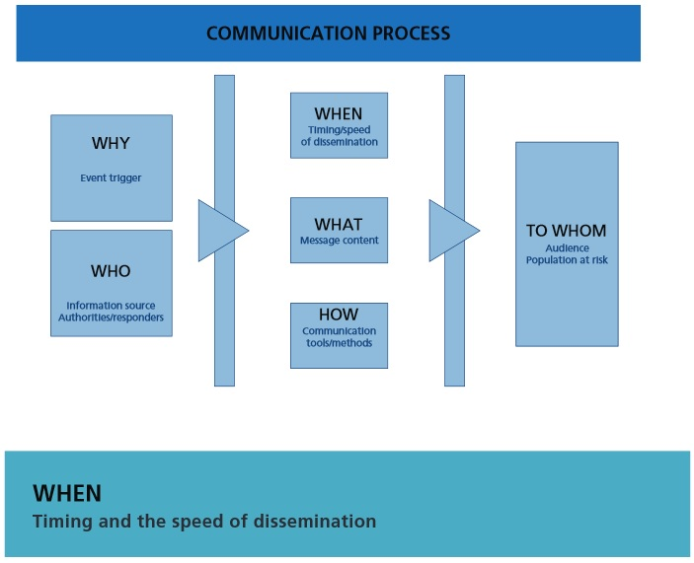 Source: Emergency Preparedness, Chapter 7: Communicating with the public

Other existing legislation also imposes a duty to provide information to the public. Under the Control of Major Accidents Hazards Regulations 1999 and the Radiation (Emergency Preparedness and Public Information) Regulations 2001, operators must provide information, through their local authority, to members of the public liable to be affected by a major accident at the operator’s establishment.

**News Co-ordination Centre**

In the event of an emergency that requires the involvement of central government, the News Co-ordination Centre (NCC) will be established in Whitehall by information staff from the Cabinet Office. It functions alongside LGD and liaises with the Central Office of Information News and Public Relations at the scene of the emergency, if outside London.

Capable of functioning 24 hours a day, the NCC helps to coordinate the information activities of the government departments and agencies involved by compiling and organising expert briefings and overseeing interview bids for ministers. The NCC works closely with national and international media, monitoring output to correct inaccuracies and identify when additional material would provide a better balance of coverage.

The NCC is also responsible for managing the delivery of public information and safety advice at the national level. Where necessary, it can invoke standing protocols with the media to issue Public Safety Information either nationwide or in specific geographical regions.

It is also responsible for communicating with local responders to ensure that strategic and high-level political decisions are based on accurate, up-to-date information. The NCC may deploy staff to the scene of an emergency for this purpose. It will also be directly involved in handling the influx of media organisations at the scene of an emergency and coordinating on site media arrangements.

Communicating bilaterally with other countries is the responsibility of the FCO, although the CCS in the Cabinet Office is responsible for liaising with the civil emergency response and mutual aid systems of the EU and NATO. Individual government departments can have bilateral relationships with specific international or multilateral institutions to be used when appropriate (see section 3.2).

**Government policy**

The government provides general advice to the public on a variety of types of emergencies from a number of sources. This includes: guidance on emergency preparedness, resilience and business continuity from the Cabinet Office; terrorism-related emergency guidance from MI5; advice on health emergencies from the Department of Health; travel advice from the FCO; weather warnings from the Meteorological Office; and flood warnings from the Environment Agency.

The National Steering Committee on Warning and Informing the Public furnishes the Cabinet Office with best practice advice on how to warn the public of possible, imminent and actual threats to life, the environment or property, and how to inform them of the appropriate action they can take. It is made up of professionals, practitioners and academics representing organisations that deal with community resilience at both a national and local level:

* devolved governments and administrations in the UK
* Civil Contingencies Secretariat
* Association of Chief Police Officers
* Chief Fire Officers Association
* health professionals/authorities - NHS
* professional institutions and societies
* Environment Agency
* Met Office
* Maritime Coastguard Agency
* Health and Safety Executive
* BBC
* SKY
* ITV
* academic institutions
* independent advisors as considered appropriate

The government also liaises with senior media editors and representatives of local responders in the UK Media Emergency Forum. The forum identifies and discusses strategic communication issues, the media’s engagement in civil protection work at local and national level, and practical arrangements for media involvement during emergencies.

# Capabilities

## Human resources

**Permanent emergency and disaster management personnel**

Four emergency services in the UK maintain full-time emergency control centres:

* Police
* Ambulance service
* Fire brigade
* Coast guard

Other emergency services, that do not have permanent control centres but can be reached via any of the four principal services listed above, include:

* Lifeboat service
* Mountain rescue service
* Cave rescue service
* Moorland search and rescue service (particularly in Cornwall and Yorkshire)
* Quicksand search and rescue service (operating in the extensive quicksands of Morecambe Bay)
* Mine rescue service
* Bomb disposal (provided by the military)

**Involvement of volunteers, volunteer organisations, and specialised NGO personnel**

No official list exists of which voluntary organisations contribute to crisis management in the UK – arrangement vary from region to region – but a *Memorandum of Understanding between Members of the Voluntary Sector Civil Protection Forum Working Party* lists the following organisations as active in this field:

* British Red Cross
* Cruse Bereavement Care
* Radio Amateurs’ Emergency Network
* St John Ambulance
* The Salvation Army
* Victim Support Service
* Royal Voluntary Service (an organisation that supports older people)

The ANVIL study found that the most prominent voluntary organisations in the field of crisis management are the British Red Cross and St John Ambulance, with the former taking the lead in disaster relief and post-trauma support and the latter specialising in training of the public in first aid.[70]

**Involvement of private businesses**

The UK has no legal framework for outsourcing crisis management responsibilities to the private sector. Instead, central government and Category 1 responders sign ad hoc agreements with private companies when an emergency occurs; indeed most Category 2 responders are private companies. During emergency response, privatised utility companies will often be recruited by local authorities.

The ANVIL study found that no autonomous private agencies deliver crisis management in the UK and failed to discover any public-private agreements focussing exclusively on emergency response. There is, however, some involvement in administrative areas of crisis management: “there is some limited involvement of private companies in telecommunications, ensuring communication between the security services (e.g. Serco in the field of information systems).”[71]

**Education programmes**

Local Resilience Forums have chief responsibility for educating citizens on the probability of an emergency occurring and the risks it poses. They can do so through local campaigns and social networks and will also educate children by visiting schools and addressing youth on emergency preparedness.

At a national level, the government seeks to build resilience across the UK through its National Resilience Capabilities Programme. A community resilience programme has been in place since 2008 to support existing community initiatives, disseminate these successful activities in other areas and raise awareness and understanding of local emergency response capability (see section 1.5). Government departments also have individual responsibilities for raising awareness about specific risks (for example, the Home Office has responsibility for raising awareness about the threat posed by terrorism) and can do so through nationwide information campaigns.

## Materiel (non-financial) resources

**Medicine reserve stocks**

The government stocks medicine reserves in case of major health related emergencies. The largest, and most controversial, expenditure is over £600 million since 2006 to stockpile 40 million doses of the antiviral drug Tamiflu to be used in the event of an influenza pandemic; there is limited evidence to prove the drug is effective. Medicine to treat nerve agent poisoning, cyanide poisoning, thallium poisoning, opioid poisoning, anthrax, plague and tularaemia can be obtained by NHS Acute Trusts and Primary Care Trusts from either their local NHS Ambulance Service Trust Emergency Control Room or the Department of Health Major Incident Coordination Centre.

**Military assets**

If required, and when practical, the armed forces can aid emergency response and recovery operations by providing niche capabilities (see section 4.3). The Defence Minister can devote armed forces and MoD assets to specific emergency response and recovery operations, such as:

* *a UK-based and UK-focussed Command and Control structure*
* *a UK focused Defence communications capability*
* *an Explosive Ordnance Disposal and Chemical Biological Radiological and Nuclear make-safe capability*
* *an air surveillance, policing and defence system*
* *Fishery Protection vessels*
* *a Special Forces capability*
* *a Search and Rescue capability*

**State control of energy sources**

The Department of Energy and Climate Change’s National Emergency Plan for Fuel contains a set of emergency response tools that can be used to regulate or prohibit the production, supply acquisition or use of substances as fuel. This applies to the oil, gas and electricity sectors. The tools can be implemented under Section 3 of The Energy Act 1976, which stipulates that if a domestic incident is likely to result in “an actual or threatened emergency affecting fuel supplies” in the UK, then an Order in Council may be made giving the Secretary of State exceptional powers for “controlling the sources and availability of energy”. The National Emergency Plan for Fuel also maintains a capability within the armed forces to make fuel deliveries in the event of a serious disruption to normal deliveries due to industrial action by fuel tanker drivers.

In an electrical supply emergency, the Department of Energy and Climate Change can, as a primary measures, instruct power stations to use alternative fuel sources to generate electricity. This emergency power is supported by the Fuel Security Code. If a prolonged electricity shortage occurs rationing may be necessary, the process for which is outlined in the Electricity Supply Emergency Code.

## Training

Cabinet Office guidance emphasises the importance of training and exercises to ensure that all organisations involved in emergency response are fully prepared for all types of emergencies.

**Statutory requirements**

CCA regulations oblige Category 1 responders to formulate plans for carrying out exercises and for training staff or other persons. The nature and frequency of these arrangements should be set out in a planning document. Training must be provided for:

* an appropriate number of suitable personnel of the Category 1 responder; and
* other persons whom the responder considers necessary. This could include contractors with a role in the plans and also civil protection partners, both statutory and non-statutory, who have a role in the plans.

**Exercises**

Cabinet Office guidance states that exercises serve three purposes: validating existing plans; testing well established procedures; and training because they develop responder staff competencies and give them an opportunity to practice their roles. Guidance states that emergency procedures cannot be considered reliable until they have been exercised and proven to be workable.

There are three main types of exercise:

* Discussion based exercises can be used at the policy formulation stage to ‘talk-through’ how to finalise the plan, but more often are used to develop awareness about a completed plan through discussion.
* Table top exercises are based on simulation and typically involve a realistic scenario and a time line against which the efficacy of existing emergency arrangements can be tested. They are run in either a single room or a series of linked rooms which simulate divisions between different responders who need to cooperate. Table top exercises play an important role in validating and exploring weaknesses in procedures.
* Live exercises test the logistics, communications and physical capabilities of emergency procedures and train staff through experiential learning. Responders can develop confidence in their skills and learn what it would be like to use the plan’s procedures in a real event.

At government level, a coordinated cross-governmental exercise programme is in place which covers a comprehensive range of potential emergencies, including accidents, natural disasters and acts of terrorism. It is “designed to test rigorously the concept of operations from the coordinated central response through the range of lead government department responsibilities and the involvement of the devolved administrations, from central government to local responders.”[72]

The ANVIL study reports that the government coordinates three or four exercises every year, two of which are necessarily in the field of counter-terrorism. However:

*Exercises in the UK do not involve all government departments. In other words, inter-departmental exercises are a rare phenomenon because of the difficulties in coordinating all departments together and because of the significant budget expenditures required for a national exercise involving all sectors of the government.[73]*

Local authorities and emergency services are also responsible for developing and implementing their own exercises to test local level capabilities. Counties may choose to invite another region of the UK to conduct a joint exercise, but this would be based on local initiatives and it is not an obligation flowing from governmental or legal requirements.

The UK also observes or participates with international partners in exercises, either through multilateral fora, such as the G8, NATO and the EU, or on a bilateral basis (see section 3.2).

**Training**

Cabinet Office guidance states that organisations should provide appropriate training to members of staff, and to contractors and the staff of voluntary organisations, who could be involved in emergency planning or response.

Staff should be trained in two broad areas:

Training for emergency preparedness includes training to conduct risk assessment, business continuity management and emergency planning.

Training for emergency response should be given to anyone involved in emergency response and recovery. Each member of staff will need to be aware of the contents of the emergency plan, their role in implementing the plan and the key skills and knowledge that are required during an emergency response.

**The Emergency Planning College**

The Emergency Planning College is the government’s leading provider of emergency preparedness training. Managed by the Serco group on behalf of the CCS, the college attracts over 6,000 delegates a year from the public and private sectors. The Emergency Planning College runs seminars, workshops and training courses on risk assessment, business continuity management, emergency planning and response and a range of specialist courses on subjects ranging from severe weather to communicating with the public in the digital age. It is the only permanent national forum for representatives of local and central government, the emergency services, the private sector and volunteer groups to network and share good practice. The ANVIL study found that: “the type of training on crisis management provided by the EPC [Emergency Planning College], for instance courses on the EU Civil Protection Mechanism, is unique in the British context; in other words there is no other public authority, private organisation or civil society group offering such intense programmes on civil protection.”[74]

**National Occupation Standards**

In 2008, Skills for Justice, a government licensed Sector Skills Council, developed 18 National Occupation Standards (NOS) for civil contingencies covering those areas considered to be essential to the practice of emergency management. NOS specify the knowledge, skills and understanding needed in a particular role and allow for a clear assessment of an individual’s competence against nationally agreed standards of performance. The standards have been adopted by the Emergency Planning Committee, an organisation for professionals dealing with emergency planning, crisis and disaster management, which developed its Core Competencies Framework around the NOS for civil contingencies. The Emergency Planning College runs courses that correlate fully with specific NOS.[75]

**Central Government Emergency Response Training**

Central Government Emergency Response Training exists for members of government departments, agencies and other response organisations who will work in or with COBR during a national emergency. Held in various Cabinet Office central London locations, its three overarching objectives are to:

* provide delegates with a good knowledge of the processes, procedures and allocation of responsibilities in crisis management
* help delegates consider the skills and techniques required to enable effective and timely pan-government crisis decision making
* illustrate the unique working styles and leadership qualities necessary when working in or with COBR

The programme has four modules:

Module 1: an e-learning module that provides an overview of key doctrine and guidance underpinning the organisation of crisis management.

Module 2: an introduction to UK central emergency response arrangements and the underpinning principles and doctrine. This familiarises delegates with the role of COBR, supporting structures and key procedures and processes.

Module 3: this module covers information management and support to crisis decision-making and explores the concept of shared situational awareness to working practices in COBR, and in departments and agencies working with COBR.

Module 4: an exploration of the strategic issues for senior civil servants arising from their input into national crisis management arrangements.

All delegates take modules 1 and 2, and then either module 3 or 4 depending on their grade and role.

Cabinet Office guidance states that: “Separate arrangements also exist to acquaint ministers and senior officials in some of the unique aspects of crisis management leadership and process management”.

## Procurement

Public sector procurement in the UK is governed the Public Contracts Regulations 2006 (SI 2006 No.5), which implement the EU procurement Directives and apply to the majority of procurements. Public utilities i.e. certain operators in the water, energy, transport sectors) are subject to the Utilities Contracts Regulations 2006 (SI 2006 No.6).

In addition, the Public Services (Social Value) Act 2012 requires relevant authorities that are engaging in a procurement exercise to consider how the proposed procurement might improve the economic, social and environmental well-being of the relevant area, and how these improvements might be secured.

There are no dedicated rules on procurement for crisis management but special rules apply to procurement in the fields of defence and security. These are set out in Chapter 8 of the Defence and Security Public Contracts Regulations 2011.

Following the adoption of new EU public procurement Directives in 2014, the Cabinet Office has just completed (but not published the results of) a public consultation entitled “Transposing the 2014 EU Procurement Directives”.

Guidance to public bodies is set out in “An Introduction to Public Procurement” (2008). This document sets out the key concepts and principles of good procurement and is intended for senior

officials. Although it focuses primarily on activities in central departments and closely associated bodies, it is also relevant where central government provides commercial governance, advice or support to what is described here as the ‘wider network’ (i.e. all devolved public sector bodies, including those in health, education, local government and the emergency services).

The Guidance is also relevant to the process of “Commissioning”. Commissioning is where the public sector decides the services or service outcomes (e.g. in adult social care or children's services) or the products that it needs, acquires them and makes sure that they meet requirements. The processes involved in commissioning and procurement are broadly the same.

Procurement in the field of defence and security typically uses restricted and negotiated procedures.

## Niche capabilities

**Training**

The government’s Emergency Planning College has leading courses on EU Civil Protection Mechanism: see sections 3.2 and 5.3, above.

**Volcanic activity**

According to the UK’s National Risk Register:

*The International Civil Aviation Organization has an established International Airways Volcano Watch consisting of nine Volcanic Ash Advisory Centres (VAACs) located around the world, each of which has the responsibility for coordinating and disseminating information on volcanic ash that might endanger aircraft. The London VAAC, run by the Met Office, has responsibility for monitoring 20 3. Risk descriptions Iceland, the UK and the north-east area of the North Atlantic.*

*Under the auspices of the World Meteorological Organization, the Met Office is also one of eight global Regionally Specialised Meteorological Centres for modelling the dispersal of particles (including ash) in the atmosphere. Such models allow evidence-based judgements to be made to determine whether it is safe to fly and whether passenger safety can be protected.*

**Counter-terrorism**

The UK is widely recognised as a leading authority on counter-terrorism in the European Union. It has played a significant role in the development of the EU’s counter-terrorism strategy and is home to the European Police College.

# Resources

## Legislative acts

Civil Contingencies Act 2004

<http://www.legislation.gov.uk/ukpga/2004/36/pdfs/ukpga_20040036_en.pdf>

Control of Major Accident Hazards Regulations 1999 (as amended 2005 and 2008)

The Pipelines Safety Regulations 1996

Radiation Emergency Preparedness and Public Information Regulations

The Energy Act 1976

Nuclear Installations Act 1965

The Ionising Radiations Regulations

The Energy Act (Carbon Capture and Storage) 2008

Safety of Sports Grounds Act 1975

Fire Safety and Safety of Places of Sport Act 1987

The Health and Safety at Work Act 1974

The Flood and Water Management Act 2010

## Official documents (white papers, strategies, etc.)

Emergency Preparedness: Guidance on part 1 of the Civil Contingencies Act 2004, its associated regulations and non-statutory arrangements.

<https://www.gov.uk/government/publications/emergency-preparedness>

Emergency Response and Recovery: Non statutory guidance accompanying the Civil Contingencies Act 2004, revised October 2013

<https://www.gov.uk/government/uploads/system/uploads/attachment_data/file/253488/Emergency_Response_and_Recovery_5th_edition_October_2013.pdf>

Responding to Emergencies: The central government’s concept of operations, April 2013.

<https://www.gov.uk/government/uploads/system/uploads/attachment_data/file/192425/CONOPs_incl_revised_chapter_24_Apr-13.pdf>

National Risk Register of Civil Emergencies 2013 edition

<https://www.gov.uk/government/uploads/system/uploads/attachment_data/file/211867/NationalRiskRegister2013_amended.pdf>

Enhanced SAGE Guidance: A strategic framework for the Scientific Advisory Group for Emergencies, October 2012.

<https://www.gov.uk/government/uploads/system/uploads/attachment_data/file/80087/sage-guidance.pdf>

The Role of the Lead Government Department in Planning for and Managing Crises, January 2011.

<https://www.gov.uk/government/uploads/system/uploads/attachment_data/file/61356/lead-government-department-framework.pdf>

The Lead Government Department and its role - Guidance and Best Practice, March 2004.

<https://www.gov.uk/government/uploads/system/uploads/attachment_data/file/61355/lead-government-departments-role.pdf>

Departments Responsibilities for Planning, Response, and Recovery from Emergencies, March 2009.

<https://www.gov.uk/government/uploads/system/uploads/attachment_data/file/61354/lead-government-department-march-2010.pdf>

Flood Support Schemes - Funding available from central government, March 2014.

<https://www.gov.uk/government/uploads/system/uploads/attachment_data/file/312180/Summary_of_Support_Guide.pdf>

Lessons Identified from UK Exercises and Operations – a Policy Framework, January 2011.

<https://www.gov.uk/government/uploads/system/uploads/attachment_data/file/61349/lessons-learned-exercises-framework.pdf>

The Government’s Response to Sir Michael Pitt’s Review of the summer 2007 Floods - Final Progress Report, 27 January 2012.

<https://www.gov.uk/government/uploads/system/uploads/attachment_data/file/69489/2012-01-31-pb13705-pitt-review-progress.pdf>

Strategic National Framework on Community Resilience, March 2011.

<https://www.gov.uk/government/uploads/system/uploads/attachment_data/file/60922/Strategic-National-Framework-on-Community-Resilience_0.pdf>

Keeping the Country Running: Natural Hazards and Infrastructure - A Guide to improving the resilience of critical infrastructure and essential services, October 2011.

<https://www.gov.uk/government/uploads/system/uploads/attachment_data/file/61342/natural-hazards-infrastructure.pdf>

Business Continuity Management Toolkit.

<https://www.gov.uk/government/uploads/system/uploads/attachment_data/file/137994/Business_Continuity_Managment_Toolkit.pdf>

Data Protection and Sharing – Guidance for Emergency Planners and Responders: Non-statutory guidance to complement Emergency Preparedness and Emergency Response & Recovery, February 2007.

<https://www.gov.uk/government/uploads/system/uploads/attachment_data/file/60970/dataprotection.pdf>

National Policing Improvement Agency guidance - Engage: Digital and Social Media Engagement for the Police Service, May 2011, p.19.

<http://www.acpo.police.uk/documents/LPpartnerships/2010/20110518%20LPPBA%20dm_engage_v61.pdf>

Operations in the UK: The Defence Contribution to Resilience, September 2007

<https://www.gov.uk/government/uploads/system/uploads/attachment_data/file/61965/defenceconrtibution1.pdf>

Using Social Media in Emergencies – Smart Tips for Category 1 Responders Using Social Media in Emergency Management, March 2012.

<https://www.gov.uk/government/uploads/system/uploads/attachment_data/file/85946/Using-social-media-in-emergencies-smart-tips.pdf>

## Online resources (e.g. websites of key CM organizations)

Emergency response and recovery: <https://www.gov.uk/emergency-response-and-recovery>

UK Police Service: <http://www.police.uk/>

Fire & Rescue Service: <https://www.gov.uk/government/policies/supporting-fire-and-rescue-authorities-to-reduce-the-number-and-impact-of-fires>

Chief Fire Officers Association: <http://www.cfoa.org.uk/>

National Health Service: <http://www.nhs.uk/Pages/homepage.aspx>

Ministry of Justice: <http://www.justice.gov.uk/>

Local Government: <https://www.gov.uk/government/topics/local-government>

Local Government Association: <http://www.local.gov.uk/?pageId=1>

Environment Agency: <https://www.gov.uk/government/organisations/environment-agency>

The Health & Safety Executive: <http://www.hse.gov.uk/>

Highways Agency: <https://www.gov.uk/government/organisations/highways-agency>

Maritime & Coastguard Agency: <https://www.gov.uk/government/organisations/maritime-and-coastguard-agency>

Ministry of Defence: <https://www.gov.uk/government/organisations/ministry-of-defence>

## Publications

Evangelos Fanoulis, Emil Kirchner and Han Dorussen, "Country Study: United Kingdom" Analysis of Civil Security Systems in Europe (FP7 ANVIL project, February 2014).

<http://anvil-project.net/wp-content/uploads/2014/02/United-Kingdom_v1.1.pdf>

Building resilience to disasters: Assessing the implementation of the Hyogo Framework for Action (2005-2015): Peer review report United Kingdom, May 2013.

<http://www.unisdr.org/files/32996_32996hfaukpeerreview20131.pdf>

House of Commons Science and Technology Select Committee Report: Scientific advice and evidence in emergencies, March 2011.

<http://www.publications.parliament.uk/pa/cm201011/cmselect/cmsctech/498/498.pdf>

Andrew CK Lee, Wendy Phillips, Kirsty Challen and Steve Goodacre. “Emergency management in health: key issues and challenges in the UK”. BMC Public Health 2012, 12:884.

<http://www.biomedcentral.com/content/pdf/1471-2458-12-884.pdf>

Andrew CK Lee, Kirsty Challen, Paolo Gardois, Kevin Mackway-Jones, Simon Carley, Wendy Phillips, Andrew Booth, Darren Walter, Steve Goodacre. "Emergency Planning in Health: Scoping study of the international literature, local information resources and key stakeholders", National Institute for Health Research study, November 2012.

<http://www.nets.nihr.ac.uk/__data/assets/pdf_file/0017/85112/FR-09-1005-03.pdf>

House of Lords European Union Committee Report: Civil Protection and Crisis Management in the European Union, March 2009.

<http://www.publications.parliament.uk/pa/ld200809/ldselect/ldeucom/43/43.pdf>

1. Cabinet Office website: https://www.gov.uk/risk-assessment-how-the-risk-of-emergencies-in-the-uk-is-assessed
2. Emergency Response and Recovery: Non statutory guidance accompanying the Civil Contingencies Act 2004, revised October 2013, p.10.
3. Ibid.
4. Civil Contingencies Act 2004, Part 1, Article 1, Paragraph 1.
5. Emergency Response and Recovery: Non statutory guidance accompanying the Civil Contingencies Act 2004, revised October 2013, p.11.
6. Ibid. p. 8-9.
7. House of Commons Science and Technology Committee Report: Scientific advice and evidence in emergencies, March 2011, p.73: <http://www.publications.parliament.uk/pa/cm201011/cmselect/cmsctech/498/498.pdf>
8. Building resilience to disasters: Assessing the implementation of the Hyogo Framework for Action (2005-2015): Peer review report United Kingdom, May 2013, p.12. <http://www.unisdr.org/files/32996_32996hfaukpeerreview20131.pdf>
9. Cabinet Office Enhanced SAGE Guidance, October 2012, p.12.

   <https://www.gov.uk/government/uploads/system/uploads/attachment_data/file/80087/sage-guidance.pdf>
10. Ibid. p.5.
11. House of Commons Science and Technology Committee Report: Scientific advice and evidence in emergencies, March 2011, p.81: <http://www.publications.parliament.uk/pa/cm201011/cmselect/cmsctech/498/498.pdf>
12. Economic and Social Research Council website: <http://www.esrc.ac.uk/research/major-investments/security-conflict.aspx>
13. Emergency Preparedness, statutory guidance to Part 1 of the Civil Contingencies Act: Chapter 5 (Emergency Planning), October 2011, p.4.

    <https://www.gov.uk/government/uploads/system/uploads/attachment_data/file/61028/Emergency_Preparedness_chapter5_amends_21112011.pdf>
14. Building resilience to disasters: Assessing the implementation of the Hyogo Framework for Action (2005-2015): Peer review report United Kingdom, May 2013, p.12. <http://www.unisdr.org/files/32996_32996hfaukpeerreview20131.pdf>
15. Ibid.
16. The Role of the Lead Government Department in Planning for and Managing Crises, January 2011, p.3. <https://www.gov.uk/government/uploads/system/uploads/attachment_data/file/61356/lead-government-department-framework.pdf>
17. Ibid. p.4.
18. Emergency Response and Recovery: Non statutory guidance accompanying the Civil Contingencies Act 2004, revised October 2013, p.18.
19. Ibid. p.91.
20. Full details of how the scheme works are available on the Department for Communities and Local Government website: <https://www.gov.uk/government/publications/bellwin-scheme-2013-to-2014-guidance>
21. Department for Communities and Local Government, Flood Support Schemes - Funding available from central government, March 2014, p.8.

    <https://www.gov.uk/government/uploads/system/uploads/attachment_data/file/312180/Summary_of_Support_Guide.pdf>
22. Evangelos Fanoulis, Emil Kirchner and Han Dorussen, "Country Study: United Kingdom" Analysis of Civil Security Systems in Europe (FP7 ANVIL project, February 2014), p.33. <http://anvil-project.net/wp-content/uploads/2014/02/United-Kingdom_v1.1.pdf>
23. Cabinet Office policy paper - Lessons identified from UK exercises and operations: a policy framework, November 2011. <https://www.gov.uk/government/uploads/system/uploads/attachment_data/file/61349/lessons-learned-exercises-framework.pdf>
24. The UK government had implemented 43 of the Pitt Review’s 92 recommendations by January 2012. <https://www.gov.uk/government/uploads/system/uploads/attachment_data/file/69489/2012-01-31-pb13705-pitt-review-progress.pdf>
25. Devon County Council – Flooding in Devon, May 2009. <http://www.devon.gov.uk/flooding_report_final.pdf>
26. South Staffordshire Council - A Review of Emergency Planning in South Staffordshire District Council. <http://www.cfps.org.uk/domains/cfps.org.uk/local/media/library/reviewofemergencyplanning.pdf>
27. Gloucestershire County Council – Severn Estuary Scrutiny Task Group

    <http://glostext.gloucestershire.gov.uk/documents/s6082/A%20I%204%20Final%20report%20091211.pdf>
28. Andrew CK Lee et al. "Emergency Planning in Health: Scoping study of the international literature, local information resources and key stakeholders", National Institute for Health Research study. November 2012, p.76.

    <http://www.nets.nihr.ac.uk/__data/assets/pdf_file/0017/85112/FR-09-1005-03.pdf>
29. Ibid. p.156.
30. Ibid. p.78.
31. BMC Public Health 2012: "Emergency management in health: key issues and challenges in the UK", p.9. <http://www.biomedcentral.com/content/pdf/1471-2458-12-884.pdf>
32. Cabinet Office website: <https://www.gov.uk/government/policies/improving-the-uks-ability-to-absorb-respond-to-and-recover-from-emergencies/supporting-pages/building-a-resilient-society>
33. Cabinet Office guidance - Keeping the Country Running: Natural Hazards and Infrastructure, October 2011, p.5. <https://www.gov.uk/government/uploads/system/uploads/attachment_data/file/61342/natural-hazards-infrastructure.pdf>
34. Ibid. p.38.
35. Sector resilience plans for the last four years can be viewed here: <https://www.gov.uk/government/collections/sector-resilience-plans>
36. Civil Protection Lexicon 2010: [www.cabinetoffice.gov.uk/cplexicon](http://www.cabinetoffice.gov.uk/cplexicon)
37. Building resilience to disasters: Assessing the implementation of the Hyogo Framework for Action (2005-2015): Peer review report United Kingdom, May 2013, p.23. <http://www.unisdr.org/files/32996_32996hfaukpeerreview20131.pdf>
38. Business Continuity Management Toolkit:

    <https://www.gov.uk/government/uploads/system/uploads/attachment_data/file/137994/Business_Continuity_Managment_Toolkit.pdf>
39. Business continuity guide for dummies sample chapter: <https://www.gov.uk/government/publications/business-continuity-guide-sample-chapter--2>
40. Emergency Preparedness, statutory guidance to Part 1 of the Civil Contingencies Act: Chapter 3 (Information Sharing), March 2012, p.4. <https://www.gov.uk/government/uploads/system/uploads/attachment_data/file/61026/Chapter-3-Formal-information-sharing-revised-March-2012.pdf>
41. Ibid. p.5.
42. Data Protection and Sharing – Guidance for Emergency Planners and Responders, February 2007, p.4 <https://www.gov.uk/government/uploads/system/uploads/attachment_data/file/60970/dataprotection.pdf>
43. Ibid. p.10.
44. Emergency Response and Recovery: Non statutory guidance accompanying the Civil Contingencies Act 2004, revised October 2013, p.139.
45. National Policing Improvement Agency guidance - Engage: Digital and Social Media Engagement for the Police Service, May 2011, p.19 <http://www.acpo.police.uk/documents/LPpartnerships/2010/20110518%20LPPBA%20dm_engage_v61.pdf>
46. Ibid.
47. Emergency powers exist in other UK primary legislation such as the Energy Act 1976 which allows for the regulation or prohibition of the production, supply, acquisition or use of fuel during an emergency affecting fuel supplies.
48. Emergency Response and Recovery: Non statutory guidance accompanying the Civil Contingencies Act 2004, revised October 2013, p.200.
49. Ibid p.201.
50. Civil Contingencies Act, Part 1, 2, (2) (k)
51. Emergency Response and Recovery: Non statutory guidance accompanying the Civil Contingencies Act 2004, revised October 2013, p.142.
52. Emergency Preparedness, statutory guidance to Part 1 of the Civil Contingencies Act: Chapter 14 (The role of the voluntary sector), October 2011, p.5-6.

    <https://www.gov.uk/government/uploads/system/uploads/attachment_data/file/61037/Chapter-14-role-of-voluntary-sector-amends-10112011.pdf>
53. Emergency Response and Recovery: Non statutory guidance accompanying the Civil Contingencies Act 2004, revised October 2013, p.143.
54. Securing Britain in an Age of Uncertainty: The Strategic Defence and Security Review, October 2010, p. 63.
55. Responding to Emergencies: The central government’s concept of operations, April 2013, p.65.

    <https://www.gov.uk/government/uploads/system/uploads/attachment_data/file/192425/CONOPs_incl_revised_chapter_24_Apr-13.pdf>
56. Ibid. p.13.
57. The Role of the Lead Government Department in Planning for and Managing Crises, January 2011, p.1. <https://www.gov.uk/government/uploads/system/uploads/attachment_data/file/61356/lead-government-department-framework.pdf>
58. Responding to Emergencies: The central government’s concept of operations, April 2013, p.8-9.

    <https://www.gov.uk/government/uploads/system/uploads/attachment_data/file/192425/CONOPs_incl_revised_chapter_24_Apr-13.pdf>
59. A breakdown is available on the government website:

    <https://www.gov.uk/government/uploads/system/uploads/attachment_data/file/61354/lead-government-department-march-2010.pdf>
60. Evangelos Fanoulis, Emil Kirchner and Han Dorussen, "Country Study: United Kingdom" Analysis of Civil Security Systems in Europe (FP7 ANVIL project, February 2014), p.20. <http://anvil-project.net/wp-content/uploads/2014/02/United-Kingdom_v1.1.pdf>
61. Ibid. p.31.
62. Ibid. p.39.
63. House of Lords European Union Committee Report: Civil Protection and Crisis Management in the European Union, March 2009, p.12. <http://www.publications.parliament.uk/pa/ld200809/ldselect/ldeucom/43/43.pdf>
64. List of EU civil protection exercises: <http://ec.europa.eu/echo/en/funding-evaluations/financing-civil-protection/civil-protection-exercises>
65. EU Exchange of Experts No 249: Volcanic Risk Field Report 7-12 April 2014, Iceland.

    <http://www.exchangeofexperts.eu/download/public/report/AT_249__SE_UK_-_IS.pdf>
66. Building resilience to disasters: Assessing the implementation of the Hyogo Framework for Action (2005-2015): Peer review report United Kingdom, May 2013, p.12. <http://www.unisdr.org/files/32996_32996hfaukpeerreview20131.pdf>
67. Evangelos Fanoulis, Emil Kirchner and Han Dorussen, "Country Study: United Kingdom" Analysis of Civil Security Systems in Europe (FP7 ANVIL project, February 2014), p.43. <http://anvil-project.net/wp-content/uploads/2014/02/United-Kingdom_v1.1.pdf>
68. Cabinet Office guidance: <https://www.gov.uk/government/publications/national-recovery-guidance-generic-issues-social-media>
69. Two recent examples: The Times, 7 January 2014 <http://www.thetimes.co.uk/tto/weather/article3967956.ece>;  
    BBC, 5 February 2014 <http://www.bbc.co.uk/news/uk-england-dorset-26045145>
70. Evangelos Fanoulis, Emil Kirchner and Han Dorussen, "Country Study: United Kingdom" Analysis of Civil Security Systems in Europe (FP7 ANVIL project, February 2014), p.26. <http://anvil-project.net/wp-content/uploads/2014/02/United-Kingdom_v1.1.pdf>
71. Ibid. p.27.
72. Cabinet Office guidance: <https://www.gov.uk/emergency-planning-and-preparedness-exercises-and-training>
73. Evangelos Fanoulis, Emil Kirchner and Han Dorussen, "Country Study: United Kingdom" Analysis of Civil Security Systems in Europe (FP7 ANVIL project, February 2014), p.24. <http://anvil-project.net/wp-content/uploads/2014/02/United-Kingdom_v1.1.pdf>
74. Ibid.
75. See: <http://www.epcollege.com/epc/training/courses/courselist/introduction-to-civil-protection>