

***Driv***ing Innovation in Crisis Management for ***E***uropean ***R***esilience

**TURKEY**  
Policy, Legislation, Organisation, Procedures & Capabilities (PLOPC) in crisis management and disaster response

*Responsible Partner: ECORYS (Laura Birkman, Rachel Beerman and Linette de Swart)*

Scope and limitations

This study serves as supporting information for further work within DRIVER.

Only limited time and budget has been available for this first general survey, which needs to be considered in terms of scope and completeness of the respective studies.

The author/s of this study is/are responsible for its content and quality.

This report was revised at the end of 2015, reviewed internally by MSB and amended according to reviewer's comments and recommendations upon the decision of the author/s.



# Overview

Turkey is prone to a range of complex emergencies – including both natural and manmade (industrial) disasters, due to its tectonic, seismic topographical and climactic structure. Turkey is subject to floods, landslides, avalanches, forest fires and, most importantly, earthquakes. In Turkey, the policy framework concerning natural disasters was conceived in the aftermath of the Erzincan Earthquake of 1939 with the "Measures and Assistances to Be Put into Effect Regarding Natural Disasters Affecting the Life of the General Public" no.7269 of 1959. The disaster management structure of Turkey underwent an important shift in 2009 with the establishment of the Disaster and Emergency Management Presidency (AFAD), the national level competent authority concerning disasters and emergencies. The AFAD Presidency undertakes the coordination function at the centre, while the responsibility for implementing the policies and operations lies with the provincial organisations – the Provincial Disaster and Emergency Directorates. AFAD is responsible for coordinating nearly all phases of disaster management including disaster risk reduction (DRR) at the national level, and installs rules, regulations, and guidelines for preparation of DRR plans at sub-national levels. The operating administrative level becomes higher as the extent and severity of disaster grows in scale and scope. While the reforms introduced in 2009 transferred significant responsibility for DRR and disaster response to the provincial and municipal levels, both of which now come under the responsibility of the province and district, this has not been implemented in practice. The system may therefore be termed both central and decentralized but is coordinated from central bodies and functions through AFAD. The state has no legal responsibility to fund the costs for national investments in preparedness, whereas investments in consequence management come directly from the AFAD budget (response and relief) and the national compulsory earthquake insurance scheme. Niche crisis management capabilities include campsite construction and canine-assisted search and rescue for earthquakes and avalanches.

# Table of Contents

TURKEY Policy, Legislation, Organisation, Procedures & Capabilities (PLOPC) in crisis management and disaster response 1813

Overview 1814

Table of Contents 1815

List of Figures 1817

List of Tables 1817

List of Abbreviations 1818

1 Policy 1820

1.1 Risk Assessment 1820

1.1.1 Key Risk Areas 1820

1.1.2 Risk assessment mechanism and procedures 1822

1.2 Policy and Governance 1823

1.2.1 Strategy scope and focus 1824

1.2.2 Monitoring and analytical support to policy making; R&D 1826

1.2.3 Policy for Prevention 1828

1.2.4 Policy for Preparedness 1828

1.2.5 Policy for Response 1829

1.2.6 Policy for Relief and Recovery 1830

1.3 Financing 1831

1.3.1 Investing in preparedness 1831

1.3.2 Investing in consequence management 1832

1.4 Policy review, Evaluation & Organisational Learning 1833

1.4.1 Post-Disaster Assessment 1833

1.4.2 Departmental Lessons Learned systems 1834

1.4.3 Centralised (national) Lessons Learned system 1834

1.4.4 International exchange for Lessons Learned 1834

1.4.5 Regular policy reviews 1834

1.5 Resilience 1834

1.6 Information sharing and data protection 1835

2 Legislation 1836

2.1 Crisis (emergency, disaster) management concept 1836

2.2 General crisis (emergency, disaster) management law 1836

2.3 Emergency rule 1839

2.4 Specific, department/agency-level legal arrangements and regulations on emergency and disaster management 1839

2.5 Specific to the regional and local authorities legal arrangements and regulations on emergency and disaster management 1840

2.6 Legal regulations on the involvement of volunteers and specialised NGOs 1841

2.7 Legal regulations for international engagements of first responders and crisis managers 1841

3 Organisation 1842

3.1 Organisational chart 1842

3.1.1 National level authorities and organisations 1843

3.1.2 Provincial level organisations 1850

3.1.3 Municipal level authority and organisations 1852

3.2 Organisational cooperation 1853

4 Procedures 1855

4.1 Standing Operating Procedures (SOPs) and Guidelines 1855

4.2 Operations planning 1855

4.3 Logistics support in crises 1858

4.4 Crisis communication to general public; Alert system; Public Information and Warnings 1858

5 Capabilities 1861

5.1 Human resources 1861

5.2 Materiel (non-financial) resources 1863

5.3 Training 1864

5.4 Procurement 1865

5.4.1 Procurement regulation 1865

5.4.2 Procurement procedures 1867

5.5 Niche capabilities 1867

Resources 1868

Legislative acts 1868

Other normative acts 1869

Official documents (white papers, strategies, etc.) 1869

Online resources (e.g. websites of key CM organizations) 1870

Publications 1871

Expert interviews 1872

## List of Figures

Figure 1: Distribution of natural disasters in Turkey, 1985-2014 1821

Figure 2: Mechanisms for DRR in Turkey 1826

Figure 3: Current financial structure of disaster management in Turkey 1833

Figure 4: Organisational Management of Disaster and Emergency Management in Turkey 1842

Figure 5: Crisis Management Cycle 1843

Figure 6: Organisational Chart of the Disaster and Emergency Management Presidency (AFAD) 1845

Figure 7: Working Groups under the Central Level Departments of the CM authority 1846

Figure 8: AFAD Disaster and Emergency High level boards/committees 1848

Figure 9: Example Organisational Chart of Provincial Directorate for Disaster and Emergency Management of Bursa Province 1852

Figure 10: Intelligence and Dissemination System 1859

Figure 11: Equipment in use for data communication and warnings and other products dissemination 1860

Figure 12: General Personnel Status of the Presidency 1861

Figure 13: Distribution of Permanent Personnel as per Service Classes 1861

## List of Tables

Table 1. Summary of Natural Disaster, human impact and economic damage. 1820

Table 2. Integrated Disaster Management Cycle: Actualizing the integrated disaster management system 1825

Table 3. Relevant legislation, Laws 1837

## List of Abbreviations

|  |  |
| --- | --- |
| ADM | Disaster and Emergency Management Directorate |
| AFAD | Disaster and Emergency Management Presidency |
| AFAYBIS | Disaster Emergency Management Information System project |
| AFEM | European Natural Disaster Training Centre |
| AKOM | Istanbul Metropolitan Municipality Disaster Coordination Center |
| AKUT | Search and Rescue Team |
| BSEC | Black Sea Economic Cooperation Organisation |
| BU | Bosphorus University (BÜ) |
| DAK | Natural Disasters Search and Rescue Battalion |
| DMI | Turkish State Meteorological Service |
| DPRoT | Turkey Disaster Response Plan |
| DSI | Turkish State Hydraulics Works |
| EIE | General Directorate of Electrical Power Resources Survey and Development Administration |
| EAB | Earthquake Advisory Board |
| İDMP | Earthquake Master Plan of Istanbul (İBB)- |
| IMM | Istanbul Metropolitan Municipality |
| ISMEP | Istanbul Seismic Risk Mitigation and Emergency Preparedness Project |
| JICA | Japan International Co-operation Agency |
| KIZILAY | Turkish Red Crescent Society |
| KOERI | BU Kandilli Observatory and Earthquake Research Institute |
| MEF | Ministry of Environment and Forest |
| METU | Middle East Technical University (ODTÜ) |
| MoH | Ministry of Health |
| MoI | Ministry of the Interior |
| MPWS | Ministry of Public Works and Settlements |
| NCIP | The National Catastrophic Insurance Program |
| NDV | Neighborhood Disaster Volunteer |
| NESAP | National Earthquake Strategy and Action Plan |
| NGO | Non Governmental Organization |
| SAR | Search and Rescue |
| TABB | Turkish Disaster Databank |
| TABIS | Turkey Disaster Information System |
| TAGEM | General Directorate of Agricultural Research |
| TCIP | Turkish Compulsory Insurance Pool |
| TDV | Earthquake Foundation of Turkey |
| TEMAD | Turkey Emergency Management General Directorate (TAY) |
| TUBITAK | Turkish Scientific and Technical Research Institute |
| TUGEM | General Directorate of Agricultural Production and Development |
| UDAP | National Earthquake Investigation Programme |
| UN-OCHA | The United Nations Office for the Coordination of Humanitarian Affairs |
| UNDP | United Nations Development Program |
| WMO | World Meteorological Organization |
|  |  |

# Policy

The Crisis Management and related[1] Policy is designed to effectively coordinate the use of national and community, public and private resources, as well as those provided through international co-operation, to protect life and property before, during and immediately following a major crisis triggered by natural disasters or man-made catastrophes. It is placed into operation whenever an emergency affecting the country, regions or locals cannot be controlled through routine, daily and normal channels and procedures.

## Risk Assessment

### Key Risk Areas

Turkey is prone to a range of complex emergencies – including both natural and manmade (industrial) disasters, in particular, floods, landslides, avalanches, forest fires and, most importantly, earthquakes, due to its tectonic, seismic topographical and climactic structure. Table 47 summarises the record of natural disasters, including their human and economic impact in Turkey during the last 30 years. Table 1 shows the percentage breakdown of these natural disasters.

Table 47. Summary of Natural Disaster, human impact and economic damage.

|  |  |  |  |  |
| --- | --- | --- | --- | --- |
| **Type of disaster** | **No. Events** | **No. Killed** | **Total affected (4)** | **Damage (000 USD)** |
| Earthquake (seismic activity) | 35 | 19841 (566.9) | 4387715 | $24,509,800 |
| Epidemic (1) | 3 | 35 | 380 | - |
| Extreme Temperature (2) | 7 | 100 | 8450 | $1000 (5) |
| Flood | 29 | 508 | 1715320 | $2,180,500 |
| Mass movement dry | 1 | 261 | 1069 | - |
| Mass movement wet (3) | 9 | 332 | 13487 | $26,000 |
| Storm | 7 | 70 | 1639 | - |
| Wildfire | 5 | 15 | 1150 | - |
| (1) Include Bacterial and Viral Infections diseases  (2) Includes cold waves, heat waves and extreme winter conditions  (3) Includes avalanches and landslides  (4) Refers to Sum of injured, homeless, and affected (People requiring immediate assistance during a period of emergency; it can also include displaced or evacuated people).  (5) Amount includes only heat waves. | | | | |

Source: EM-DAT: The OFDA/CRED International Disaster Database, www.emdat.be - Université catholique de Louvain - Brussels – Belgium.

Figure 72: Distribution of natural disasters in Turkey, 1985-2014[2]

Earthquakes have, by far, the greatest impact to the population and infrastructure of Turkey. Turkey ranks third in terms of human losses resulting from earthquakes, and eighth in terms of the number of individuals impacted by earthquakes (AFAD Earthquake Department Database).

On average, Turkey experiences at least one earthquake each year with a magnitude between 5 and 6. The majority of the population (70%) lives in seismically active, earthquake-prone areas, where major economic investments and significant vital infrastructure (75% of the country’s industrial plants) and related construction take place (AFAD, 2013). Economic losses caused by natural disasters, either directly or indirectly, underscore the necessity of effective disaster management in Turkey.

Turkey is also prone to floods, which are the most frequent and costly natural disasters in Turkey in terms of human impact and economic loss. According to the historical flood database, 4,067 flood occurrences in Turkey have been recorded between 1955 and 2009, causing 1,400 deaths and serious damage to 30,800 dwelling units. Landslides, rock-falls and avalanches have also caused significant human and economic loss during the last 50 years. From 1955 to 2009, landslides affected 5,472 settlements and killed 200 people. In this period 68,300 dwelling units were relocated to safer places. Landslides frequently affect inner and eastern Anatolia, and particularly the Black Sea regions in Turkey. According to AFAD data in 2013, 25% of the country is exposed to landslide hazards, with 11% of the population located in landslide areas. Finally, extreme winter conditions, cold waves and heat waves have affected thousands of people and killed several hundred during the years. The direct economic losses of such weather conditions (heat waves) are not taken into account in the EM-dat database (WMO, 2012; AFAD website).

### Risk assessment mechanism and procedures

The Disaster and Emergency Management Presidency (AFAD), the national level competent authority concerning disasters and emergencies, is responsible for preparing multi-hazard assessments, including maps and micro-zoning mapping studies, which are then developed at the regional level and in particular for urban areas. The government has invested significant resources in a number of projects aimed at determining the natural and man-made risks that threaten the country and on how to manage them. An important step in this regard occurred with the establishment of the Turkish Disaster Data Bank in 2014. The Turkish Disaster Data Bank project, conducted by the Middle East Technical University (METU) Disaster Management Centre and AFAD, aggregates data on historical risks to demonstrate the nation’s vulnerabilities in order to identify strategic priorities for future risk mitigation. A second important project, the Disaster Risk Modelling project, was launched in early 2014. This project will use mathematical models to perform predictions of probable disasters.[3] AFAD uses the data collected to determine the country-level strategy for disaster and emergency situations.

Numerous risk assessments exist, however they focus primarily on geophysical hazards - and generally limited to earthquakes - and on the Marmara region. Flood hazard maps have only been prepared for West Black Sea Region based on the floods of 2010. These maps were produced by Turkish State Hydraulics Works (DSI). A major limitation is therefore the fact that no national level multi-hazard risk assessments have been developed to date with a common methodology available to inform planning and development. According to current legislation and strategic planning, AFAD has commenced efforts towards the development of the definition of risk assessment standards for the full spectrum of disasters. AFAD is tasked with developing risk assessment guidelines for local governments and providing technical support to local authorities to carry out risk assessments in their jurisdiction. These local risk assessments are then provided to AFAD by the local governments that have launched risk assessment studies at the local level. AFAD has acquired technical capacities in GIS and databases development and management (Department of Data Processing) (WMO, 2012)

The following hazard maps and risk scenarios were available as of 2011:

* The National Seismic Zoning Map of Turkey (Earthquake Research Department).
* Earthquake Prediction Models (Laboratory Division of the Earthquake Research Department, developed with the support of Germany).
* GIS for assessing the potential extent of floods and the scope of earthquake related damage based on fully digitalised nationwide geological maps (General Directorate for Mineral Research and Exploration).
* Hydrometeorological hazard risk maps, which are not systematically produced over the entire country but developed by the Turkish State Meteorological Services (DMI) and Turkish State Hydraulics Works (DSI) when requested by a community.
* Forest fire susceptibility maps at the national level (General Directorate of Forestry).
* Maps showing the distribution of landslides, rock falls and snow avalanches affecting residential areas at the national level (UNDP/WMO, 2011).

Risk assessments with higher resolution are limited to the Greater Municipality owing to the high seismic risk in Istanbul (i.e., the disaster risk reduction (DRR) plan of the Istanbul Metropolitan Municipality (IMM)).

The following databases are available, which are important for characterizing the earthquake risk. They contain geological, geotechnical and structural engineering data provided by GIS systems and are used in order to carry out a detailed mitigation study:

* **Earthquake Source Database:** Identifies the seismic sources, characterized by their geometry, maximum magnitude, recurrence relationship, and attenuation from source to site, that define the earthquake threat for the region (e.g. Istanbul). Data may include probability of rupture on a fault segment conditional based on the timing of previous ruptures thus providing time-dependent hazard estimates.
* **Geotechnical Hazard Database:** Comprises a soil classification scheme and site characteristics, including the potential for liquefaction, landslide, and fault rupture in the study region.
* **Vulnerability Database:** Defines the engineering principles that relate ground motion characteristics and damage ratio for different types of structures in the study region. (UNDP/WMO, 2011)

AFAD has access to two different databases for flood-related hazards.

* **Turkey National Disaster Archive Project (TUAA):** Developed by the former General Directorate of Disaster Affairs, TUAA is the National Disaster Inventory System. This database includes (i) date and place of the event, (ii) affected area, (iii) affected buildings, and (iv)affected people (number of dead, number of injured people).
* An archive of the data collected in collaboration with the DSI since 2009.[4] Since 2011, AFAD and DSI have been working together to develop a systematic approach to flood data collection and hazard mapping. AFAD uses this data to determine the country-level strategy for disaster and emergency situations.

## Policy and Governance

On 16 December 2009, the new department called “Disaster and Emergency Management Presidency” (AFAD) was established under the Prime Ministry by Law No. 5902. to take necessary measures for an effective emergency management and civil protection issues Turkish nationwide. AFAD is authorized to act in all disasters and emergencies situations in the country. It has the mandate to produce and implement policies on: (i) pre-incident: preparation, mitigation and risk management before the occurrence of events, (ii) during incident: response during the event, (iii) post-incident: recovery and reconstruction after the event, and (iv) and for the effective implementation of these activities across the country.

### Strategy scope and focus

Since the early 1960’s, Turkey had in place a range of regulations and implementation arrangements concerning disaster and crisis management which referred to all phases of the disaster and crisis management cycle, however disaster and emergency management policies have been more reactionary in nature, resulting in a strategy focused on the response and the recovery and rehabilitation phases, rather than prevention and reduction of disaster risks. The experience of the 1999 Marmara Earthquakes made clear the insufficiency of existing arrangements. Since then, the focus has begun to shift to risk mitigation and prevention.

The AFAD Strategic Plan 2013-2017, adopted in 2013, introduced a new disaster management model in Turkey, shifting the priority from ‘‘Crisis Management’’ to ‘‘Risk Management’’. The new model, today called the ‘‘Integrated Disaster Management System’’,

provides for identification of hazards and risks in advance to mitigate the losses caused by disasters and emergencies, taking measures to prevent or minimize possible losses before the disaster takes place, ensuring effective response and coordination, and carrying out post-disaster recovery works in an integrated manner.[5]

The integrated disaster management system consists of 4 axes: Mitigation, Preparedness, Response, and Recovery. The activities and outputs for each of the axes are presented in table 2

.

Table 48. Integrated Disaster Management Cycle: Actualizing the integrated disaster management system

|  |  |
| --- | --- |
| **Mitigation axis…** | **Preparedness axis…** |
| Covers activities oriented to reduce or eliminate the likelihood of loss or lessen its intensity through risk evaluations. Under this axis raising public awareness on disaster risk, developing organizational structures and legislation implemented before and after disasters, and developing research and development policies and strategies in line with needs and priorities are actions covered. In this framework, the following outputs constitute the basis of mitigation activities:   * Risk management and mitigation plans based on disaster and emergency studies implemented at country level, * National Disaster Management Strategy and Action Plan, * Determination of possible disaster and emergency regions and announcement of preventive measures, * Plans, projects and zoning principles for areas likely to suffer damages, * Information and evaluation reports on disasters and emergencies taking place in the country and abroad, * Principles of in-kind, in-cash and humanitarian aid, * International exchange of information, * Arrangements oriented to inform, educate and raise awareness of the public on disasters and emergencies, and * Standards of disaster and emergency services | Implicates the preparation and training activities for intervention in disasters through coordination of people and institutions. In this phase AFAD’s purpose is to ensure full scale preparedness against disasters. In this framework, the following outputs constitute the basis of disaster preparedness activities:   * Arrangements oriented to inform, educate and raise awareness of the public on disasters and emergencies, * Emergency aid and logistic service plans, * Disaster and emergency plans for miscellaneous groups, * Information, communication, forecasting and early warning systems, * Resource management system, * Risk maps, * Research and development activities, * Training of response teams, * Exercises concerning disasters, * International cooperation, * Generalizing insurance services, * Ensuring conformity of NGOs to disaster-related service standards, and * Ensuring conformity to standards of disaster and emergency management centres’ common communication and information systems |
| **Response** | **Recovery** |
| Covers the activities to determine and meet all necessities that may arise as a result of disasters and emergencies, as fast as possible. In this framework, the following services are crucial in ensuring coordination and effective job distribution by AFAD for quick delivery:   * Communication * Transportation, * Protection from fire and hazardous substances, * Search and rescue, * Safety and traffic, * Health and sanitation, * Damage assessment, * Infrastructure reparation, * Safety of food, agriculture and animal, * Emergency shelter, * Nutrition, * Interment, * Debris removal, * Social support, * Logistics and maintenance, * Information management, and * Emergency aid funding | Covers activities to normalize and, if possible, further improvement of all life systems that have been disrupted due to disaster or emergency, in the fastest and most accurate way. In this framework, the following outputs and services are essential in ensuring return to normal social life and increasing disaster resilience:   * Measures to normalize life after disaster and emergency, * Safe site selection, * Disaster housing, * Credit to those building their homes, * Zoning, planning and project arrangements for disaster prone locations * Post-disaster safe re-building |

Source: AFAD Strategic Plan 2013-2017

In addition to the AFAD Strategic Plan, the Presidency has developed and begun implementation of three additional national strategic and action plans (all of which are inter-related with the AFAD Strategic Plan). These plans are:

* National Earthquake Strategy and Action Plan (2013-2023)
* National Climate Change Strategy / National Climate Change Action Plan (2011-2023)
* Turkey Disaster Response Plan

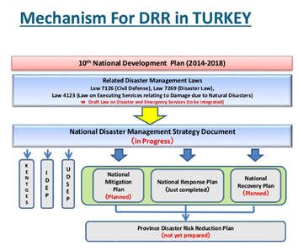

Figure 73: Mechanisms for DRR in Turkey[6]

Together, these plans build Turkey’s road map until 2023.[7] AFAD’s Recovery department has drafted a National Recovery Plan that is waiting to be confirmed as of *National Progress Report on the implementation of the Hyogo Framework for Action (HFA) (2011-2013*) (see AFAD, 2013b). The plans are described in greater detail in 4.2.

### Monitoring and analytical support to policy making; R&D

The AFAD Strategic Plan 2013-2017 identifies monitoring of disaster losses and hazards, and related R&D as critical to its approach to disaster risk reduction. The provincial directorates can develop project plans and submit them to the Ministry of Development for Projects, but the Presidency is the main responsible body for the development of Projects. According to the Plan, AFAD fulfils its duties in this regard by:

* Collecting necessary basic data on disaster risks and developing the necessary planning tools in order to monitor the relationship between the development policy and disaster risk,
* Collecting and disseminating data required for making timely and effective development plans and policies to reduce disaster risk,
* Re-orienting disaster risk reduction sectors, mobilizing and warning the public.

At the national level, Turkey has in place a number of systems for systematically reporting, monitoring and analysing disaster losses and hazards: the National Earthquake Observation Network, operated by AFAD, produces data that is stored within the National Earthquake Data Center’s database and shared with the public; The Flash Flood Early Warning Project, which covers 6 countries (Turkey, Azerbaijan, Armenia, Georgia, Bulgaria and Syria) in the Black Sea and the Middle East is being conducted in cooperation with the World Meteorology Organization (WMO) and the American Hydrology Research Centre (HRC). The output is the Flash Flood Early Warning System test products; Finally, fires are monitored by the Fire Operations Centre.

In 2012, Turkey initiated a National Earthquake Investigation Programme (UDAP). With this programme, AFAD will fund earthquake investigation projects of universities and governmental institutions between 2012 and 2023.[8] The Annual budget for 2012 was set at 1.000.000 USD, and will increase annually. The budgets for 2013 and 2014 were 1.076.000, 1.654.000, respectively; and the budget for 2015 is set at 1.815.000 USD. In addition to this, international financial resources have been provided by World Bank, EU, JICA and Islamic Development Bank, etc. to be used in the DRR projects.

A number of universities, particularly Karadeniz Technical University, were involved in more than thirty research projects and studies between 2011 and 2013 on reducing the disaster risks. One such project is the Disaster Emergency Management Information System (AFAYBIS) project that is being carried out by YTU. The AFAYBIS project aims to support both disaster management and e-Government studies in Turkey. During the analysis stage of the project, approximately 50 institutions related to disaster management are under examination (AFAD, 2013b).

At the local level, research studies have been carried out in, e.g. Istanbul which provide estimated risk parameters to the population, buildings, transportation systems, and lifelines. Parameters have also been developed to estimate the potential impact of risks on essential facilities, services and emergency response. Inventory data on urban elements at risk have been obtained from a range of sources, including from relevant state/public institutions, private companies, specific studies and from satellite imagery, and are used in the following projects and studies:

* Disaster Prevention / Mitigation Basic Plan in Istanbul including Seismic Microzonation in the Republic of Turkey – (JICA – IMM).
* Earthquake Risk Assessment for Istanbul Metropolitan Area – Bogazici University (supported by the American Red Cross) (BU – ARC).
* Earthquake Risk Assessment for Industrial Facilities in Istanbul – Bogazici University (supported by Munich-Re Group)
* Turkish Improvement of Natural Hazard Insurance and Disaster Funding Strategy (TEFER) Project – Turkish Treasury (supported by the World Bank and conducted by Cordis-Willis with the assistance of CAR and Bogazici University). (AFAD, 2013b)

### Policy for Prevention

Specific policies distinguished by prevention, preparedness, response, relief and recovery could not be identified in the framework of this study.

Notwithstanding the lack of clarity on the policy for prevention, several relevant players can be identified.

* The Earthquake Engineering Division established within AFAD is responsible for the development of building codes and standards for construction in disaster prone areas, aimed at increased resistance to earthquakes.
* The Ministry of Public Works and Settlement (MPWS) is another key actor in this phase, responsible for the monitoring of the aforementioned building codes (together with the municipalities). The MPWS is also responsible for retrofitting of large scale bridges.
* Implementation of the building code policies is done by the local, district and provincial governments.
* Local governments are tasked with enforcing building codes and related urban development and planning standards within their jurisdiction. Outside the municipal boundaries, however, enforcement and implementation of building codes and standards is left to provincial and district governments.
* The MEF, through the DSI and DMI, is tasked with the protection of surface and underground water, sea and land environments and the prevention of pollution. (UNDP/WMO, 2011)

### Policy for Preparedness

Specific policies distinguished by prevention, preparedness, response, relief and recovery could not be identified in the framework of this study.

At the central level, the Department of Planning and Mitigation at AFAD is responsible for all coordination aspects of preparedness; In the event of an earthquake, Department of Earthquakes is also involved. The main tasks/responsibilities of the department of Planning and Mitigation include:

* To prepare disaster and emergency response, risk management and hazard reduction plans, which will be applied nation wide.
* To determine possible disaster and emergency areas and to pronounce preventive measures.
* To determine reconstruction, plan and project rudiments of disaster prone areas.
* To determine cash, goods and humanitarian aid rules.
* To work for informing and raising awareness of public about disasters and emergencies.
* To collect and evaluate information about disasters and emergencies occurred inside and abroad.
* To determine standards of common communication and data systems in Disaster and Emergency Management Centres and inspect them.
* To carry out the routine works of Disaster and Emergency Training Centre related to Disaster and Emergencies.
* To execute other tasks given by Director General.
* To determine administrative strategies.
* To establish and operate all kinds of communication, early warning, data and prediction centres.
* To suggest to related agencies about public investments and personnel requirements.
* To ensure improvements and generalize insurance services.
* To determine and supervise service and accreditation standards. [AFAD website]

The most important organisational bodies involved in the development and implementation of disaster preparedness in Turkey are the provincial and district governments.

Two other organisations play a role in disaster preparedness. These are the Turkish Red Crescent Society (TRCS) and the Turkish armed forces. The former formulates Disaster Preparedness and Intervention Plans at the national, provincial and local levels, while the latter develop their own Military Emergency Assistance Plans in coordination with the provincial and local governments. The plans reviewed and revised annually and approved by the Land Forces Command (Ganapati, 2008).

### Policy for Response

Specific policies distinguished by prevention, preparedness, response, relief and recovery could not be identified in the framework of this study.

Tasks, mandates and responsibilities concerning response are ascribed to AFAD under Law N. 5902 and specified according to Law N.7269 Article 4. At the central level, AFAD’s Department of Response is the responsible entity for the coordination of all disaster response activities. In the event of an earthquake, the Department of Earthquakes is also involved. The main responsibilities ascribed to the Department of Response of AFAD include:

* During the disaster and emergency situations: to carry out works to resolve the effects of disaster and emergency situations by evaluating the any source belong to public, private and NGO, foreigners and organizations;
* To manage Prime Ministry Disaster and Emergency Situations Centre;
* To ensure the establishment and management of emergency management centres at governmental agencies and in provinces;
* To define the standards of Fire Brigade and SAR Teams and to cooperate with the agencies and institutions providing these services;
* To plan and conduct protective and rescuer activities;
* To conduct missions given by the agreements related to disaster and emergency situations;
* To co-operate with the International Agencies and Foreign Governments in its own field.

[AFAD website]

At the provincial level, the provincial directorate is the lead organisation responsible for response operations. The directorate is tied to the Governorate and has the right to ask for the participation of all other public institutions in the province. The key organisational units involved in response operations are the provincial and district (municipal) governments through the implementation of the disaster response plans by the Provincial and District Rescue and Aid Committees (RAC) (described in section 3.1.2).

Municipalities are also involved at the level of implementation; municipal bodies are not involved in the policy development, but rather through the provision of equipment and staff in the event of a crisis. In practice, a high level secretary of the deputy mayorship is invited to the provincial directorate and may contribute to coordination of the municipal team. (Ganapati, 2008).

In addition to the central and local governments, the Turkish Red Crescent Society is involved in response and rescue activities (see section 5.2).

### Policy for Relief and Recovery

Specific policies distinguished by prevention, preparedness, response, relief and recovery could not be identified in the framework of this study.

Tasks, mandates and responsibilities concerning rehabilitation and reconstruction are ascribed to AFAD under Law N. 5902 and specified according to Law N.7269 Article 4. The Recovery approach in Turkey focuses not only on reconstruction of damaged buildings, but also it engages in an integrated approach that covers the disaster area as a whole, including infrastructure, schools, hospitals, road, parks and physical and social environments. The recovery activities incorporate risk reduction measures for a resilient recovery and aim to reduce necessary recovery activities in the future through strengthening infrastructure and retrofitting (UNDP/WMO, 2011).

At the central level, AFAD’s Department of Recovery is the lead entity responsible for the coordination of relief and recovery operations. The main tasks/responsibilities ascribed to the Department of Recovery include:

* To take necessary measures for normalising life after disaster and emergency situations;
* To assure temporary settlement at disaster and emergency areas and to provide psychological support, social aid, food and medical treatment to effected people;
* To ensure coordination with other governmental authorities on the legal process of reconstruction, planning and projection work at disaster effected areas and to supervise the activities performed;
* To accept and provide international humanitarian aid;
* To prepare reconstruction and recruitment plans for post-disaster period in cooperation with Governmental Agencies, Local Authorities, Universities and Non-Governmental Organisations and to propound this plan to Supreme Committee of Disaster and Emergency Situations and to coordinate the application of approved plans, preparation of Expansion Reports related to application. [AFAD website]

The Earthquake Engineering Division at AFAD is responsible for developing the basic principles for the rehabilitation of structures damaged by earthquakes. The Ministry for Public Works and Settlement (MPWS) is also a key player during relief and recovery operations. The MPWS is responsible for damage assessment and reconstruction and rehabilitation of damaged buildings. The Ministry of Education is responsible for damages to schools. The provincial level is also heavily involved in relief and recovery in their jurisdiction (AFAD website).

## Financing

### Investing in preparedness

Concrete figures could not be obtained, as budget documents are not available in English. However, according to the official *IPA Beneficiary Needs Assessment – Turkey* report (UNDP/WMO, 2011) one percent of the national budget is allocated for studies, in-service training, education and awareness-raising amongst public authorities, volunteers and the population related to disaster risk reduction in Turkey. The budget of the Province Governorships is directly transferred from the AFAD Presidency. The governorship is then similarly required to transfer a minimum of one percent of their budget to the Provincial Disaster and Emergency Directorates. On top of the budget allocated by AFAD to the Provincial Disaster and Emergency Directorates, additional funding sources are available in case of any need or implementation of capacity building projects. However, although the State has a legal obligation (Law No. 7269) to fund the costs of reconstructing buildings after an earthquake, the State has no similar legal responsibility concerning DRR. There also appears to be a dearth of information regarding the exact budgeting for such resources.

International donations are the other principal funds contributing to the disaster related budget in Turkey. Over the last decade the World Bank provided over USD 1 billion for the improvement of infrastructure, emergency management and risk reduction activities and capabilities of the country; the Japanese International Cooperation Agency (JICA), the United Nations Development Programme (UNDP)[9] and the Swiss Agency for Development and Cooperation provided USD 870,000 to support of the UNDP Local Capacity Building for Disaster Prevention Programme, while the European Commission Humanitarian Aid Office has also contributed towards DRR in Turkey (UNDP/WMO, 2011).[10]

### Investing in consequence management

Funding for relief in the aftermath of disasters comes directly from the central government. AFAD is authorized to allocate the disaster response and recovery budget to the related institutions and the local government in the scope of their needs. This comes, for instance, in the form of tents, the construction of temporary residences, and rubble clean up for the residents of damaged homes, as well as in the form of compensation funds during the rehabilitation phase. Following the earthquake in the Marmara Region, temporary residences were constructed by the MPWS. Supplying temporary residences required funding to cover the rental fee of land, the cost of infrastructure provision, and actual construction costs.

The Ministry of Finance has a Disaster Reserve Fund, which can be used for the disasters during the period of recovery (AFAD, 2013b).

Finally, since 1999, in the aftermath of the two major earthquakes that caused widespread destruction of the country’s building stock, the Government of Turkey enforces compulsory earthquake insurance for residential buildings on a nationwide basis (Decree 587). With this decree law, it is compulsory to take out insurance for all residential buildings that fall within municipality boundaries, effectively abolishing the obligation of the government to extend credit to the victims of an earthquake (previously a requirement under the Disaster Law). The purpose was to privatize the risk in two steps: (1) by offering insurance through the Turkish Catastrophic Insurance Pool (TCIP, or DASK in Turkish – Do-al Afet Sigortalari Kurumu)[11], (2) then by exporting large parts of the risk to the world’s reinsurance and capital markets. To serve this purpose, the World Bank funded the creation of the Compulsory Earthquake Insurance Authority as a separate state owned entity to carry out the National Catastrophic Insurance Programme (NCIP). This program became part of a larger initiative known as the Turkish Emergency Flood and Earthquake Recovery Program (TEFER – Turkiye Acil Sel ve Deprem lyilestirme Programi) (Gülkan et al, 2012).

The various mechanisms for financing disaster management in Turkey are shown schematically in the figure below.

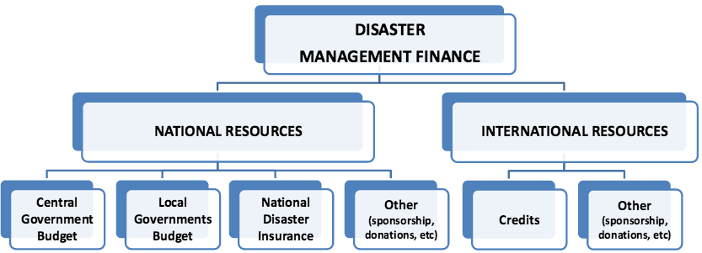

Figure 74: Current financial structure of disaster management in Turkey[12]

Limitations of the programme:

Among the limitations to the current set up is that the compulsory scheme covers only residential buildings that fall within municipality boundaries, while dwellings in small villages are excluded; it does not coverage retrofitting nor promote renewal policies, and; the penalty for non-insurance is not sufficiently high. All of these drawbacks have been cited in reference to preventing the further productivity of the policy. In addition, as TCIP is a privately funded entity, its funding has been primarily dependent upon premium contributions made by homeowners under the insurance scheme (ibid).

## Policy review, Evaluation & Organisational Learning

### Post-Disaster Assessment

AFAD is formally charged with overseeing post-disaster assessments however there is no formal mechanism for assessing the experience of individual emergencies – either at the national or provincial / municipal level.

At the central level, the Presidency keeps records of events and prepares reports on particular emergencies or disasters where significant actions have been taken. For instance, the Presidency prepared a report (which included Lessons Learned) following the experience of the Van Province Earthquakes in 2011. The reports were then sent to all provincial directorates. These reports are also shared with other stakeholders to share experience and information with all relevant and involved stakeholders.

At the provincial level, following a response operation, the relevant authorities meet to discuss the adequateness and efficiency of the legislations and capacity. On this basis, new regulations and planning is introduced. However these discussions take place informally.

### Departmental Lessons Learned systems

There are no formalised Lessons Learned systems. Lessons learned practices are incorporated informally into post-disaster assessments, in particular where significant actions have been taken.

### Centralised (national) Lessons Learned system

There are no formalised Lessons Learned systems. Lessons learned practices are incorporated informally into post-disaster assessments, in particular where significant actions have been taken.

### International exchange for Lessons Learned

Turkey is engaged in international activities at the multilateral, regional and bilateral levels and currently profits from know-how and technological transfer coming from the UNDP and the World Bank. In addition to these activities, AFAD signed a Plan of Action with UN-OCHA in March 2013 to strengthen the partnership between the two entities. The plan foresees greater cooperation in information management, strategic and operational coordination, advocacy and capacity-building. The two are also working with Turkish NGOs to promote better collaboration with the international humanitarian response system.[13]

AFAD shares information with EU Commission bodies (DG ECHO, ODDG, etc.) and attends meetings of the Commission in which it shares information regarding its risk and damage mitigation experience. However there is no integrated system connecting AFAD with the EU.

### Regular policy reviews

AFAD conducts regular policy reviews through the high council meetings/boards where AFAD functions as the secretary (see section 3.1). Specific information on the scope and content of such policy reviews could not be obtained in the framework of this study due to lack of English translations.

## Resilience

Turkey’s approach to the concept of resilience is based on increasing disaster awareness through education (educational campaigns in 2013) with the aim to build a more resilient society. This is considered to be an important component of Turkey’s overall approach to DRR. AFAD is responsible for education, training, and awareness-raising activities in the field of disaster risk reduction.

No specific international standard is pursued; rather, standardisation is sought through the application of the relevant regulations and circulars. AFAD undertakes the role of accrediting the NGOs and organises awareness raising meetings with the private sector representatives. However, they do not have a regulatory or auditing power on the standards for different stakeholders.

Equipment that has been standardised includes: uniforms/service dressed were standardised, provincial duties, representation in protocols, indispensable equipment at the provincial directorates were standardized.

## Information sharing and data protection

Turkey does not have an updated database in use. While in the past there were obligations for civil defence that included registers, with the establishment of AFAD, civil defence records halted and it was turned into volunteering; They have the roster of NGOs but not the individual volunteers. So they do not share such volunteer information. Relevant regulation (for certification or standardisation) has not yet been prepared by AFAD. Studies on this issue are ongoing (expert interview).

No such policy is in place regarding the sharing of classified information and the current regulations do not foresee sharing of classified information. The regulation is developed based on local experience (ibid).

The use of social media is not common practice for the purpose of crisis management in Turkey. No such plans are in the making (ibid).

# Legislation

## Crisis (emergency, disaster) management concept

Law no 7269 on Precaution and Aid Against Disasters Effecting Common Life, dated 15 May 1959, introduced the concepts of disasters such as earthquake, flood, landslide, rock fall, avalanche, fire and storm, and possible disasters, and covers the measures to be taken for the protection of lives and property before a disaster in settlement areas that are prone to disasters.

Beyond this indication, however, a dedicated crisis management concept, other than the structures and documents described in this report, could not be obtained nor identified in the frame of this study.

## General crisis (emergency, disaster) management law

The current disaster legislation framework consists of a range of laws, decree laws, regulations, directives and circulars which date back to the late 1920’s and 1930’s since the Republic of Turkey was established in 1923 The most important laws in the field of emergency and disaster management are as follows:

**Law No. 7126 (1958)** on **Civil Defence** established the General Directorate of Civil Defence under the Ministry of Home Affairs. With this, the directorate and its local branches were tasked with disaster response and preparedness.

**Law No. 7269 (1959)** on **"Measures and Assistances to Be Put into Effect Regarding Natural Disasters Affecting the Life of the General Public”** represented a critical codification of the legal regulations in terms of disaster management in Turkey. The law attempted to fill the legal gaps in this area and established the legal basis for different phases on disaster management and the establishment of relevant state organisations. The law has been amended several times, though it is still the main legislative document on disasters in Turkey.

**Law No 3194 (1985),** the **Development Law**, outlines the principles of preparation and implementation of plans for settlements, building construction and building permits by local and provincial governments, as well as the role of central government Ministries.

**Law No. 5902 (2009)** on the **“Organization and Functions of the Disaster and Emergency Management Presidency”** established the new department called “Disaster and Emergency Management Presidency” (AFAD) *(Afet ve Acil Durum Yonetimi Baskanligi)* under the Prime Ministry. AFAD was established to take necessary measures for an effective emergency management and civil protection issues Turkish nationwide. The new law combines under one roof the actors responsible for Disaster Management. The law describes the necessary administrational structure, its activities, responsibilities, relations with other units and running of tasks related to disaster and emergency management of natural technological and human originated hazards. The law aims: (1) To take necessary precautions and measurements on disaster and civil protection related services at country level; (2) to maintain coordination amongst the organisations that have a role in pre- and post- disaster activities; (3) to policy making and implementation on disaster management. (Ganapati, 2008; AFAD, 2012a)

Additional disaster-related laws, regulations, decrees and related measures can be found in the Table 49 below.

Table 49. Relevant legislation, Laws

| **Name of Law** | **Year** | **Law, Decree, etc. Number** | **Details** |
| --- | --- | --- | --- |
| Civil Defence Law | 1958 | Law No. 7126 | Establishes the General Directorate of Civil Defence under the Ministry and describes the responsibilities of the directorate and its local branches in relation to disaster response and preparedness; Addresses issues of training on civil defence |
| Measures and assistances to be put into effect regarding disasters affecting the life of the general public | 1959 | Law No. 7269 | Confers extraordinary powers to provincial governors and district heads and details responsibilities of these and other key players in disaster scenarios; includes statements on relocation of settlements. |
| Decree on Basic Principles Related to Disasters Affecting the Life of the General Public | 1968 | Official Gazette No. 13007 | Outlines the basic criteria to be used in declaring disasters |
| Extraordinary Situation Law | 1983 | Law No. 2935 | Provides the legal basis for action to the respective bodies in a state of emergency (together with the 1984 Decree on State of Emergency Council (No. 84/7778)) |
| Development Law | 1985 | Law No. 3194 | Outlines principles for preparation and implementation of plans for settlements, building construction, and building permits by local and provincial governments; outlines role of MPWS concerning settlement plans, and that of State Planning Organization concerning regional plans. |
| Execution of services related to damage and disruption caused by natural disasters | 1995 | Law No. 4123 | Outlines procedures of distribution of financial aid to areas affected by disasters |
| Regulations on Disaster Mitigation | 1999 | Decree No. 582 | Provides information concerning debris removal following a disaster. According to the Decree, the Prime Ministry, and the Local Government support an Emergency Fund Program that provides resources from the Ministry of Finance in disaster response(Ural) |
| Regulation on Civil Defence and Municipality Law | 1999 and 2000 | Decree Law No. 586 and 596 | Enhances response capacity of the Ministry of the Interior (where the government’s search and rescue teams are located) with the establishment of provincial directorates of civil defence in 11 provinces. These are equipped with necessary vehicles and devices recruiting 2500 personnel and 300 on a contractual basis, to prepare detailed local plans for their training and exercises; the SAR teams are to be created within hours. |
| Decree Law on Mandatory Earthquake Insurance | 1999 | Decree No. 587 | Establishes the responsibilities of the Natural Disasters Insurance Administration and details how it is governed; provides information on the earthquake insurance regulation for residential buildings located in urban areas; Public buildings and buildings in rural areas fall outside the scope of the decree. |
| Law on Building Inspection | 2001 | Law No. 4708 | Establishes responsibilities of Building Inspection Firms (BIFs) and inspection Committees regarding construction inspection. |
| Decree on Working Procedures and Principles of Natural Disasters Insurance Administrations | 2001 | Official Gazette No. 24600 | Outlines the responsibilities, procedures and working principles of the Natural Disasters Insurance Administration |
| Law on Municipalities | 2004 | Law No. 5272 | Establishes the responsibilities and describes the organisational structure of municipalities; provides details on their budget arrangements. It is the main legislation that gives additional power and responsibilities to Municipalities, previously limited to mitigating disasters |
| Disaster Insurance Law | 2006 | Law No. 6305 | Determines the procedures and principles for the compulsory earthquake insurance to cover the financial losses which may arise in buildings due to earthquakes and for the insurance and reinsurance coverage to be presented in order to cover the material and physical damages which may arise as a result of various disasters and risks which cannot be covered by insurance companies, or which bring about challenges with regards to offering coverage. |
| Organization and Functions of the Disaster and Emergency Management Presidency | 2009 | Law No. 5902 | Lays down the provisions to be implemented where there is a need for a declaration of a state of emergency in cases of serious disturbances of public order by epidemics, serious economic recessions, and comprehensive terrorist acts in order to distort the democratic order established by the Constitution and to eliminate fundamental rights and freedoms. |
| Restructuring [Transformation] of areas under risk of disasters | 2012 | Law No. 6306 | Responsible for determining the procedures and principles regarding recovery, resettlement, renewal to provide healthy and safe living environments in the areas under the risk of disaster and in the other areas and fields where risky constructions exist. |

Sources: AFAD, 2012a; Ganapati, 2008; Ural 2005

## Emergency rule

The conditions for extraordinary situations resulting in a state of emergency are described in Art. 4 of the Law No. 7269. Expert interviews reveal that the conditions vis-à-vis the concept of urgency as laid out in Law no 7269, however, are vague and not clearly defined.

The 1983 Law on State of Emergency (No. 2935) and the 1984 Decree on State of Emergency Council (No. 84/7778) provide the legal basis for action to the respective bodies in a state of emergency. Under the law, a state of emergency can be announced by the Prime Minister only. If a state of emergency is declared by the Council, Governors and district heads are mandated to implement it.

Under Law No. 2935, personal rights may be restricted with the decision of the Cabinet and Council of Ministers.

## Specific, department/agency-level legal arrangements and regulations on emergency and disaster management

Under the new Law No. 5902 (2009), AFAD is responsible for coordinating nearly all phases of disaster management including disaster risk reduction (DRR) at the national level, and installs rules, regulations, and guidelines for preparation of DRR plans at sub-national levels. It also has a coordination role between the various institutions and organisations that are responsible for different types of disasters. This includes the Forestry and Hydraulics Ministry for floods, the Environment and Urbanization Ministry for climate change, and the Food, Agriculture and Livestock Ministry for droughts.

However, according to Law No. 7269 of 1959, which is the main legislative document and relates to all disaster-related activities and responsibilities at country level, MPWS is the coordinating governmental body. Both legislative acts are in operation, which means the coordination itself has not been identified very clearly by related legislation. Moreover there are still “conflicts between laws governing sectorial responsibilities and the Disaster Law as well as what type of planning processes are necessary for DRR which need clarification.” (UNDP/WMO, 2011: 9). For example, MPWS is the main body responsible for the coordination of disaster response activities (Law No. 7269), whereas AFAD is responsible for coordinating nearly all phases of disaster management, including DDRR at the national level, and for instigating the rules, regulations and guidelines for the preparation of DRR plans at the sub-national level (Law No. 5902).

Although the Law No. 5902 greatly improved the efficiency of the different phases of the disaster management cycle, official documents report that the coordination mechanisms between AFAD, MPWS, PMCMC and the ministries on the one hand, and between public authorities and other actors on the other, remain insufficient (ibid).

## Specific to the regional and local authorities legal arrangements and regulations on emergency and disaster management

Law No. 5902 transferred significant levels of responsibility to local authorities. While the central government is responsible for reconstruction and rehabilitation, responsibility for mitigation, preparedness and response activities, such as the implementation of earthquake-resistant building codes for construction within their jurisdiction, come under the authority of the province (Governor) and District (Qaimaqam). Response to a disaster is under the responsibility of the Governor at the Provincial level and Qaimaqam at district level.

The latest legal arrangements regarding local government in Turkey are the Special Provincial Administration Law (No. 5302), the Municipality Law (No. 5393) and the Metropolitan Municipality Law (No. 5216). The Municipality Law No. 5393 is the main legislation that gives additional power and responsibilities to municipalities.[14] According to this law, local governments are now responsible for making disaster and state of emergency plans, as well as public awareness programmes.

The law states:

Bearing in mind the characteristics of the town, the municipality shall draw up the necessary disaster and emergency plans to protect the town from fire, industrial accidents, earthquakes and other natural disasters and reduce the damage caused by such disasters, and prepare the necessary teams and equipment for the purpose.

In the preparation of emergency plans, coordination shall be ensured with other provincial-scale emergency plans if any, and the opinions of relevant ministries, public organizations, professional organizations, universities and other local governments shall be consulted.

Necessary measures shall be taken to educate the public in accordance with the plans, and joint programs may be drawn up with the authorities, entities cited in the second paragraph. In the event of a fire or natural disaster outside the municipal boundaries, the municipality may provide the necessary assistance and support to the regions concerned. (Art. 53)

Expert interviews further indicate that the provincial directorate has no real autonomy and capabilities to take initiative at all levels are limited. The provincial directorates do not have financial capacity to intervene on their own; rather, additional financing must be requested from the Presidency, and then it may be allocated to the province.

## Legal regulations on the involvement of volunteers and specialised NGOs

Prior to 1999, NGOs other than the TRCS did not have a legal role to play in disaster preparedness. Laws and regulations have since been introduced to formalise their participation. For example, under the Directive on Conditions of Participation of Volunteers in Civil Defence Service, volunteer search and rescue teams can participate in training and drills undertaken by the General Directorate of Civil Defence. The Regulation on Voluntary Participation in Services of Special Provincial Administrations and Municipalities states that “Special provincial administrations or municipalities may, depending on their purview, employ volunteers” for the purpose of “Inspection and emergency services such as traffic, fire fighting, search and rescue”(Official Gazette Issue: 25961, Art 5).

Specific provisions for the involvement of the NGOs however are mainly foreseen in the provincial plans prepared by the provincial directorates. No specific rules or policies on liability or insurance regarding their involvement are in place. It is anticipated that this issue will be handled together with the regulation of volunteer participation.

## Legal regulations for international engagements of first responders and crisis managers

The Presidency is authorised to establish connections for international engagement; In kind and in cash assistance or other technical support provided by the international organizations are coordinated through the Presidency. Law no. 7126 on Civil Defence (1959) regulates the rescue and first aid actions that are to be carried out during disasters. The provincial directorate are not capable to establish connections with the international organizations.

# Organisation

The new Law No 5902 defines the central and provincial level structure of crisis management in Turkey, which involves all concerned governmental bodies and is replicated almost identically at the central (Prime minister), provincial (Governor) and local (Sub-governor/Qaimaqam/District Governor) levels.[15]

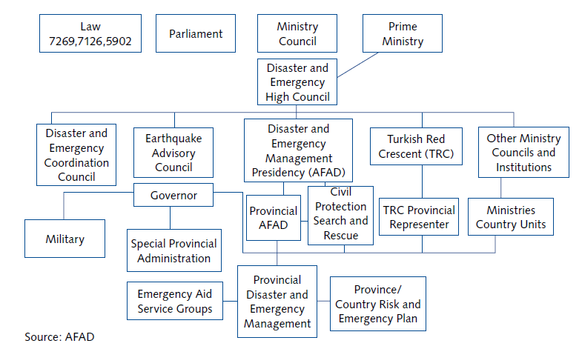

Figure 75: Organisational Management of Disaster and Emergency Management in Turkey [16]

## Organisational chart

The following organisations have a crucial role in the Turkish disaster and crisis management:

* AFAD (central and provincial)
* Government ministries, in particular
  + Prime Ministry Office
  + Ministry of Public Works and Settlement (MPWS)
  + Ministry of the Interior
  + Ministry of Environment and Forests (MEF)
  + Ministry of Health
* Public security bodies (e.g. police HQ, gendarmerie, fire services)
* Provincial units and municipalities
* TRCS, NGOs
* Turkish Armed Forces

The range of actors that may be involved in a disaster or crisis situation in Turkey are many and wide-ranging and may include institutions not dedicated to crisis management services, e.g. Housing Development Associations or DSI. See, for instance, the range of possible actors in Figure 76 below.

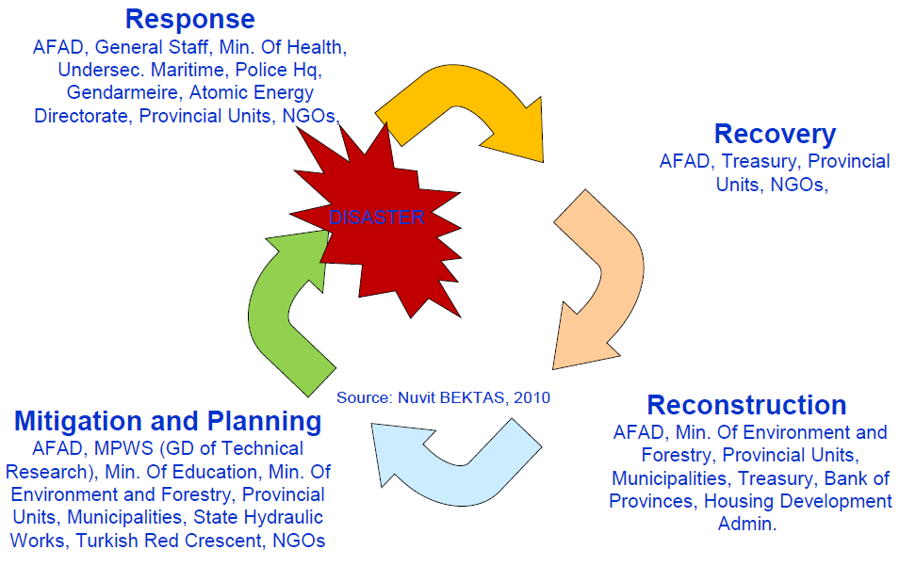

Figure 76: Crisis Management Cycle[17]

The AFAD Presidency undertakes the coordination function at the centre, while the responsibility for developing and implementing disaster preparedness plans and operations in Turkey lies with the provincial organisations – the Provincial Disaster and Emergency Directorates.

### National level authorities and organisations

Disaster and Emergency Management Presidency (AFAD)

AFAD was established by the Law No. 5902 (2009) to take necessary measures for the provision of effective emergency management and civil protection issues nationwide and for the coordination of other institutions at every phase of disaster management. AFAD functions like an umbrella organization; depending on the nature (type of disaster ranging from floods to extreme weather to earthquakes), the incidence level (local, provincial, national) and magnitude of the disaster or emergency, AFAD collaborates with the Turkish General Staff, the Ministry of Foreign Affairs, the Ministry of Health, the Ministry of Forests and Hydraulic Works and other relevant ministries as well as non-governmental organizations. In a disaster and emergency situation, AFAD is the only responsible organisation at the national level.

AFAD has the responsibility for coordinating nearly all phases of disaster and crisis management including disaster risk reduction (DRR) at the national level, and installs rules, regulations, and guidelines for preparation of DRR plans at the provincial (sub-national) levels. It also has a coordination role between institutions and organizations. AFAD is authorized to act in all disasters and emergencies situations in the country. It has the mandate to produce and implement policies on: (i) pre-incident: preparation, mitigation and risk management before the occurrence of events, (ii) during incident: response during the event, (iii) post-incident: recovery and reconstruction after the event, and (iv) and for the effective implementation of these activities across the country.

AFAD further has the mandate to:

* define the needs of in kind, in cash and humanitarian assistance;
* determine management strategies;
* establish and operate all kinds of information, communication, forecasting and early warning systems;
* make proposals to the relevant authorities with the need of public investment and personnel;
* implement training activities and exercises;
* take the recovery measures to ensure return to normal life after the disaster;
* provide temporary settlement in disaster areas.

The law also established eight central level departments within the new unit. These are:

* Department of Planning and Mitigation
* Department of Response
* Department of Recovery
* Department of Civil Protection
* Department of Earthquakes
* Department of Administrative Affairs/Services
* Department of Information Technologies and Communication [Added 24 October 2011]
* Department of Strategy Development [Added 24 October 2011]
* Department of Legal Consultancy [Added 24 October 2011] [18]

Figure 77 illustrates the organisational chart of the Presidency. The duties and responsibilities of the departments are outlined in Chapter 1.

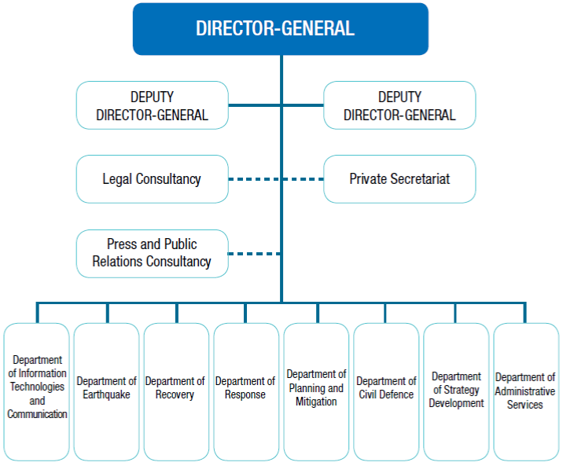

Figure 77: Organisational Chart of the Disaster and Emergency Management Presidency (AFAD)[19]

Under the eight departments, several working groups have been established to cover different topics as shown in Figure 78 below.

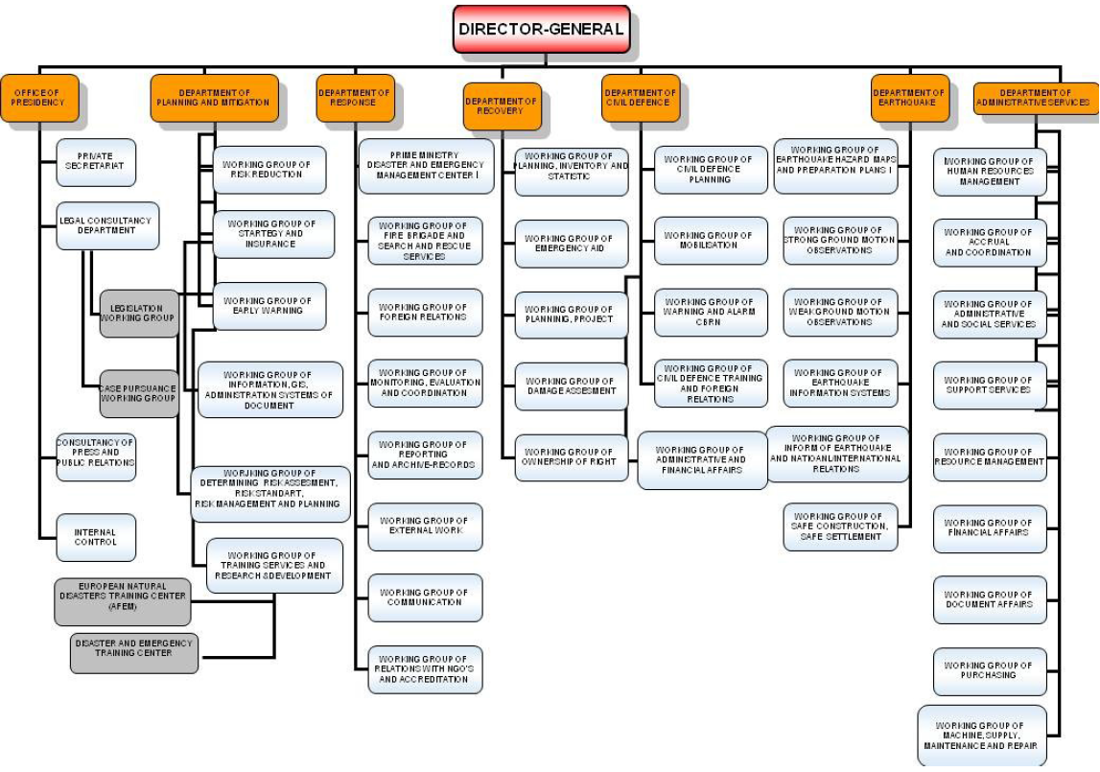

Figure 78: Working Groups under the Central Level Departments of the CM authority [20]

In addition to these departments the plan outlines three high levels boards/committees. The composition of these committees/boards is presented in Figure 79.

* **The Disaster and Emergency Management Higher Committee/Supreme Board,** consists of appointed ministers under the chair of the Prime Minster or his/her appointed Deputy Prime Minister. The board is tasked with the duty of approving the plans, programmes and reports related to disasters and emergencies. The Board convenes twice yearly, and may be summoned for an extraordinary meeting at the request of the chair. The Secretariat of the Board is conducted by the Presidency (AFAD).
* **The Disaster and Emergency Management Co-ordination Committee/Board,** is composed of the relevant undersecretaries and organization executives under the chair of Undersecretary of the Prime Ministry (i.e. (i.e. Undersecretaries of National Defence, Interior, Foreign Affairs, Finance, National Education, Health, Transportation, Energy and Natural Sources, Environment and Forest and Public Works and Settlement Ministries; Undersecretary of State Planning Organisation, Director General of Disaster an Emergency Management Presidency, Head of Turkish Red Crescent).

The Board is responsible for evaluating information in cases of disasters and emergencies, determining measures to be taken, ensuring and inspecting their implementation, and ensuring coordination with agencies, organizations and NGOs. The Board convenes at least four times a year, and may be summoned for an extraordinary meeting at the request of the chair when needed.

* **The Earthquake Advisory Board (EAB)** is comprised of the relevant representatives under the chair of AFAD and is responsible for presenting alternative policies for mitigating damages caused by earthquakes and setting priorities and policies for earthquake-related research. The EAB is a multi-stakeholder consultancy mechanism. The EAB provided support to the Earthquake Department in the Presidency in the preparation the National Earthquake Strategy and Action Plan that was launched in 2011. The secretariat of the Board is conducted by the Earthquake Department of the Presidency.

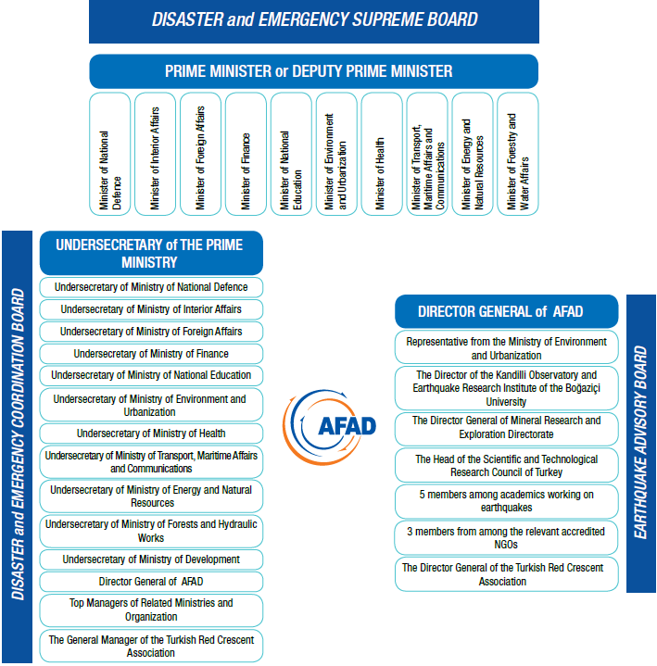

Figure 79: AFAD Disaster and Emergency High level boards/committees[21]

Other Government Ministries involved in crisis management/risk reduction and Inter-ministerial arrangements

The institutions involved may vary depending on type and severity of disaster/risk. In addition to AFAD, the relevant institutions include:

**Ministry of Public Works and Settlement (MPWS),** acts as the main body responsible for the coordination of disaster response activities (according to Law No. 7269) and develops the standards for seismic microzonation to guide safe construction within the regulations concerning “Specification for Structures To Be Built in Disaster Areas.” The MPWS is responsible for implementing and monitoring the regulations at the central level, while it is the responsibility of the municipalities to administer and enforce these regulations in practice (UNDP/WMO, 2011).

**Ministry of Environment and Forestry (MEF)** comprises the bodies responsible for the national hydrological (i.e. General Directorate of State Hydraulic Works - DSI) and meteorological services (i.e. General Directorate of State Meteorological Services - DMI) in Turkey:

* The **DSI** operates the National Hydrological Observation Network through its 23 regional offices and is responsible for monitoring the whole country, excluding the large urban areas where responsibility is held by the Municipalities, and for hazard assessment of flood and hydraulic drought. DSI is responsible for the monitoring the whole country excluding the large urban areas where responsibility is held by the Municipalities With 25 regional directors, DSI coordinates the preparation of the strategic and action plans for the water sector. Specific tasks include: managing the national hydrological database; producing annual and monthly reports, and; the provision of hydrological services to the agriculture, energy, environment and services sectors.
* The **DMI** operates and maintains the National Meteorological Observation Network and is responsible for monitoring and hazard assessment of meteorological hazards. Specific tasks include: producing meteorological analyses, weather forecasts and disseminating hazard warnings (and related information) to authorities and the public. The main objective of the DMI is to: make observations, provide forecasts; provide climatological data, archive data and other information; communication of these to the public; provide meteorological needs for army and civil aviation.

Both the DMI and DSI play a role in policy making on DRR planning through the Ministry of Environment and Forestry (MEF) as sources of basic hydro-meteorological information, though they do not have a role as integrated partners in policy making and strategy planning of the national DRR (WMO, 2012).

**Ministry of Agriculture & Rural Affairs**, through the ***General Directorate of Agricultural Production and Development (TUGEM)***, is responsible for the Agricultural drought management and coordinator of the Turkey Agricultural Drought Action Plan, specifically for the Monitoring and Early |Warning Committee and the Risk Assessment Committee. The ***General Directorate of Agricultural Research (TAGEM)*** (also falling in the same Ministry) provides services and information to TUGEM and collaborates with DMI to develop R&D projects on agrometeorological early warning and crop simulation modelling.

**Ministry of Energy and Natural Resources,** through the ***General Directorate of Electrical Power Resources Survey and Development Administration******(EIE)***, carries out engineering services for the production of electrical energy and is an investor public organisation. It is was established under Law No. 2819 and has the status of a juridical person, governed by private law and administered in accordance with commercial methods. (WMO, 2012; UNDP/WMO, 2011)

Turkish Red Crescent Society

The Turkish Red Crescent Society (TRCS) is the main non-governmental organisation operating in the field of disaster management in Turkey. TRCS is supported by the International Federation of the Red Cross (IFRC) and the Red Crescent societies and forms an independent national organisation with strong legislative links to the Government and funding.It has national, provincial and district level committees that are heavily involved in disaster preparedness through the conduct of public awareness and training activities. TRCS also actively operates in disaster areas through its search and rescue (SAR) activities. (UNDP/WMO, 2011). Other NGOs active in the field in Turkey are presented in Chapter 5.1.

Turkish Armed Forces

The Turkish Armed Forces are a part of central local disaster management in Turkey (though they do not play a role in DRR). During emergencies, authorities coordinate response activities with the Turkish Armed Forces. In the aftermath of the August 1999 earthquake, the Turkish Armed Forces made the decision to form a battalion size search and rescue Unit subordinate to Special Forces Command with intent to better cope with large-scale natural disasters. The special group is called “Natural Disasters Search and Rescue Battalion” (DAK) (UNDP/WMO, 2011).

### Provincial level organisations

The dual organization of local administration in Turkey that was mentioned in the introduction to this chapter, comprised of appointed governors on the one hand and elected municipal officials on the other, establishes the basis for distinguishing their different roles in disaster management. The *IPA Beneficiary Needs Assessment* report states that,

Provincial governors are agents of the central authority; therefore they perform in–line functions when managing emergency situations province-wide. This is achieved through powers provided in the ‘Disasters Law’ (7269). Accordingly, the governor assumes authority to act in extraordinary situations. The mayor and municipal bodies fall under the authority of the governor in these circumstances.[22]

The organizational structure of crisis management and disaster risk reduction at the provincial level is under the authorization of the governor. The governor does not have an operational role but coordinates and mobilizes others. The governor may also demand assistance from other provinces, which have not been affected by a disaster. Figure 80 shows an example organisational chart of the provincial level for the Bursa province.

Organisational procedures

At the provincial level, the Law on Municipalities No. 5272 (2004) mandates the provincial and district governments to prepare Emergency Assistance Plans. The provincial directorate of AFAD prepares the provincial plans, which are then submitted to the governorate for approval. There are 26 service group plans below it. Depending on the type of crisis/disaster situation, the relevant public agency is to take responsibility in line with its provincial plan and in compliance with the plan of the provincial directorate of AFAD. Out of those 26 service groups, 8 group plans are prepared by the provincial directorate of AFAD. The other 18 is prepared by the provincial directorates of other central institutions/ministries.

Provincial directorates

AFAD undertakes its responsibilities at the provincial level through the Provincial Disaster and Emergency Management Directorates, which are legally required in each city / province, and are directly attached to the city governor, and theProvincial Civil Defence Search and Rescue Team Directorates, which have been established in 11 provinces. Each governorship also has its own Provincial Rescue and Aid Committee (RACs), responsible only for response and recovery activities.The 11 provincial civil defence search and rescue directorates were established to reinforce the provincial rescue and aid committees and local relief forces with more professional and alert reserves at strategically stationed regional centres.

The Provincial Directors for Disaster and Emergency are the authorities responsible for the coordination and mobilisation of human, material and monetary resources inside and outside of the province (Law No. 7269). They are responsible for:

* Determining hazards and risks at the provincial level;
* preparing provincial emergency aid and response plans for the province with the help of the Provincial Search and Aid Groups and in cooperation with the Provincial Red Crescent Units (Law No. 5902);
* implementing and monitoring emergency and response plans in times of disasters;
* managing the logistic services at the time of disaster and emergency;
* undertaking loss and damage assessments of the province;
* accrediting civil society organisations involved in disasters (e.g., search and rescue teams);
* managing the Provincial Disaster and Emergency Management Center; and,
* educating the public. (UNDP/WMO, 2011).

According to the *IPA Beneficiary Needs Assessment - Turkey* report, “A common problem is that provincial officials in charge of disaster management are in most cases unfamiliar with the reality on the ground, especially as the turnover of government officials can be high in certain provinces.” (2011).

Provincial Civil Defence Search and Rescue Team Directorate

The 11 provincial civil defence search and rescue directorates were established by Decree Law No. 586 and Decree 596 (2000). These are: Adana, Afyon, Ankara, Bursa, Diyarbakir, Erzurum, Istanbul, Izmir, Sakarya, Samsun, and Van. Each one is equipped with necessary vehicles and devices recruiting 2500 personnel and 300 on a contractual basis, to prepare detailed local plans for their training and exercises.

Provincial Rescue and Aid Committees (RACs)

Under each RAC, there are 9 service groups. The 9 service groups are responsible only for response and recovery activities. These include: communications, accessibility/transportation, search and debris removal, first aid and medical services, damage assessment and temporary shelter, security, purchase-rental distribution, agricultural services, and electricity-water sewer (Ganapati, 2008; WMO, 2012). Both the provincial and district levels are mandated by law to have rescue and aid committees (RACs).

**Turkish Red Crescent**

In every province and district, TRCS has its own branches for community participation; at the Provincial level, it is involved with the provincial RACs that serve to foster community participation through volunteers and community leaders in each province and also has branches in most of the major cities. TRCS provides blood transfusion services, first aid trainings and disaster preparedness training to support preparedness efforts (TRCS website). See also Chapter 4.3 and 5.1.

Military:

Although the military plays an important role in Turkey, the role of the Turkish Armed Forces in disaster management is limited to the coordination of response activities and the provision of support through provincial garrisons that are in direct contact with the governors (UNDP/WMO, 2011).

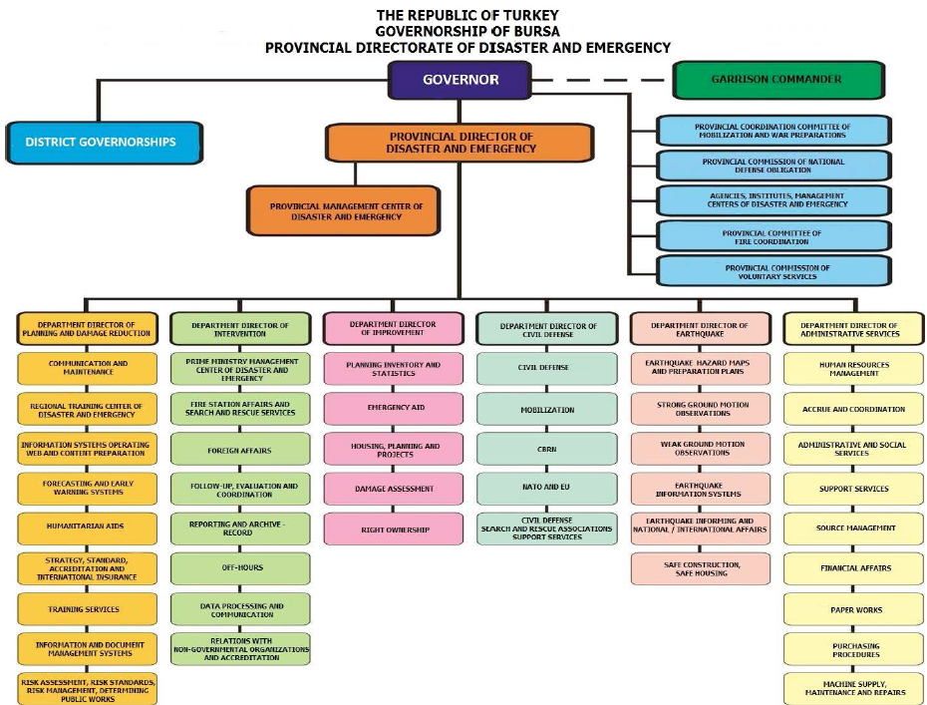

Figure 80: Example Organisational Chart of Provincial Directorate for Disaster and Emergency Management of Bursa Province [23]

### Municipal level authority and organisations

The municipality, via the governors, are responsible for preparing and implementing disaster and emergency plans for their jurisdiction, and organising mitigation, preparedness and response measures. The governor of the municipality must ensure the feasibility of local disaster and state of emergency management plans as well as their compatibility with the provincial and national level plans.

The Law on Municipalities (No. 5272/5393, 2004), states “The Municipality shall make plans according to the characteristics of the territory in order to prevent fire, industrial accidents, earthquakes and other natural disasters and to minimise the risks of such events and prepare the teams and equipment for action” (Art. 53). These laws are discussed in more detail in Section 2.5.

At the district and municipal level, officials:

* organise disaster preparedness activities,
* control fire departments,
* implement and monitor regulations on MPWS building standards for seismic micro-zones, land use decisions, and
* make preparations for the development strategies (under the provisions of the 1985 Development Law).

One issue that has been noted in official reports is that the mayors and municipal bodies are not held liable for DRR activities and come under the authority of the governors in extraordinary situations. It is the provinces that bear all responsibility. This constitutes a problem because the provinces are not involved in local DRR activities.[24]

TRCS has its own branches for community participation at the district/local level, similar to the province level. See 3.1.3 above.

## Organisational cooperation

As described in section 3.1, AFAD has the primary responsibility for coordinating emergency organisations in Turkey.

Interviews with key stakeholders indicate that in the case of simultaneous occurrences of events, there are bilateral MoUs signed and in place, where parties take action accordingly. Teams are mobilised immediately according to the e-mail or fax that comes from their stakeholders. Principal areas of international organisational cooperation are coordination in response and risk sharing.

In terms of regional cooperation,

Since 2008 Turkey has been represented at the regional level by the [AFAD] through the Disaster Preparedness and Prevention Initiative (DPPI) for South Eastern Europe and hosted the regional DPPI meeting in 2009. […] Another form of regional cooperation concerning disaster management is Turkey's engagement within the Civil-Military Emergency Planning Council of South Eastern Europe, which encourages civilian control of military resources during disasters whilst building a multi-national “network of networks” that favours cooperation between neighbouring countries. Turkey and Greece signed the Protocol on the Formation of a Joint Hellenic-Turkish Standby Disaster Response Unit to improve cooperation and joint response mechanisms. A joint exercise was successfully conducted in Ankara in December 2006. The Black Sea Economic Cooperation Agreement signed by Turkey includes a clause for emergency assistance and emergency response to natural and manmade disasters. Hazard and risk assessments are developed jointly by the Mediterranean countries. A real-time flood forecasting and early warning system for the Maritsa and Tundzha rivers was developed jointly by Turkey and Bulgaria with French and Dutch support as a constituent of the European PHARE Project: Capacity Improvement for Flood Forecasting in the Bulgarian-Turkish Cross-border Cooperation Region. A Data Exchange Tool for the DSI, the MEF and decision makers was created along with a dynamic website that is accessible to the general public.[25]

In addition to these activities, AFAD signed a Plan of Action with UN-OCHA in March 2013 to strengthen the partnerships between the two entities. The two are also working with Turkish NGOs to promote better collaboration with the international humanitarian response system.[26] Other partners include FEMA, with which Turkey has initiated important hazard reduction related agreements (e.g., Cooperative Hazard Impact-reduction Effort via Education (ACHIEVE)).

Turkey is an active member of the Capacity for Disaster Reduction Initiative (CADRI) and is eligible for support coming from the Euro-Atlantic Disaster Response Coordination Centre as a NATO member. As a candidate country for EU accession, Turkey receives significant support from the European Union and participates in a range of projects and activities. The Ministry of Interior has participated in meetings of the EU General Directorate since 2000 and is eligible to participate in the EU Civil Protection Mechanism for Facilitating Cooperation in the event of Major Emergencies. (UNDP/WMO, 2011).

In terms of regional cooperation, AFAD actively participates in the activities and projects of DPPI SEE, BSEC, ECO, NEAMTIC and EUROMED PPRD which are mostly based of disaster preparedness and prevention. [27]

# Procedures

## Standing Operating Procedures (SOPs) and Guidelines

No SOPs at the central level could be identified in the context of this study, while provincial level stakeholders in the country indicate that at the provincial level, response plans include such procedures. The unit which is responsible to manage the disaster response is defined as “solution partner” in the response plan. That institution also prepares its own provincial plan, and collects necessary capacity information from other relevant public offices in the province.

The SOPs include the following:

* Where the institutions will gather in the event of emergency or crisis
* How the aforementioned institutions will reach the disaster regions – plan is developed
* Service units plan how to locate their service groups in the region.

However the stakeholders indicate that the SOPs are not fully understood by all institutions, though they aim to assist the provincial institutions through meetings and trainings. The provincial plans include a section for regular tests and drills to be held, however this has not yet been implemented. A national CBRN (chemical, biological, radiological and nuclear) drill is planned in the coming months in Istanbul. Relevant staff from all 81 provinces will attend the drill.

## Operations planning

Central government and provincial/district government bodies, the military and NGOs are responsible for drawing up emergency preparedness and response plans (see Figure 73)

At the national level, a National Disaster Management Strategy and Action Plan is under preparation (as of the publication of the AFAD Strategic Plan 2013-2017) with the purpose of forming an effective and efficient management structure and high-level strategy that will ensure consistency and harmony between national plans. The national plans determine the duties, powers and responsibilities of all stakeholders involved in the national disaster management system. The national plans have been, or are in the process of being prepared. These include:

* National Disaster Response Plan
* National Recovery Plan
* National Disaster Mitigation Plan

**Turkey Disaster Response Plan *(completed)*:** Finalized in 2013, the National Disaster Response Plan (UAMP) covers all the response activities necessary in case of any disaster or emergency and defines the processes, roles and duties of the service groups, coordination units and other central and local bodies that will take part in the response operations, including also communication ways and logistics in the event of a disaster/crisis. For instance, the Ministry of Health will be responsible for the psycho-social support to be provided for the surviving victims. The Plan identifies the basic principles of response planning before, during and after disasters. UAMP has been prepared by AFAD with the support from all relevant actors that have a role in response phase. The response plan will take effect in 2015.

According to the *HFA Monitor Report* (2013),

The plan links completely the central and local management and the supporting actors. Geographical Information System based implementations that come into force for better management of the disasters and emergencies. Logistical needs are identified and steps taken for the creation of logistical centres. Special tents were designed which are proper for the Turkish families and for four seasons and stocked 65000 unit. Istanbul Civil Defence Search and Rescue Brigade is certified as a heavy class brigade by UN INSARAG and it is targeted that all the brigades will be certified in a few years. Together with the countries in the region, search and rescue exercises are performed in a planned way especially with NATO and European Union. For more effective coordination of civil and military assets, Turkey, Qatar and Dominican Republic initiated HOPEFOR initiative in 2010 and the Second International HOPEFOR Conference took place in Antalya in 2012 and an exercise took place in the scope of the conference which shows the effective coordination of civil and military assets. It is planned that Land Forces Command Natural Disasters Search and Rescue Troop will give trainings on natural disasters to Kyrgyzstan and Albania delegates. To reduce the loss of life and property in multi dwelling places like the institutions, the schools, the teacher guest houses, the club houses, the Ministry of Education issued a circular letter for performing 'Personnel Evacuation Exercise' to the central and local organization, the schools and the institutions during the Week of Earthquake between 01-07 March.[28]

**National Recovery Plan** ***(Planned / Waiting to be confirmed as of the HFA National Progress Report 2011-2013 report)****:* To be prepared by end of 2014, the National Recovery Plan will ensure that life returns to normal as soon as possible after a disaster. The plan aims to increase the speed of recovery by addressing several factors, such as social, economic, physical and environmental factors and IC technologies.

**National Disaster Mitigation Plan *(in development/planned)*:** To be prepared by end of 2015, the National Disaster Mitigation Plan constitutes an important step in the transition from crisis management to risk management. The plan aims to increase the public’s capacity to cope with disasters by defining the activities carried out for the purpose of identifying disaster hazards and risks as well as for preventing or minimizing their impacts (AFAD, 2012a; AFAD, 2013b)

**Procedures related to the development of operational plans**

At the provincial level, the provincial directorate of AFAD prepares the provincial Emergency Assistance Plans for their provincial district governments, which are then submitted to the governorate for approval. There are 26 service group plans below it. Depending on the type of crisis/disaster situation, the relevant public agency is to take responsibility in line with its provincial plan and in compliance with the plan of the provincial directorate of AFAD. Out of those 26 service groups, 8 group plans are prepared by the provincial directorate of AFAD. The other 18 are prepared by the provincial directorates of other central institutions/ministries. The plans of the provincial directorate of AFAD are:

1. service logistics,
2. sheltering services,
3. CBRN service,
4. search and rescue,
5. budget and accounting,
6. procurement,
7. resource management,
8. information management.

These plans are directly linked with the national level plans. The same plans are also prepared at the national level by the relevant central organizations/ministries (AFAD, 2013b).

According to the *IPA Needs Assessment* report (2011), these provincial level Disaster Emergency Relief Plans currently exist irregularly, depending on the type and magnitude of the disaster in the event of an earthquake. Moreover, the preparation of regional contingency plans remains optional. As a result,

certain areas present a low level of preparedness, while areas of fast growing and illegal urbanisation lack emergency relief plans altogether. Plans prepared at different scales differ in their scope and strategy and create overlaps and contradicts. This is particularly the case in metropolitan areas, where government has charged different institutions with establishing local relief plans according to their realm of expertise.[29]

The Turkish Red Crescent Society (TRCS) and the Turkish armed forces also play a role in operations planning and disaster preparedness. See Section 1.2.4 for a description of their role.

No international standardisation approach is used or adopted. Standardisation in the operation planning process is limited with the exception of the provincial response plans. Provincial level stakeholders indicate that a higher level of detail and standardisation was foreseen at the beginning of the process; however this has not been pursued in practice.

Military support is anticipated in all provincial plans for all emergency situations, as foreseen in the relevant regulations. See Chapter 3 for discussion of TAF involvement in Turkish disaster management.

## Logistics support in crises

Private logistics providers are involved in crises situations. For example, private sector facilities such as cool silos and other special facilities are anticipated for use in the event of an emergency. Other private sector providers of logistics support include the Istanbul Bus Company (İETT) and Istanbul Sea Buses Company (İDO). The companies have made preparations for evacuating people from disaster areas to safe places (UNDP/WMO, 2011).

Military logistics support is also anticipated. The Turkish Armed Forces, for example, maintain logistic support coordination centres to ensure timely response in the event of emergencies. During the Van Earthquakes (2011) the use of military planes was made available for delivering SAR forces and other rescue workers, equipment and aid (e.g., blankets, tents, etc.).

Logistics support is also provided through non-governmental providers, such as TRCS, which has a disaster response and assistance unit consisting of 5 branches: Disaster Preparedness and Planning Unit, International Disaster Response Unit, Operational Unit, Logistics Unit, Psycho-Social Support Unit. These units maintain several logistic depository facilities with stocks of tents, food and blankets in each province, airport and harbour that support its emergency operations. These include a tent production facility and storage facilities distributed around the country to provide logistics support in the event of a disaster (one central storage in Ankara and satellite storages in seven other provinces) (Ganapati, 2008).

## Crisis communication to general public; Alert system; Public Information and Warnings

The monitoring, notification and warning systems are comprised of several networks, notification centres and early warning. A national coordination body has been established and early warning and communications systems that are in place for immediate threat of disaster are well developed. Figure 81 shows the intelligence and dissemination system as defined in the AFAD Strategic Plan 2013-2017.

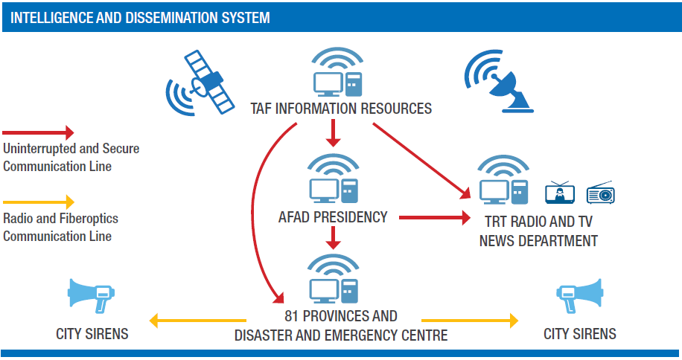

Figure 81: Intelligence and Dissemination System [30]

Regarding crisis communication to the public,

Warnings for the public are issued for a variety of parameters, all of which cause damage to life, property and infrastructure – examples of these are strong precipitation, hail, storms, cold and heat waves, coastal and sea area warnings, sand and dust storms, and forest fires. The messages outline possible risks such as flash flood, landslides, lightning and hail for a strong precipitation event.[31]

Networks and forecasting

Two main networks exist to record land deformations to forecast seismic risks. These are the National Telemetric Earthquake Observation Network (TURKNET) and the National Earthquake Monitoring Network. TURKNET is monitored by the Seismology Division housed in AFAD and consists of 24 stations dispersed across the country. [32] The National Earthquake Monitoring Network is operated by KOERI and consists of 116 broadband and 22 short period seismometers and a satellite system, all of which support real-time communication. Additional data from 72 stations is provided through agreements with neighbouring countries.[33] DMI and DSI (see 3.1.1) operate early warning systems in Turkey for all hydro-meteorological risks.

The DMI Observation Network prepares short and longer term weather predictions and is extremely dense, encompassing:

* 257 hydro-meteorological stations,
* 132 synoptic stations,
* nearly 500 automatically transmitting radio sonde stations,
* 118 lake observation systems,
* 150 snow stations,
* 330 meteorological stations; and,
* 1,000 water quality and sedimentation measurement stations

The DSI network comprises:

* 710 precipitation stations,
* of which 357 are currently operational and
* 1,176 discharge measurement stations.

The equipment used by DMI and DSI for data communication and dissemination of warnings is described in Figure 82 below.

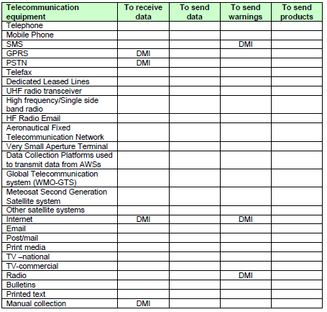

Figure 82: Equipment in use for data communication and warnings and other products dissemination[34]

# Capabilities

## Human resources

The number of personnel cadres assigned to the Presidency is 515. As of the writing of the AFAD Strategic Plan document 2013-2017, the total number of personnel employed in the Presidency is 447. Of this, 322 are permanent employees while the remaining 125 are temporary.

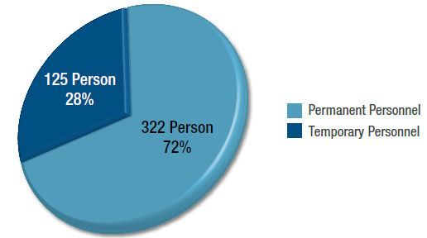

Figure 83: General Personnel Status of the Presidency[35]

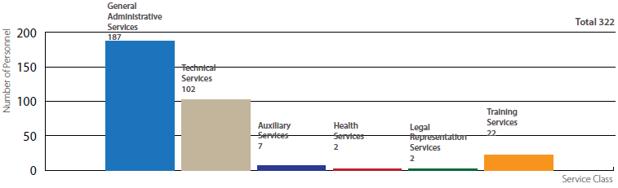

Figure 84: Distribution of Permanent Personnel as per Service Classes[36]

The personnel composition structure of the Presidency is mainly comprised of disaster management experts, engineers from related disciplines, instructors, technical staff and administrative staff (AFAD 2014). At the provincial level, staff is predominately comprised of search and rescue professionals and a smaller number of technical staff. [37] Stakeholders in the country indicate, however, that the capacity to mobilize is dependent upon the situation.

In addition to the Presidency’s staff, “[a] stand-by operative network” comprised of well trained staff from the General Directorate of Civil Defence, the natural disasters search and rescue battalions, regional disaster commands and natural disaster assistance troops subordinate to the Turkish Armed Forces, as well as a network of volunteers from the TRCS and other NGOs is ready to intervene in the event of a disaster (UNDP/WMO, 2011). The armed forces are involved mainly through the implementation of their Emergency Assistance Plans (See 1.2.4). In addition, they carry out search and rescue activities and provide services related to security, health, shelters, transportation, communication, and service to basic needs of victims (Ganapati 2008).

NGOs are mainly involved in search and rescue operations. Among the major NGOs involved in the field of disaster and crisis management in Turkey are the search and rescue association AKUT, the Neighbourhood Disaster Support Group (MAG), the Disaster Preparedness and Earthquake Training Association and, most importantly, Turkish Red Crescent Society (TRCS).

* **AKUT** is the first volunteer search and rescue organisation. AKUT has 9 regional offices and is increasingly supported through volunteer participation and fund-raising activities.
* **The Disaster Preparedness and Earthquake Training Association** is the only organisation with a central focus on disaster prevention and mitigation rather than on protection and rescue. The association aims to increase community awareness through training activities that cover disaster awareness, environment and water awareness, fire prevention as well as first-aid and search and rescue training aimed at children, families and municipalities. The trainings are certified by the Ministry of Health.
* **TRCS** is an NGO with a special status and strong legislative links to the Government and funding due to its role at the national, provincial and local levels. It has national, provincial and district level committees that are heavily involved in disaster preparedness through the conduct of public awareness and training activities. In October and November 2011, the TRCS successfully mobilized and deployed 986 of its staff for the response operation. (UNDP/WMO, 2011).

These NGOs are also members of the National Platform established in March 2011 (See also Section 3.1). The GEA Search and Rescue Group[38] is also members of the Platform.

Foundations, which are under the oversight of the General Directorate of Foundations, support the Government with research efforts, training and education, and public awareness activities. The Environment Foundation of Turkey[39] is particularly active in the field as a member of the National Platform, as well as through its dissemination of materials on public training and awareness and the organisation of national and international conferences.

Professional organisations which are active in disaster and crisis management include the Chamber of Geological Engineers, the Chamber of Geophysical Engineers, the Chamber of Civil Engineers and the Psychiatric Association of Turkey as well as the Chamber of Architects, the Chamber of Commerce and the Chamber of Medical Doctors. The first four are also members of the National Platform (UNDP/WMO, 2011).

From the private sector, the following are represented in the National Platform: the Turkish Industrialists’ and Businessmen’s Association, the Union of Chambers and Commodity Exchanges of Turkey, the Turkish Contractors Association as well as the General Directorate for Press and Information, the Turkish Association of Journalists and Turkish Radio and Television Cooperation. Commercial enterprises are increasingly investing in business continuity services designed to assess and then mitigate physical and or operational risks. The importance of public-private partnerships for disaster management has been stimulated by the combination of building codes and reinsurance rates. (ibid).

## Materiel (non-financial) resources

AFAD has warehouses and equipment available from the moment an earthquake hits. At the provincial level, a number of provinces have established large warehouses for the storage of necessary stock and equipment, such as containers, tents, blankets, kitchen utensils, clothing, etc. In Istanbul, for example, a year’s supply of medicine and equipment is ready on stand-by and replenished annually; portable toilets procured, and; tent areas identified and water and sewage infrastructure completed. The Istanbul Emergency Aid and Lifesaver Directorate put together 2,500 emergency aid kits to use in the early stage of response. IMM’s Emergency Aid and Lifesaver Directorate also has 20 emergency response stations and 29 ambulances available to it. Ankara does not yet have such a warehouse as described above, but plans are ongoing. The exact levels (numbers) of provincial stocks are not publicly available.

Provision is made in administrative law for the mobilisation or commandeering of private assets during a crisis. Certain provisions are made for governments to mobilise or commandeer private assets during crises, as in Law no. 7269. Assets can be mobilized in a number of ways, such as through hiring and appropriating.

Regarding the involvement of military assets, in Ankara, for example, the provincial level has access to the aerial capacities of the law enforcement agencies in Ankara through the governorate. The planned use of other military assets, either at the national, provincial or municipal levels, is not clear. At the central level, AFAD has been developing projects with the National Police for the visual local identification and damage assessment.

The TRCS provides first aid and health services, distributes tents, foods and blankets to victims on the basis of its preparedness and intervention plans (information on the TRCS logistics support, including its tent production facilities is provided in section 4.3) (Ganapati, 2008).

A bread distribution organization plan has been developed for use during an earthquake. The plan is based on the results of studies on production, storage and distribution of 5 million loaves of bread “with high calories and good nutrition” (UNDP/WMO, 2011: 29). Istanbul Public Bread factories are able to make production with LPG.

## Training

AFAD is responsible for education, training, and awareness-raising activities in the field of disaster risk reduction with the aim to target all relevant stakeholder groups at all levels, including decision makers, national and local officials from directors-general to experts working on disaster and emergency management, NGOs and the general public.

Within the framework of regular training for national level officials, provincial and district governors, an official report states

the General Training Department of the Ministry of Interior […] has initiated seminars on disaster management for government officials. Officials are also trained through the [AFAD] Disaster and Emergency Training Centre. An agreement was signed between Istanbul Technical University and the Ministry of Interior of Turkey in 2001 for four projects: (i) Training on Emergency Management, (ii) Development of Turkish Fire Brigades, (iii) Development of an Emergency Management System and (iv) GIS Standards Based on Emergency Management. Moreover, the University has cooperated with the Ministry of Interior's Strategic Research Unit to develop training that is targeted at provincial and district governors. The Turkish Emergency Management General Directorate (now integrated into the [AFAD]) carried out three International Disaster Management Courses aimed at managers in government ministries, the police, the military, emergency services, non-governmental institutions and industry in partnership with Bournemouth University. Many new projects are currently in the start-up phase, two of them being the National Exercise Simulation Centre at the DEMP headquarters and the Centre of Excellence for the Training of Fire Brigades.[40]

Certification is provided for relevant public officials and public employees, especially in the fields of search and rescue. This certification is also sought for public institutions to take part in drills and tests. No international standards are pursued; national rules and regulations are applied.

Provincial level directorates conduct and participate in provincial and departmental training exercises and provide regular trainings on search and rescue and civil defence for relevant public officials, as well as earthquake simulation exercises for professionals and the wider public. More specific information on this subject could not be identified within the context of this study.

The training of volunteers at the local and provincial level is held in SAR, non-structural mitigation and first-aid. For example, the Neighbourhood Disaster Volunteer (NDV) Programme was implemented by the Neighbourhood Disaster Volunteer Association with support from the government. As of 2011, more than 3,472 Neighbourhood Disaster Volunteers from 85 neighbourhoods located within the provinces of Kocaeli, Istanbul, Yalova and Izmir had completed the standard basic training programme and signed cooperation protocols with Civil Defence.[41]

The “Safe Life Volunteers Campaign”, implemented within the framework of the Istanbul Seismic Risk Mitigation and Emergency Preparedness Project, offered 15 different training modules on disaster preparedness, including one child-friendly programme. More than 26,000 people have been reached since 2008 and all of the training material is made available to the public.[42]

Since 2012, AFADEM offers a training for ‘Basic Disaster Awareness Trainers’ aimed at presenting a very systematic approach on top of previous efforts. The personnel of AFAD local organizations, Provincial Directorates of the Ministry of Youth and Sports and the municipalities have been trained under this programme. As of the HFA Monitor 2011-2013, trainings are planned for social services, the Turkish Red Crescent and the Union of Psychosocial Services in Disasters workers in order to reach vulnerable areas after disasters and to inspect disturbed psychosocial structure. (AFAD, 2013b).

## Procurement

### Procurement regulation

Background

Within the European legislation three different procurement directives apply, which are mutually exclusive, meaning that only one of the directives apply to public procurement. Two of the three directives are topic specific, the first relating to the procurement of energy, water, transport and postal goods and services and the second one relating to the procurement in the defence and security industry. If none of the specific directives apply the general public procurement directive will apply. It is vital to know which of the three directives apply to the procurement of CM tools and services as the three directives have different procedures and thresholds.

Not all goods and services need to be publicly procured. First of all, contracts with values below the specified thresholds do not have to be procured. The thresholds differ between the directives as well as between goods and services (including trainings). Also some of the articles are not compulsory and Member States can choose not to implement these articles. On the other hand the directives provide minimum rules and Member States can opt to maintain stricter rules as long as the stricter rules are non-discriminatory. Therefore quite some differences might exist between the procurement schemes within Member States and this can influence the adaptation of CM tools and services in the different MS.

This project revolves around the procurement related to crisis management. This is for example the procurement of ambulances, emergency packs or training. In Turkey there is a procurement law which applies to the procurement of goods and services. This section will explain the scope of the procurement law, the award procures and the evaluation of tenders.

Scope

The Turkish public procurement law applies to the procurement of goods, services or works of which the costs are paid from resources of the public administrations included in the general budget, state economic enterprises and social security establishments etc. that are assigned with public duties (article 2). This is only the case if the estimated value of the project is above the threshold value. The threshold values are:

* Three hundred billion Turkish Liras for procurement of goods and services, operating under the general or the annexed budget;
* Five hundred billion Turkish Liras for procurement of goods and services by other contracting authorities within the scope of the PPL;
* Eleven trillion Turkish Liras for the works by any of the contracting authority covered by the procurement law.

Furthermore, the procurement law does not apply to all goods, services and works of these public organisations. Article 3 makes an exception for several types of procurement, for example: procurement related to defence, security or intelligence that need to be treated confidentially; procurement which is pursuant to international agreements and have foreign financing and the institutions covered by law; procurement necessary for research and development projects, executed or supported by national research and development institutions; drafting emergency response plans and procurement of services etc., which are urgently needed to decontaminate the sea environment. Furthermore the procurement law does not apply when there is an urgent need that will come up in cases such as defence, security and humanitarian aid issues.

Award procedures

The contracting authorities are liable for ensuring transparency competition, equal treatment, reliability, confidentiality, public supervision, and fulfilment of needs appropriately, promptly, and

efficient use of resources. The contracting authorities can divide the procurement into lots, but this can’t be done with the purpose of avoiding threshold values (article 5).

In the procurement of goods, the contracting authority can apply the open procedure, the restricted procedure or the negotiated procure.

In the open procedure, all tenderers may submit their tender (article 19). In the restricted procedure, only tenderers that are invited, following a pre-qualification by the contracting authority, can submit their tenders (article 20). This procedure can be used when the open procedure is not applicable, since the nature of the subject necessitates speciality and/or technology and in procurement works where estimated costs exceed half the threshold value. The pre-qualification shall be carried out in accordance with the qualification criteria.

The negotiated procedure may be applied when it is inevitable to conduct the tender procedures immediately, due to unexpected and unforeseen events or due to occurrence of specific events relating to defence and security. More over the procedure can be used when the procurement is requiring a research and development process; the procurement has specific and complex characteristics or procurements with an estimated costs up to fifty billion Turkish Liras (article 21). In this procedure, the tenderers who are accepted as qualified may submit their initial proposals. This does not include prices on aspects such as technical details and realization methods. The contracting authority shall then interview each tenderer on the best methods and solutions. After this interview, the tenderers will submit their proposal, including a price offer.

In several cases, the contracting authority can use direct procurement, for example when the goods and services can only be supplied by one natural or legal person; when the procurement has a low value or when the procurement is related to medicine (article 22).

Evaluation

The tenderers whose tenders are not in compliance with the requirements of article 36 shall be excluded from the evaluation proceedings (article 37). If the information is not crucial for the tender, the contracting authority may request the tenderer to complete the information. The tenderer shall be examined for their conformity with the qualification criteria, determining the capacity of the tenderer to perform the contract as well as the conditions set forth in the tender document. Tenders that are abnormally low shall be evaluated on economic nature of the manufacturing process and the methods of work; selected technical solutions and advantageous conditions utilized by the tenderer and the originality of the works proposed (article 38).

The tender shall be awarded to the tenderer with the economically most advantageous tender. This is determined solely on the basis of the price or together with the price by taking into account the non-price factors. When the price is the only determination factor and two or more tenderers have the same price, the evaluation will also take the non-price factors into account. If non-price factors play a role in the evaluation process, these factors must be expressed in monetary values (article 40).

### Procurement procedures

Background

The European directives provide the legal boundaries for procurement, but they do not fully regulate the procedures followed. Other projects done show that the actual procedures can differ between Member States. It is important to understand whether the procurement activities are carried out by a civilian or military organisation. Also insight in their public procurement procedures (which are often defined at a national level) provides a good overview of the different practises.

Crisis management will not be limited to EU-28 countries and neighbouring countries might also be affected. Procurement in these countries is not covered by the EU directives and therefore it is important to have some insights in the procurement practices in these neighbouring countries.

## Niche capabilities

Niche capabilities of Turkey’s AFAD include: Campsite construction and canine-assisted search and rescue for earthquakes and avalanches.

# Resources

## Legislative acts

Development Law (No. 3194) [Imar Kanunu] (effective by 9 May 1985), Basbakanlik. Available http://mevzuat.basbakanlik.gov.tr/mevzuat/metinx.asp?mevzuatkod=1.5.3194.

Law on Building Inspection (No. 4708) [Yapi Denetimi Hakkinda Kanun] (effective by 13 July 2001), *Resmi Gazete* Available <http://rega.basbakanlik.gov.tr>.

Law on Civil Defence (No. 7126) [Sivil Savunma Kanunu] (effective by 13 June 1958), Sivil Savunma Genel Mudurlugu Available <http://www.ssgm.gov.tr/mevzuat/mevzuat.html>.

Law on Measures and Assistance to be Put into Effect Regarding Disasters Affecting the Life of the General Public (No. 7269) [Umumi Hayata Muessir Afetler Dolayisiyle Alinacak Tedbirlerle Yapilacak Yardimlara Dair Kanun] (effective by 25 May 1959), in *Kanunlar Yonetmelikler ve Kararnameler*, Afet Isleri Genel Mudurlugu, Ankara, 2000.

Law on Metropolitan Municipalities (No. 5215) (effective date 7 October 2004), Official Gazette No. 25531. Accessed 17 October 2014. <http://www.migm.gov.tr/en/Laws/Law5216_MetropolitanMunicipalities_2010-12-31_EN_rev01.pdf>.

Law on Municipalities (No. 5272/No. 5393) [Belediye Kanunu] (effective by 24 December 2004), *Resmi Gazete* Available <http://rega.basbakanlik.gov.tr>. Accessed 17 October 2014. <http://www.migm.gov.tr/en/Laws/Law5393_Municipality_2010-12-31_EN_rev01.pdf>.

Law on the Organisation and Functions of the Disaster and Emergency Management Presidency (effective date 17 December 2009*). Official Gazette* No. 5902.

Law on Special Provincial Administration (No. 5302), (effective date 2 February 2005) In the *Official Gazette* No. 25745. Accessed 17 October 2014.

<http://www.migm.gov.tr/en/Laws/Law5302_SpecialProvincialAdmin_2010-12-31_EN_rev01.pdf>.

Law on State of Emergency (No. 2935) [Olaganustu Hal Kanunu] (effective by 27 October 1983), in *Kanunlar Yonetmelikler ve Kararnameler*, Afet Isleri Genel Mudurlugu (T.C. Bayindirlik ve Iskan Bakanligi), Ankara, 2000.

Republic of Turkey, Procurement authority (2012): Public procurement law.

Regulation on Voluntary Participation in Services of Special Provincial Administrations and Municipalities (2005, Official Gazette Issue: 25961, Art 5). Accessed 12 November 2014. <http://www.migm.gov.tr/en/Regulations/Reg_VoluntaryParticipationInSPA&MunicipalServices_2010-12-31_EN_rev01.pdf>

## Other normative acts

Decree on Basic Principles Related to Disasters Affecting the Life of the General Public [Afetlerin Genel Hayata Etkinligine Iliskin Temel Kurallar Hakkinda Yonetmelik] (effective by 21 September 1968), in *Kanunlar Yonetmelikler ve Kararnameler*. Afet Isleri Genel Mudurlugu, Ankara, 2000.

Decree on Working Procedures and Principles of Natural Disasters Insurance Administration (No. 246000) [Doğal Afet Sigortalari Kurumu Yönetim Kurulu Çalis, ma Usul ve Esaslari Hakkinda Yönetmelik] (effective by 1 December 2001), Dogal Afet Sigortalari Kurumu. Available <http://www.dask.gov.tr/daskhakkinda/yonetmelik.htm>.

Decree with the Power of Law on the Mandatory Earthquake Insurance (No. 587) [Zorunlu Deprem Sigortasi Hakkinda Kanun Hukmunde Kararname] (effective by 27 December 1999), Dogal Afet Sigortalari Kurumu http://www.dask.gov.tr/daskhakkinda/mevzuat.htm.

Directive on Conditions of Participation of Volunteers in Civil Defence Service [Gonullu- lerin Sivil Savunma Hizmetlerine Katilma Esaslari Yonergesi] (effective by 2000), Sivil Savunma Genel Mudurlugu. Available http://www.ssgm.gov.tr/mevzuat/mevzuat.html.

## Official documents (white papers, strategies, etc.)

AFAD (2009), “Disaster and Emergency Management Presidency. A New change in the disaster management structure of Turkey”. Official Communique, Prime Ministry, 17 December 2009. Accessed 25 September 2014. <http://preventionweb.net/go/12840>.

AFAD (2012a) “Strategic Plan 2013 – 2017.” Ankara, Turkey: Republic of Turkey, Prime Ministry Disaster and Emergency Management Presidency. Accessed 25 September 2014. <https://www.afad.gov.tr/UserFiles/File/STRATEJI/Afad%20Strtjk%20web_en%20son.pdf>.

AFAD (2012b). “National Earthquake Strategy and Action Plan (NESAP), 2012 – 2023.” Ankara, Turkey: Republic of Turkey, Prime Ministry Disaster and Emergency Management Presidency, 2012. Accessed 25 September 2014. <http://preventionweb.net/go/26236>.

Cariki, Mehmet Ferden (2014). "Statement by H.E. Ambassador Mehmet Ferden Cariki, Permanent Representative of the Republic of Turkey to the UN Office at Geneva and Other International Organisations in Switzerland (2014). First Preparatory Committee of the 3rd World Conference on Disaster Risk Reduction, 14-15 July 2014, Geneva. Accessed 25 September 2014. <http://preventionweb.net/go/38519>.

Istanbul DED, “Istanbul ADMIP: Disaster and Emergency Prevention, Response and Recovery Plan,” June 2014. Available <http://www.guvenliyasam.org/Contents/rehber-kitaplar/en/ADMIP-EN.pdf>.

## Online resources (e.g. websites of key CM organizations)

AFAD website, [https://www.afad.gov.tr/EN/](https://www.afad.gov.tr/EN/index.aspx)

AFAD, Department of Earthquakes database. Available: <http://www.deprem.gov.tr>.

Beyaz Gemi Training and Consulting. Available: [www.beyazgemi.com.tr](http://www.beyazgemi.com.tr),

Disaster Management Information System. Available: www.secure-ifrc.org

EM-DAT: The OFDA/CRED International Disaster Database, www.emdat.be - Université catholique de Louvain - Brussels – Belgium.

Environment Foundation of Turkey. Available: <http://www.cevre.org.tr/>

GEA Search and Rescue Group. Available: <http://www.gea.org.tr/?lang=en>.

Neighbourhood Disaster Volunteers, Available. [www.mag.org.tr/eng/proje2.html](http://www.mag.org.tr/eng/proje2.html)

Preventionweb.net, “European Natural Disasters Training Centre (AFEM), Turkey.” Available: <http://www.preventionweb.net/english/professional/contacts/profile.php?id=2654>.

SEBA Hydrometric, Turkey Emergency Flood and Earthquake Recovery Project. Available: <http://www.seba-hydrometrie.de/en/reference-projects/tefer-turkey.html>.

Turkish Catastrophe Insurance Pool. Available: <http://www.dask.gov.tr>.

Turkish Red Crescent Society (Türk Kızılayı). Available: <http://www.kizilay.org.tr/>. English available: <http://www.ifrc.org/en/what-we-do/where-we-work/europe/turkish-red-crescent-society/>.

UN-OCHA, “Turkey.“ Accessed 25 September 2014. <http://www.unocha.org/romena/about-us/about-ocha-regional/turkey>.

## Publications

AFAD (2010). “A New Disaster Management Structure in Turkey.” Presentation at the 1st Meeting of the European Forum for Disaster Risk Reduction (EFDRR), Stenungsund, Gothenburg, Sweden, 6-8 October 2010.

AFAD, (2013a). “Flood Risk Management in Turkey,” Presentation on in Dakar, 2013. Available <http://www.sesric.org/imgs/news/image/853-p-afad.pdf>.

AFAD (2013b). “Turkey – National progress report on the implementation of the Hyogo Framework for Action (2011-2013).” *HFA Monitor*: PreventionWeb, 2013. Accessed 25 September 2014. <http://preventionweb.net/go/31302>.

AFAD (2013c). “Prime Minister Disaster and Emergency Management Agency.” Presentation on 13 December 2013, Available <http://www.oecd.org/gov/risk/HLRF_2013_Plenary_3_Tetik.pdf>.

AFAD (2014). “New Understanding about Disaster Risk Management Policy at Turkey.“ AFAD Presentation at the 5th International Disaster and Risk Conference IDRC 2014, 24-28 August 2014, Davos, Switzerland. Accessed 25 September 2014. <https://www.conftool.pro/idrc2014/index.php?page=browseSessions&print=head&form_session=124&metadata=show&presentations=hide>.

Ganapati, Emel N. (2008). “Disaster Management Structure in Turkey: Away from a Reactive and Paternalistic Approach?” In *Disaster Management Handbook*, edited by Jack Pinkowski, 281-319. Boca Raton: CRC Press, 2008.

Gülkan, Polat; Yılmaz, Özlem; Kestel, A. Sevtap; Erkan, B. Burçak Başbuğ (2012). “Disaster Risk Management in Turkey.“ In *Improving the Assessment of Disaster Risks to Strengthen Financial Resilience*. *A Special Joint G20 publication by the Government of Mexico and the World Bank*, Global Facility for Disaster Reduction and Recovery (GFDRR), 223-241. Washington, DC: International Bank for Reconstruction and Development / International Development Association and World Bank, 2012. Accessed 25 September 2012. <http://preventionweb.net/go/29011>.

ISMEP (2014). “Enhancement of Emergency Preparedness Capacity,” *ISMEP Guide Book*s No. 7, Istanbul: ISMEP. Accesed 10 November 2014. <http://www.guvenliyasam.org/Contents/rehber-kitaplar/en/KAPASITE-EN.pdf>.

UNDP (2011). “Disaster Risk Reduction Capacity Assessment Report: For Turkey.” UNDP, Bureau for Crisis Prevention and Recovery.

UNDP/WMO (2011). “IPA Beneficiary Country Needs Assessment – Turkey.”

UNEP/OCHA Environment Unit (2007),”Environmental Emergencies Capacity Assessment in Turkey: workshop results and recommendations,” Ankara, Turkey, 20-25 January 2007. Accessed 11 November 2014. <https://docs.unocha.org/sites/dms/Documents/2007_EnvironmentalEmergenciesCapacityAssessment_Turkey.pdf>

Ural, Derin. N. (2005). “Emergency Management in Turkey:Disasters Experienced, Lessons Learned, and Recommendations for the Future.” Istanbul Technical University.

WMO (2012). “Meteorological, Hydrological and Climate Services to Support Disaster Risk Reduction and Early Warning Systems in Turkey.” In *Strengthening Multi-Hazard Early Warning Systems and Risk Assessment in the Western Balkans and Turkey: Assessment of Capacities, Gaps and Needs*, 195-224. Geneva: World Meteorological Organization, 2012. Accessed 25 September 2014. <http://preventionweb.net/go/32013>.

## Expert interviews

Expert Interview, Provincial Disaster and Emergency Directorate of the Ankara province, November 2014.

Please only mention here the organisation and month of the interview. Only refer to “expert interview” in the text.

Statement from the informed consent form to be sent to the interview partners: “The results will be published with no possibility to trace the individual views and arguments from the participant. Only the organization name will be mentioned in a list under resources / expert interviews. The limited personal information gathered will be handled under confidentiality and will duly be respected.” Please store any personal data separately from this survey, if it is confirmed by the interview partner to be included in the Driver community of interest.

1. E.g. in Germany the responsibility for crises of different types is defined by the “Grundgesetz” (German Constitution).
2. EM-DAT: The OFDA/CRED International Disaster Database, www.emdat.be - Université catholique de Louvain - Brussels - Belgium
3. Statement by H.E. Ambassador Mehmet Ferden Cariki, Permanent Representative of the Republic of Turkey to the UN Office at Geneva and Other International Organisations in Switzerland (2014). First Preparatory Committee of the 3rd World Conference on Disaster Risk Reduction, 14-15 July 2014, Geneva.
4. For more information on hazard analysis and mapping for hydrometeorological risk assessment, see WMO (2012), “Meteorological, Hydrological and Climate Services to Support Disaster Risk Reduction and Early Warning Systems in Turkey.” In *Strengthening Multi-Hazard Early Warning Systems and Risk Assessment in the Western Balkans and Turkey: Assessment of Capacities, Gaps and Needs*, 211-212.
5. AFAD website, accessed 25 September 2014.
6. AFAD (2014) Presentation at the 5th International Disaster and Risk Conference IDRC 2014, 24-28 August 2014, Davos, Switzerland.
7. Statement by the Ambassador M.F. Cariki to the UN, July 2014.
8. Regarding the UDAP program, 6 projects (implemented by academics) had already been launched by the end of 2012.
9. Contribution from the Target for Resource Assignment (core of USD 368,900) to support the National Programme for Disaster Prevention, aimed at improving public awareness, training, upgrading capacities in technological preparedness and impact mitigation.
10. Ibid. Funding provided for 32 emergency and humanitarian relief projects through a contribution of 380,000 Euros for a UNDP programme to strengthen the capacities to cope with earthquakes and a further 20 million Euros for the Marmara Earthquake Recovery Project. IPA Needs Assessment#2, p. 12.
11. TCIP is a legal public entity managed by the TCIP Management Board, which consists of representatives of the Prime Ministry, the Treasury, the MPWS, the Capital Markets Board, the Association of Insurers, an operational manager, and an earthquake scientist. See: Turkish Catastrophe Insurance Pool, <http://www.dask.gov.tr>.
12. AFAD (2013c). “Prime Minister Disaster and Emergency Management Agency.” Presentation on 13 December 2013, accessed <http://www.oecd.org/gov/risk/HLRF_2013_Plenary_3_Tetik.pdf>
13. UN-OCHA website, Turkey. Available http://www.unocha.org/romena/about-us/about-ocha-regional/turkey. Accessed 25 September 2014.
14. A municipal administration can be established in localities of more than 5,000 inhabitants with a referendum. As to provinces and districts, municipal administration has to be instituted irrespective of their population. Metropolitan municipalities are defined as "Cities which comprise more than one district within their own boundaries". This concept was introduced by the Act of Metropolitan Municipalities (No. 5216). See Ural (2005a) for more information.
15. Local authorities in Turkey are of three types: Municipalities, Special Provincial Administrations, and Village Administrations.
16. Gülkan et al, 2012, “Disaster Risk Management in Turkey.“ In *Improving the Assessment of Disaster Risks to Strengthen Financial Resilience*. *A Special Joint G20 publication by the Government of Mexico and the World Bank*.
17. AFAD, 2010, “A New Disaster Management Structure in Turkey.” Presentation at the 1st Meeting of the European Forum for Disaster Risk Reduction (EFDRR), Stenungsund, Gothenburg, Sweden, 6-8 October 2010.
18. AFAD, 2009, “A new change in the disaster management structure of Turkey,” Prime Ministry, 17 December 2009, accessed 25 September 2014, <http://preventionweb.net/go/12840>.
19. AFAD (2012a) “AFAD Strategic Plan 2013 – 2017.” Ankara, Turkey: Republic of Turkey, Prime Ministry Disaster and Emergency Management Presidency.
20. AFAD, Strategic Plan 2013 – 2017
21. AFAD, Strategic Plan 2013-2017.
22. UNDP/WMO, 2011, “IPA Beneficiary Country Needs Assessment – Turkey,” p. 9
23. UNDP/WMO, 2011, “IPA Needs Assessment”.
24. “The IMM is a special case due to the fact that the Istanbul Metropolitan Municipality Disaster Coordination Centre (AKOM) was established to act as the responsible head of the fire brigades, health, transportation, enterprises and civil defence departments when an emergency situation arises. ” The issue of liability has been noted in WMO (2012), UNDP/WMO (2011), and UNDP(2013).
25. UNDP/WMO, 2011, “IPA Needs Assessment”, p. 23-24.
26. UN-OCHA, “Turkey.“
27. Statement by H.E. Ambassador Mehmet Ferden Cariki, Preparatory Committee of the 3rd World Conference on Disaster Risk Reduction, 14-15 July 2014, Geneva.
28. AFAD, 2013b, “HFA Monitor Report - Turkey,” 30.
29. UNDP/WMO, “IPA Needs”, p. 19-20. It should be noted that the Disaster and Emergency Response Plan for Istanbul represents an extremely high level of preparedness within the IMM. For more information, see Istanbul DED, “Istanbul ADMIP: Disaster and Emergency Prevention, Response and Recovery Plan,” June 2014. Available <http://www.guvenliyasam.org/Contents/rehber-kitaplar/en/ADMIP-EN.pdf>.
30. AFAD, 2012a, Strategic Plan 2013-2017
31. UNDP, 2011, “Disaster Risk Reduction Capacity Assessment Report: For Turkey,” UNDP, Bureau for Crisis Prevention and Recovery.
32. For more information, SEBA Hydrometric, Turkey Emergency Flood and Earthquake Recovery Project, < http://www.seba-hydrometrie.de/en/reference-projects/tefer-turkey.html>.
33.
34. WMO, 2012, “Meteorological, Hydrological and Climate Services to Support Disaster Risk Reduction and Early Warning Systems in Turkey.” In *Strengthening Multi-Hazard Early Warning Systems and Risk Assessment in the Western Balkans and Turkey: Assessment of Capacities, Gaps and Needs*, 195-224.
35. AFAD, Strategic Plan 2013-2017
36. Ibid.
37. For example, in Ankara, the provincial directorate staff is made up of 100 search and rescue professionals and 20 technical staff (e.g., engineers, mechanics, health and administrative staff).
38. GEA Search and Rescue Group, <http://www.gea.org.tr/?lang=en>.
39. Environment Foundation of Turkey, <http://www.cevre.org.tr/>.
40. UNDP/WMO, 2011, “IPA Needs”, 17-18.
41. www.mag.org.tr/eng/proje2.html
42. www.guvenliyasam.org ; [www.beyazgemi.com.tr](http://www.beyazgemi.com.tr); All of these projects have been conducted by Beyaz Gemi Training and Consulting. See UNDP/WMO, 2011.