Driving Innovation in Crisis Management for European Resilience

SLOVENIA
Policy, Legislation, Organisation, Procedures & Capabilities (PLOPC) in crisis management and disaster response

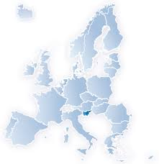
  - Scope and limitations
This study serves as supporting information for further work within DRIVER.
Only limited time and budget has been available for this first general survey, which needs to be considered in terms of scope and completeness of the respective studies.
The author/s of this study is/are responsible for its content and quality.
This report was revised at the end of 2015, reviewed internally by AIT and amended according to reviewer's comments and recommendations upon the decision of the author/s.
Responsible Partner: CSDM (Valeri Ratchev)

Overview
According to official documents and reports, Slovenia is threatened by a variety of natural hazards, mostly earthquakes, floods, landslides, hail, storms, sleet, frost, and fire. The country has one nuclear power plant and a large industrial sector that operates dangerous substances – a potential source of ecological damages and catastrophic accidents.
The recent civil protection system has been constructed after 1992 by means of the adoption of a number of legislative acts and organisational reforms. The core characteristic of the civil protection system of Slovenia is that protection against natural and man-made disasters has been separated from the national defence system. This way, an integral and functionally unified system has been established based on common goals and principles. However, the main administrative and co-ordination structure for civil protection – Administration of the Republic of Slovenia for Civil Protection and Disaster Relief (ACPDR) is a constituent body of the Ministry of Defence.

Figure 30: Symbol of the Administration of the Republic of Slovenia for Civil Protection and Disaster Relief (ACPDR).

Conceptually, the civil protection and rescue system is one of the three pillars of national security along with the defence system and the internal security system. However, “civil protection” in Slovenia is a relatively narrow concept; it includes very specific range of activities, commanding and co-ordinating bodies and specialised units for interventions and rescue in emergencies.
The system is built at three levels – national, regional and municipality. Functionally the focus is on regional capabilities and local authorities, supported by the state. Commercial entities, civil organisations and citizens have legally prescribed important functions for prevention, monitoring, alarming and responding to any extreme developments. Volunteering has a long lasting tradition in Slovenia.
Key civil protection stakeholders are the National Assembly, the Government, particular ministers, and the civil protection service that includes commanders, headquarters and heads of intervention and rescue units, and the local authorities. The administrative and specific expert tasks related to protection against natural and other disasters are carried out by the ACPDR, which is a multi-sectorial and coordinating body.
The units of the Slovenian Armed Forces and the Police are to carry out protection and rescue tasks related to their training and equipment. Their participation in protection and rescue operations is decided upon by the government and in emergency cases by the respective ministers at the request of the Commander of Civil Protection of the Republic of Slovenia.
Republic of Slovenia allocates annually approximately 0,5 % of the national budget for protection against natural and other disasters, while local authorities dedicate 3 % of municipal budgets for that purpose. In addition, fire protection is financed partially from the “fire fund,” generated from a fire insurance taxation.

Table of Contents
SLOVENIA Policy, Legislation, Organisation, Procedures & Capabilities (PLOPC) in crisis management and disaster response 1441
Overview 1442
Table of Contents 1444
List of Figures 1446
List of Tables 1446
List of Abbreviations 1447
1 Policy 1448
1.1 Risk Assessment 1449
1.2 Policy and Governance 1460
1.2.1 Strategy scope and focus 1460
1.2.2 Monitoring and analytical support to policy making; R&D 1462
1.2.3 Policy for Prevention 1465
1.2.4 Policy for Preparedness 1465
1.2.5 Policy for Response 1466
1.2.6 Policy for Relief and Recovery 1466
1.3 Financing 1467
1.3.1 Investing in preparedness 1467
1.3.2 Investing in consequence management 1469
1.4 Policy review, Evaluation & Organisational Learning 1470
1.4.1 Post-Disaster Assessment 1470
1.4.2 Departmental lessons learned systems 1471
1.4.3 Centralised (national) lessons learned system 1472
1.4.4 International exchange for lessons learned 1472
1.4.5 Regular policy reviews 1473
1.5 Resilience 1473
1.6 Information sharing and data protection 1474
2 Legislation 1475
2.1 Crisis (emergency, disaster) management concept 1475
2.2 General crisis (emergency, disaster) management law 1476
2.3 Emergency rule 1478
2.4 Specific, department/agency-level legal arrangements and regulations on emergency and disaster management 1479
2.5 Specific to the regional and local authorities legal arrangements and regulations on emergency and disaster management 1479
2.6 Legal regulations on the involvement of volunteers and specialised NGOs 1480
2.7 Legal regulations for international engagements of first responders and crisis managers 1480
3 Organisation 1482
3.1 Organisational chart 1482
3.2 Organisational co-operation 1486
4 Procedures 1489
4.1 Standing Operating Procedures (SOPs) and Guidelines 1489
4.2 Operations planning 1490
4.3 Logistics support in crises 1492
4.4 Crisis communication to general public; Alert system; Public Information and Warnings 1492
5 Capabilities 1494
5.1 Human resources 1494
5.2 Materiel (non-financial) resources 1497
5.3 Training 1498
5.4 Procurement 1500
5.4.1 Procurement regulation 1500
5.4.2 Procurement procedures 1501
5.5 Niche capabilities 1502
Resources 1504
Legislative acts 1504
Other normative acts 1504
Official documents (white papers, strategies, etc.) 1505
Online resources (e.g. websites of key CM organizations) 1505
Publications 1506

List of Figures
Figure 1: Symbol of the Administration of the Republic of Slovenia for Civil Protection and Disaster Relief (ACPDR). 1442
Figure 2: Construct of the Slovenian National Security System. 1449
Figure 3. Population delivery vis-a-vis probabilistic assessments of seismic activities of 7, 8, and 9 level on MCS scale. 1451
Figure 4: Seismic Hazard Distribution Map. 1452
Figure 5: Seismic zones in Slovenia (Seismological Institute of the Republic of Slovenia, 1991). 1453
Figure 6. The biggest rivers in Slovenia that cause most dangerous floods. 1454
Figure 7. Flood hazard in Slovenia. 1455
Figure 8. Landslide susceptibility map of Slovenia. 1455
Figure 9: Avalanche threat in the Republic of Slovenia. 1456
Figure 10: Slovenian nuclear facilities. 1458
Figure 11: Main sources of risks due to major accidents involving dangerous substances (DS). 1460
Figure 12: Monitoring, notification and warning sub-system. 1463
Figure 13. Regional notification centres 1464
Figure 14: Organisational chart of the Slovenia’s disaster management system. 1483
Figure 15: Lines of communication. 1483
Figure 16. Pictures from training polygons at the Centre for Civil Protection and Disaster Relief of the Republic of Slovenia. 1500

List of Tables
Table 1. Number of natural and other disasters and incidents in Slovenia for 2014. 1450
Table 2. The most damaging natural disasters in Slovenia. 1450
Table 3. Most powerful earthquakes on the territory of Slovenia. 1451
Table 4. Natural disasters and response operations in 2014. 1457
Table 5. Radiation exposure of the adult population in Slovenia due to global contamination of the environment with artificial radionuclides in 2014 1459
Table 6. Use of Slovenian Armed Forces helicopters for search and assistance in 2013-14. 1486
Table 7. Levels of disaster management planning. 1491
Table 8. State level Civil Protection personnel. 1494
Table 9. Civil Protection members by regions (2008). 1495
Table 10. Education and training on protection against natural and other disasters. 1499

List of Abbreviations
ACPDR | Administration (of the Republic of Slovenia) for Civil Protection and Disaster Relief
ARAO | Agency for Radwaste Management
CISF | Central Interim Storage Facility
CMAS | World Underwater Association
CRED | Centre for Research of the Epidemiology of Disasters
DPPI SEE | Disaster Preparedness and Prevention Initiative for South Eastern Europe
DUNJA | Sound Alarm Management and Triggering System
EM-DAT | Emergency management data base
EU | European Union
FCI | International Canine Federation
GDP | Gross Domestic Product
GIS-Ujme | Geographic Information System
IKAR | International Mountain Rescue Commission
IRO | International Rescue Dogs Organisation
JSI | Jožef Stefan Institute
LILM | Storing Low- and Intermediate- Level Wast
MCS | Mercalli-Cancani-Sieberg scale
MoD | Ministry of Defence
NATO | North Atlantic Treaty Organization
NRC | National Review Commission
OECD | Organisation for Economic Co-operation and Development
OJSR | Official Journal (Gazette) of the Republic of Slovenia
RCB | Radiological, chemical and biological (protection)
RIC | Reactor Infrastructure Center
SEE | South-eastern Europe
SOP | Standing operating procedures
UNISDR | United Nation’s Office for Disaster Risk Reduction
WOSM | World Organisation of Scouting Movements

Policy
According to a study of the public opinion on threat perceptions, “… the great majority of adult citizens in Slovenia feel safe and secure.” However, serious natural disasters during the last decade made them increasingly aware of ecological, natural and man-made emergency. The governments reflect the growing public demands for improving the preparedness and rapid reaction capabilities, making civil protection one of the pillars of national security policy.
The National Security Strategy explains civil protection policy as a component of the national security policy along with foreign, defence, and internal security policies.
The social context of civil protection in Slovenia is the nation’s long lasting tradition in volunteering in cases of emergencies like fires, avalanches in the mountains, and floods. Despite the separation of the civil protection system from the defence system, Slovenians strongly perceive (above 80 %) an important military role in cases of emergency.

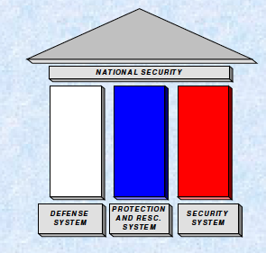
Figure 31: Construct of the Slovenian National Security System.

Risk Assessment
According to the National progress report on the implementation of the Hyogo Framework for Action (2013-2015), Slovenia has adopted (2014) a Regulation implementing the Decision on the Mechanism of the Union in the field of civil protection. It “…determines the form, content and method for making individual risk assessments at the state level, risk assessment for individual hazards on local level, national risk assessment, the method of adoption and deadlines.” According to the same report, “[r]isk assessment for individual types of disasters is based on the Instruction for Conducting Risk Assessment, which serves as a basis for all risk assessments. The Administration of the Republic of Slovenia for Civil Protection and Disaster Relief is responsible for risk assessment for individual natural or other disasters, which affect the entire or parts of the national territory while risk assessment at the local level is performed by the competent municipal bodies.”
Natural and man-made disasters are between the focal points of the Slovenian National Security Strategy. The document points out that, “[n]atural disasters, which pose greatest risks to the Republic of Slovenia are earthquakes, floods, storms, droughts, major wildfires, and massive outbreaks of infectious diseases in human, animals, and plants.”
The Doctrine for Protection, Rescue and Relief (2002) determines that, “the main sources of dangers and threats of natural and other disasters are inadequate encroachment on the environment, pollution, military threats, terrorism, and other non-military sources of threat.” Regarding the technological hazards, the Doctrine underlines that the industrial and transportation accidents, as well as those that are results of malicious attacks are of particular importance.
As a country, which is independent only since 1991, Slovenia continues to develop its system for hazards, risks and vulnerabilities mapping. In the EM-DAT database, hazards data of Slovenia is available only from 1995 onwards. However, as the preventive aspect of civil protection has been determined as a security policy priority, systematic efforts in this direction have been undertaken.
The Ministry of Defence’s Annual Report for 2014 accounts for over 14500 disasters and incidents in Slovenia in 2014, grouped in eight main categories (see Table 1).
A) Natural hazards
According to the Brussels-based Centre for Research of the Epidemiology of Disasters (CRED), earthquakes, extreme temperatures and storms cause the deadliest natural disasters.
Obviously, in terms of fatalities, the most dangerous proved to be extreme temperatures and earthquakes. For the period of the last 35 years, the average number of disasters per year is respectively, 0.03 and 0.06. The floods and storms cause the most serious material and financial damage, with an
average appearance of 0.06 storms and 0.03 floods per year.
Table 24. Number of natural and other disasters and incidents in Slovenia for 2014.
Event | Number of Events
Natural Disasters | 1957
Other Disasters | 1201
Traffic Accidents | 2270
Fires and Explosions | 3598
Pollution, Accidents Involving Dangerous Substances | 655
Nuclear and Other Events | 5
Findings of UXO, Supply Disruptions and Damage to Facilities | 850
Technical and Other Assistance | 4013
Total: | 14549
*Data on events in 2014 are based on the reports completed by 29 January 2015

Table 25. The most damaging natural disasters in Slovenia.
Hazard | Date | Number of killed | Number of affected | Damage (000US$)
Extreme hot temperature | 07/2003 | 289 |  | 80 000
Storm | 18/09/2007 | 6 | 1 050 | 292 000
Earthquake (seismic activity) | 12/07/2004 | 1 |  | 10 000
Extreme cold temperature | 31/01/2014 | 1 | 50 000
Flood | 05/11/2012 |  | 12 000 | 265 000
Earthquake (seismic activity) | 12/04/1998 |  | 700
Earthquake (seismic activity) | 12/07/2014 |  | 605
Storm | 17/01/2007 |  |  | 100 000
Flood | 19/08/2005 |  |  | 5 000
Source: "EM-DAT: The OFDA/CRED International Disaster Databasewww.em-dat.net - Université Catholique de Louvain - Brussels – Belgium

Earthquakes
From a geotectonic point of view, each year Slovenia is shaken by about ten weak to moderate seismic shocks, which focus is at a depth between five and ten kilometres. This is because the country lies on the seismically active southern boundary of the Eurasian tectonic plate on the North-Western boundary of the Mediterranean-Himalayan seismic belt, which is one of the most seismically active zones on Earth.
According to a 2014 EU sponsored study, “The territory of Slovenia is characterised by high geological and tectonic complexity. A principal geologic feature of the Slovenia is very diverse lithology, which is mainly composed of sediments or sedimentary rocks. Consequently, approximately one-third of Slovenia (and approximately 20 % of inhabitants) is at least highly exposed to slope mass movements due to morphology, geological and tectonic conditions. In general terms, slope mass movements occur in almost all parts of the country.”
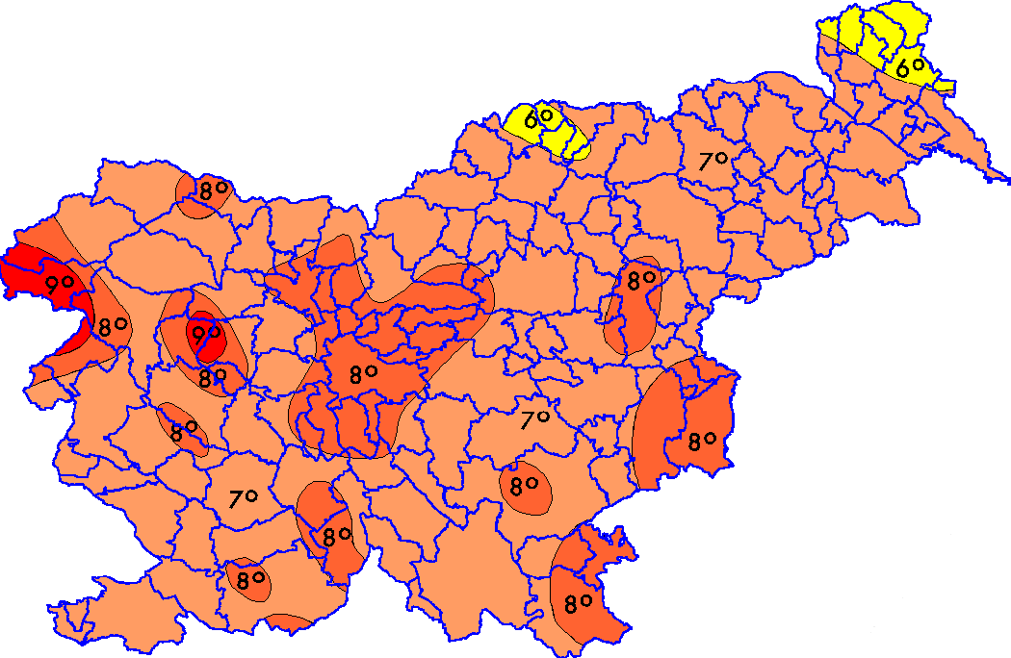
Figure 32. Population delivery vis-a-vis probabilistic assessments of seismic activities of 7, 8, and 9 level on MCS scale.

The Slovenian territory is the juncture of three geotectonic units: the Alps in the north and west, the Dinarides in the Southern, South-Western and central part, and the Pannonian Basin in the northeast. There have been many destructive earthquakes in this region: in 1895, a strong earthquake with a magnitude between 8 and 9 on the MCS scale severely damaged Ljubljana, affecting the largest density of population and numerous important government functions. Historically, the most destructive of them are the following:

Table 26. Most powerful earthquakes on the territory of Slovenia.
Date | Time | Location | MCS | Magnitude | Effect
26 March 1511 | 2 pm | Idrija-Cerkno | X | 6,90 | Destructive
8 August 1511 | - | Čedad | IX | 5,70
17 June 1928 | 6 pm | Krško-Brestanica | VIII | 5,06
Year 1640 | - | Brežice | IX | 4,91 | Shallow
10 May 1689 | 3 am | dolina Temenice | VIII | 5,00
11 February 1699 | - | Metlika | VIII | 5,02 | Extensive damage
7 March 1857 | 2.56 am | Cerkno-Straža | VII-VIII | 5,50
14 April 1895 | 8.17 pm | Ljubljana | VIII-IX | 6,06 | Destructive
9 January 1917 | 8.23 am | Brežice-Krška vas | VIII | 5,59 | Destructive

According to the World Health Organisation, the seismic map of Slovenia includes two specific areas of seismic activities. While the most active as a number of cases area is between the towns Ptuj and Novo Mesto the most dangerous epicentre of seismic activities is 50-70 km west from the capital city of Ljubljana, the so-called Gorenjska-Ljubljana area (with a seismic hazard higher than 4).
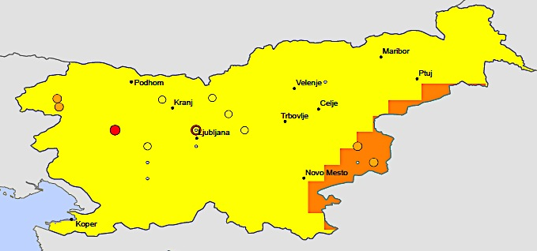
Figure 33: Seismic Hazard Distribution Map.
The Seismological Institute of the Republic of Slovenia provides the following scheme of the country’s seismic zones (in Slovenian language spelling):
- Čičarija area (A);
- Goriško-Javornik area (B);
- Gorenjska- Ljubljana area (C1);
- Dolenjska-Notranjska-Bela Krajina area (C2);
- Karawanke-Kozjansko area (D);
- Koroška-Haloze area (E);
- Štajerska-Goričko area (F).
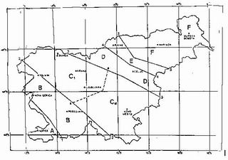
Figure 34: Seismic zones in Slovenia (Seismological Institute of the Republic of Slovenia, 1991).
The most active zones are C1 and C2 with assessed maximum magnitude as of 6.2 and intensity of 8-9 levels on the MSC scale. The towns at the highest risk include Idrija, Ljubljana, Krško, Tolmin, Ilirska Bistrica and Litija with a population about 700 000 citizens (more than 33% of the country’s population). The recent application of probabilistic seismic hazards methodology for distributed seismicity confirms the historical statistics.
Floods
In recent Slovenia, floods are considered as the natural phenomena with increasing damaging capacity and impact on people and economy. Floods pose a threat to over 300 000 hectares of land (about 15% of the territory of the country), which lies mostly in narrow valleys carved by torrents. The floods are a source of risk for about 600 000 people or over 30% of the population while under high risk of flooding are 24% of them.
The Slovenian authorities pay special attention to the floods: the research and monitoring of the flood risk is one of the civil protection focuses, along with the alert system, preventive measures and training of the population. Risk assessments are conducted according to the character of floods and source of the high water: heavy rains and the melting of snow. The civil protection organisation uses the following set of qualifications for analyses of the character of floods:
- Type of stream (mountain, valley-bottom, flatland);
- Terrain (sloping, depressed);
- Volume;
- Intensity and extent of precipitation;
- Season (autumn, spring);
- Type of high-water wave;
- Duration;
- Frequency in particular timeframe (5 for frequent to 50 years for catastrophic floods);
- Type of land and of inundated facilities.
In terms of defining the floods hazard, the local authorities have qualified the country’s rivers in four categories, depending the main source of high waters – snow or rain:
- A – Snow driven regime (Mura and Drava rivers);
- B – Snow-rain driven regime (Sava and Savinja rivers);
- C – Rain-snow driven regime (Soca river);
- D – Rain driven regime (Dragonja, Rižana, Reka and Pivka rivers).
The risk from floods comes mostly from the River Sava (Upper, Middle and Lower Sava), as well from Drava and Savinja rivers (Figure 6).
The distribution and timing of rainfall are largely influenced by the geographical location of Slovenia and the diversity of its terrain. According to ACPDR, “[m]ost rainfall occurs during advances of wet and relatively warm air from the Mediterranean.” The map of flood hazard level, produced by the World Health Organisation, illustrates that the level of flood risk is the highest (Figure 7, coloured in orange) for the North-eastern part of the country, followed by the area of Ceije in central Slovenia, and the Valley of Sava River, including the capital city of Ljubljana.
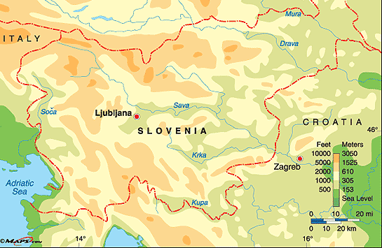
Figure 35. The biggest rivers in Slovenia that cause most dangerous floods.
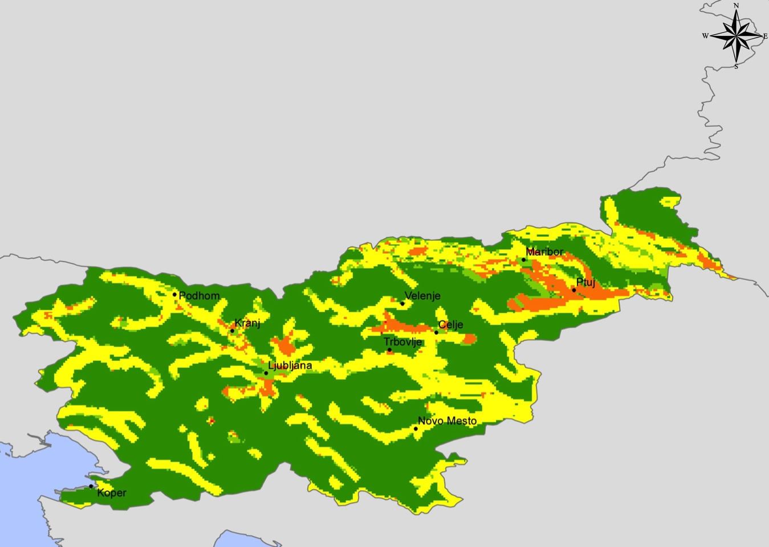
Figure 36. Flood hazard in Slovenia.

Landslides
Slovenian area is relatively highly exposed to slope mass movement processes due to its geological and morphological settings. Heavy rains and floods are the most often source of landslides – in Slovenia there are about 1 400 landslides at encompassing a territory of approximately 7 000 km² (everywhere, except in the Primorska and Dolenjska Karst region).
According to the latest study of landslides, “… the 15-years average landslide damage represents 7.6 % of total damages due to disasters in Slovenia (and 0.03 % of the GDP).” In the last 15 years, more than 10 people have been killed in landslide events.” Landslide susceptibility map of Slovenia at scale 1:250,000 have been completed, based on the extensive landslide database and analyses of
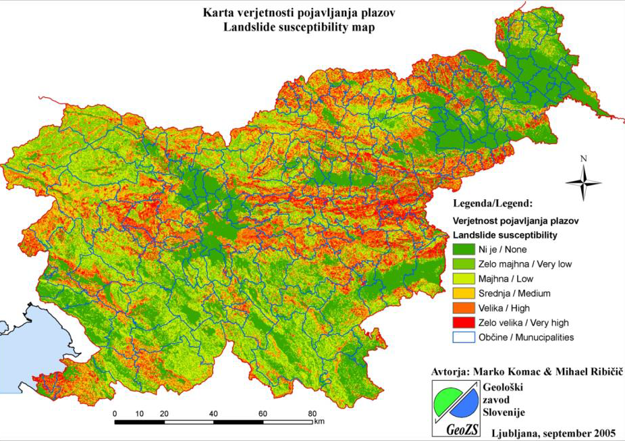
Figure 37. Landslide susceptibility map of Slovenia.

landslide spatial occurrence. The map below illustrates that the landslides have been concentrated along the main river valleys, related most of all to river regimes and the rain-snow factor.
Avalanches
Given the dominant mountain character of the country, avalanches are of permanent concern for the local people, tourists and business. With the overall expansion of ski tourism the government’s concerns of avalanches are increasing – recently, more than 1260 possible avalanches have been registered.
Forest fires
Forests are of special importance for the Slovenian people. The state provides comprehensive care for the health of the forests from a biological and reforesting point of view. According to the Government web cite, “forest fires are a serious problem, especially common in the [region of] Karst.”
A specific character of the risk assessment of forest fires is the fact that during the last years, de-nationalisation of the land, the forests also became mostly private. According to the Slovenia Forest Service, 71 % of the total forested area in Slovenia is now privately owned (about 300 000 private owners), 26 % is in state ownership and 3% are owned by legal entities (local communities or other organisations). However, from a risk point of view, the area covered by private forests is highly frag
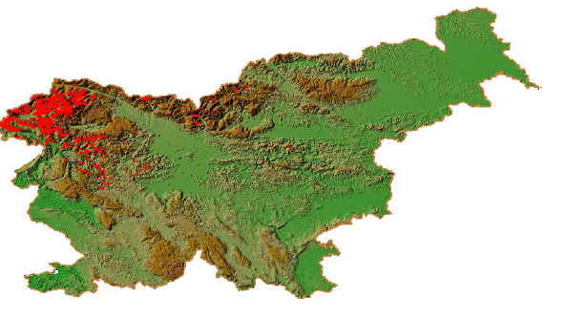
Figure 38: Avalanche threat in the Republic of Slovenia.

mented – the size of the average forest holding is less than 3 ha. The larger forest holdings are in the hilly areas Koroška, Zgornja Savinjska, and Pohorje.
Dangerous weather (cold, sleet)
The first major case of countrywide sleet has occurred on 31 January 2014: because of the heavy burden, trees and electrical infrastructure have started to collapse and fall down. On 2 and 3 February, there was widespread damage on electrical infrastructure and forests. From all 13, eleven provinces were affected: a lot of households were left without electricity; over 2000 km of electrical grid were affected; 40 % of forests in Slovenia were heavily damaged and it will take decades to mitigate this damage. Combined estimated damage is over 430 million €, with one casualty and 23 injured at the end of the intervention among rescuers, electrical company workers and army personnel.
The Ministry of Defence Annual Report for 2014 provides a detailed picture of the number of natural disasters and incidents and the relevant number of operations that took place in 2014 (Table 4).
B) Technological hazards
The main technological hazards affecting Slovenia are those associated with nuclear and other radiological threats and chemical and industrial accidents.
Nuclear and other radiological threats
Slovenian authorities consider the following sources of nuclear and radiological threats:
- Nuclear facilities (nuclear power plant, nuclear research reactor, uranium enrichment facilities, facilities for the production of fissile substances, facilities for the treatment and depositing of irradiated nuclear fuel, and facilities used for the storage, processing and depositing of nuclear waste material);

Table 27. Natural disasters and response operations in 2014.
Date | Number of Emergency Response Operations | Number of Participants | Number of Injured People
High Sea Tide | 14 | 17 | 0
Floods | 2321 | 17216 | 3
Avalanches | 241 | 1673 | 0
Deep Snow | 1284 | 6865 | 1
Hail | 6 | 76 | 0
Strong Wind | 451 | 2883 | 0
Lightning Strike | 26 | 217 | 1
Sleet | 2613 | 24433 | 13
Disruptions of Traffic due to Natural Disasters | 16 | 95 | 0
Total | 6972 | 53475 | 18
- Facilities where sources of radioactivity are used (stationary or mobile facilities where radioisotopes are used, e.g. in industry, research institutions and hospitals)
- Transport of radioactive substances (by road, rail, air or sea).

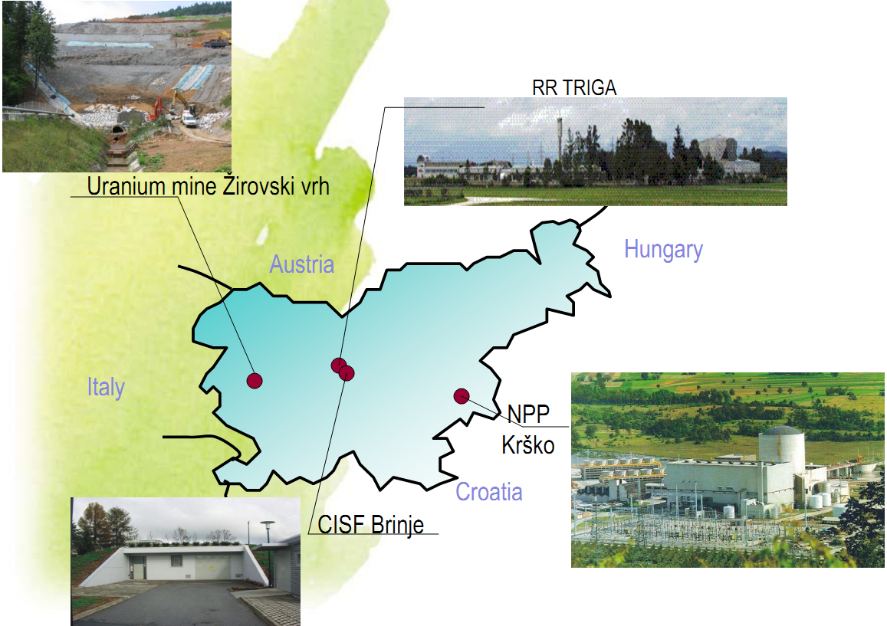
Figure 39: Slovenian nuclear facilities.
From civil protection point of view, there are four main nuclear and radiological facilities in Slovenia that may pose serious risks:
- There is one nuclear power plant in Slovenia (Krško NPP). It is situated on the left bank of the Sava River, around 3 km from the town of Krško. The power plant is 70 km South-East of Ljubljana and 35 km North-West of Zagreb. In 2013, the Krško NPP has produced about 5,3 MWh gross electrical energy from the output of the generator.
According to the 2013 Annual Report on Radiation and Nuclear Safety in the Republic of Slovenia, there have been three operations shutdowns at Krško NPP. For its part, the latest Annual Report on Radiation and Nuclear Safety notes that 2014 has been “…one of the quietest years in recent years. At the Krško Nuclear Power Plant, there were no obstructions worth mentioning. It operated the whole year without interruption.” The Report underlines that “[F]or the first time the Krško NPP exceeded the magical limit of 6 TWh of electrical energy produced due to a year of no outages and enough water from the Sava river.” The Report states also that, “In the autumn the owners of the Krško NPP approved an investment in the safety upgrades programme in accordance with requirements on the basis of the lessons learned from the Fukushima accident.”
- The second nuclear reactor TRIGA (RR TRIGA at Fig. 7) is for research purposes and is located near the town Brinje. The operator of the TRIGA Mark II Research Reactor is the Jožef Stefan Institute (JSI) and operation is carried out by the personnel of the Reactor Infrastructure Center (RIC). According to the above quoted Annual Report, in 2013, there were ten automatic reactor shutdowns, three of which were caused by operator error, six by disturbances of the linear channel switch, and one by primary water activity detector disturbances.
- The Central Interim Storage Facility (CISF BRINJE at Fig. 7) in Brinje is managed by the Agency for Radwaste Management (ARAO). It is for storing Low- and Intermediate- Level Wast (LILM) from small producers (about 130 industrial organisations and 7 hospitals). There are also still some temporary storage facilities operating under a special licence. The storage facility on the site of the Krško NPP accepts all LILW from the NPP. Its capacity will be probably filled out by 2020.
- In the area around Žirovski Vrh, the extraction of uranium ore had taken place between 1982 and 1990. Mill tailings have been disposed of on the Jazbec mine waste pile and hydrometallurgical tailings – at the Boršt site. In 1990, after the extraction of uranium ore has been temporarily halted and a subsequent decision on permanent cessation has been taken, the process of remediating the mining and its consequences has begun.
In general, the overall effective dose of radiation of an adult in Slovenia is estimated by the Annual Report 2014 as “extremely low.”
Table 28. Radiation exposure of the adult population in Slovenia due to global contamination of the environment with artificial radionuclides in 2014
Transfer pathway | Effective dose (mSv per year)
Inhalation | 0.001
Ingestion: drinking water | 0.037
Ingestion: food | 1.1
External radiation | 6.4
Total (rounded) | 7.5

Chemical and industrial accidents with ecological consequences
The chemical sector of Slovenia represents manufacturing of chemicals, chemical products and man-made fibres (about 2/3 of the Slovenian chemical industry’s total income), as well as of rubber and plastic products (about 34 % of the total branch income). Manufacturing of pharmaceutical preparations and raw materials is indisputably the most important subgroup of the Slovenian chemical industry. As the range of the chemical industry’s products is rather extensive, only the basic subgroups of products are listed below:
- Chemicals, chemical products and man-made fibres includes technical gases, dyes and pigments, inorganic chemicals, organic chemicals, basic polymer materials, pesticides and other agrochemical products, coatings, lacquers, printing inks, putties, sealants, pharmaceutical raw materials, pharmaceutical preparations, soaps, detergents, cleansers, polishes, cosmetic products, explosives, adhesives, essential oils, other chemical products, man-made fibres;
- Rubber and plastic products, includes tires and air-tubes for vehicles, reconditioned tires, other rubber products, plastic plates, tapes, foils, tubes, pipes, hoses, profiles, plastics packaging, plastic products for construction, other plastic products.

Figure 11 illustrates the scope of sources of technology hazards throughout the territory of Slovenia. Obviously, areas under the most serious threats are the valleys of rivers Sava and Drina:
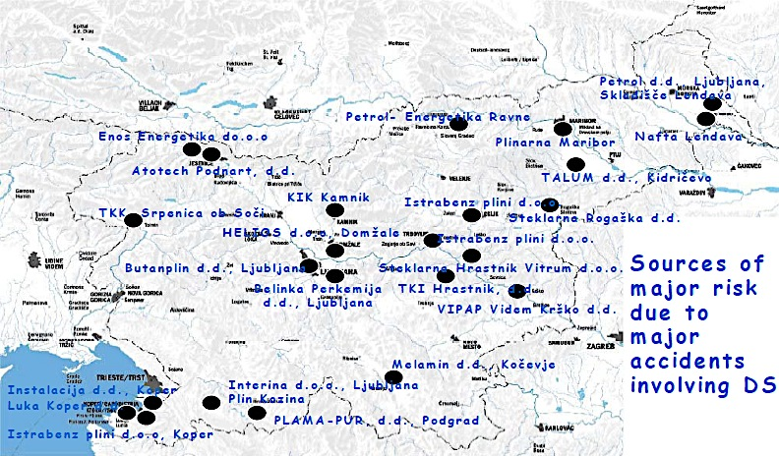
Figure 40: Main sources of risks due to major accidents involving dangerous substances (DS).

Policy and Governance

Strategy scope and focus
To continue the overall national security related legislative and organisational reforms, undertaken in Slovenia, the Government approved a package of principle documents: Act on Protection Against Natural and Other Disasters (1994), Resolution on the National Security Strategy of the Republic of Slovenia in 2001, Doctrine on Protection, Rescue and Relief in May 2002. This set framed the country’s new approach towards comprehensive security in the 21st Century, civil protection included. The framework is innovative and with an ambition of being efficient and relevant.
In the Resolution on the National Security Strategy of the Republic of Slovenia of 2001, the political statement was that the national security policy consists of the three “basic” policies plus the economic policy and policy of protecting and preserving the national environment and space.” Obviously, this overwhelming definition puts civil protection from a natural and man-made disaster into a comprehensive context of the “national environment and space.”
In 2010, the new National Security Strategy of the Republic of Slovenia introduced important changes. Accordingly, the overall approach to civil protection is seen as a part of the national security policy “… consists of the foreign policy, the defence policy, the policy of ensuring internal security and the policy of protection against natural and other disasters.” (Art. 5.1) Even more, the chapter “Policy of Protection against Natural and Other Disasters” utters that “[t]he policy of protection against natural and other disasters will remain to be focused on the comprehensive management of natural and other disasters.” The policy is about wider and important social relationships that are governed through a variety of political, legal, organisational and other instruments while management is the implementation of policy by the state administration.
It is not clear, why the Slovenian authorities have decided to leave the comprehensive context and political approach and to focus on operational disaster management. The new approach builds an impression that the disaster management sector is too isolated and has more practical character than a political one. This issue is important, because definitions pave the way from political/institutional declarations towards instrumental legal regulations and the building of implementation architecture (in terms of organisation, procedures, and resources).
From one side, the country applies a comprehensive approach (NSS, 2010, art. 5.1) to security at all levels (international, national, societal and individual) and aspects (economic, social, environmental, medical, demographic, educational, scientific and technological…). If one adds to this list also the ‘standard” aspects of foreign policy, defence and internal security, will see that the scope of security of Slovenia is extremely wide for a country in a relatively stable and secure international and internal environment. However, the National Security Strategy puts “…the protection of life and a high level of all forms of security for its people…” in a very broad context that definitely includes civil protection from natural and other disasters. Even more, the document entails an important political message that “[i]n the future, the fundamental purpose of the national security policy of the Republic of Slovenia will be to ensure the highest possible level of human security …,” as stipulated by art. 5.1 – so the paradigm shift from national towards human security is an impressive ambition and the civil protection policy is in its context.
From another side, it is obvious the strong emphasis on “management” instead of on “policy.” The chapter “Policy of Protection against Natural and Other Disasters” begins with the statement that in the Art. 5.1 that “[t]he policy of protection against natural and other disasters will remain to be focused on the comprehensive management of natural and other disasters.” It is not clear, whether such a replacement of policy with management is a result of a poor expression or there is a strong desire to make things more practical than political.
However, in summary, the key points of the recent Slovenian strategy towards civil protection include:
- Disasters – natural and man-made, are between the risk factors for the national security;
- All kinds of disasters are managed under integrated and co-ordinated policy;
- Disaster management policy is a civil one;
- The core political approach is to guarantee the balance and co-ordination between national and local authorities;
- The core strategic organisational approach is towards strengthening the capacity of local administration and communities and equalisation of the capabilities between different communities;
- The scope of disaster management includes preparedness, response and relief;
- The focus of the disaster interventions is rescue and relief;
- The human resources for disaster management is a rational combination between professional units and large number of volunteers;
- Raising citizen awareness and ability for providing personal, family and community protection;
- Budgets for disaster management are provided at national, ministerial and local level;
- Socialisation of risks and consequences is reduced through strengthening of the insurance policy and culture;
- Enhanced regional and bi-lateral co-operation in disaster management, contribution to the EU overall civil security mechanism and active engagement in the relevant international organisations and programmes.

Monitoring and analytical support to policy making; R&D
According to the Doctrine on Protection, Rescue and Relief (2002), “[d]isaster preparedness consists of monitoring and researching dangers and methods for protecting against them.” Among the key instruments for providing protection, rescue and relief are the “monitoring, notification and warning system.” Art. 4 defines it as a “unified subsystem” that “consists of informational and telecommunication systems, notification centres and warning equipment.” In later documents, monitoring and warning are determined as components of the Slovenian “comprehensive management of natural and other disasters.” Currently, the unified monitoring, notification and warning system in Slovenia comprises:
- Monitoring networks;
- Notification centres;
- Computer support and telecommunications service;
- Warning system.
Slovenia’s report of 2005 for the Hyogo Framework for Action explains the basic objectives of the system in the following way:
- monitoring of meteorological, hydrological, seismological, radiological, ecological, health and other conditions;
- a collection of data on hazards, disasters and other phenomena and developments important to the protection system against disasters;
- organisation and maintenance of a database of protection, rescue and relief units and their intervention and resources;
- provision of information to competent national, local community and other bodies and services responsible for the management and implementation of protection, rescue and relief operations;
- warning of the population of any imminent danger, and public alarm announcements;
- activation and co-ordination of rescue service operations;
- logistical and other forms of support in the provision of rescue services.
The monitoring, notification and warning sub-system has the following architecture:

Administration for Civil Protection and Disaster Relief

National Notification Centre

Regional Offices
(13)
Regional Offices
(13)
Regional Offices
(13)
Regional Offices
(13)
Regional Offices
(13)

112
Regional Notification Centre
Regional Logistic Centre

Figure 41: Monitoring, notification and warning sub-system.
Monitoring of natural and other hazards is organised through institutionally based observation posts or networks, contributions from incidental informers and through the horizontal exchange of information. Data are collected, processed, stored, and forwarded by the national and regional notification centres. In particular, data on meteorological, hydrological, seismological, nuclear, and environmental situations, threats to health, traffic events, obstruction of infrastructure systems, other dangers and threats, the conducting of protection, rescue and relief efforts, and damage are collected in permanent databases.”
According to the National progress report on the implementation of the Hyogo Framework for Action (2013-2015), “The unified monitoring, notification and warning system in Slovenia comprises:
- the monitoring network,
- notification centres (13 x 112 Centres),
- the computer support and telecommunications service, and
- alarming and warning system.”
The report enlightens the multi-agency approach to monitoring the hazards and the established a shared information system that connects the monitors with notification centres. A further development of the video control system for wildfire and oil spills at the sea shall provide capacity to monitor of about 40,000 additional hectares.
The network of notification centres (see Figure 13) is seen as the core of the system: the National Notification Centre and 13 regional offices establish the hub that connects the sources of information with the decision-making bodies. Each regional office of the ACPDR includes a regional notification centre and a regional logistic centre (warehouse). The National Notification Centre integrates different monitoring sources, manages the overall communication and information system, does the analytical and statistical work on collected data and has less operational duties. The regional centres, in addition to collecting data and responding to emergency 112 calls, are in charge of dispatches for fire-fighting, emergency medical aid, the mountain rescue service, the cave rescue service, the underwater rescue service, civil protection and other rescue services.” The regional centres are based in Ljubljana, Kranj, Trbovlje, Celje, Slovenj Gradec, Maribor, Murska Sobota, Ptuj, Krško, Novo mesto, Postoja, Koper and in Nova Gorica.
According to the Slovenia’s 2005 Hyogo report, the number 112 has been used in Slovenia since the beginning of 1997. Ordinary citizens can call this number in an emergency or if they need a fire brigade, emergency first aid, or aid from any other rescue services. “By dialling 112, people also can obtain critical information on weather, water, snow and other conditions, on disturbances and interruptions in the supply of potable water, electricity and gas and in other areas of life importance.”
All 13 regional notification centres are integrated into a computer network. Information support is provided through tailor-made computer applications in the regional notification centres, such as the Geographic Information System (GIS-Ujme), the sound alarm management and triggering system (DUNJA), the system for the acceptance of telephone calls (ROK), the radio traffic control system (KC08), the radio network control system (Nadzor ZARE) and the pager system (ZAPP).
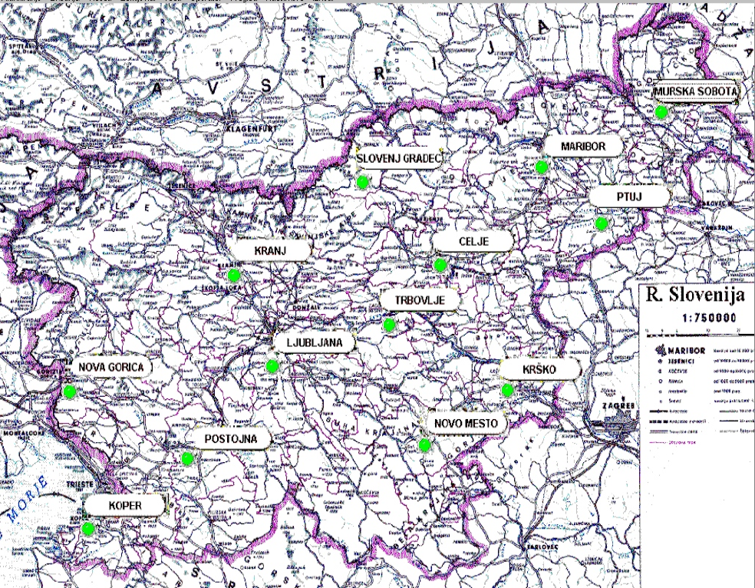
Figure 42. Regional notification centres

In recent years, much attention has been devoted to the communication and information system upgrade of notification centres. The new services regarding the 112 emergency calls (application SMS112 for receiving text emergency calls and application video112 for receiving video emergency calls) have been introduced, and the public alert system has been reorganised.
In Slovenia, the civil protection is viewed as an interdisciplinary field in terms of research and scientific work, analysis, experimentation, and development. Academia, specialised institutes, private companies and individual researchers provide scientific support to disaster management. “The majority of work is accomplished in the following areas: civil engineering, chemistry and chemical technology, water resources management, forestry, geology, health, public relations, fire engineering, computer science, information systems, psychology and insurance companies.”
Slovenian National progress report on the implementation of the Hyogo Framework for Action (2013-2015) informs that “…the following research and development projects have been successfully concluded in 2013:
1. Seismic hazard in Slovenia for the needs of civil protection – POTROG;
2. Early warning system in case of danger of triggering landslides – MASPREM;
3. Fire Control in nature - video surveillance system - VIDEOKRAS 4.”

Policy for Prevention
According to the Act on the Protection Against Natural and Other Disasters (1994, amended in 2006), the principle of prevention is determined in the following way:
Article 12 (Principle of prevention)
In providing protection against natural and other disasters, the state and the local community shall, within their competence, give priority to the organization of preventive measures.
The act stipulates that each ministry is in charge for prevention in its area of work while the Administration of the Republic of Slovenia for Civil Protection and Disaster Relief uses their monitoring for risk reduction. In terms of prevention, the administration is charged with the tasks related to spatial planning.

Policy for Preparedness
According to the concept of civil protection, recently applied in Slovenia through the Act on the Protection against Natural and other Disasters, preparedness is the key function, performed at national, local and individual level that provides effective protection of people and infrastructure from natural and other disasters. The Doctrine on Protection, Rescue and Relief emphasises, “Priority is given to preventive measures in all forms of planning protection against natural and other disasters.” The policy of preparedness is built on a precise risk assessment and forecasting (including using modelling and simulations) of a variety of natural and man-made hazards. An expanding monitoring, notification and warning system helps to integrate data and risk assessments through horizontal and vertical chains of communication and reporting. National and local contingency plans for emergency protection, rescue, and relief are drafted based on this comprehensive picture. The power of these plans is the combination of specialised protection and rescue units and a wide number of volunteers – both well trained and equipped. In parallel to the organisational and technical solutions, a system for education, training, and public awareness on hazards has been established. Relevant as size and components state and local reserves for protection, rescue and relief purposes have been provided and maintained.

Policy for Response
According to the Act on the Protection against Natural and other Disasters and the Doctrine of Protection, Rescue and Relief, the policy for response in cases of emergency is based on three core principles. The focal point of any intervention, rescue and relief and other protection activities during natural and other disasters is to protect the life of the people: every person has the right to protection and his/her protection shall be a priority over any other protection in case of emergency. Secondly, response to an emergency shall be started by the affected local authorities and expand gradually, engaging neighbours, regions, and the state; the Armed Forces and their resources are the last resort. Thirdly, the central authorities provide co-ordinated response to the major disasters, assisting to local communities in emergency response, providing support to the Civil Protection Commander and guaranteeing that the basic conditions for life are provided.
For the success of the response policy, citizens also have a crucial role. The Act on the Protection Against Natural and Other Disasters obliges them to:
- participate in the Civil Protection;
- provide material means (hereinafter referred to as material obligation);
- be trained and prepared for personal and mutual protection and implementation of required protective measures.
The overall responsibility for the co-ordination of disaster response preparedness and intervention is Administration of the Republic of Slovenia for Civil Protection and Disaster Relief.

Policy for Relief and Recovery
Conceptually, the Slovenian approach to post-emergency phases puts rescue and relief into a pair, while recovery is the last component of disaster management. This construct reflects the mechanism of decision-making and implementation, as well as the funding of recovery measures, programmes and policies. The Slovenian authorities believe that the focus on recovery is completely relevant and will provide more coherent and consecutive measures not only to return to function through rehabilitation of damages but for reconstruction and improvement. By law, the policy for recovery is one of the core responsibilities of the state. It shall provide “assistance in reconstruction and recovery from natural and other disasters in order to protect the life and health of people, property, cultural heritage and the environment, prevent further damage and provide basic living conditions.”
The Ministry of the Environment and Spatial Planning is the core state institution for recovery planning and management. Its operational body is the Natural Disaster Recovery Division, whose basic aim is to organise, co-ordinate and perform implementation of emergency works to stabilise and prevent the spread of the consequences of natural disasters. The Natural Disaster Recovery Division’s functions include also:
- Drafting programme proposals for elimination of disaster effects;
- Observation of potentially endangered areas;
- Experts identification and assessment of risks within the disaster impact area;
- Drafting proposals for relocation, expansion and other adjustments for the existing infrastructure facilities, affected by the disaster events;
- Preparation of national spatial plan for cases of major interventions;
- In case of emergency, implementation of works to stabilise and prevent the spread of damages and other consequences;
- Conducting of administrative procedure which deals with removing the aftermath of natural disasters;
- Monitoring of measures for removing the aftermath of disasters;
- Implementation of decisions for allocation of funds for rebuilding to any beneficiary ;
- Management of reconstruction works, based on the Removal of Consequences of Natural Disasters Act;
- Learning lessons and drafting legal and organisational proposals for further risk reduction;
- Database management as a basis for carrying out preventive measures and removing the aftermath of natural disasters as well as on the use of state aid funds;
- Others.
The municipalities are also responsible for organising and conducting recovery activities in their respective areas.
The policy for recovery is regulated by the Act on the Recovery from the Consequences of Natural Disasters (Official Gazette of the Republic of Slovenia, 75/2003), the Procedure for Damage Assessment in Case of Natural and Other Disasters (ACPDR nb.017-00-23/2005-2 of 09/27/2005), and the Decree on the Damage Evaluation Methodology.
Recovery and reconstruction are also objects for academic and engineering research, experimentation, and development.

Financing

Investing in preparedness
Despite that, Slovenia (followed by Bulgaria) has the largest emergency reserve fund in the Balkans – about USD 40 million, the amounts allocated are grossly inadequate for funding a major disaster event. The administrative process involved in mobilising additional resources in cases of major disasters (e.g. when the size of damages by far exceeds the financial resources available) appears to be administratively cumbersome, lengthy and complex, and as a result rather time-consuming.
Planning for emergencies is an integral part of the government budgetary process. According to the Public Finance Act, a budget reserve of up to 1.5 per cent from the total revenue “… shall be used to finance expenditures covering the elimination of the consequences of emergency situations such as an earthquake, floods, landslide, snowslide, snowdrifts, hurricane, hail, sleet, frost, drought, mass outbreak of contagious human, animal or vegetal diseases other natural or ecological disasters.” (Art. 46) The annual budgetary allocations for emergencies are typically mandated by existing legislation on disasters caused by the impact of natural hazards and on another emergency. In addition, the Government may provide additional budgetary resources through several state agencies, which can be released in the case of a disaster. In cases of emergencies, the Slovenian authorities (Government and Parliament) can also increase the originally planned budgetary appropriations for disasters by passing special emergency legislation. Country disaster funds seem to be non-accruing budgetary funds, meaning that they maintain the same statutory size and that in years when there are no losses they do not receive additional financial allocations.
Disaster management activities are financed through the national and municipal budgets, and through insurance payments and other funds contributed by commercial companies, institutions and other organisations. According to UN study, “[e]very year the Government of Slovenia allocates approximately 0.4 per cent of the national budget to the disaster management system. Municipalities are required to earmark 3 per cent of their annual budgets to civil protection, although the average actual figure stands at just 2.1 per cent.”
Fire risk reduction activities are partly financed from a separate fire fund, which is generated from a tax on fire insurance. Currently, 5 per cent of all fire premiums is used for fire risk reduction activities.
The main financing body in terms of environmental protection and disaster prevention is the Investment Monitoring and Finance Division within the Ministry of the Environment and Spatial Planning. This directorate, among other functions, performs tasks related to the environmental protection public services and remediation of natural disasters. It provides cohesion policy for all kind of state investments in programmes and other measures aimed at reducing of natural hazards.
According to the Ecological Agency, there are six large-scale landslides in Slovenia, for which state aid for removal of consequences of landslides, prevention of their expansion and their stabilisation is legally defined. For this purpose, the following actions are defined:
- Prevention of spreading and stabilisation of landslide through construction of water management infrastructure;
- Restoration and replacement of damaged objects of local and state infrastructure, cultural sites, and protected natural sights;
- Renovation or replacement of residential and commercial buildings.
For state aid are entitled persons of public and private law (help for building replacement of facilities that need to be removed from the influence area due to landslide risk), local communities and competent ministries (for the reconstruction of infrastructure facilities). Funding amounts are determined by a programme for removal of landslide consequences for each financial year and for each landslide separately.
Different institutions fund hazard mapping on a different scale, as an important component of disaster management preparedness:
- Slovenian Research Agency (ARRS) within the Ministry of the Environment and Spatial Planning;
- “Geological Survey of Slovenia” (GeoZS);
- Faculty of Civil Engineering and Geodesy (FGG);
- “Anton Melik” Geographical Institute (GIAM);
- “GeoInženiring” (engineering geological mapping and rock classification, field and laboratory research for underground structures, landslides and mineral resources for construction).

Investing in consequence management
The Republic of Slovenia has had detailed assessment procedures in place on the national, regional and municipal level since 2004. The Decree on the Damage Evaluation Methodology specifies the number of formulas for calculation of material and other wastes. Moreover, it rates prices list are published annually on the ACPDR website.
According to the Act on the Removal of Consequences of Natural Disasters, beneficiaries of recovery funds and measures could be: national authorities; municipalities; persons of public law; persons of private law for the renovation of facilities in which activities are carried out; apartment owners; owners of the buildings, which have been declared cultural monuments or an object that is intended to safeguard the natural heritage.
Funds for removal of the consequences of the natural disaster are allocated to the municipality as a special transfer from the government for reconstruction of the following objects:
- Public infrastructure and facilities of local importance;
- Objects that are owned by municipality and are used for carrying out its activities and for local public service;
- Residential buildings, which are owned by municipality;
- Objects that are owned and used by persons of public law, of which the founder or co-founder is the municipality and for which investment, investment-maintenance or maintenance work are provided within municipality budget;
- Forest roads, in the case of co-financing of reconstruction, for which funds are provided in accordance with the regulations, governing the management of forests.
From their side, the municipality allocates funds for removal the consequences of natural disasters.
The Agency of the Republic of Slovenia for Agricultural Markets and Rural Development, subordinated to the Ministry of Agriculture, Forestry and Food, ensures proper and timely payment of the approved funds to final agriculture and food sector beneficiaries, suffered from natural and other disasters.
At an individual level, insurance companies are providing an evaluation of direct material damages due to the personal insurance policies.

Policy review, Evaluation & Organisational Learning

Post-Disaster Assessment
Post-disaster assessment is regulated by the Decree on the Damage Evaluation Methodology. This Regulation sets out the methodology for determining, assessing and documenting damage and other consequences, caused by natural and other disasters such as earthquakes, floods, landslides, avalanche, high snow, strong winds, sleet, frost, drought, storm, as well as from industrial accidents.
Damages are quantified in five categories:
1. Land: Forests; Agricultural land; Land for construction.
2. Facilities: Buildings (residential and non-residential); Civil engineering - Transport infrastructure (roads, railways, bridges, etc.), Distribution piping for water and wastewater; Waterworks and others; Electricity and telecommunications networks.
3. Fixed and current assets: Fixed and current assets - movable property; The current agricultural production; Orchard.
4. Cultural properties: Cultural and religious buildings, memorials, museums and other; Movable heritage (and other artwork).
5. Other.
Damage is divided into two categories: primary and secondary. Primary damage comprises the main emergency and the attendant costs to restore and set up damaged items in the condition in which they have been initially and the cost of repair and replacement of damaged parts or assemblies. The primary damage also includes the cost of clearing the site of damage, demolition of damaged and unserviceable parts, their removal and the necessary start-up costs. The secondary damage comprises operating costs of protection, rescue and relief and emergency protective or preventive measures for the protection of human, animal and other damaged items. It covers essential safety work, such as buffer embankments, ditches, splints, pumping, removal, spraying, fertilizer and other similar measures.
For post-disaster or accident assessment, the government sets up regional and national damage assessment committees. In the committees, judicial officers, insurance evaluator and others authorised representatives of public institutions, professional teams or specialised services, and experts or members of professional associations and other institutions may be appointed. At local level, competent regional committees make the damage assessments.
According to the established procedures, when an accident occurs, the local community immediately informs the regional notification centre and provides (no later than 24 hours) a written report to the ACPDR’s regional branch. ACPDR experts together with local authorities, visit the damaged area and identify the scope and intensity of disasters; based on this assessment, ACPDR issues a resolution for damage assessment, in which the start and end date of the damage assessment are determined. Within this timeframe, local authorities invite affected people to report the damage, filling prescribed sheets, and form a commission to review presented sheets, to assess their objectivity and, if necessary, amend or supplement them. After the expiration of the period, the local commission sends the collected application sheets to the regional committee for review and evaluation. The Regional Damage Assessment Committee sends the applications to the National Damage Assessment Committee, which elaborate a report for the Government. The Government decides on the report and the reimbursement of costs.

Departmental lessons learned systems
The documentation on civil protection in Slovenia does not contain requirements for a specific mechanism for learning lessons from emergencies to be established. However, one of the tasks of the Administration for Civil Protection and Disasters Relief is to produce proposals for improvement of legislation, organisation and procedures, which represents a kind of informal lessons learned practice.
The Law on Protection against Natural and Other Disasters stipulates the rights and responsibilities of the national authorities and local community authorities to use “…data on resources, natural and other disasters hazards, the inhabitants in endangered areas, residential and other buildings, public services, associations and other non-governmental organisations, commercial companies, institutions and other organisations the activities of which are important for protection, rescue and relief, collected and recorded with statistical research programmes or contained in other statistical data-bases, managed and provided by the national statistical agency and other authorised agencies, responsible for the implementation of mid-term and annual statistical research programmes…” The data should be used for the purposes of threat assessment, planning and implementation of protection, rescue and relief. Despite that, such a regulation does not formally establish a uniformed lessons learned system, in practice the huge amount of information, organised as a database, could be successfully used for improving legislation and the organisation of the civil protection. The same law (Art. 51, (6)) defines the Administration of the Republic of Slovenia for Civil Protection and Disaster Relief as the main national source of information on emergencies. ACPDR shall collect and manage data in a form of integrated central databases for the purposes of the preventive programmes planning, emergency management and post-disaster assessments. By law, these data should be shareable and made public, following prescribed procedures.
Information from emergencies is important also for the post-emergency assessments. The above-quoted Procedure for Damage Assessment in Case of Natural and Other Disasters requires general and technical databases to be established. The former include facts, such as location, type of damaged items, address or registered office, ownership, type and time of the accident, damage to a property group, purpose and activities. The technical data from crisis events consists of a description of the situation and its characteristics, explanation of damaged items depending on their purpose, type, age and technical parameters.

Centralised (national) lessons learned system
The Doctrine on Protection, Rescue and Relief determines the lessons learned from previous accidents as one of the basics for planning and conducting protection, rescue and assistance efforts. Together with the systematic “…interdisciplinary research of causes, forms of phenomena and consequences of disasters…,” lessons from each emergency are expected to provide ground for improving the overall civil protection system of the country and any particular hazard as well.
Recently, in Slovenia no institution is explicitly focused on learning lessons from the emergency. However, the country’s civil protection legislation, organisation, practice and traditions stimulate cross-sector learning from past events and provide access to facts, statistics and expertise within the area of learning from emergencies and disasters in order to improve safety work at national and local levels.
As explained in the 2005 Hyogo report, ACPDR has prerogatives to provide a collective overview and assessment of incident and accident trends and safety work in society, thus giving decision-makers and the public a broad and unbiased overview of both emergency and post-disasters situations in different sectors and areas. Such task requires the ACPDR to develop and maintain a reporting system, databases and web applications to collect data, determined by law. As the law regulates the post-disaster assessment as well, the civil protection system also includes an estimation of the economic burden of injuries and damages.
Slovenia has reported that research methods and tools for multi-risk assessments and cost-benefit analysis are developed and strengthened.

International exchange for lessons learned
According to Jeraj, Slovenia has signed bilateral agreements on cooperation with neighbouring countries (Austria, Croatia, Hungary, cross-border protocol with Italy), and with Bosnia and Herzegovina, the Czech Republic, Germany, Macedonia, Montenegro, Poland, Slovakia and the Russian Federation. All the aforementioned agreements include provisions on mutual exchange of information and early warning in case of major disasters.
Slovenia, as a member of European Union, participates in the EU Civil Protection Mechanism and is also a signatory of the United Nations Convention on the Transboundary Effects of Industrial Accidents.
According to the European Commission’s Vademecum on Civil Protection, in the regional co-operation format, Slovenia participates in the Disaster Preparedness and Prevention Initiative for South Eastern Europe (DPPI SEE) and the Adriatic-Ionian Initiative. The country implements the Alpine Convention as regards disaster risk reduction.

Regular policy reviews
The policy for civil protection as regards disaster management and relief is embodied by the “national programme of protection against natural and other disasters”. The national programme “…shall be to set out the aims, policy and strategy of protection against natural and other disasters in the country for a minimum period of five years.”
According to the mechanism of programming (followed by annual planning), the policy review and amendment should be done within the frame of programme review and assessment (the same for the annual plans).
However, there is no available information about policy review in the form of an overall assessment. In some cases, reports on performance during particular emergencies are published – e.g. Annual Reports on Radiation and Nuclear Safety in the Republic of Slovenia, Annual Reports of the Ministry of Defence, and others.

Resilience
The concept of resilience in civil protection, in terms of country’s capacity to withstand shocks due to natural and other disasters, to rebuild itself with efficiency, and to improve on the pre-existing state wherever possible, has not been explicitly established in Slovenia by law or other normative acts.
However, the Slovenian approach towards civil protection from natural and another disaster is focused on four basic aims that form country’s resilience policy “by doing”:
- Effective decision-making – in Slovenia, it is based on a common understanding that the sectors at the highest risk should be the framework for prioritising the investment policy (in terms of financial, material, human, and political resources and the research agenda) in resilience.
- Efficiency – at this point of time, efficient disaster management steps on a national platform that centralises key data so all state and local institutions, society, the business, and the researchers as well, have access to information that is critical to protecting homes, property, community, regional, and national infrastructure.
- Transparency and openness – Slovenian disaster management framework is aimed to provide greater transparency and to build a culture of openness by removing restrictive barriers on accessing government and local administration plans, performance reports, and specialised database.
- Availability – the Slovenian approach towards civil protection is based on the universal right of all citizens and their property, as well as the national and local material values to be protected from natural and other disasters.

Information sharing and data protection
Collection and protection of personal data related to disaster management, including for preparation, disaster intervention, volunteers, and damage assessment are regulated by the Law on Protection Against Natural and Other Disasters. The law stipulates that the following personal data shall be collected, processed, used and kept by the administrative bodies, responsible for civil protection:
- “Name and surname, date and place of birth, permanent and temporary residence address, date of birth of children, data on knowledge and skills relevant to protection, rescue and relief, education, employment, telephone number and mobile phone number of the members of the Civil Protection, civil servants in the field of protection and relief and citizens who voluntarily participate in the performance of protection, rescue and relief duties
- For the members of the Civil Protection additional data on the date of medical check-up of health and psycho-physical condition, responsibility within the Civil Protection for the purpose of ensuring up-to-date preparations, mobilisation and activation and provision of rights and obligations of the Civil Protection members and other protection, rescue and relief forces;
- Type, capacity and condition of means of transport and other means subject to material obligation as well as name, surname, home or business address of owners and users of such means, premises and buildings, for the purpose of completing headquarters, units and services.”
The Law prescribes also that the relevant administrative bodies shall keep personal databases on members of the Civil Protection, civil servants in the area of protection and rescue, citizens who voluntarily participate in protection, rescue and relief and persons subject to material obligation. The institutions are responsible for the protection of personal data.
The civil protection administration is authorised by law to collect, keep, and communicate above-mentioned personal data to the responsible national or local authority at their request. The relevant commercial companies, institutions and other organisations may request personal data on members of the Civil Protection assigned to them. All authorities, commercial companies, institutions and other organisations may use such personal data only for the purpose of organising protection against natural and other disasters and are responsible for the protection of personal data.

Legislation
Slovenia’s legislation, related to disaster management, comprises conceptual, basic, specific, and emergency laws and acts. The legal framework in the field has been developed after the independence of the country and has been improved based on the accumulated experience in emergency response. Significant improvement of the package of laws has followed Slovenia’s membership in the European Union. However, as mentioned earlier, the Slovenian model has some specific aspects and differs from both the European and South-East European countries’ civil protection systems. In any case, the legal framework in Slovenia provides systematic planning for risk reduction and relevant preparedness, a comprehensive mechanism for monitoring and alerting, a mixture between professional and volunteer human power, adequate resources and reserves for intervention and recovery.

Crisis (emergency, disaster) management concept
The core conceptual document on crisis management in cases of natural and other disasters is the Doctrine on Protection, Rescue and Relief. It is a document of the Government of the Republic of Slovenia, issued pursuant to Article 93 of the Law on Protection Against Natural and Other Disasters and adopted at the government’s 76th regular session on 30 May 2002. This document is conceptually linked to the country’s founding act in the field of security – The Resolution on the National Security Strategy of the Republic of Slovenia, published in OJRS, 56/2001.
The Doctrine provides a set of common principles on how should protection, rescue and relief be organised within the civil protection system. It also stipulates operational guidance to all professional and volunteer, national and local, state and private forces that based on law or other forms of organised engagement contribute to all or some aspects of the protection against natural and other disasters.
The platform of the Doctrine is that protection against natural and other disasters is a part of the internal security of Slovenia and “…that protection and rescue is, organisationally and functionally, an independent and unified subsystem of Slovenia’s national security.” Out of this starting point, the Doctrine builds a system of integrated or co-ordinated preventive measures, protection operations, emergency services, and other efforts, which cope with the demands of the citizen for security against natural and man-made disasters and extreme conditions.
The document defines the “basic goal of protection, rescue, and disaster relief is to protect people, animals, material and other goods, as well as the environment, against disasters or destruction, damage and other consequences of disasters and to alleviate the consequences.” Despite that the Doctrine does not strictly prescribes the most popular in Europe crisis management cycle – prevention and mitigation, preparation, response, and recovery, it includes core activities with similar content: preventive activities, preparedness for action, monitoring, notification and warning system, protection, rescue and disaster relief, and alleviation of the aftermath of disasters.
The Doctrine determines that the starting points for planning, organising and conducting protection, rescue and relief efforts and operations should be “…the dangers and threats posed to people, animals, property, cultural heritage, and the environment.”
In terms of disaster management preparedness, the concept includes “…monitoring and researching dangers and methods for protecting against them”, notification and warning, organising, equipping and training of specialised forces and volunteers as well as training of the population for personal and collective protection. Preparation also includes the provision of any kind of material and equipment that could be necessary in cases of emergency. Planning at all levels – national, institutional, local, and business, is also an important component of the country’s preparedness.
The principles of organising and providing civil protection are a combination of bottom-up and top-down approaches. First, in a case of emergency everyone is obliged to provide information to and about the others and to offer assistance to others (based on the Slovenian culture of volunteering). Still, the state and local authorities are obliged to provide the necessary preventive measures and preparation efforts, and, in a case of emergency, to conduct protection, rescue and relief operations.
From an organisational point of view, the Doctrine introduces a mixed system of professional permanent civil protection units and comprehensive network of volunteers – organised and individual. There is a single chain of command system for any rescue and relief operation. “Armed forces and defence assets can be used for protection, rescue and relief efforts if the forces and assets available are not sufficient for emergency rescue and relief and if the armed forces are not needed to conduct defence missions.”
The Police are also engaged in the mechanism of civil protection to “…prevent, detect and investigate criminal offences and violations, detect and apprehend perpetrators and other wanted persons and deliver them to competent bodies, maintain law and order, control and organise traffic and the movement of persons, participate in securing dangerous areas or accidents, conduct certain missions concerning foreigners and, if required, participate in rescue missions.”

General crisis (emergency, disaster) management law
The new legislation that framed Slovenia’s policy and organisation for disaster management was adopted after 1992 and has been conceptually and operationally amended after 2000. The number of legal acts has “…separated the system of protection against natural and other disasters from the defence system in order to organise it as an integral interdisciplinary activity based on common goals and principles, and to merge all rescue services and other protection, rescue and relief forces into an organisationally and functionally unified system.” This approach has been applied to make the previous highly centralised and militarised system more flexible for inter-agency co-operation, more decentralised between the state and local authorities, and more open for extensive engagement of volunteers, NGOs and the business. Formally and legally prevention has become the fundamental guideline and major task of this system with implementation being carried out mainly by the local communities.
Recently, the protection from natural and other disasters in Slovenia is governed through a package of legal acts – laws (acts), different Government decisions (decrees), and a variety of sector-specific regulations. The most important between them is the Act on the Protection Against Natural and other Disasters (Published in the Official Gazette of the Republic of Slovenia No 64/94, dated 14 October 1994). It has been approved by the Parliament on 3 May 2006 and since then serves as a hub between the conceptual Doctrine on Protection, Rescue and Relief and variety of sector-specific regulations as the Fire Protection Act, the Fire Service Act, the Recovery from the Consequences of Natural Disasters Act, the Environment Protection Act, the Protection Against Drowning Act, and others, as well as several general laws as Public Administration Act, Material Obligation Act, and others.
The Act on the Protection Against Natural and other Disasters sets the principles, architecture and key procedures for disaster management in a systematic manner:
- The scope of protection, provided through the Law, includes “…people, animals, property, cultural heritage, and natural environment.” (Art. 1)
- In protection, priority is given to the “risk reduction” (despite that the Law does not use the term), achievable through measures to reduce both the number of disasters and the number of casualties and other consequences.
- The established system for civil protection comprises programming, planning, organisation, implementation, supervision, and financing of measures and activities in implementation of Government’s policy and strategy on protection against natural and other disasters.
- The Law defines variety of basic tasks of the protection system that make it comprehensive and complicated, including detection, monitoring and research of natural and other disaster hazards, prevention measures, notification and warning of people, education and training, organisation of Civil Protection, mechanism for mobilisation in cases of emergency, rescue and relief, recovery, post-disaster damage assessment, as well as participation in international disaster management efforts.
- Civil Protection is both a service and an institution. The service might be mandatory, volunteer, and by contract. Mandatory service starts at 18 and ends at 55 for women, and at 63 for men while the volunteer starts at the age of 15. The contract service is in the Civil Protection units or is performed by individual contract for people that have been designated for highly specialised subject-matter duties. The organisation comprises of management bodies, protection, rescue and relief units and services, protection and rescue equipment and facilities for protection, rescue and relief. Thus, Civil Protection is “a special-purpose element of the system of protection against natural and other disasters.” (Art. 3)
- The core principles of providing protection include the right of every person of receiving protection, requirement for mutual assistance in emergency, the right of people to be timely and consistently informed about hazards and emergencies, dominant prevention and risk reduction measures, the principle of personal, corporate and official responsibility for implementation of protection measures and activities, gradual deployment of units and resources in emergency, and relevance of all protective legislation and practice to the international humanitarian law and international law on the protection of people, animals, cultural heritage and environment against harmful effects of natural and other disasters and pursuant to the accepted international obligations.
- The Law determines the responsibilities of the state, local authorities, commercial subjects, institutions, and private persons (as owners and users of buildings and other infrastructure).
- Long-term planning for disaster management is arranged through a national programme for a minimum period of five years and an annual plan. The local communities adopt their own programmes and plans of protection against natural and other disasters, which must not be in contradiction with the national programme.
- Emergency plans are elaborated at the national level by the Administration for Civil Protection and Disaster relief, and at the local level by the relevant authorities. Commercial units also prepare such plans.
- The notification and warning system is comprehensive and includes state, ministries and agencies, regional, and local elements, supported by all-citizen contribution. At the head of the system is the Emergency Notification Centre of the Republic of Slovenia, supported by regional notification centres.
- Implementation of protection policy is performed by “…units, services and other operational structures of associations and other non-governmental organisations; commercial companies, institutions and other organizations; Civil Protection units and services; the Police; the Slovenian Armed Forces in accordance with the law.” (Art. 72)
- The Law prescribes wider role to civil society volunteer organisations and associations and commercial entities in each aspect of the civil protection.
- The administrative and technical duties relating to protection, rescue and relief and other duties within the protection against natural and other disasters are dedicated to the Administration of the Republic of Slovenia for Civil Protection and Disaster Relief and its regional branches.
- National commander, to whom local commanders are subordinated, commands Civil Protection through a single chain of command.
- Post-disaster damage assessment is organised at national and local levels.
- The Law stipulates variety of requirements for providing safety at work and home.
- Education and training on protection are comprehensive and includes schools and all people, institutions and formal units. Training Centre for Civil Protection and Disaster Relief of the Republic of Slovenia is established.
- Funding of civil protection is provided through the state and local budgets, insurance premium, financial resources of commercial companies, institutions and other organisations, as well as by voluntary contributions and international aid.
- Penalty provisions are determined for violation of civil protection rules.
- The Law also introduces several EU directives.
- Control over the implementation of laws governing the protection system is executed by the constituent body of the Ministry of Defence: the Inspectorate of the Republic of Slovenia for Protection against Natural and Other Disasters, and its branch offices.

Emergency rule
The Law on Protection Against Natural and Other Disasters does not treat the emergency rule issue, as it is regulated by the Constitution. According to art. 92:
A state of emergency shall be declared whenever a great and general danger threatens the existence of the state. The declaration of war or state of emergency, urgent measures, and their repeal shall be decided upon by the National Assembly on the proposal of the Government.
The National Assembly decides on the use of the defence forces.
In the event that the National Assembly is unable to convene, the President of the Republic shall decide on matters from the first and second paragraphs of this article. Such decisions must be submitted for confirmation to the National Assembly immediately upon it next convening.
The Constitution (Art. 16) regulates the scope of limitations on individual rights and liberties during a “state of emergency” in the following way:
Human rights and fundamental freedoms provided by this Constitution may exceptionally be temporarily suspended or restricted during a war and state of emergency. Human rights and fundamental freedoms may be suspended or restricted only for the duration of the war or state of emergency, but only to the extent required by such circumstances and inasmuch as the measures adopted do not create inequality based solely on race, national origin, sex, language, religion, political, or other conviction, material standing, birth, education, social status, or any other personal circumstance.

Specific, department/agency-level legal arrangements and regulations on emergency and disaster management
To ensure the implementation of the above-mentioned sector-specific laws, the Government issues decisions, including the following: Decree on Fire Insurance Tax, Decree on Protection from Fire in a Natural Environment, Decree on Shelter Construction and Maintenance, Decree on the Organisation and Functioning of the Monitoring, Notification and Alarm System, Decree on Providing Protection, Rescue and Relief from Aircraft, Decree on the Organisation, Equipment and Training of Protection, Rescue and Relief Forces, and others.
The operational document that integrates the implementation of all legal acts into a civil protection effect for the people and the state is The Resolution on the National Programme of Protection Against Natural and Other Disasters for 2009-2015.

Specific to the regional and local authorities legal arrangements and regulations on emergency and disaster management
All issues, related to the regional and local authorities obligations and rights are regulated by the Act on the Protection Against Natural and Other Disasters. According to art. 37, local communities shall be responsible for the implementation of protection against natural and other disasters on their territories. They may co-operate with each other including sharing resources and capabilities and for protection, rescue and relief operations.
The local communities are responsible for:
- Management of all systems for civil protection on their territory;
- Systematic monitoring of all hazards;
- Notification and warning of the population;
- Drafting, resourcing and implementing of all required by Law plans and co-ordinating them with the neighbouring communities;
- Establishment of relevant to the hazards organisation for civil protection;
- Providing those organisations with resources, equipment and training;
- Providing basic conditions of living for affected by natural and other disasters people;
- Participating in international co-operation in protection, rescue and relief.

Legal regulations on the involvement of volunteers and specialised NGOs
The commercial companies, private institutions and other organisations have legal obligations according to art. 38 of the Law on Protection Against Natural and Other Disasters. Especially those that operate with hazardous substances shall elaborate a threat assessment, draft emergency response plans and implement them on their own expenses. This includes responsibilities to organise necessary rescue and relief forces, ensure notification and warning of employees and the surrounding population of danger and co-finance preparatory activities of the local community proportional to the extend and degree of threat constituted by their activity. The local authorities determine the type and the proportional scope of preparations in emergency response plans of commercial entities. They are also obliged to engage the personnel in relevant to the case specific hazards training.
The same requirements are spread also over any educational institution.
The Law on Protection Against Natural and other Disasters regulates all issues, related to the organisation and engagement of volunteers in any rescue and relief operations. Volunteerism is a national tradition in Slovenia and volunteers and other non-professional contributors have important role within the overall civil protection system. Reasonably, their status in case of emergency is equalised with those of the members of the Civil Protection service. Those that formally, through the planning process, are engaged in civil protection organisations as fire brigades, Red Cross organisations, Mountain Rescue Service, speleologists clubs, diving clubs, canine clubs, scout organizations, radio-amateurs clubs and other organisations) shall not be assigned to defence duties or Civil Protection operations.
Concerned the role of the NGOs in civil protection there two basic acts: the Act on Slovenian Red Cross (published in OJ RS, 7/93) and the Societies Act (published in OJ RS, 61/06).

Legal regulations for international engagements of first responders and crisis managers
Both the Law on the Protection Against Natural and other Disasters and Doctrine on Protection, Rescue and Relief regulate the international contributions and engagements of Slovenia in form of international aid.
Assistance to other countries is carried out by designated units. However, the Law provides an opportunity a separate operational structure to be organised for the performance of protection, rescue and relief in other countries. In both cases the Administration for Civil Protection and Disaster Relief is mandated to make proposals to the Government.
The decision to assist other countries is mandated to the Government on the proposal of the Civil Protection Commander of the Republic of Slovenia or the Minister of Defence, if it is related to international obligations of the state. However, they must perform duties that only correspond to the international and legal status of the Civil Protection.
Members of such units must be informed (through the contract) of the possibility that they might be deployed to other countries to perform their duties. Insurance for cases of death, permanent loss of general ability to work and temporary inability to work have to be provided for all of them.

Organisation

Organisational chart
The fundamental tasks of the protection system of Slovenia are 1) prevention, 2) warning, and 3) protection against natural and other hazards through 4) rescue and relief operations during disasters, 5) provision of basic living conditions after disasters and 6) reconstruction measures.
The system has been built and includes the whole range of activities carried out on the national and local (municipal) levels. Between, there is a regional level of administrative structures (so-called urban municipalities, which are 13), aimed to provide better co-ordination when more than two local areas are affected by any kind of disaster. Moreover, with the Act on Protection against Natural and other Disasters have been established obligations to commercial companies, institutions and other organisations that, within the scope of their activities, are responsible for implementing of emergency measures, and as well as to the citizens for their private protection. At the state level, obligations and rights to introduce measures and take interventions have been assigned to the Government as a whole and to particular ministries. The leading role between them is for the Ministry of Defence – within its structure, the Administration of the Republic of Slovenia for Civil Protection and Disaster Relief (ACPDR) has been established by law in 1991 as the main national administrative body for disaster management.
According to Slovenia’s report to the World Conference on Disaster Reduction, the management and administration of the system has been layered the following way:
The National Assembly lays down the basic guidelines for organising and implementing protection against natural and other disasters at the national level, adopts the national programme of protection against natural and other disasters and supervises its implementation, and secures funds for the reparation of the effects of major natural disasters.
The government guides and co-ordinates the organisation, preparation and implementation of protection against natural and other disasters at the national level, adopts the annual plan of protection against natural and other disasters and national protection and rescue plans, manages the protection, rescue and relief and reparation of the effects of major natural and other disasters, and regulates international disaster relief. The government also guides and co-ordinates the operations of the Ministries responsible for the implementation of measures and the prevention of natural and other disasters and their consequences, along with states of readiness and the adoption of measures in the areas under their jurisdiction.
Operational management of civil and other protection, rescue and relief forces is organised and carried out as a uniform national system. Civil Protection commanders, headquarters and heads of intervention and rescue units carry it out. The municipalities operate and manage he system of protection against natural and other disasters independently in their areas. Professional protection, rescue and relief tasks are carried out by the municipal administration.

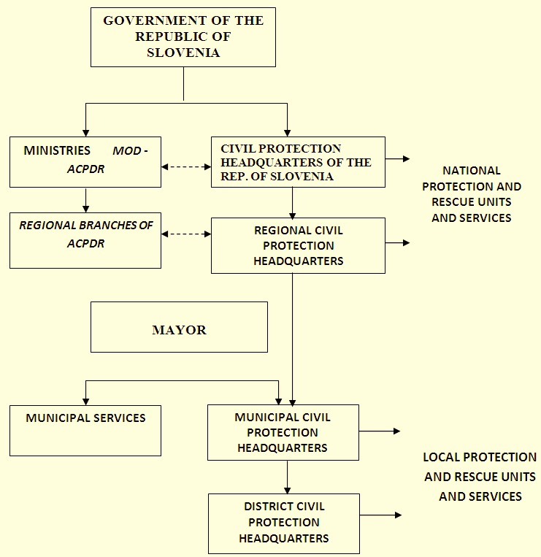
Council for Protection Against Natural and Other Disasters
(2014)
Figure 43: Organisational chart of the Slovenia’s disaster management system.
Within this architecture, the lines of command, control and reporting have been organised the following way:
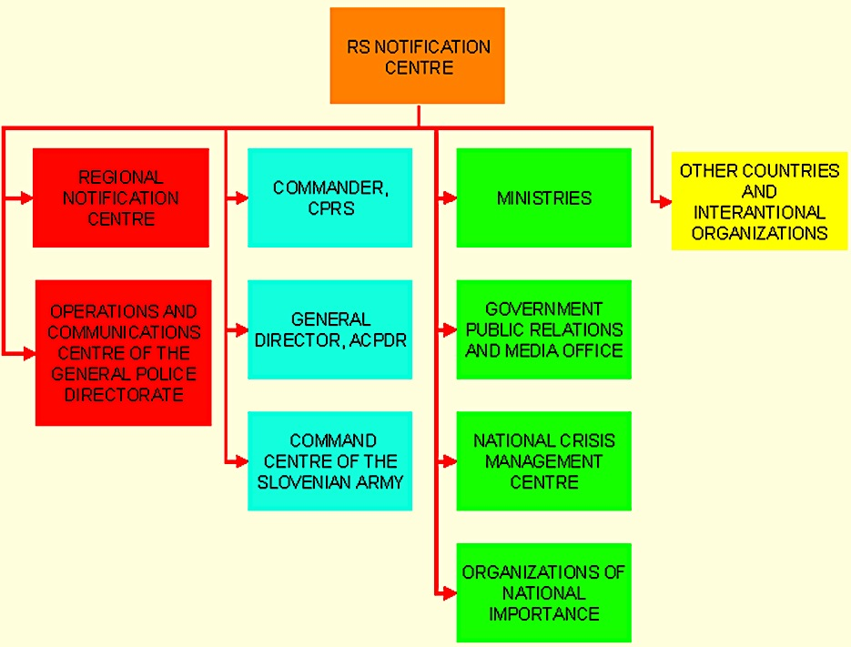
Figure 44: Lines of communication.
According to the Slovenian National progress report on the implementation of the Hyogo Framework for Action (2013-2015), the Government has established a Council of the Government of the Republic of Slovenia for Protection Against Natural and Other Disasters. The new body (since 24th July 2014) has been founded as an advisory body to the Government on protection against natural and other disasters. The Council shall function as a National Platform for Disaster Risk Reduction.
As a permanent co-ordinating body at national level, the Administration of the Republic of Slovenia for Civil Protection and Disaster Relief (ACPDR) is charged with the following administrative and technical duties:
- “Elaboration of proposals of research and development projects relating to the protection against natural and other disasters;
- Elaboration of the proposal of the national programme and plan of protection against natural and other disasters;
- Providing for the organization and operation of the monitoring, notification and warning system;
- Elaboration of threat assessments and other technical documents for the planning of protection, rescue and relief and directing and coordinating of measures for the prevention and mitigation of consequences of natural and other disasters;
- Monitoring and announcing of danger of natural and other disasters and giving instructions for handling;
- Elaboration of national emergency response plans in co-operation with ministries and governmental services;
- Organisation, equipment and training of national Civil Protection units and services and other protection, rescue and relief forces and provision of conditions for the work of the commander, the Headquarters of the Civil Protection of the Republic of Slovenia and the national and regional damage assessment committee;
- Monitoring and co-ordination of the organisation of the Civil Protection and other protection, rescue and relief forces;
- Elaboration of programmes as well as organization and delivery of education and training for protection, rescue and relief;
- Creation and maintenance of national material reserves for the case of natural and other disasters.”

ACPDR is divided into six units and is based in Ljubljana:
- Office for Prevention and Operations:
  - Sector for monitoring and alarming, including National Notification Centre;
  - Sector for Planning, Operations and Damage Assessments;
  - Sector for Fire Prevention, Protection and Fire-fighting;
- Office for Education and Training:
  - Sector for Education and training;
  - National Training Centre for Civil Protection and Disaster Relief and Fire-fighting school;
- Sector for Information and Communication;
- Department for General Affairs;
- Department for International co-operation and EU affairs.
According to the ACPDR web site, the unit has subordinated “…13 other ACPDR-branches operating throughout Slovenia. Within each branch, there is a regional notification centre that performs a 24-hour duty service. Altogether, 300 people are employed at the ACPDR branches and notification centres.”
Protection, rescue and relief forces at various levels (municipal, regional and national) are professional and volunteer and include also Civil Protection and certain companies, institutions and other organisations, which are, given the nature of their activities involved in this system:
- The volunteer forces are the volunteer fire brigade, Red Cross, Slovenian Caritas, divers, dog-handler units, girl and boy scouts, scouts, amateur, broadcasters, Mountain Rescue Service, Cave Rescue Service and others.
- Professional emergency services include professional fire-fighters, public health services, public social welfare services, public veterinary services, environmental laboratory, mine rescue units, emergency rescue for disasters connected to corrosive substances, mobile meteorological unit, public utilities, regional and government public services and contract organisation.
- Civil protection is organised as a specific and deliberate part of protection and relief system and includes first aid teams, units for veterinary first aid, technical rescue units, units for radiological, chemical and biological defence, services for maintenance and usage of shelters, unit for protection against unexploded ordnance, unit for triggering avalanches, rescue unit for rapid intervention and support services.
Duty bound units and services for the protection, rescue and relief operations are organised on the basis of civic duty (units and departments of Civil Protection service). According to the Regulation on Organising, Equipping, and Training Forces for Protection, Rescue and Aid the following structure has been established:
- Units for first aid;
- Units for the first veterinary assistance;
- Technical rescue units;
- Units for radiological, chemical and biological (RCB) protection;
- Units for protection against unexploded ordnance;
- Units for use shelters;
- Service triggering avalanches;
- Support Services;
- Civil Protection commanders and their deputies and staffs of the Civil Protection;
- Commissioners for Civil Protection and their deputies;
- Information centres;
- Logistics centres;
- Other units and departments.
Civil Protection itself is organised at the national level, regions, municipalities, institutions and commercial companies. At the state level, the Headquarters of the Civil Protection of the Republic of Slovenia and the National Unit for Rapid Intervention (in Slovenian – EHI) have been established. The latter is designed to perform specific difficult tasks in the field of protection and rescue in Slovenia and for providing international assistance to other countries in need. At the level of municipalities, staffs, units and departments of Civil Protection are organised differently. The structure depends on dominant regional threats, protection and rescue plans and the number of members of professional and volunteer units.
The Police and Slovenian Armed Forces are seen as “the last resorts” for natural and other non-violent disasters. According to the Law, the Police participate in the tasks of protection, rescue and relief in accordance with the law, particularly in providing security, public order, public peace and cooperation in rescue operations by helicopters and other forces.
Slovenian Armed Forces participate in the tasks of protection, rescue and relief in accordance with the law, their structure, equipment and ability. In carrying out the tasks aviation units, units for nuclear, chemical and biological defence, engineering units, medical service and other units (if they are not engaged in carrying out defence duties) are involved. The table below illustrates the use of military helicopters for search and rescue operations and other civil protection in 2013-14:

Table 29. Use of Slovenian Armed Forces helicopters for search and assistance in 2013-14.
Number of Rescue Operations/ Injured Persons and Total Flying Hours | 2013 | 2014 | Change index
Mountain Rescue | 85 | 88 | 104
Helicopter Emergency Medical Assistance | 56 | 76 | 136
Wildfires and Disasters | 14 | 25 | 179
Total Number of Rescue Operations | 155 | 189 | 122
Total Number of Helicopter Flying Hours | 257 | 270 | 105
Total Number of Injured Persons | 145 | 176 | 121

Organisational co-operation
At the international level, in Slovenia, the importance of cross-border cooperation is considered in the five-year National Programme as the highest policy and planning document for disaster management, and defined in the main legislative act – the Law on Protection against Natural and other Disasters.
According to an official report, “Joint bilateral committees and sub-committees for cooperation between Slovenia and neighbouring countries have been established, such as joint committees led by director-generals of the competent national organisations and experts” sub-committees (i.e. for the prevention and preparedness of forest fires; early warning and notification, including the emergency call number 112; emergency response plans for joint risks at bordering regions; education and training).” Joint project teams have been established as well.
The principal areas of international organisational co-operation include:
- Early warning and notification on emergencies;
- Information exchange on hazards and emerging threats;
- Sharing of knowledge and experience;
- Joint education, training and exercises;
- Mutual assistance in case of disasters;
- Co-operation in international disaster response interventions;
- Co-operation within EU and NATO, and others.
According to the Slovenian National progress report on the implementation of the Hyogo Framework for Action (2013-2015), bilateral agreements have been signed with the neighbouring Austria, Croatia, Hungary, and Italy, as well as with Bosnia and Herzegovina, Czech Republic, Germany, Montenegro, Poland, Slovak Republic, Russian Federation. In addition, intensive bilateral co-operation, particularly in the field of education and training, is ongoing with France, Sweden and the United States of America.
Standard operating procedures with Croatia to assist the aircraft on fire in an open space that defines the mutual exchange of information on hazards and fires in the border area has been signed in 2013.
An agreement is negotiated with Serbia. Co-operation has been arranged also with Albania and Kosovo.
Slovenia is also very active in the regional DPPI SEE and, together with Croatia, led the Disaster Management Training Programme, in which more than thousand participants from South-Eastern Europe have been educated and trained in disaster management.
The Administration of the Republic of Slovenia for Civil Protection and Disaster Relief is responsible for developing projects and research activities in support of the civil protection system improvement. It delivers a special emphasis on building capacity for mutual reinforcement at both horizontal (interagency) and vertical (state-regions-municipalities) operational levels.
The Administration is also co-ordinating and implementing the international co-operation activities of Slovenia in disaster management with neighbouring and other countries, as well as with regional initiatives, international organisations and the EU. It provides and co-ordinates rescue assistance in the event of major disasters abroad.
According to the 2014 Annual report of the Ministry of Defence, the international engagement of the Slovenia civil protection capabilities is the following:
At the end of May and beginning of June 2014, in accordance with the decision of the Slovenian Government, the SAF took part in rescue and assistance operations abroad (Bosnia and Herzegovina and Serbia) organizing and carrying out the transport of humanitarian aid and helicopter emergency response operations in flooded areas. Six convoys for the transport of humanitarian and other assistance to the affected areas were organised, with 110 vehicles transporting 705 tons of cargo. A SAF company with 120 members, who participated in the EUFOR joint military exercise in Bosnia and Herzegovina during the operations for the mitigation of flood consequences, were actively involved in those operations in June. Company members removed debris, disinfected public areas and facilities (nurseries, primary and secondary schools, health centres, municipalities) and analysed water and soil.

Procedures

Standing Operating Procedures (SOPs) and Guidelines
The principal source of standing operating procedures (SOPs) is the Ministry of Defence of Slovenia as disaster management is under its supervision.
SOP for fire-fighting has been developed in 2011 when a document, “Operativni Taktični Postopki” (Tactical Operational Procedures) was adopted. It is about 13 professional fire departments, 1299 active volunteer fire fighting societies and 68 volunteer industrial fire-fighting societies. They are linked in 120 local and regional fire-fighting associations, which are all covered by the umbrella organisation, the Fire Fighting Association of Slovenia. Every fire department has operational units, which are classified into a range of categories according to the risks of fire in concrete areas.
SOP for nuclear, radiological, chemical, and biological protection (Standardni operativni postopek (SOP) za jedrsko, radiološko, kemično, biološko (JRKB) zaščito) was adopted in 2007.
Under the umbrella agreement between the governments of Slovenia and Croatia on cooperation in protection against natural or civil disaster, signed in 1997, standard operating procedure for the Administration of the Republic of Slovenia for Civil Protection and Disaster Relief and National Protection and Rescue Directorate of the Republic of Croatia was introduced in 2014. SOP is about providing assistance with aircraft in cases of fires in open space. The document guides information sharing and co-operation procedures for providing cross-border assistance with specialised aircraft. It is aimed to allow faster and more co-ordinated response to potential fires, especially in the border area.
Other forms of SOPs are the plans for emergency response that are developed at the state level and for each region. (See Chapter 4.2)
SOPs are provided also through officially issued by the Administration for Civil Protection and Disaster Relief instructions for citizens:
- Emergency food supply;
- Measures to take in the event of an earthquake;
- Measures to take in the event of a flood;
- Measures to take in the event of heavy snowfall;
- Protection against avalanches;
- Protection against lightning;
- Measures to take in the event of a fire in the natural environment;
- Measures to take in the event of a fire in a building;
- Measures to take in the event of the use of chemical weapons;
- Measures in the event of an accident involving chlorine;
- Protection against radiation;
- Measures to take in the event of the outbreak of a communicable disease;
- Measures to take in the event of an airstrike;
- How to prepare and use a shelter/refuge;
- Measures to take if you encounter unexploded ordnance;
- First psychological aid;
- Giving first aid;
- How to ensure healthy drinking water.
SOPs have been tested by both national and international exercises and through international exchange in forms of seminars and conferences.

Operations planning
According to the Hyogo, 2005, “Protection and rescue plans are drawn up by state bodies, local communities, commercial companies and other organisations. The plans are drawn up in accordance with the Decree on Content and Drawing up of the Plans for Protection and Rescue.” The relevant responsible bodies must adopt the plans – the Government adopts national protection and rescue plans, and local community plans – by mayors. The adopted protection and rescue plans have to be made public, particularly to threatened people and to other publics with a vested interest.
Protection and rescue measures must be drawn up for each individual type of disaster. The plans should define:
- Individual type of disaster for which plan is elaborated;
- Extent of planning;
- Concept of protection, rescue and disaster relief for the disaster for which plan was elaborated;
- Management and leading;
- Measures and tasks of protection, rescue and relief;
- Personal and mutual protection;
- Explanation of terms and abbreviations;
- Necessary forces and means and resources available;
- Organisation and implementation of monitoring, warning and alarming;
- Mobilisation of forces and resources.
Supplements and attachments to the plan are:
- Plans of activities of executors of the protection and rescue;
- Database needed for implementation of the plan;
- Programme of qualification, training and exercises;
- Instruction for maintenance and distribution of protection and rescue plan.
The national protection and rescue plans are drawn up by the Administration of the Republic of Slovenia for Civil Protection and Disaster Relief in co-operation with the ministries and other national bodies. On the national level, protection and rescue plans for the potential large-scale disasters are drawn up that could affect several communities or regions. The following plans have been prepared:
- Emergency Response Plan in the event of Aircraft Accident;
- Emergency Response Plan in the event of an Earthquake in the Republic of Slovenia;
- Emergency Response Plan in the event of Floods;
- Nuclear Emergency Response;
- Emergency Response Plan in the event of Railway Accident;
- Emergency Response Plan in the event of Accidents at Sea;
- Emergency Response Plan in the event of Terrorist use of Weapons or Means of mass Destruction and/or in the event of Terrorist Attack with Conventional Means;
- Protection and Rescue Plan in a case of multiplicative appearance of contagious disease at animals;
- Military Aggression Protection and Rescue Plan.
Plans are drawn up based on the following information:
- Risk assessments;
- Analysis of vulnerability;
- Studies.
The planning scheme by different entities reflects the levels of the civil protection system (Table 7).

Table 30. Levels of disaster management planning.
Threat, disaster | Company | Municipality (local) | Urban municipality (region) | State (national)
Earthquakes | - | X | X | X
Floods | - | X | X | X
Heavy snow | - | X | X | X
Fires | X | X | - | -
Landslides and avalanches | - | X | X | -
Nuclear accidents | X | X | X | X
Accidents, involving hazardous substances | X | X | X | X
Air crashes | X | - | X | X
Railway accidents | X | X | X | -
Tunnel accidents | - | X | X | -
Cable-car accidents | X | - | - | -
Mining accidents | X | - | - | -
Contagious disease at animals | X | X | X | X
War | - | X | X | X

Logistics support in crises
The Slovenian authorities see logistics as one of the emergency management systems along with monitoring, information, and communication systems. It is determined by the Law on Protection Against Natural and Other Disasters and has been established through the mechanism of the National Programme of Protection Against Natural and Other Disasters (Art. 41).
The Law prescribes eventual military logistic support from the Slovenian Armed Forces under the following conditions: “Where the available forces and resources are insufficient in order to carry out the necessary rescue and relief operations, armed forces and defence resources may be deployed, provided that such armed forces are not indispensable for defence operations.” (Art. 14)
Administration of the Republic of Slovenia for Civil Protection and Disaster Relief is responsible for the organisation and equipping of national civil protection units and services, provision of guidelines for the development and readiness of all public rescue services within national jurisdiction and co-funding of fire-fighting units that are of great importance for society and other organizations and societies. Under its command, the National Logistic Centre is dedicated to creating and maintain relevant as quantity and specifications national reserves of material assets for protection, rescue and relief purposes.
The Slovenian Armed Forces include a Logistics Brigade (deployed in the town of Kranj), which is able to provide logistics support in case of any type of natural or man-made disaster. It includes two logistics regiments and a Military Medical Unit. Despite that the brigade itself is not deployable abroad, the Slovenian military is engaged in an active international co-operation with the US and other NATO forces on emergency logistics not only for wartime but also for delivery of humanitarian support abroad.

Crisis communication to general public; Alert system; Public Information and Warnings
The monitoring, notification and warning system is comprised of monitoring network, notification centres, computer support and telecommunications service and warning. The Administration for Civil Protection and Disaster Relief is the headquarters of the communications and information support.
The Slovenian national report and information on disaster reduction for the world conference on disaster reduction provides the following information about the country’s crisis communications:
A uniform (autonomous) system of operational radio communication (ZARE) and personal calls (pagers) is used in the administration of protection, rescue and relief operations. The ZARE is used by all rescue services. The communication centres of this system are located in regional information centres and are used to connect users to public and other telecommunication systems.
The ZARE radio communication system operates in the VHF range. There are 32 semi-duplex channels available for over 40 upper transmission layer repeaters and 36 simplex channels for direct connections. The pagers system consists of 40 upper layer transmitters and 50 lower layer transmitters. The ZARE system provides adequate protection against disturbance (sub-tone) and abuse (ID code). Plans for a gradual transition to a new beam radio communication system have been established.
Computer network and information support integrate all 13 regional notification centers and the Education, the Training Center, and the Administration for Civil Protection and Disaster Relief into one computer network. It serves the needs of the centers so they can ensure protection against natural and other disasters. For major connections, we use leased virtual transmission ways via the Internet, which allow for a smooth increase in transmission speed on an as needed basis. Information support is provided through tailor made computer applications in the regional notification centers, such as the Geographic Information System (GIS-Ujme), the sound alarm management and triggering system (DUNJA), the system for the acceptance of telephone calls (ROK), the radio traffic control system (KC08), the radio network control system (Nadzor ZARE) and the pager system (ZAPP). All the systems are linked into a uniform application used for the management of interventions (SPU112). There are also web applications available in the computer network, such as GIS and hazardous materials.
The emergency call number “112” has been used in Slovenia since the beginning of 1997. All citizens can use this number in an emergency or if they need a fire brigade, emergency first aid or aid from any other rescue services. In addition, by dialling this number, people can obtain other important information on weather, water, snow and other conditions, disturbances and interruptions in the supply of potable water and electrical and other energy sources and other areas of life importance. According to the Slovenian Ministry of Defence’s annual report for 2011, a StatKlic application was introduced in 2011 and the E-CALL upgrade should have been completed in 2012.

Capabilities

Human resources
Human resources for civil protection in Slovenia are managed under the Government’s Decree on the Organisation, Equipment and Training of Protection, Rescue and Relief Forces of 2007 (amended in 2009 and 2011) and the Decree on Service in Civil Protection (2008).
According to the Ministry of Defence, at the end of 2014, the Civil Protection had listed more than 40 000 members of the Protection, Rescue and Relief forces (PRR). Of them, there have been about 22 000 members of duty units and about 18 000 volunteers. National PRR forces have consisted of 840 professionals, 1 200 volunteers and more than 1 505 members of duty units.
Table 8 presents the numbers of personnel of the Headquarter of the Civil Protection of the Republic of Slovenia and the National Unit for Rapid Intervention at the state level (see also Chapter 3.1). Table 9 shows how the members of the Civil Protection are distributed through the regions.
However, the report states that due to budgetary constraints, the Administration for Civil Protection and Disaster Relief is far from providing the necessary highly qualified professional staff even for the most critical duties.
Protection, rescue and relief tasks are performed by volunteer and other nongovernmental organisations and their operational units in response to decisions made by the competent body at the local or national level if they meet the required personnel and material/technical conditions. These organisations include:

Table 31. State level Civil Protection personnel.
Structure |  | Number of personnel
Headquarter of the Civil Protection of the Republic of Slovenia |  | 21
National Unit for Rapid Intervention |  | 176
From them | Command | 7
 | Unit for Technical Rescue | 73
 | RCB Protection Unit | 23
 | Unit for First Medical Aid | 8
 | Unit for Technical Diving | 20
 | Unit for Supplying | 39
 | Section for Electricity | 4
 | Section for water | 2

Table 32. Civil Protection members by regions (2008).
Region | Number of contractors
Brežice | 115
Celje | 132
Koper | 102
Kranj | 117
Ljubljana | 120
Maribor | 121
Murska Sobota | 104
Nova Gorica | 124
Novo Mesto | 100
Postojna | 103
Ptuj | 100
Slovenj Gradec | 107
Trbovlje | 106

- Slovenian Fire-fighting Association: In all 212 municipalities of Slovenia there are public fire services. Fire service is obligatory local service with no headquarters on the national level. Local Fire-fighting Chief is responsible to the mayor for preparedness, management, command and control of the Fire service. The number of volunteers is approximately 113,000 members, 44,000 of them active. There are nearly 500 professional fire-fighters and another 300 professional fire-fighters that work in industrial enterprises. All fire brigades include a fire-fighting unit trained and equipped to extinguish fires and provide rescue services in the event of a fire or other disaster. The Fire brigades are linked together by municipal and regional fire-fighting associations, which together form the Slovenian Fire-fighting Association. The Slovenian Fire-fighting Association became a member of CTIF (International Technical Committee for the Prevention and Extinction of Fire) since 1992.
- Slovenian Red Cross (SRC): As a non-governmental, non-political non-profit humanitarian organisation, the Slovenian Red Cross is primarily responsible for the areas of health and social welfare. Its volunteers see to the implementation of social welfare, health education and first aid programmes, blood donation, investigation services, and assistance to high-risk groups within the population. The Law on the Slovenian Red Cross (Art. 9) authorises the Red Cross to perform the following tasks:
“- Tasks related to informing, recording and inquiring about the victims of armed conflict and persons afflicted in natural and other disasters;
- Organising the training of staff for the performance of tasks arising from the Geneva Conventions;
- Organising first-aid courses and examinations;
- Organising and trains first-aid units;
- Carries out campaigns for recruiting blood donors and organising blood drives;
- Issuing cards to donors of parts of the human body;
- Carries out measures for protecting the health of persons during natural and other disasters and in the event of armed conflict;
- Carries outs measures for the reception of evacuated and other endangered persons, measures which may contribute to the care afflicted persons.”
“SRC is composed out of 56 Local Branches, covering one to three local municipalities with the network spread over 887 local organisation, that are run by committed volunteers. Under the Slovenian Red Cross Association there is also a Slovenian Red Cross Youth and Health Resort Debeli rtič, based on the Slovenian Coast.” The Slovenian Red Cross is comprised of 800,000 volunteers and supporting members. It has been a member of the international Red Cross Movement since 1993 and is a member of the International Committee of the Red Cross and the International Federation of Red Cross and Red Crescent Societies.
- “Caritas Slovenia”: “Caritas Slovenia” is a charity institution of the Roman Catholic Church in Slovenia. Its activities are distributed among diocese and parish Caritas organisations. Its purpose is to perform charity and social welfare activities within the Slovenian Church and society, particularly related to response to the results of natural and other disasters both in Slovenia and throughout the world. Caritas of Slovenia is a member of both the international and European Caritas organisations. The organisation has about 9,000 volunteers.
- Slovenian Mountain Rescue Service: The Law on security against natural and other accidents has established the Slovenian Mountain Rescue Service as a public rescue service of national importance. It is organised in 17 stations that cover the entire Slovenian Alpine and Sub-Alpine regions. More than 660 volunteer mountain rescuers operate the stations. The Slovenian Mountain Rescue Service was formally recognised by the International Mountain Rescue Commission (IKAR) in 1992, although the Slovenian Mountain Rescue Service has co-operated actively with this Commission and was the representative of all Yugoslav mountain rescuers from 1955 on.
- Slovenian Cave Rescue Service: The Act on the Protection against Natural and other Disasters has established the Slovenian Cave Rescue Service as a public rescue service at the national level. It is organised into seven rescue centers - Ljubljana, Postojna, Sežana, Tolmin, Kranj, Velenje and Novo mesto where 55 cave rescuers serve on contract basis. The organisation is a member of the International Speleological Association – Cave Protection Commission (UIS) since 1993.
- The Slovenian Canine Association and the Slovenian Federation of Associations of Rescue Dog Handlers: In Slovenia, there are 62 sport and 18 hunting canine associations, with a total of 7,500 members. These associations are linked to the Slovenian Canine Association and the Slovenian Federation of Associations of Rescue Dog Handlers. More than 150 rescue dog handlers, members of canine associations, are involved in rescues from rubble and landslides. The Slovenian Canine Association was accepted into the International Canine Federation (FCI) in 1992. The Slovenian Federation of Associations of Rescue Dog Handlers became a member of the International Rescue Dogs Organisation (IRO) in 1995.
- Slovenian Federation of Divers: There are 21 associations with 1,200 volunteer divers, of whom 62 are instructors and 27 specialist physicians. The associations and their federation have jointly organised an underwater rescue service, intended to provide rescue services from and on a water. More than 90 volunteer divers are involved in underwater rescue activities. The Slovenian Federation of Divers became a member of the World Underwater Association (CMAS) in 1993.
- Slovenian Scout Association and the Slovenian Catholic Girl Guides and Boy Scouts Association: Scouts are organised in branches and other organisational forms of camping and Scouting associations, and are linked to the Slovenian Scout Association and the Slovenian Association of Catholic Scouts. All together, they include 12,000 Scouts. Through their activities, scouts systematically develop their level of preparedness to help people in the event of natural and other disasters. Their primary task is to set up tents and other temporary shelters for people who are left without safe accommodation in the event of a disaster. Slovenian Scout Association was accepted into the World Organisation of Scouting Movements (WOSM) in 1994.
- Association of Slovenia Radio-Amateurs: In Slovenia, there are 90 amateur radio-operator clubs with a membership of more than 7,000 volunteer amateur radio operators. Amateur radio operators can provide supplementary radio communications systems in municipalities for protection and rescue needs in the event of a mass disaster. They can also participate in providing information to the international public of the consequences of the disaster and the aid needed. The Association of Slovenian Radio-Amateurs became a member of the International Amateur Radio Union (IARU) in 1992.”

Materiel (non-financial) resources
Material resources for civil protection and disaster relief are provided under the Decree on Minimum Personal and Collective Protection Resources and Equipment in the Event of Natural and Other Disasters and War of 1992. Head manager of the material reserves is the Administration of the Republic of Slovenia for Civil Protection and Disaster Relief. In the last decade, the Administration systematically enhanced the national commodity reserves, which according to the Law on Protection Against Natural and Other Disasters, are provided through the Institute for Commodity Reserves. Those resources are stored in the National Logistics Centre in Roje in Ljubljana and in the warehouse of commodity reserves in Zalog. In the National Logistics Center in Roje the following equipment has been accumulated as state commodity reserve: readers, dosimeters, special suits, safety masks, safety, respirators, gloves, special protective boots, water containers, decontamination means and equipment, etc.
According to the Law on Protection Against Natural and Other Disasters available defence resources might be used to carry out the necessary rescue and relief operations if the civilian resources are insufficient and the military are not indispensable for defence operations (Art. 14). Article 85 of the Law regulates the special powers, mandated to the Civil Protection commanders in cases of emergencies. It states (between others) that in the course of protection, rescue and relief the Civil Protection commander or incident commander shall have the right to order that:
- “… private means of transport be made available and used for the transportation of injured persons or required means of protection, rescue and relief;”
- “private premises be used for the purposes of protection, rescue and relief;”
- “premises be used as a temporary storage site for debris, soil and other material produced during the performance of protection, rescue and relief duties aimed at provision of basic living conditions;”
- “buildings be demolished or trees be cut.”
Such measures “…may only be ordered, where no other measures can ensure the protection of people and property and the performance of protection, rescue and relief, and shall apply no longer than absolutely necessary.”
The responsibility of the Civil Protection commander for using private and corporate assets is regulated by paragraph 5 of the same Article in the following way:
Normally, records shall be kept of decisions made by a Civil Protection commander or incident commander. For decisions with bigger financial implications, written orders shall be issued. Circumstances permitting, the written order shall be issued as soon as possible. In urgent cases Civil Protection commander or incident commander shall have the right to order owners or users of residential and other accommodation facilities that they provide temporary shelter and care for threatened persons until a decision has been made by the Mayor.

Training
Education and training on behaviour in cases of different emergencies is a national priority as a core component of disaster preparedness and nation’s resilience. It well regulated by the Law on Protection Against Natural and Other Disasters where a special Chapter (XIII) with six articles is dedicated to education and training. The elements of organising education and training are presented in Table 10.
According to the web site of the Administration for Civil Protection and Disaster Relief, the main training institution is the Centre for Civil Protection and Disaster Relief of the Republic of Slovenia. “The Training Centre is responsible for the development and evaluation of training programmes and prepares training materials” for Civil Protection members, members of units, services and other operational systems of associations and other non-governmental organizations, commercial companies, institutions and other organisations. It also organises training forms within international organisations, mostly NATO, EU, UN and in a regional format. “It provides professional publishing support for the “Ujma” national magazine, which addresses issues of disaster management.” The Training Centre has a legal mandate to engage in testing of protection and rescue equipment.

Table 33. Education and training on protection against natural and other disasters.
Education  (As part of the educational process) |  | Training
Elementary schools | Basic knowledge about natural and other disasters and protection against them. | Training of the citizens for personal and mutual protection | Training and preparation on personal and mutual protection and implementation of the required protective measures is a legal duty of citizens;  Training of residents on personal and mutual protection and on implementation of the required protection measures is conducted as an optional form of training, particularly through educational radio and television broadcasts, news and educational materials received at home, public presentation of plans for protection and rescue, and monitoring of practical exercises.  This training is organised by the competent national authorities and municipalities in accordance with the threat of the environment.
Secondary and university education | Knowledge on protection against natural and other disasters in accordance with educational objectives and learning content of the programmes. | Training of volunteers in rescue services | - Training of volunteers in the fire brigade, mountain rescue service, cave rescue service, underwater rescue and other services is organized and conducted by voluntary organizations that organize this services.  This training is conducted with accordance to the programs, prescribed by the Minister of defence.
 |  | Training of Civil Protection (CP) units | - Training of the CP comprises introductory, basic and advanced training. Introductory and basic training should not exceed 15 days, while advanced must not last more than five days (usually in non-working days).  - Advanced training is done through practice as well as examination of the participants” skills.  - Training is conducted in accordance to the programs, prescribed by the Minister of defence.

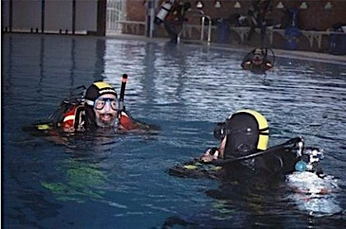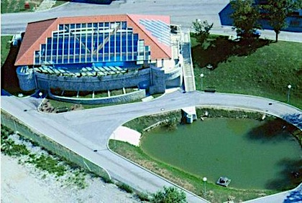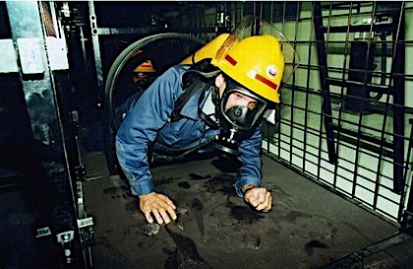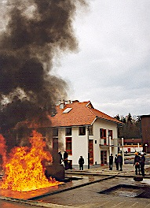
Figure 45. Pictures from training polygons at the Centre for Civil Protection and Disaster Relief of the Republic of Slovenia.

Procurement

Procurement regulation
Slovenia’s public procurement policy has been progressively harmonised with both EU directives and World Trade Organisation Government Agreement (GPA) since 2000. Recently, public procurement in Slovenia is regulated by the following legislation:
- The Public Procurement Act which lays down the procedures for the procurement of goods, services and works, which must be obeyed by public procurement authorities and providers, who submit a bid.
- The Public Procurement in the Water, Energy, Transport and Postal Services Sector Act covering procedures for public purchasing in the water, energy, transport and postal services sector, and
- The Review of the Public Procurement Procedures Act which lays down the laws and other regulations relating to procedures concerning the award of public contracts and the means of implementing EU legislation.
Applied to all state institutions and local administration, public undertaking and utilities, including those related to protection against natural and other disasters, “… the Public Procurement Act has increased protection for bidders, unified all procedural requirements and eliminated the 10% preference for domestic bidders. The Act established an independent body, the National Review Commission (NRC) whose members are appointed by Parliament to ensure their independence.”
According to the Law on Protection Against Natural and Other Disasters (Art. 102) for the aims of providing protection, rescue and relief the Administration for Civil Protection and Disaster Relief has the right to provide the affected population with relief resources, specific protection and rescue equipment and tools free of charge. It also permitted by that Law, selected protection and rescue equipment and tools to be reassigned free of charge to units, services and operational structures. However, for any free of charge delivery the Government or the Minister of Defence and other ministers should take a decision.

Procurement procedures
The legislation on public procurement in Slovenia provides several options for the contracting authorities to open up a public procurement using one of the following procedures:
- Open procedure;
- Procedure with prior verification of eligibility (qualitative selection);
- Competitive dialogue;
- Negotiated procedure without publication of a contract notice;
- Negotiated procedure with prior publication of a contract notice;
- Procedure for collecting bids after prior call for competition;
- Procedure for collecting bids.
According to the legislation, any contracting authority must send notification of an intended procurement to the Office of the Official Publications of the European Communities, which will publish it, and to the Public Procurement Portal, if a procurement without VAT amounts to the following values:
- EUR 133,000 for procurement in goods and services, if the contracting authorities are State authorities or local councils,
- EUR 206,000 if goods and services are purchased by another contracting authority,
- EUR 5,150,000 for public procurement in construction works.
- For public procurement in the water, energy, transport and postal services sector the threshold amount for goods and services is EUR 412,000 and for construction works EUR 5,150,000.
However, the thresholds are different for each procedure, and for each type of public procurement, in particularly in the field of defence. Detailed provisions are laid down in the Public Procurement Act and in the Decision on the publication of thresholds for public procurement procedures.
This Act also created a single central administration for public procurement – Public Procurement Office. It is in charge for implementation of all kind of procurement procedures, provides analyses of the procurement situation in the country and abroad and co-operates with EU, WTO and other international governmental organisations as well as with the NRC.
Slovenia has a completely developed and fully operational single information portal on public procurement managed by the Ministry of Finance. The state and local authorities are obliged by the Law to publish on that portal all public tenders- related information. The portal provides standardised web application and variety of administrative elements in electronic format as receipt-and-delivery system application, e-payments, e-serving, e-signature, e-awarding of contracts and e-auction. According to web-based information, on the procurement portal have to be published announcements for:
- Procurement of goods and services by Public Procurement Act subject, with a value equal to or greater than EUR 20,000;
- Works contracts awarded by Public Procurement Act subject, with a value equal to or greater than € 40,000;
- Procurement of goods and services by Public Procurement in the Water, Energy, Transport and Postal Services Sector Act subjects, whose value is equal to or greater than € 40,000;
- Works contracts awarded by Public Procurement in the Water, Energy, Transport and Postal Services Sector Act subjects, whose value is equal to or greater than € 80,000.
Announcements should include:
- Prior information notice or periodic indicative notice
- Contract notice small value,
- Contract award notice small value,
- Notice of contract by tendering procedure with prior publication,
- Notice of award of the contract by tendering procedure with prior publication,
- Contract notice,
- Contract award notice,
- Notice of competition,
- Results of the competition,
- Voluntary ex-ante transparency notice,
- Simplified contract notice on a dynamic purchasing system
- Notice of the system of qualification
- Notice of award of individual contracts based on framework agreement
- Notice for additional information, information on incomplete procedure or corrigendum.
In terms of exception from the general public procurement regulations, the Law on Protection Against Natural and Other Disasters (Art. 85, paragraphs 4 - 6) provides a Civil Protection commander or incident commander with the right to order urgent construction, technical and other works to commercial companies, institutions or other organisations with which the national or local authority has signed a contract on the performance of specific operational protection and rescue duties. In the absence of such entities, a Civil Protection commander or incident commander might order that private or legal subjects, who have adequate equipment or capabilities, perform these duties. The order shall be written, or if the circumstances do not allow, in exceptional circumstances, oral. In this case, a written order shall be issued as soon as possible. The order shall determine the type and scope of work that needs to be done. For decisions with bigger financial implications, written orders shall be issued.

Niche capabilities
The Slovenian civil protection system has specifics that make it different from the European experience, but they reflect the country’s realities and traditions. There are several principal areas of excellence that may be used within EU context and format:
- Slovenia has a well-established disaster management planning process for the nine separate hazards, based on scenarios. Especially advanced is the emergency response plan covering disasters.
- Public engagement on a regular basis in the disaster preparedness and response is a national tradition and value. Legal acts, guides and instructions support the specific focus on both individual capacities and collective assistance.
- Education and training on behaviour in an emergency is life long and well managed. The European Emergency Number association has acknowledged the training in Slovenia on the use of 112.
- The communication and information sharing and the alerting systems are at the highest European level of quality.
- Slovenia has well established and maintained capacity for mountain and cave rescue operations.

Resources

Legislative acts
Act amending the Act on the Protection against Natural and other Disasters. Official Gazette of the Republic of Slovenia No 28/06.
Act on the Protection against Natural and other Disasters. Official Gazette of the Republic of Slovenia No 64/94. Available at http://www.sos112.si/db/priloga/p4360.pdf.
Constitution. Official Gazette of the Republic of Slovenia Nos. 33/91-I, 42/97, 66/2000, 24/03, 69/04, 68/06, and 47/13. Available at http://www.us-rs.si/media/constitution.pdf.
Environment Protection Act. Official Gazette of the Republic of Slovenia No 41/04.
Fire Protection Act (official consolidated text). Available at www.sos112.si/db/priloga/p4361.pdf.
Material Obligation Act. Official Gazette of the Republic of Slovenia No 87/01, 08. 11. 2001, Spatial Planning Act (Zpnačrt), www.uradni-list.si/1/objava.jsp?urlid=200733&stevilka=1761.
Public Administration Act. Official Gazette of the Republic of Slovenia No 52/02.
Public Procurement Act (ZJN-2). Available at http://www.dkom.si/mma/-/2007100210195957/.
Removal of Consequences of Natural Disasters Act. Available at http://www.uradni-list.si/1/objava.jsp?urlid=200375&stevilka=3620.

Other normative acts
Decree on Fire Insurance Tax. Official Gazette of the Republic of Slovenia No 34/06.
Decree on Minimum Personal and Collective Protection Resources and Equipment in the Event of Natural and Other Disasters and War. Official Gazette of the Republic of Slovenia No 32/92.
Decree on Protection from Fire in a Natural Environment. Official Gazette of the Republic of Slovenia No 4/06.
Decree on Providing Protection, Rescue and Relief from Aircraft. Official Gazette of the Republic of Slovenia No 46/98.
Decree on Shelter Construction and Maintenance. Official Gazette of the Republic of Slovenia No 57/96.
Decree on the Organisation and Functioning of the Monitoring, Notification and Alarm System. Official Gazette of the Republic of Slovenia No 105/07.
Decree on the Organisation, Equipment and Training of Protection, Rescue and Relief Forces. Official Gazette of the Republic of Slovenia No 92/07, amended in 2009.
Regulation of Fire Order. Official Gazette of the Republic of Slovenia No 52/07.
Regulation on Fire Safety in Buildings. Official Gazette of the Republic of Slovenia No 31/04, amended in 2005 and 2007.
Regulation on Protection from EOD – Explosive Ordnance Disposal. Official Gazette of the Republic of Slovenia No 21/03.
Regulation on the Conditions, which must be met by Educational Institutions Providing Training in Protection Against Natural and Other Disasters. Official Gazette of the Republic of Slovenia Nos 16/96 and 31/97.
Regulation on the Methodology of Assessing Damage. Available at http://www.uradni-list.si/1/objava.jsp?urlid=200367&stevilka=3224.
Resolution on The National Programme of Protection Against Natural and Other Disasters 2009-2015, http://zakonodaja.gov.si/rpsi/r05/predpis_RESO65.html.

Official documents (white papers, strategies, etc.)
Administration of the Republic of Slovenia for Civil Protection and Disaster Relief, Ministry of Defence, National progress report on the implementation of the Hyogo Framework for Action (2013-2015). Available at http://www.preventionweb.net/files/41665_SVN_NationalHFAprogress_2013-15.pdf.
Annual Report 2013 on Radiation and Nuclear Safety in the Republic of Slovenia. Slovenian Nuclear Safety Administration. 2013. Available at http://www.ursjv.gov.si/fileadmin/ujv.gov.si/pageuploads/ si/Porocila/ LetnaPorocila/2013/LP_2013.pdf.
Annual Report 2014 on Radiation and Nuclear Safety in the Republic of Slovenia, Slovenian Nuclear Safety Administration. 2014. Available at http://www.ursjv.gov.si/fileadmin/ujv.gov.si/pageuploads/ si/Porocila/LetnaPorocila/2014/Annual_report.pdf.
Annual Report of the Ministry of Defence for 2011 (Ljubljana, 2012). Available at www.mo.gov.si/fileadmin/mo.gov.si/pageuploads/pdf/javne_objave/2013/AR_MOD_2011.pdf.
Annual Report of the Ministry of Defence for 2014 (Ljubljana, 2015). Available at http://www.mo.gov.si/fileadmin/mo.gov.si/pageuploads/pdf/ministrstvo/annual_report_2014.pdf.
Doctrine on Protection, Rescue and Relief. Government of the Republic of Slovenia, 2002. Available at http://www.sos112.si/db/priloga/p4359.pdf.
Operativni Taktični Postopki, Ministry of Defence (2011). Available at www.gasilec.net/modules/ simplemod/datoteke/0-Operativno%20takticni%20postopki/RRN%20OTP.pdf.
Republic of Slovenia National Report and Information on Disaster Reduction for the World Conference on Disaster Reduction (Kobe-Hyogo, Japan, 18-22 January 2005). Available at http://www.unisdr.org/2005/mdgs-drr/national-reports/Slovenia-report.pdf.
Resolution on the National Security Strategy of the Republic of Slovenia. Ministry of Defence, Ljubljana, 2010. Available at http://www.mo.gov.si/fileadmin/mo.gov.si/pageuploads/pdf/ ministrstvo/RSNV2010_slo_en.pdf.
Standardni operativni postopek (SOP) za jedrsko, radiološko, kemično, biološko (JRKB) zaščito, Ministry of Defence, 2007.

Online resources (e.g. websites of key CM organizations)
Administration of the Republic of Slovenia for Civil Protection and Disaster Relief (ACPDR), http://www.sos112.si/eng/.
Agency for Radwaste Management (ARAO), http://www.arao.si/resolutions.
Agency of the Republic of Slovenia for Agricultural Markets and Rural Development, www.arsktrp.gov.si/en.
Anton Melik Geographical Institute (Scientific Research Centre of the Slovenian Academy of Sciences and Arts), http://giam.zrc-sazu.si/?q=en.
Building and Civil Engineering Institute (ZRMK Institute), Department of Geotechnical Engineering and Geology, http://www.gi-zrmk.si/CZGG/Default.aspx.
EHO project, http://ehoprojekt.si/component/option,com_frontpage/Itemid,1/.
Elektro-Slovenija, d.o.o. (ELES), www.eles.si/en.
Faculty of Civil Engineering and Geodesy, www2.fgg.uni-lj.si/.
GeoInženiring, www.geo-inz.si.
Geological Survey of Slovenia, www.geo-zs.si/podrocje.aspx?langid=1033.
Institute for Water of the Republic of Slovenia, www.izvrs.si.
Ministry of Defence, http://www.vlada.si/en/.
Ministry of the Environment and Spatial Planning, www.mop.gov.si/en.
Public procurement portal, http://www.enarocanje.si/default.asp?podrocje=portal.
Slovenian Nuclear Safety Administration’s (SNSA), http://www.ursjv.gov.si/en/.

Publications
Adamic, Milan Orozen, “Earthquake Threat in Ljubljana.” Geografski zbornik, XXXV (1995): 46–112.
Gurenko, Eugene, Zakout, Wael Mitigating the Adverse Financial Effects of Natural Hazards on the Economies of South Eastern Europe. A Study of Disaster Risk Financing Options South Eastern Europe Disaster Risk Mitigation and Adaptation Programme. World Bank: February 2008. Available at http://siteresources.worldbank.org/FINANCIALSECTOR/Resources/Insurance Report_ISDR.pdf.
Jelušič, Ljubica “Slovenian Public Opinion on Security, Defence and Military Issues.“ In The Public Image of Security, Defence and the Military in Central and Eastern Europe, edited by Marija Vlahova. Belgrade: DCAF & CCMR, 2003.
Jeraj, Milena, Bilateral and regional cooperation in disaster management – good practices/experiences of Slovenia, 22nd OSCE Economic and Environmental Forum “Responding to environmental challenges with a view to promoting cooperation and security in the OSCE area,” Vienna, 27 - 28 January 2014. Available at www.osce.org/eea/110805.
Komac, Marko and Ribicic Mihael, “Landslide susceptibility map of Slovenia at scale 1 : 250,000.” Geologija 49, no. 2 (2006): 295–309.
Mesko, Gorazd, Dimitrievic, Dejana and Fields, Charles, Understanding and Managing Threats to the Environment in South Eastern Europe. Dordrecht: Springer, 2010
National progress report on the implementation of the Hyogo Framework for Action (2011-2013) available at http://www.preventionweb.net/files/ 31307_svn_NationalHFAprogress_2011-13.pdf
National Report and Information on Disaster Reduction, World Conference On Disaster Reduction (Kobe-HYOGO, Japan, 18-22 January 2005), available at http://www.unisdr.org/2005/mdgs-drr/national-reports/Slovenia-report.pdf
OECD Economic Surveys: Slovenia 2009. OECD ISBN 978-64-03078-7
Peternel, Tina, Mateja Jemec Auflič , Mitja Janža, Matjaž Mikoš and Jože Papež, Benchmark report on common procedures in hazard/risk assessment and mapping for Slovenia. A 2014 deliverable from WP4 Project “State-of-the-Art in Risk Management Technology: Implementation and Trial for Usability in Engineering Practice and Policy.” Available at http://www.researchgate.net/publication/272153281_Benchmark_report_on_common_procedures_in_hazardrisk_assessment_and_mapping_for_Slovenia
Šinigoj Jasna, Podboj Martin, Komac Marko, Požar Mitja, Krivic Matija, and Jemec-Auflic Mateja, “Susceptibility map of triggering landslides due to rainfall forecast as a part of innovative inspire compliant cloud based infrastructure – InGeoCloudS.” Geophysical Research Abstracts 16 (2014), EGU2014-15980.
UNISDIR, World Bank and others The Structure, Role and Mandate of Civil Protection in Disaster Risk Reduction for South Eastern Europe. (2008). Available at www.unisdr.org/files/ 9346_Europe.pdf.

For example see Doctrine on Protection, Rescue and Relief. Government of the Republic of Slovenia, 2002, http://www.sos112.si/db/priloga/p4359.pdf.
For example see Republic of Slovenia National Report and Information on Disaster Reduction for the World Conference on Disaster Reduction, Kobe-Hyogo, Japan, 18-22 January 2005, available at http://www.unisdr.org/2005/mdgs-drr/national-reports/Slovenia-report.pdf.
Web site of the Administration of the Republic of Slovenia for Civil Protection and Disaster Relief www.sos112.si/eng/.
GHK, Strategic Evaluation of Environment and Risk Prevention under Structural and Cohesion funds for the period 2007-2013. National Evaluation Report for Slovenia. Executive Summary (Brussels: Directorate General Regional Policy, 2006).
Gerhard Kummel, Giuseppe Caforio and Christopher Dandeker (eds.), Armed Forces, Soldiers and Civil-Military Relations (Wiesbaden: VS Verlag fur Sozialwissenschaften , 2009), p. 137.
Resolution of the National Security Strategy of Slovenia, Ljubljana, 2010, http://www.mo.gov.si/fileadmin/ mo.gov.si/pageuploads/pdf/ministrstvo/RSNV2010_slo_en.pdf.
Ljubica Jelušič, “Slovenian Public Opinion on Security, Defence and Military Issues,” in The Public Image of Security, Defence and the Military in Central and Eastern Europe, edited by Marija Vlahova (Belgrade: DCAF & CCMR, 2003).
Romana Slabe (MoD – ACPDR), Presentation at an international roundtable in Sofia, 2009.
Administration of the Republic of Slovenia for Civil Protection and Disaster Relief, Ministry of Defence, National progress report on the implementation of the Hyogo Framework for Action (2013-2015) (PreventionWeb, 2015), p. 2. Available at http://www.preventionweb.net/files/41665_SVN_ NationalHFAprogress_2013-15.pdf.
Ibid, p. 13.
National Security Strategy of the Republic of Slovenia (2010), Art. 4.3.2.
Doctrine on Protection, Rescue and Relief.
International Disasters Database at the Centre for Research of the Epidemiology of Disasters (CRED), available at http://www.emdat.be/database.
Ministry of Defence, Annual Report for 2014. http://www.mo.gov.si/fileadmin/mo.gov.si/pageuploads/pdf/ ministrstvo/annual_report_2014.pdf.
Preventionweb, http://www.preventionweb.net/english/countries/statistics/?cid=157.
Data are relevant from 1991 (the independence of Slovenia) to January 2014.
Peternel, Tina, Mateja Jemec Auflič , Mitja Janža, Matjaž Mikoš and Jože Papež, Benchmark report on common procedures in hazard/risk assessment and mapping for Slovenia. A 2014 deliverable from WP4 Project “State-of-the-Art in Risk Management Technology: Implementation and Trial for Usability in Engineering Practice and Policy,” www.researchgate.net/publication/272153281_Benchmark_ report_on_common_procedures_in_hazardrisk_assessment_and_mapping_for_Slovenia.
ACPDR, “Damage assessment and usability of earthquake damaged building,” http://www.protezionecivile.gov.it/cms/attach/editor/Slovenia_damage_assessment.pdf.
Slovenian Environment Agency.
Milan Orozen Adamic, “Earthquake Threat in Ljubljana,” Geografski zbornik 35 (1995): 46–112.
Administration of the Republic of Slovenia for Geophysics, www.sos112.si/eng/page.php?src=og11.htm.
World Health Organization, www.who-eatlas.org/europe/images/map/slovenia/svn-seismic.pdf.
Source: http://www.sos112.si/eng/page.php?src=og11.htm.
2005 Hyogo report.
ACPDR web site, http://www.sos112.si/eng/page.php?src=og11.htm.
ACPDR web site, http://www.sos112.si/eng/page.php?src=og12.htm.
World Health Organization (Europe), http://data.euro.who.int/e-atlas/europe/images/map/slovenia/svn-flood.pdf.
Jasna Šinigoj, Podboj Martin, Komac Marko, Požar Mitja, Krivic Matija, and Jemec-Auflic Mateja, “Susceptibility Map of Triggering Landslides Due to Rainfall Forecast as a Part of Innovative Inspire Compliant Cloud Based Infrastructure – InGeoCloudS,” Geophysical Research Abstracts (2014), EGU2014-15980.
Peternel, Tina et al. (2014), p. 5.
Ibid.
Komac and Ribicic, “Landslide susceptibility map of Slovenia.”
Marko Komac and Mihael Ribicic, “Landslide susceptibility map of Slovenia at scale 1 : 250,000,” Geologija 49, no. 2 (2006): 295–309.
Danica Babic (MoD/ACPDR), “Emergency response in Slovenia,” www.unece.org/fileadmin/DAM/env/teia/ ConsulationPoCII/Slovenia.pdf.
Information from the web site of the Slovenian Government, www.vlada.si/en/about_slovenia/geography/ forests_in_slovenia/the_threat_to_slovenian_forests/.
Babic, “Emergency response in Slovenia.”
Slovenia Forest Service brochure, http://www.zgs.si/fileadmin/zgs/main/img/PDF/PDF_BROSURE/Brosura_ ANGL.pdf.
Branko Dervodel, Presentation delivered in Montenegro, 22-24 April 2014, http://dppi.info/sites/ default/files/SIovenian%20Experience%20-%20Sleet%20disaster%20%28February%202014%29.pdf.
Annual Report 2014 on Radiation and Nuclear Safety in the Republic of Slovenia, Republic of Slovenia, Nuclear Safety Administration, http://www.ursjv.gov.si/fileadmin/ujv.gov.si/pageuploads/si/Porocila/ LetnaPorocila/2014/Annual_report.pdf.
Ministry of Defence Annual Report for 2014, http://www.mo.gov.si/fileadmin/mo.gov.si/ pageuploads/pdf/ministrstvo/ annual_report_2014.pdf.
Agency for Radwaste Management (ARAO), http://www.arao.si/resolutions.
Annual Report 2013 on Radiation and Nuclear Safety in the Republic of Slovenia, Slovenian Nuclear Safety Administration, http://www.ursjv.gov.si/fileadmin/ujv.gov.si/pageuploads/si/Porocila/LetnaPorocila/2013/ Ang._LP_2013.pdf.
Annual Report 2014 on Radiation and Nuclear Safety in the Republic of Slovenia, p. 3.
TRIGA reactor is the most widely used non-power nuclear reactor in the world. General Atomics (a division of General Dynamics) has sold 66 TRIGA reactors, which are in use or under construction at universities, government and industrial laboratories, and medical centres in 24 countries.
Danica Babic, “Emergency response in Slovenia.”
Mesko et al., 2010.
On the Doctrine on Protection, Rescue and Relief, see Chapter 2.1.
National Security Strategy (2010), Art. 5.1.
Hyogo, 2005, Art. 2.5, p. 15.
Republic of Slovenia National Report and Information on Disaster Reduction for the World Conference on Disaster Reduction (Kobe-Hyogo, Japan, 18-22 January 2005), p. 5. Available at www.unisdr.org/2005/ mdgs-drr/national-reports/Slovenia-report.pdf. Further down referred to as “2005 Hyogo report.”
Doctrine on Protection, Rescue and Relief, Art. 9.
National progress report on the implementation of the Hyogo Framework for Action (2013-2015), p.16, available at http://www.preventionweb.net/files/41665_SVN_NationalHFAprogress_2013-15.pdf.
2005 Hyogo report, Art. 2.5, p. 16.
2005 Hyogo report, p. 16.
The Administration for Civil Protection and Disaster Relief of the Republic of Slovenia plans a gradual transition to a new beam radio communication system after 2010.
Babic, “Emergency response in Slovenia.”
Detailed information on Slovenian communication and information system for civil protection is provided in Chapter 4.4.
2005 Hyogo report, Art. 3.2.
Slovenian National progress report on the implementation of the Hyogo Framework for Action (2013-2015), available at http://www.preventionweb.net/files/41665_SVN_NationalHFAprogress_2013-15.pdf, p 22-23.
The Act is available at http://www.sos112.si/db/priloga/p4360.pdf.
Doctrine on Protection, Rescue and Relief, Art. 3.
Doctrine, 2002; 2005 Hyogo report; Hyogo Progress report, 2013, 2015.
Act on the Protection against Natural and other Disasters, Art. 15.
Act on Protection, Rescue and Relief, Art. 36.
For details see 1.3.2.
Available in Slovenian language at http://www.uradni-list.si/1/objava.jsp?urlid=200375&stevilka=3620.
Available in Slovenian language at www.uradni-list.si/1/objava.jsp?urlid=200367&stevilka=3224.
According to UN-WB study (Gurenko, Zakout, 2008). To compare: Bulgaria provides about US$32 m.
Public Finance Act, http://unpan1.un.org/intradoc/groups/public/documents/UNTC/UNPAN015731.pdf.
UNISDIR, WB, 2008.
Hyogo, 2005.
Source: http://www.arso.gov.si/varstvo%20okolja/poro%C4%8Dila/poro%C4%8Dila%20o%20stanju%20 okolja%20v%20 Sloveniji/nesrece.pdf, as it is quoted in Who does what in Slovenia? Stakeholders involved in natural risk mitigation and risk management. Published by the Alpine Network of Natural Hazards and Risks Prevention at www. Risknat.org.
Ibid.
Ibid.
According to art. 8 of the Act on Protection Against Natural and Other Disasters “Region means a geographic, urban or otherwise integrated area comprising two or more local communities which, for the purposes of protection against natural and other disasters, represents a whole.”
Large parts of the forests in Slovenia are private.
Available in Slovenian language at http://www.uradni-list.si/1/objava.jsp?urlid=200367&stevilka=3224.
Law on Protection Against Natural and Other Disasters, Art. 97, p. 1.
Procedure for Damage Assessment in Case of Natural and Other Disasters (ACPDR nb.017-00-23/2005-2 of 09/27/2005).
Law on Protection against Natural and Other Disasters, Art. 51, (1).
Doctrine, 2005, Art. 2.3
Ibid.
2005 Hyogo report, p. 6-7.
According to the National Progress Report on the Implementation of the Hyogo Framework for Action (2011-2013), “Development research work in the area of disaster management has been performed on the basis of target research programme “Knowledge for Security and Peace for the period 2002–2010”, technology programme “Technology for Security and Peace 2006–2012”, individual researches and case studies in relation to the central activities and projects financed in the field of fire protection by the Fire Protection Fund.”
Milena Jeraj, Bilateral and regional cooperation in disaster management – good practices/experiences of Slovenia, 22nd OSCE Economic and Environmental Forum “Responding to environmental challenges with a view to promoting cooperation and security in the OSCE area,” Vienna, 27 - 28 January 2014. Available at www.osce.org/eea/110805.
Slovenia’s 2005 Hyogo report.
As of 06 December 2015, the source is under reconstruction.
Law on Protection Against Natural and Other Disasters, Art. 41, (1).
Comments based on Dean Myburgh, Chris Webb and Dr Erica Seville, “Enhancing Organizations’ Adaptive Capacity and Resilience Through Effective Decision‐Making in the Recovery Phase,” Continuity Central.com (2012). Available at https://www.continuitycentral.com/enhancingresilience.pdf.
Law on Protection Against Natural and Other Disasters, Article 32 Collection and protection of personal data and materials.
Ibid.
Ibid., Article 33 Communication of personal data and materials.
OJ is abbreviation of the name of the Official Gazette of the Republic of Slovenia in Slovenian language.
All quotations hereinafter in Chapter 2.1 are from the Doctrine on Protection, Rescue and Relief as it is published at http://www.sos112.si/db/priloga/p4359.pdf.
Doctrine, 2005, Article 6.5.
Hyogo, 2005.
Available at http://www.sos112.si/db/priloga/p4361.pdf.
Art. 76 delivers a description of civil protection units and services.
The relevant EU Council Directives are 89/391/EEC, 89/618/EURATOM, 96/29/EURATOM, and 96/82/EC.
In times of war these units, together with Civil Protection units, perform civil defence functions.
There are 211 municipalities in Slovenia.
2005 Hyogo report.
EC Vademecum on Civil Protection, http://ec.europa.eu/echo/files/civil_protection/vademecum/si/2-si-1.html#orga; and Slovenian National progress report on the implementation of the Hyogo Framework for Action (2013-2015).
EC Vademecum.
Slovenian National progress report on the implementation of the Hyogo Framework for Action (2013-2015). Available at http://www.preventionweb.net/files/41665_SVN_NationalHFAprogress_2013-15.pdf.
Law on Protection Against Natural and Other Disasters, Art. 102.
See www.mo.gov.si/en/about_the_ministry/organization/administration_of_the_republic_of_slovenia_for_ civil_protection_and_disaster_relief/ and http://www.sos112.si/eng/.
ACPDR, “Regional Offices,” http://www.sos112.si/eng/.
EC Vademecum.
EC Vademecum.
Law on Protection Against Natural and Other Disasters, articles 14 and 79.
Annual Report of the Ministry of Defence for 2014. The “change index” illustrates the level of increase of the parameter (index 104 means increase with 4%).
Jeraj (2014) provides information on seven international projects.
Slovenian National progress report on the implementation of the Hyogo Framework for Action (2013-2015).
Ministry of Defence Annual report for 2014.
The document is available in Slovenian language at www.gasilec.net/modules/simplemod/datoteke/0-Operativno%20takticni%20postopki/RRN%20OTP.pdf.
Hyperlinks to the instructions are provided.
2005 Hyogo report, Component 5.1.
2005 Hyogo report.
Hyperlinks to the available plans are provided.
2005 Hyogo report, p. 25; website of the Administration of Civil Protection and Disaster Relief.
Hyogo, 2005, p. 16-17.
Ministry of Defence Annual Report for 2014, p. 24.
Sistem Varstva Pred Naravnimi in Drugimi Nesrečami, www.sos112.si/db/priloga/p6709.doc.
Matej Kejžar, Presentation at a roundtable on 112 in Antalya, 2013, www.eena.org/ressource/static/ files/4.-kejzar.pdf; and Milan Dubravac, Presentation in Hungary, 2014, http://tuzoltoszovetseg.hu/data/ files/november/ FIRE_SERVICE_IN_SLOVENIA_Hungary_2014.pdf.
Law on the Slovenian Red Cross, Article 9, https://www.icrc.org/applic/ihl/ihl-nat.nsf/0/ 1e1be625c2973b89412565be0035800b/$FILE/Slovenian%20Red%20Cross%20Law_ENG.pdf.
Slovenian Red Cross brochure, www.rks.si/docs/About_Slovenian_Red_Cross/SRC_brief_general_3.pdf.
Caritas Slovenia, http://www.caritas.org/where-we-are/europe/slovenia/.
Mountain Rescue Association of Slovenia, www.grzs.si/ftp/publikacije/Introduction%20of%20GRZS.pdf; Vladimir Prebilič and Uroš Svete, New Challenges and Possible Reorganization of Slovenian Mountain Rescue Service, http://www.mountaincartography.org/publications/papers/papers_bohinj_06/19_Prebilic_ Svete.pdf.
Cave Rescue Service, http://jamarska-zveza.si/index.php/foreigners/crs.
Slovenian Scout Association, available only in Slovenian language at http://www.taborniki.si/; and Slovenian Catholic Girl Guides and Boy Scouts Association, http://skavti.si/en.
2005 Hyogo report.
Odlok o Minimumu Sredstev in Opreme za Osebno in Skupinsko Zascito ob naravnih in Drugih Nesrecah ter in Vojni (Uradni List RS No 32/92) (Decree on Minimum Personal and Collective Protection Resources and Equipment in the Event of Natural and Other Disasters and War). Available in Slovenian language at http://www.pisrs.si/Pis.web/ pregledPredpisa?id=ODLO483.
Source: http://www.sos112.si/eng/page.php?src=iz1.htm.
Ibid.
Based on the Law on Protection Against Natural and Other Disasters, EC Vademecum, Olga Andrejek, Presentation, http://www.zagreb.hr/UserDocsImages/Sistem%20VNDN%20olga%20zagreb1.ppt; and Slovenian National progress report on the implementation of the Hyogo Framework for Action (2013-2015).
Administration of the Republic of Slovenia for Civil Protection and Disaster Relief, www.sos112.si/eng/ page.php?src=iz1.htm.
OECD, 2009.
Available in Slovenian language only at http://www.enarocanje.si/?podrocje=portal.
UNISDIR, 2008.

