Driving Innovation in Crisis Management for European Resilience

FRANCE
Policy, Legislation, Organisation, Procedures & Capabilities (PLOPC) in crisis management and disaster response
Responsible Partner: EPLFM (Frédérique Giroud)

  - Scope and limitations
This study serves as supporting information for further work within DRIVER.
Only limited time and budget has been available for this first general survey, which needs to be considered in terms of scope and completeness of the respective studies.
The author/s of this study is/are responsible for its content and quality.
This report was revised at the end of 2015, reviewed internally by FhG-INT and amended according to reviewer's comments and recommendations upon the decision of the author/s.

Overview
The French crisis management & disaster response concept is driven by the ORSEC mechanism (Organisation of the Civil Defence Response) which organizes event management and crisis management. As it is modular and progressive, it can adapt to the type, scale and evolution of the event. In the occurrence of a major disaster, the Prime Minister is the head of upper level operations. Operations are coordinated with the other ministries. The operational organization managing crises at the Directorate-General for Civil Protection is the Interministerial Crisis Management Operating Centre (COGIC). The COGIC can activate national means in response to crises. All French departments have an operational centre or crisis unit. At the departmental level, the department Prefect, invested with police powers, is the Director of Rescue Operations (DOS). He commands the ORSEC mechanism (Organisation of the Civil Protection Response). He activates the Departmental Operational Centre (COD) and deploys the Operational Commandment Post (POC). At the departmental level, the Prefect gathers around him a hard core of actors: Departmental Fire and Rescue Service (SDIS); sanitary and social services; police; gendarmerie (military police); regional council; equipment agency; civil protection associations. Each entity has its own organization and its own operational response. Of course, NGOs participate to crisis management but they must receive an agreement from the General Directory of Civil Protection and Crisis management (DGSCGC) in order to work and to be integrated into an emergency device. Moreover, private businesses can be requisitioned by the Prefect as needed. Each institution involved in crisis management participates with its own funds and according to their policy to the preparation of rescue operations and response. Financing can be from national or local (region, department, municipal...) sources.
Concerning international cooperation, the Ministry of the Interior, through a specific unit, is in charge of managing the engagement for disaster response and relief.
France owns several modules that can be sent in reinforcement for crisis in the EU or other MS.

Table of Contents
FRANCE Policy, Legislation, Organisation, Procedures & Capabilities (PLOPC) in crisis management and disaster response 708
Overview 709
Table of Contents 710
List of Figures 712
List of Tables 712
List of Abbreviations 713
1 Policy 716
1.1 Risk Assessment 716
1.2 Policy and Governance 717
1.2.1 Strategy scope and focus 717
1.2.2 Monitoring and analytical support to policy making; R&D 718
1.2.3 Policy for Prevention 719
1.2.4 Policy for Preparedness 720
1.2.5 Policy for Response 720
1.2.6 Policy for Relief and Recovery 721
1.3 Financing 723
1.3.1 Investing in preparedness 723
1.3.2 Investing in consequence management 723
1.4 Policy review, Evaluation &Organisational Learning 724
1.4.1 Post-Disaster Assessment 724
1.4.2 Departmental Lessons Learned systems 725
1.4.3 Centralised (national) Lessons Learned system 725
1.4.4 International exchange for Lessons Learned 726
1.4.5 Regular policy reviews 726
1.5 Resilience 726
1.6 Information sharing and data protection 728
1.6.1 Data protection and Information sharing in Crisis Management 728
1.6.2 Voluntary Organisation Databases 729
1.6.3 Social media and crisis management 729
2 Legislation 730
2.1 Crisis (emergency, disaster) management concept 730
2.2 General crisis (emergency, disaster) management law 730
2.3 Emergency rule 731
2.4 Specific, department/agency-level legal arrangements and regulations on emergency and disaster management 732
2.5 Specific to the regional and local authorities legal arrangements and regulations on emergency and disaster management 732
2.5.1 Departmental level 732
2.5.2 Local level 733
2.6 Legal regulations on the involvement of volunteers and specialised NGOs 733
2.7 Legal regulations for international engagements of first responders and crisis managers 735
3 Organisation 737
3.1 Organisational chart 737
3.2 Organisational cooperation 744
4 Procedures 746
4.1 Standing Operating Procedures (SOPs) and Guidelines 746
4.2 Operations planning 746
4.3 Logistics support in crises 747
4.4 Crisis communication to general public; Alert system; Public Information and Warnings 747
5 Capabilities 749
5.1 Human resources 749
5.2 Material (non-financial) resources 752
5.3 Training 755
5.4 Procurement 757
5.4.1 Procurement regulation 757
5.4.2 Procurement procedures 762
5.5 Niche capabilities 764
Resources 767
Legislative acts 767
Official documents (white papers, strategies, etc.) 768
Online resources (e.g. websites of key CM organizations) 768

List of Figures
Figure 1: Authority Powers at the Central Level (EPLFM) 737
Figure 2: Territorial Organization for Defence (EPLFL document) 738
Figure 3: Structures for Defence and Crisis Management (EPLFM document) 739
Figure 4: Organisation of the Zone Operational Centre (EPLFM Document) 741
Figure 5: Structure Levels of Ministries (part 1, EPLFM document) 742
Figure 6: Structure Levels of Ministries (part 2, EPLFM document)) 743
Figure 7: Organisation of the Departmental Command Post (EPLFM document) 744

List of Tables
Table 1 Responsibilities of crisis management players (EPLFM document) 718
Table 2: Public procurement Procedures for supplies and services (EPLFM document) 763

List of Abbreviations
ANEMF | Medical Students of France
ANR | National Agency for Research
AMUF | Association of Emergency Doctors of France
BMPM | Marine Fire Brigade of Marseille
BOAMP | Official Journal for Public Procurement Announcing
BPI France | Public Bank of Investment
BSPP | Paris Fire Brigade
CBRN-E | Chemical, Biological, Radiological, Nuclear and Explosives
CECIS | Common Emergency Communication and Information System
CIC | Interministerial Crisis Centre
CMP | Public Procurement Code
CNIL | National Commission for Computing and Freedom
COD | Departmental Operations Centre
CODIS | Operational centre or Crisis Unit
COGIC | Interministerial Crisis Management Operational Centre
COS | Incident Commander
COZ | Zone Operational Centre
CPCO | National Police and Planning and conduct Operation Centre
CRICR | Regional Information and Road Coordination Centre
DAJ | Direction of Legal Affairs
DDRM | Departmental File for Major Risks
DDSP | Departmental Director of Public Security
DICRIM | Municipal Information File for Major Risks
DIS | Airborne specialized intervention detachment
DGGN | General Directorate of National Gendarmerie
DGPN | General Directorate of the National Police
DGPR | Head Office for Risk Prevention
DGSCGC | General Directorate of Civil Protection and Crisis Management
DOS | Director of Rescue Operations
ECASC | School of Application of Civil Protection
EEN | European Enterprise Network
EMiZ | Interministerial Defence Zone
ENSOSP | National School for Civil Protection Officer
EPRUS | Establishment of Preparedness and Response to Health Emergencies
ERC | Emergency Response Centre
ESCRIM | Unit of Civil Protection for Quick Medicalised Response (French Hospital of Civil Protection)
ESOL | Logistics and Operational Support Unit
FEDER | (ERDF) European Regional Development Fund
FNRASEC | National Federation of Radio Transmitters at the service of Civil Security
FORMISC | Military Civil Protection Units
FUI | Interministerial Single Fund
HUSAR | Heavy USAR Team
JAL | Legal Announcing Journal
JORF | Official Journal of French Republic
INSARAG | International Search and Rescue Advisory Group
LUSAR | Light USAR Team
MUSAR | Medium USAR Team
OCHA | Office for the Coordination of Humanitarian Affairs
MSGU | Social Media In Emergency Situation
OJEU | Official Journal of European Union
ORSEC | Organisation of the Civil Protection Response
PCC | Local Command Post
PCS | Local Protection Plan
POC | Operational Commandment Post
PPI | Specific Intervention Plan
PPR | Plan for Risk Prevention
PRCI | International Collaborative Research Projects
RCSC | Local Civil Protection Reserve
SAMU | Emergency Medical Assistance Service
SDIS | Departmental Fire and Rescue Service
SFMC | French Society of Disaster Medicine
SFMU | French Society of Emergency Medicine
SIDPC | Interministerial Service of Defence and Civil Protection
SGAP | General Secretarial Office for Police Administration
SMEM | Social Media in Emergency Management
SNCF | National Society of French Railways
SOP | Standing Operating Procedures
SZSIC | Zone Information and Communication Systems Service
TPE | Multidisciplinary sixth-form school project
USAR | Urban Search and Rescue
VLTT | Off-road liaison vehicle
VISOV | International Volunteers Supporting Virtual Operations

Policy

Risk Assessment
Risk assessment in France is established based on the study of hazards and stake vulnerability, it is integrated in risk prevention plans, elaborated at the initiative of the State, and stipulated and approved by the Prefect after consulting local authorities and after a public inquiry.
This knowledge relies on three foundations:
- Knowledge of past events thanks to historical researches and to the creation of data bases (seismicity, climatology, snow layer study), atlases (flood risk area maps, avalanche hazard maps), etc..;
- Research conducted by different services of the State, such as Météo-France (French national meteorological centre), and by French and European laboratories with the aim of penetrating phenomena mechanisms and anticipating their behaviours, either for earthquakes, ground movements, forest fires or hydraulic and technologic risks;
- Technical studies that enable to establish maps predicting the increase and intensity of the phenomena. Those studies sometimes allow predicting the appearance of some events a few hours or a few minutes before their appearance.
The regional Prefect, with the support of the regional directorates, operates the management and the coordination of government policies, especially the ones related to crisis management, implemented under the authority of the departmental Prefect.

The Prefect is required to inform the Mayor of the risks present on his municipality (art. L.121-2 du Code de l’Urbanisme; French town planning code). Nevertheless, local elected representatives can take the initiative of additional studies if needed. The “porté à connaissance” (brought to notice) of the Prefect is the Mayor’s main source of information for natural hazards. In addition to the DDRM (Dossier Départemental des Risques Majeurs: Departmental File for Major Risks), the Prefect has to forward to the Mayor all available documents concerning the natural and technological risks present on the district.

France is mainly subject to flood and ground movement hazards (especially clay shrinkage and swelling) but also to phenomena linked to atmosphere (storms, cyclones in the DOM TOM (Departments and Territoires d’Outre Mer: Overseas Departments and Territories), lighting, hail, snow and freezing rain), to periods of intense cold, heat waves or drought, to forest fires and to avalanches. The country is also subject to seismic risks and more locally to volcanic eruption. The tsunami risk should also be taken into account.

According to the Ministry, two out of three municipalities are more or less submitted to at least one natural risk. For a total of 36 000 municipalities, more than 18 000 are vulnerable to flooding (more than one out of four French person and one out of three jobs would be situated in a potential flooding area).
Likewise, more than 11 000 municipalities are vulnerable to ground movements, not less than 21 000 municipalities are subject to seismic risk and more than 6 000 are threatened by forest fires.

The notion of technological risk, opposed to the one of natural risk, gathers the risks from anthropogenic origins: industrial, nuclear and biological risks. Four sources of major technological risk are presents in France: industrial facilities, nuclear facilities, large dams and hazardous material transports. Furthermore, mining sites can also be a source of accidents.

Policy and Governance

Strategy scope and focus
In the following table are reported the actors in charge of each activity, showing that the strategic scope of crisis management is fully covered.

What | Who | How
Hazard knowledge | Ministry of Sustainable Development  Ministry of Agriculture (forest) | Financing of scientific and technical studies
Monitoring | Ministry of Sustainable Development  Ministry of Agriculture  Ministry of the Interior (Home Office)  Ministry of Research | Equipment of the areas with means to monitor floods, volcanism, large ground movements, earthquakes, tsunamis.
Information | Ministry of Sustainable Development  Ministry of Interior (Home Office)  Mayor | The Prefect creates, with the Ministry of Sustainable Development financing, the DDRM (Department File for Major Risk).  The Mayor creates the DICRIM (Dossier d'information communal sur les risques majeurs : Municipal Information File for Major Risks)  The Ministry of Sustainable Development operates a national dissemination of the information via internet.
Education | Ministry of National Education  Ministry of Sustainable Development  Ministry of Research | Transcription in Middle school and high school programs and in the multi disciplinary sixth-grade school project (TPE: travaux personnels encadrés)  Network of Coordinators besides the local education officers  National day for the risk
Risk Awareness and Land Planning | Ministry of Sustainable Development | Establishment of risk prevention plans (PPR: plans de prévention des risques).National regulatory compliance of seismic risk prevention (seismic zones, earthquake-resistant construction rules)  Checking of regulatory compliance
Mitigation | Ministry of Sustainable Development | Training of professionals (architects, engineers, tradesmen)
The preparation of the crisis | Ministry of the Interior (Home Office)  Mayor | Depending on the scale, civil protection services or the Mayor prepare the crisis. See section 2.5.
Experience feed-back | The participants to the preparation of the emergency plans | Missions of disasters analysis : experience feed-back
Crisis management | Ministry of Interior (Prefect)  Mayor  Regional Council (fire fighters) | Mobilisation of means for response and recovery (state employees, public services, possibly army)
Compensation | Committee for natural disasters (Ministry of economy, Ministry of Sustainable Development, Ministry of Interior, Central reinsurance Agency) | Once the Order of Natural Disaster is taken, the insurances set up a specific compensation procedure

Table 5 Responsibilities of crisis management players (EPLFM document)

Monitoring and analytical support to policy making; R&D
The French State works to improve a global environment favourable to companies and to innovation, and to sustain the research and development effort (R&D) led within competitiveness clusters. Therefore, at the national or regional levels, it supports their research and development projects:
- By granting, via the Interministerial single fund (FUI: Fond Unique Interministériel), financial aids to the best R&D projects having an economical objective, via calls for projects; besides the financial aid of the State, the projects will benefit from aids from local authorities and community funds (ERDF: European Regional Development Fund).
- By setting specific or generic supports through the program for investment with prospects;
- By involving various partners: National Agency for Research (ANR: Agence Nationale de la Recherche), Public Bank for Investment (BPI France: Banque Publique d’Investissement), Deposit Office (Caisse des Dépôts).
- By facilitating the access to information on European programs to support innovation, through the European Enterprise Network (EEN) in particular.
Every year, the National Research Agency (ANR) launches a generic call for projects, open to all scientific fields and to all kinds of researches, from the most academic projects to applied researches carried out in the frame of partnerships with companies, SMEs (small and medium-sized enterprises) and SOHOs (single office/home office) in particular.
The scientific and thematic fields targeted by this call for projects and the financial instruments available are numerous and include regularly the theme of crisis management. This integrated tool is included in the frame fixed at French level by the strategic Agenda “France Europe 2020”.
Furthermore, to facilitate international collaborations, the ANR has concluded bilateral agreements with homologous agencies. The projects integrated in this frame (PRCI: Projets de Recherche Collaborative Internationale; International Collaborative Research Projects) are included in the generic call for projects but are submitted to a specific submission timetable.

Otherwise, all local authorities (city halls, prefectures, and region) can launch a request for proposals in research and development on the theme of crisis management depending on territorial needs.

Policy for Prevention
The French State guarantees the protection of the population and of the environment. Both at the departmental and regional level, State services work to prevent and manage natural and technological risks (natural risks, mining, technological, industrial and sanitary) and to guarantee population protection. The head office for risk prevention (DGPR: Direction Générale de la Prévention des Risques), is one of the seven specialised modules of the central office of the Ministry of Ecology, of Sustainable Development, of Transports and of Housing (5 head offices and 2 delegations of power) which includes various expertise in order to implement the policies stemming from the multiparty debate on the environment (Grenelle de l’Environnement).
The DGPR (head office for risk prevention) develops and implements the politics for the knowledge, assessment, prevention and reduction of technological, natural and hydraulic risks, risks linked to human activity, pollution and nuisances, as well as waste management. It also works on the nuclear safety and radioprotection policy, under the joint custody of the Minister of Sustainable Development, of the Minister of Industry and of the Minister of Health. Finally, its role of interministerial coordination is applied on matters of major risk prevention, on fight against noise and on waste management.

The prevention policy leans on the seven pillars of prevention, which complement each other, they are:
- knowledge of hazards and stakes;
- monitoring, forecast, awareness and warning;
- training and preventive information of citizens;
- monitoring of urban development and of building methods through regulations and plans for risk prevention;
- reduction of vulnerability;
- protection and planning of rescue teams;
- preparation to emergency situations by taking into account experience feedback.
This policy adapts and gets richer by fighting against oblivion and by analysing past crises.

Policy for Preparedness
When a phenomena starts, the best operational response must be given as quickly as possible (alert and information, emergency response, support). Each organisation, each participant to crisis management, previously and operationally prepares its response in terms of staff and means, with different tools and supports.
The policy of preparedness is based on plans at various levels:
- At the local level, from where the crisis starts, specific plans are set up by local authorities:
The local protection plan, (PCS: Plans Communaux de Sauvegarde) organises the mobilisation of the resources of the municipality in case of civil protection events. It is mandatory for some municipalities exposed to localised major risks. At this local level, the Mayor can constitute a municipal civil protection reserve, used to protect people.
- At the inter-municipalities level, the specific intervention plan (PPI: Plan Particulier d’Intervention) is a device defined in France to protect populations, goods and environment, to face specific risks linked to the existence of one or more industrial equipments. This PPI, designed and written by the public authorities, is part of the departmental ORSEC device.
- At the departmental level or zone level , the organisation of the civil protection response (ORSEC: Organisation de Reponse de Sécurité Civile) worked out by the State, aim to prepare actors, in a preventive way, to the management of natural and technological risks

Policy for Response
« The political and strategic leadership for response to major crisis is given by the President of the Republic and by the Prime Minister. They provide the impulse and political decisions during a crisis. They must be able to rely on commandment means adapted to major crises, enabling them to be informed in real time on the crisis and to steer government communication. This organisation must be known by the public, media and by the different interveners in France and abroad. It will be the natural entry point into the crisis management device for European and International high level interlocutors. »
Extract from the White Paper on Defense and National Security (p.192)
The political and strategic leadership of the crisis is based upon a crisis unit, permanently activated at the Hotel de Matignon in the occurrence of a crisis. This unit is under the authority of a member of the cabinet of the Prime Minister. The General Secretariat of defence and national security is in charge of office duties.
The crisis unit of the Prime Minister oversees strategic crisis steering and is in permanent liaison with the minister in charge of operational action enforcement.
The composition of the crisis unit is not rigid but adapted to the specifics of each crisis.
The Prime Minister is in charge of steering the operational aspects of a crisis on the national territory. In this respect, the Directorate of National Security Planning (DPSN: Direction de Planification de Sécurité Nationale) manages the Interministerial Crisis Centre located Place Beauvau.
This centre guarantees the transmission of information to the political and strategic leaders of the crisis (President of the Republic and Prime Minister) and to the Ministry of the Interior. It suggests strategic decisions to the political and strategic leaders of the crisis (DPSC), guarantees interministerial operational continuity through the operational centres of the ministries and elaborates in close collaboration with the DPSC the crisis communication strategy.
If the crisis is restricted to the departmental or zone level, the prefect will be the director of rescue operations and will determine the strategic axes for crisis management. His objective is: « return to the normal situation as fast as possible and in the best conditions ». He can mobilise the whole of public and private means.
If the crisis is restricted to the municipality level, the Mayor, with his police power, is the director of rescue operations.

Policy for Relief and Recovery
Emergency planning is defined by the DGSCGC within the Ministry of Interior. Depending on the extent of the disaster, in addition to emergency professionals, different actors can be mobilised on different levels, in the public and private domains. Indeed, state services, rescue services, territorial authorities, network operators (telecommunications, electricity, transport, water), associations, and operators of classified sites can intervene.
The involvement of territorial authorities is very important because they have increasing human and material resources and they have good field knowledge. Regarding defence and national security, the cooperation between civilians and militaries remains a major asset. Finally, it seems essential to integrate the citizen into the crisis management system to favour risk awareness so he can play an active role. This would strengthen the resilience capacity of a population.

During a disaster, France is divided into four territorial levels:
- The local level;
- The departmental level;
- The zone level;
- The national level.
In order to efficiently perform their functions and to be properly informed all the authorities concerned have, at these different levels, all the respective commandment structures.

In a crisis management situation, the roles are well defined.
The Director of rescue operations (DOS: Directeur des Opérations de Secours) determines the strategic axes for crisis management. His objective is: « return to the normal situation as fast as possible and in the best conditions ». He can mobilise the whole of public and private means.
During events on his municipality, the Mayor, with his police power, is the DOS. In larger crises, the Prefect is the DOS, and if he is absent, this function can be taken on an interim basis by the Prefect’s Chief of staff.
The director of the Departmental Fire and Rescue Services (SDIS Director) is usually the Incident Commander (COS: Commandant des Opérations de Secours), but this role can be carried out by the Departmental Director of Public Security (DDSP: Directeur Départemental de la Sécurité Publique) for an internal security crisis. Under the authority of the DOS, he carries out, on the accident site, the coordination of all public, private or associative rescue means, to accomplish rescue operations.

This commanding unit (DOS/COS), articulated between a strategic and a more operational level, allows the coherence of operations and constitutes one of the first fundamental principles as well as a specificity of the French Civil Protection.
The recovery policy concerns two different topics:
- Once relief and rescue operations are completed, crisis management actors must evaluate, establish damage extent, observe what happened, understand the causes and the spatial and time evolution of the disaster, but also the strengths and weaknesses of the relief device that was applied. These findings allow to establish and to carry out management plans, repairs and improvements. For this, the office of planning, exercises and feedback is responsible, pursuant to Decree ORSEC of 13 September 2005, of ensuring the synthesis and dissemination of lessons learned made under the authority of the representative of the state after any resort to the ORSEC device. Since 2010, the ORSEC portal is the instrument of feedback transmission. It is interesting to note that this tool is every year more and better used.
- Repair and compensation which go through the following steps:
  - Compensate
  - Repair
  - Finance
  - Perform the work

Financing

Investing in preparedness
Each institution participates with its own funds and according to their policy to the preparation of rescue operations and response. Financing can be from national or local (region, department, municipal...) sources.

The SDIS, for example, are autonomous administrative public entities and have an annual budget voted by the board of directors. The income (investment and operating) mainly originates from the following contributions: municipalities, inter-municipal public entities (EPCI), General Council (Conseil Général) and State (mainly investment aid funds – FAI).

Companies invest in prevention, preparation and rescue actions according to their safety policy and regulatory or legislative constraints.

For natural disasters, the Barnier funds have been planned. Created in 1995, the aim of these funds for the Prevention of Major Natural Disasters (FPRNM) was to finance the expropriation of assets exposed to natural hazards and representing a serious risk for human life. It is financed in part by insurance premiums for natural disasters. In 2005, its purpose was extended to:

- amicable purchase by the State, municipalities or groups of municipalities of assets strongly damaged by a natural disaster,
- actions to reduce vulnerability listed in a risk prevention plan (PPRN) for assets positioned in risk areas,
- prevention studies and contractor works for local authorities having a PPRN plan.

Investing in consequence management
Each institution participates with its own funds to rescue operations. In France, free rescue is the principle and the cost must not be covered by the people who are rescued.
- The SDIS are in charge of the direct rescue and emergency operations expenses ;
- Municipalities finance expenses for immediate population needs (food, emergency accommodation, psycho-medical assistance, cleaning of streets…). The expenses for personnel and equipment of the SDIS are mandatory.
- The State pays for expenses linked to public and private means coming from outside the department (salaries, transport, personnel accommodation and subsistence, replacement of destroyed equipment…).
Insurances also finance part of the recovery with the Natural Disaster Fund. Indeed, in France there is a principle of solidarity and equality. This principle is applied to natural disasters.
Law n°82-600 of 13 July 1982 promulgates the texts for the compensation of victims of natural disasters.
Any person having an insurance contract for property damage pays an insurance premium according to the chosen guarantees and capital. An undifferentiated extra premium, regardless risk type and exposure to natural hazard, is determined by the State and represents a percentage of the insurance fee: extra premium of 12% for house insurance and 6% for a car insurance contract.

The natural disaster condition is declared through the publication of a ministerial decree decided by an Interministerial Commission. The expenses are divided between the insurance and the insurance reinsurance fund (CCR – Fond de reassurance des Assurances). If the expenses are very high and exceed the CCR capacity, the State is called as a guarantee.

Finally, law n°95-101 of 2 February 1995 concerning environment protection, states the polluter-pays principle. Expenses resulting from pollution prevention, reduction and fight must be paid by the polluter.

Policy review, Evaluation &Organisational Learning

Post-Disaster Assessment
In general, post-disaster assessment begins when the emergency services involved in crisis management leave from the disaster area. Of course, the transition from an emergency phase to the post-disaster phase is difficult to define. In any case, the emergency services will still have to participate in the early phase of post disaster.
We can therefore distinguish two steps in the post-disaster assessment: the short term one (post disaster) and the long term one (recovery & reconstruction). The post disaster may be a relatively short phase, covering the period between the withdrawal of services who managed the emergency phase and the beginning of the development of a device to handle reconstruction. This period can vary from several days to several months.
The reconstruction period that follows is much longer and can last several years. Themes of the post-disaster management can be grouped under the following framework:
- Supporting people
- Evaluation and reporting of damage
- The administration of reconstruction
- The reconstruction
- The feedback.

Departmental Lessons Learned systems
Law No. 2004-811 of 13 August 2004 on the modernization of the civil protection emphasises the need to improve the ORSEC plan by conducting exercises and feedback (lessons learned). This allows actors of crisis management (firefighters, SAMU, police officers, etc.) to better know each other and develop good habits; the feedback allows learning real or simulated accidents through those exercises. For large crisis (example, German Wings aircrash), there is always a Retex (retour d’expérience: feedback) report on what happened on how it was managed, and what could be improved.
The minister in charge of Civil Protection must disseminate the results as widely as possible. A methodological guide is available to apply the lesson learned systems.
At the local level, lessons learned process is conducted by the prefect. A meeting is organised with all the involved institutions. The mayor, having a major role in the post disaster phase can be supported by civil protection associations to support victims. As an example, the Specific Intervention Plans include general regulations to proceed to environment cleaning after a technological accident.

Centralised (national) Lessons Learned system
- Is there a centralised (national) Lessons Learned system (state/federal level)? If so, which is the responsible agency? How stakeholders exchange information about problems and success in previous events?

At the national level, this system is applied by Interministerial or parliamentary committees. The Ministry has specific structures and personnel in charge of elaborating the feedback system. The framework is the following:
- Gathering and analysing the data related to the disaster
- Setting up expertise groups participating to the definition of policies for prevention purposes.
- Disseminating the lessons learned from previous disaster analyses (in France or abroad)
At the moment, the lessons learned system is more focused on prevention and response and recovery management than on post disaster management. For this last problem, regulations mainly cover the compensation of victims through law n°82-600 of 13 July 1982, creating the CATNAT system (Natural disaster) and law n°2003-699 of 30 July 2003 and its application decree n°2005-1466 of 28 November 2005, creating the CAT-TECH device (Technological disaster).

- How is the system connected or planned to be connected to efforts at EU-level (i.e. DG ECHO lessons learned system)?

DGF ECHO organises lessons learned meetings for all the emergencies under the umbrella of the Civil Protection Mechanism. The French national civil protection focal point (an officer from the Ministry of the Interior) is invited by DG ECHO to participate at a lesson learned session that follows each activation of the EU Civil Protection Mechanism for a real crisis or for an exercise. For example, this was the case for the Croatia floods in 2014.

International exchange for Lessons Learned
After an international crisis, a lesson learnt session is organised by OCHA. If French rescue forces were involved in the crisis, the French representative (from the Ministry of the Interior or Ministry of Foreign Affairs) participates to this session, where the lessons learnt by the French forces are presented and discussed.
This was the case of the lessons learnt from UsAR procedures applied during the Haiti earthquake
(Etude en temps réel de la gestion de la crise en Haïti après le séisme du 12 janvier 2010, groupe URD, Etude financée par la Délégation aux Affaires Stratégiques du Ministère de la Défense).

Regular policy reviews
The lessons learned process is primarily devoted to highlight the required areas of improvements. At the end of the lessons learned process, actions, associated to a schedule are proposed. Until now, lessons learned from previous disasters allowed numerous prefectures to set up structures improving civil protection events:
- Public information unit
- COD operating regulations
- ...
Those areas for improvement can be concerned by the correction of deficiencies observed during the crisis, but also in the promotion of attitudes and behaviours of organisations that have proven to be effective by reducing the impact of the crisis.

Resilience
- Does the country/IO implement the concept of resilience? If yes, please describe how it fits into the crisis management ecosystem

The White Paper (2008 and 2013) on defence and national security defines resilience as "the willingness and the ability of a country, society and government to withstand the consequences of an attack or major disaster, and to quickly restore their ability to work normally or at least in a socially acceptable mode.”
In France, due to the increase of disaster frequency such as floods, regulatory and legislative measures have been taken. Can be listed, for example:
- Law No. 87-565 of 22 July 1987 organising civil protection and major risks prevention, creating the right to information.
- Law No. 95-101 of 2 February 1995 on strengthening environment protection, called" Loi Barnier. "
- Law No. 2003-699 of 30 July 2003 on technological and natural risks prevention and on damage repair.
- Law No. 2004-811 of 13 August 2004 on the modernization of civil protection.

These laws were enacted by the state following the increase of major disasters and life loss occurrence. Following feedbacks from major crises, these laws mainly allow strengthening the evaluation and alert capacities of authorities. And emergency works can be carried out to ensure a faster return to normal.
There are two trends in the concept of resilience: reactive resilience to short-term and proactive resilience to long-term. The provisions to overcome a crisis are on the one hand the static vision of resilience (reactive resilience to short-term) with the ability to return to the original condition. It is an idea of a rapid return to the initial equilibrium (engineering resilience). And on the other hand, a dynamic vision of resilience (proactive resilience to long-term) which is the ability of a system to adapt, transform or to change direction to reach a new equilibrium (ecological resilience).
In France, the methods used in risk management and supported by competent authorities remain much focused on engineering resilience which is based on the return time of a system to equilibrium or to normal after trauma.
Source: http://geographie.ens.fr/IMG/file/resilience/Quenault_presentation.pdf

- Do CM organisation, local community and private business apply related standards, e.g. ISO 22301 "Business Continuity Management - Requirements" or any other (formal or industrial) standards? Please specify.

In 2013, the Department of Defence and National Security established a guide to elaborate a plan for business continuity (PBC) for State organisations, local communities and private businesses. PBC is mandatory for State organisations, but not for local communities. In this guide, all notions of compliance refer to the ISO 22301 standard.

In France, various industrial groups and companies participated with AFNOR (French Association for Standardisation) certification body, to the elaboration of the Annual Full NF X50-259 relative to crisis management and which partly meets the requirements of the ISO 22301 standard on the "management system of the business continuity".
(Guide pour réaliser un plan de continuité, Secrétariat Général de la Défense et de la Sécurité Nationale, 2013)

Information sharing and data protection

Data protection and Information sharing in Crisis Management
- The sharing of personal data during crises [in 'extreme cases'] or for crisis management purposes, e.g. data on people with particular disabilities .

Created in 1978 in France, the CNIL (Commission Nationale Informatique et Liberté: National Commission for Computing and Freedom) is an independent administrative body that operates in accordance with the data protection legislation of 6 January 1978 as amended on the 6 August 2004. The independence of the CNIL is guaranteed by its composition and organisation.
The CNIL has been entrusted with the general duty to inform people on the rights that the data protection legislation gives them. It tries to reach out to the general public, either through the press, its internet site, social network sites or by providing teaching tools.
Concerning personal data protection during crises, a specific deliberation was adopted to dispense the declaration of personnel data treatment of people involved in crisis management. It is proceeding n° 2012-389 of 8 November 2012.

- The sharing of classified information (internally and with third states/ organisations), e.g. data about specific vulnerabilities or about terrorist threats.

In October 2009, the CNIL established two decrees, establishing personal data processing for crimes against public security on date of 16 October 2009 and published in the Official Journal of 18 October 2009. They concern "people whose individual or collective activity indicates that they may affect public safety”. This includes ”collecting, storing and analyzing information regarding the persons who may be involved in collective acts of violence, particularly in urban areas or during sporting events”.

The Office of the Ombudsperson was created by Security Council resolution 1904, adopted on 17 December 2009, and its mandate was extended by resolution 1989, adopted on 17 June 2011, by resolution 2083, adopted on 17 December 2012, and by resolution 2161, adopted on 17 June 2014. It has formal agreements and arrangements in place to access Confidential/Classified/Sensitive Information. As well, some States have been willing to share such information on an ad hoc basis without either an arrangement or agreement. France signed an agreement on 15 May 2012.

Voluntary Organisation Databases
There is a web site (www.secourisme.net) where all the voluntary organisations involved in crisis management are listed. Each association or organisation employing volunteers is required to prepare an annual capacity list for the various jobs requiring a national training (instructor, rescuer,....). This list must be communicated to the local prefect.

Social media and crisis management
No official plan or procedure exists concerning data gathering from social media during crisis. Nevertheless, two actions have been undertaken by two defence zones (East and South), during the last two catastrophic flood episodes that occurred in November 2014 in the South of France (Lamalou and Ales, Gard Department). A lot of information was acquired from social networks during the floods and transmitted to the French DGSCGC. Please see section 4.4 for further information.
International volunteers supporting virtual operations (VISOV) were grouped in a non-profit organisation providing technical, methodological and operational support reinforcements during actions on Social Media in Emergency Management (SMEM).
One person involved belongs to the National Operational Crisis Management Centre, and has created a specific monitoring and analysis unit. Some initiatives are taken by ENTENTE/ENSOSP on this topic and in November 2014 has been organised a specific workshop in the South of France. The objective was to create a working group on this topic and to officially develop this activity in France.

Legislation

Crisis (emergency, disaster) management concept
The ORSEC mechanism (Organisation of the Civil Defence Response) organises event management and crisis management. As it is modular and progressive, it can adapt to the type, scale and evolution of the event.
It includes the inventory and the analysis of the risks, an operational set-up answering this analysis and personnel preparation and training methods.
It organises the mobilisation, implementation and coordination of any public or private person participating to the general protection of populations.

According to the situation, the ORSEC mechanism can be used totally or only partially by the Department Prefect, the Zone Prefect or the Naval Prefect.

The circular n° NOR : INT/E/06/00120/C of 29 December 2006 defines the ORSEC mechanism.

General crisis (emergency, disaster) management law
The White Book on the defence and national security assesses that the politic and strategic direction of the major crisis is under the authority of the President and the Prime Minister of the French Republic.
The Law 2004-811 of 13 August 2004 modernising Civil Protection has for objective to mobilise the whole competences implied in the prevention and organisation of the rescue regarding the technological, natural and terrorist risks.
The decrees that determine the ORSEC mechanism were established in 2005, 2006 and 2012 are:
- Decree n°2005-1157 of 13 September 2005 related to the ORSEC mechanism (department, zone and sea).
- Circular N°NOR :INT/E/06/00120/C of 29 December 2006 defining the departmental ORSEC mechanism
- Circular n°5567-SG of 2 January 2012 : governmental organisation in case of major crisis management

Additional laws (CBRN cases):

- Circulars 007/SGDN/PSE/PPS of 8 October 2009 and 747/SGDN/PSE/PPS of 30 October 2009: intervention doctrines when facing a CBRN terrorist threat or attack, defines interveners and State doctrine.
- The CBRN governmental plan 10135/SGDN/PSE/PPS CD of 16 September 2010 : its aim is to provide a decision aid to the Prime Minister and to his ministers during CBRN threats and events.
- Circular 700/SGDN/PSE/PSS of 7 November 2008 : urban chemical attack against civilian population and Circular 800/SGDN/PSE/PSS of 18 February 2011 on radioactive attacks.
- Circular 2002-119 of 29/05/2002 : elaboration of a specific security plan against major risks for schools.
- Circular of 3 May 2002: set up of an emergency preparedness plan (white plan) for every public health facility in order to cope with numerous victims.

Emergency rule
In case of major cross-industry crisis with a National impact, the Prime Minister can decide to activate a CIC (Interministerial Crisis Unit) that merge the whole ministries affected by the event. He can decide to coordinate himself the Governmental action or to entrust it to a Minister depending on the event kind. In case of major crisis on the National territory, the Minister of Interior will ensure in principle the governmental coordination of this unit.
If the crisis is even more major, the European level can be engaged with the ERCC (Emergency Response Coordination Centre). “The EU is committed to providing disaster response in a timely and efficient manner and to ensure European assistance meets the real needs in the population affected, whether in Europe or beyond” from ECHO description of the ERCC.
The ERCC’s role is to support a coordinated and quicker disaster response using resources from the Countries participating in the European Union civil Protection Mechanism.
In case of crisis such as terrorist attack where National security is threatened, the President of the French Republic can have extra power.
The exceptional powers of the President or « powers of crisis » have been defined by the “Article 16 of the Constitution of the 5th Republic”. This law allows the President to get hold of exceptional powers in case of major crisis.
The principle is that the President of the Republic takes the necessary measures required by the circumstances in case of crisis. However this competence is submitted to content and form conditions.
The first “content” conditions are that the integrity of the national territory, independency of the country or international engagements should be threatened in a serious and immediate way. The second “content” conditions are that the measures should have for objectives to ensure to the public powers the means to accomplish their mission.
In addition, “form” conditions apply. The President should consult the Prime Minister, the Presidents of the two Parliaments and the Constitutional Council and inform the country of the implementation of the Article 16.

Specific, department/agency-level legal arrangements and regulations on emergency and disaster management
Two circulars regulate the management of disaster and emergency in France.

- Circular n°5567-SG of 2 January 2012: governmental organisation, major crisis management with the creation of an Interministerial Crisis Unit (Cellule Interministérielle de Crise) under the authority of the Prime Minister.

- Decree 2011-988 of 23 August 2011: created the General Directorate of Civil Protection and Crisis Management (Direction Générale de la Sécurité Civile et de la Gestion de Crise) as well as its organisation and attributions.

Specific to the regional and local authorities legal arrangements and regulations on emergency and disaster management

2.5.1 Departmental level
The Departmental entity for emergency and disaster management are the SDIS.

- Law n°96 -369 of 3 May 1996 related to fire and rescue services, created in each department a public entity called SDIS which incorporates a departmental fire-fighter unit (professionals and volunteers) organised in brigades. The decree 97-1225 of 26 December 1997 details the organisation mode of the SDIS.

Two kinds of fire fighters and rescue personnel exist: professional and volunteers:
- Decree 2013-412 of 17 May 2013: concerns voluntary fire-fighters status updating.

A circular specifies the creation, organisation and functioning of the CODIS – CTA (Departmental Fire and rescue Operational Centre – Alert Treatment Centre).
- Circular of 24 July 1991.

2.5.2 Local level
The Law 2004-811 of 13 August 2004 modernising civil protection created the civil protection reserve with circular 2004-811 of 12 August 2005 which details the related arrangements. The aim of these reserves is to support civil protection services in case occur: events exceeding their usual capacities or specific types of events. The reserves participate to population assistance and are under the authority of the mayor.

The Article 13 of law n°2004-811 of 13 August 2004 establishes the local protection plan (PCS - Plan Communal de Sauvegarde). This local protection plan defines the basis of the local organisation (men, means, missions) that will enable to quickly react to an emergency. The decree of 13 September 2005 details the contents of this decision aid tool.

The Law 2007-294 of 5 March 2007 related to the health system preparation created a health reserve unit in order to complete those set up by the state and by local authorities. This unit is constituted by professionals and by retired health professionals.
Please see section 4 for additional information.

Legal regulations on the involvement of volunteers and specialised NGOs
The French state has several relays to develop risk culture and NGOs are among them.
France has ratified (law 98-1166 of 18 December 1998) the European Convention on the recognition of the legal personality of International nongovernmental organisations.
A nongovernmental organisation (NGO) is a public interest organisation which is neither part of a State or of an International institution. NGOs do not have the status of an International law subject. An NGO is a non-profit organisation.
It is usual to keep the term for non-profit legal entities financed by private funds.
Article 1 of the law of 1901 defines the association as a « convention through which two or several people put in common, permanently, their knowledge or activity in a purpose different to sharing profits ».
In France, the association law is a branch of private law ruled by the Civil Code and by the law of 1 July 1901 which regulates the functioning of French associations. Law n°82-1169 of 31 December 1982 concerning the administrative organisation of the cities of Paris, Marseille and Lyon and of intermunicipal (between cities) public entities plans that associations can participate in city activities if they make the request. When this is the case, town halls provide dedicated advertising boards.
The National Council of Association Life was created by the decree of 25 February 1983.
The circular of 22 December 1999 sets up departmental delegates for associative life (DDVA). Their task is to accompany the development of associations and their daily management.
In order to assist the prime Minister, decree n°2001-865 of 21 September 2001, created a permanent group in charge of guaranteeing dialogue between public authorities and associations for all aspects of associative life.
Two types of personnel are present in associations:
- Employees: this status is characterised by two necessary and sufficient conditions :
  - Work paid through a salary, housing, car or flat-rate.
  - Existence of a subordination relationship. The Court of Cassation stipulates that it is the link characterised by work carried out under the authority of an employer who provides instructions, orders and controls work program with the ability to punish the failures of his subordinate.
- Volunteers: freely participate and receive no payment. The volunteer has no social protection in case of an accident but the civil responsibility of the association can be searched. The laws of 17 January 1986 and of 17 January 1986 give employees who are voluntary members of an association time-off in order to represent their association in all state authorities listed by law.

Responsibility of the association and of its leaders:
An association is a legal entity governed by private law. Most legal disputes fall within the jurisdiction of judicial courts except for disputes related to trade. In this case they fall within the jurisdiction of the Commercial Court or administrative courts if the dispute occurs between an association and a public entity.
As a legal entity, the association can incur liability:
- Civil justice
An association, as a legal entity, is liable if the decisions are taken by the members of the governing body or by members of the board. This responsibility is extended to members and to third parties acting on their own, in case of serious personal misconduct or authority overstepping. For example, failure to respect a general obligation having caused damage not covered by insurance. However, unlike for penal responsibility, some damages can be covered by insurances.
- Criminal justice
The association can be liable on criminal aspects if it commits acts punished by criminal law such as involuntary or negligent manslaughter, embezzlement, forgery etc…
As a physical person, a manager can be held liable.
Administrators can be personally prosecuted:
- for civil matters : non-compliance to statutory obligations, authority overstepping, damage caused to third party, bankruptcy and liquidation of assets in case of mismanagement or negligence to respecting legal, social or fiscal obligations.
- for criminal matters : can be criminally liable if he/she is responsible for the offence.

Legal regulations for international engagements of first responders and crisis managers
The French international engagements towards countries affected by catastrophic events are mainly regulated by European laws. The following EUROPEAN texts regulate the different actions undertaken.

- Council Regulation (CE) no 1257/96 of 20 June 1996 on humanitarian aid.
- Council Decision 1999/847/CE 9 of December 1999 providing a community action program in the field of civil protection.
- Council Decision 2001/792/CE of 23 October 2001 establishing a Community mechanism to facilitate reinforced cooperation in civil protection assistance interventions.
- Commission decision of 29 December 2003 laying down rules for the implementation of Council decision 2001/792/EC, Euratom establishing a Community mechanism to facilitate reinforced cooperation in civil protection assistance interventions. (Modified by Commission Decision of 20 December 2007 n°2007/779/CE and Commission Decision of 29 July 2010 n°2010/481/UE).
- Council Decision 2007/779/EC, Euratom of 8 November 2007 establishing a Community Civil Protection Mechanism.
- Council Decision 2007/162/CE, Euratom of 5 march 2007 establishing a civil protection financial instrument.
- Decision No 1313/2013/EU of the European Parliament and of the council of 17 December 2013 on a Union Civil Protection Mechanism.

Organisation

Organisational chart
- National/ IO authority for emergency and disaster management; chain of command and high-level decision-making

In the event of a major disaster, the Prime Minister is the head of the upper conducting operations. Operations are coordinated with the other ministries.

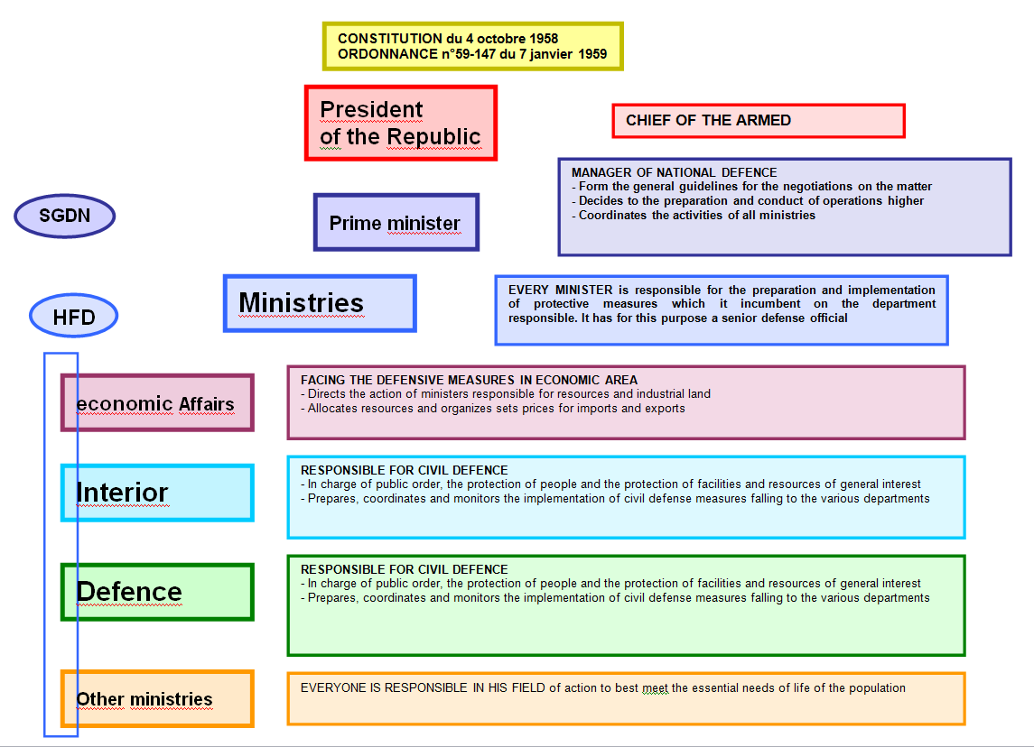
Figure 12: Authority Powers at the Central Level (EPLFM)

There are four levels:
- national level;
- zone level;
- departmental level;
- local level

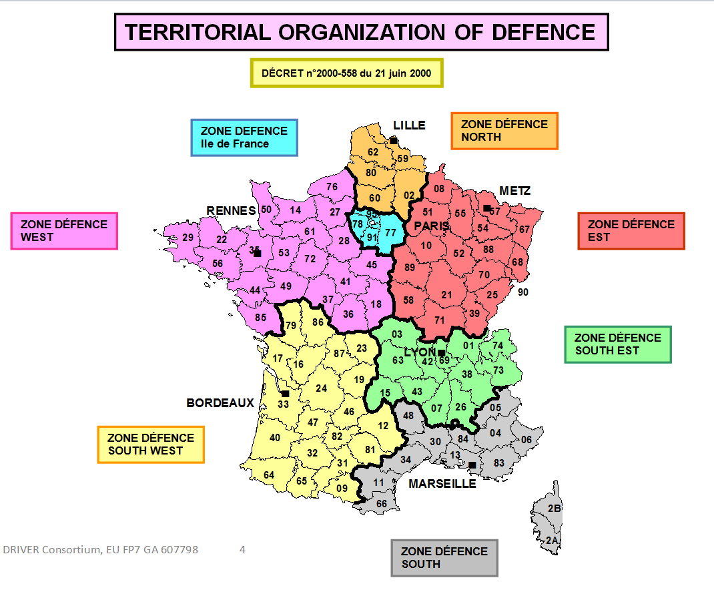

Figure 13: Territorial Organization for Defence (EPLFL document)

France has a comprehensive approach of crisis management, which is why all ministries are involved.
However, in most cases only the Ministry of the Interior, (possibly the Department of Defence) needs to be activated.
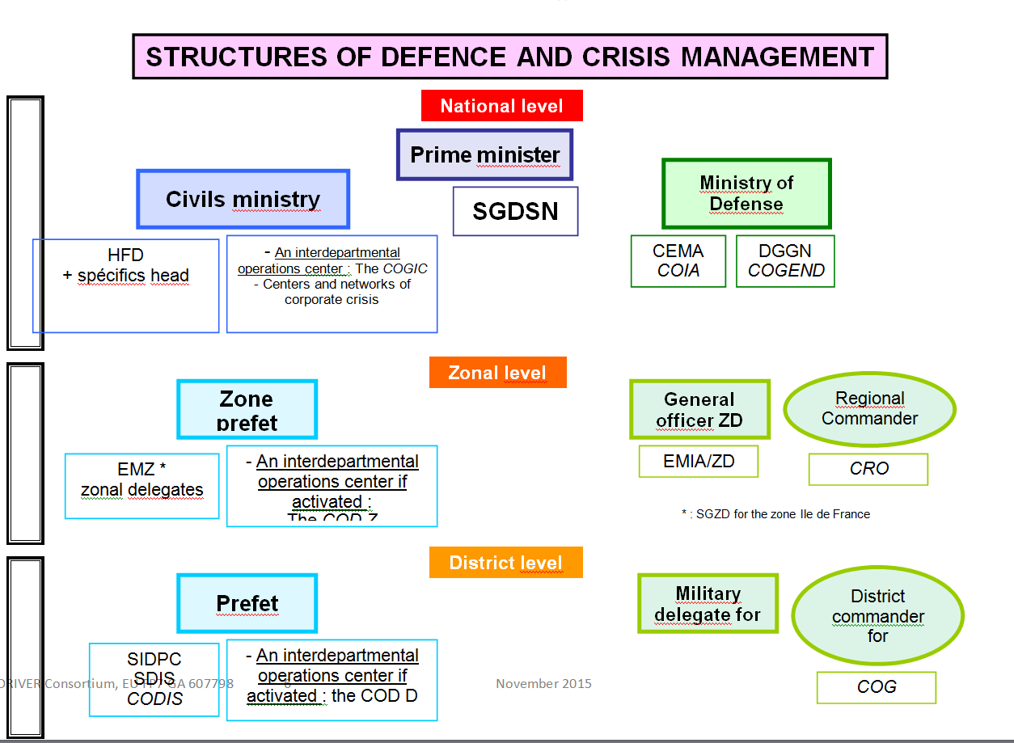
Figure 14: Structures for Defence and Crisis Management (EPLFM document)

- National permanent emergency and disaster management unit(s)/ formations; first responders
For crisis management and civil protection, the government and the Minister of the Interior have the Interministerial Crisis Management Operating Centre (COGIC) which is the operational organisation managing crises at the Directorate-General for Civil Protection.
The COGIC can activate in response to crises the following nationals means:
- military civil protection units (FORMISC);
- water bomber aircrafts;
- helicopters;
- logistic Bases (ESOL);
- bomb-disposal expert.

In constant contact with the operational centre of the National Police and the Planning and Conduct of Operations Centre (CPCO) of the Department of Defence, the COGIC continuously informs the minister's office, offers intervention procedures, prepares and coordinates the action of government interventions.

The centre occupies a total area of 500 m², divided into several structures:
- an operational centre dedicated to continuous monitoring, (24/7), defence and civil protection;
- a crisis centre, activated when needed;
- a communications centre, plays a key role in informing the public through the pre-established national alert network links with key national media;
- a documentation centre.
A total of 40 officers and non-commissioned members maintain the COGIC.

- Planned/ anticipated use of specialised military assets

During the summer season, there is an agreement between the Ministry of Defence and the Ministry of Interior for the provision of specialised assets and means (helicopters, engineer assets, etc).
On the other hand, Prefects may, at any time, requisition military means to deal with unusual disasters.

- Regional authorities and arrangements for emergency and disaster management (e.g. crisis HQ)

The intermediate level is the zone level. There are 7 areas of defence and therefore 7 inter-ministerial Defence Zones (EMIZ).
The EMIZ has an operational centre.

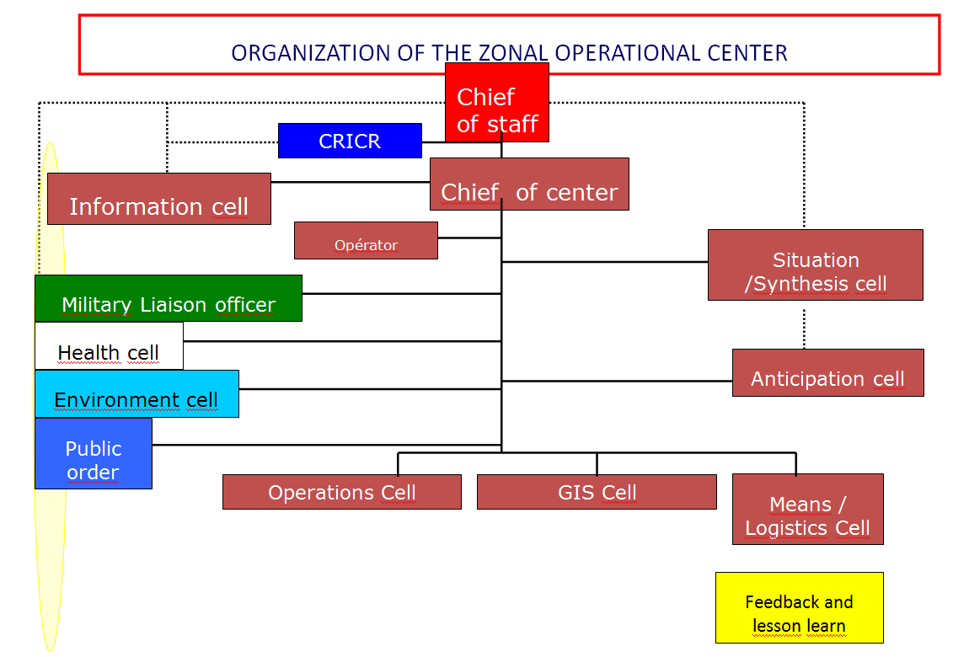
Figure 15: Organisation of the Zone Operational Centre (EPLFM Document)

- Departmental emergency and disaster management arrangements
All French departments have an operational centre or crisis unit (CODIS). Some are not activated 24/7. When there is a disagreement between some departments, it is the Prime Minister who arbitrates.

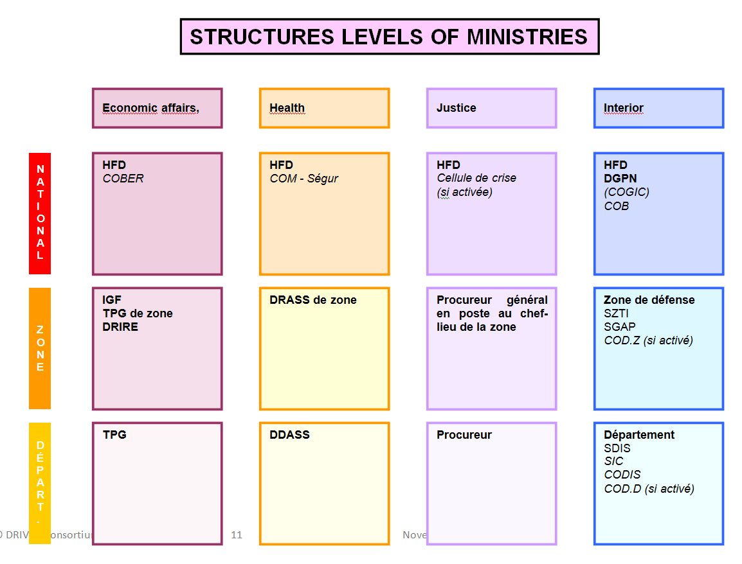

Figure 16: Structure Levels of Ministries (part 1, EPLFM document)

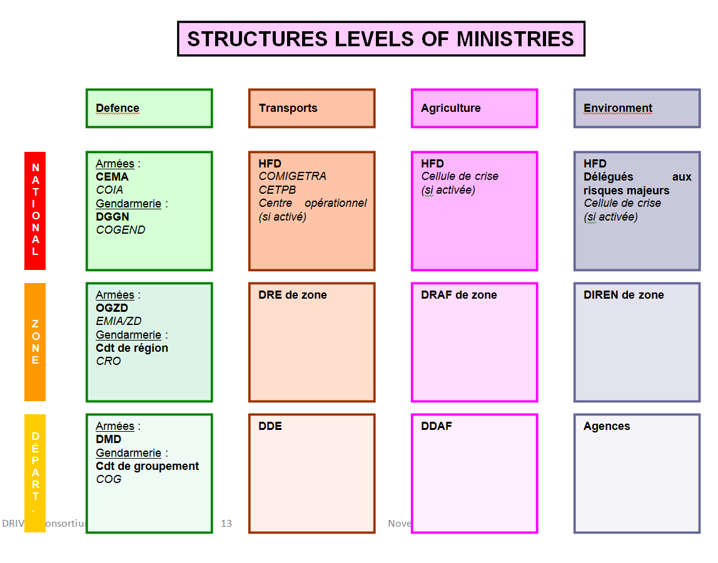
Figure 17: Structure Levels of Ministries (part 2, EPLFM document))

- Local (municipal, town) authorities and arrangements for emergency and disaster management

At the level of the department, the Prefect manages the crisis in a specific operational centre: the Departmental Operational Centre “COD”.

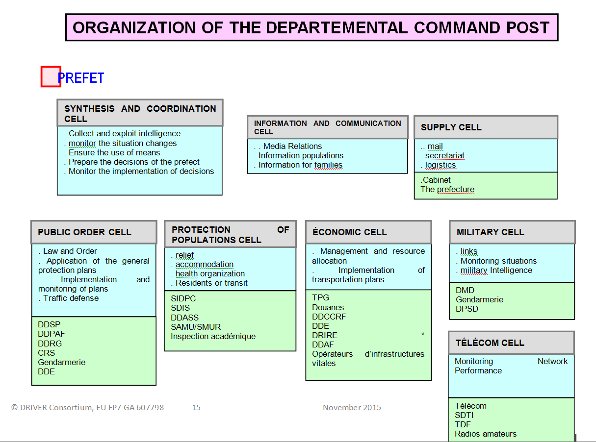

Figure 18: Organisation of the Departmental Command Post (EPLFM document)

- Volunteers and volunteer organisations; specialised NGOs
In order to work and to be integrated into an emergency device, NGOs must receive an agreement from the DGSCGC.

- Private businesses
They can be requisitioned by the Prefect as needed.

Organisational cooperation
- Operational cooperation (e.g., coordinated CM operations planning and response at national level, cross-border operational cooperation, operational cooperation within the EU)

  - How priorities are assigned in the case of simultaneous occurrence of events?
In France, the priorities are guided and determined by the issues and they are:
- population;
- property;
- economic activities;
- damage to the environment.

  - How cross-border collaboration is organised? Please identify procedures used by stakeholders for cross-border cooperation (e.g., how is it initiated)
For small operations there are agreements of the Prefects.
For larger operations involving the work of other departments or national resources, the decision falls within the Ministries of the Interior and of Foreign Affairs.

Procedures
See section 3 for additional information.

Standing Operating Procedures (SOPs) and Guidelines
- Is there a written/ published document(s)?
There are standard operating procedures and guidelines. These are published by the DGSCGC. The command organization is taught at all levels. The officer’s School of Aix en Provence guarantees the use of this doctrine at the national level.

- What is the scope of the SOP document(s)
The SOP document is related to all the procedures needed at the national level.

- Are SOPs understood and accepted by all parties, and implemented in practice?
Operating procedures and national guidelines are obviously used in practice, not only nationally but internationally in many partner countries.

- Are the SOPs regularly tested both by activation and by exercise?
SOPs are unified in France. They are written in the national reference guides. SOPs are taught in the county and national schools from the lowest levels to the highest level of the hierarchy. SOPs are used in exercises and in real intervention.

Operations planning
- Is there a national crisis/ emergency, disaster/ plan?
There are emergency plans at the National level and in each department (see section 3), the ORSEC plan.

- Are there departmental crisis/ emergency, disaster/ plans? Please enumerate.
Regarding the Ministry of the Interior and Civil Protection, plans are available for each type of disaster (flood, earthquake, etc.). All the plans are described in specific Guides books.

- Are there local crisis/ emergency, disaster/ plans?
Plans are linked from the national to the municipal level (ORSEC plan).

Logistics support in crises
- Planned/ anticipated use of private logistics providers (e.g. DHL)
The French Civil Protection has 4 logistic bases located in the territory and that respond to many disasters. However, a prefect authority has the ability to command private companies for relief purposes.

- Planned/ anticipated use of military logistics support
The armed forces are involved in civil protection missions, either through an agreement signed for several years or after a requisition made by a Prefect.

Crisis communication to general public; Alert system; Public Information and Warnings
- Who is responsible for crisis communication? Who coordinates crisis communication within and among MSs? How is the inter-organisational coordination of information exchange about crisis communication to the general public organised and managed?
Each ministry provides its own communication. When a crisis requires an inter-departmental management (COGIC), the DGSCGC performs crisis communication with its own office. All the classic ways of communication are used: press, radio, TV. News tools such as MSGU (Médias Sociaux en Situation d’Urgence: Social Medias in Emergency Situation) are also developed by all the national organisations implied in crisis management : Ministry of Interior, Prefet, Police, Civil safety…

- How long does it take for the general public to become informed about pending hazards?
Once the departments agree on the elements of language, the DGSCGC can make public information through radio channels and national television. Usually the general public will be informed within the first hour. However the delay can be shorter by the official (oral) communication of the public authorities and the Social Medias official accounts of the administration.

- Which technical infrastructure is used to achieve situational awareness at local/ national/ European/ international level?
Television, radio, newspaper, national, zone and departmental command posts, sirens, municipal and national police, ERCC, etc…

Capabilities

Human resources
- Permanent emergency and disaster management personnel
At the local or municipal level, the mayor is in charge with police powers and a local command post (PCC). The mayor manages local means (municipal police, urban planning, etc.) and has the capacity to requisition. He has a Local Protection Plan (PCS) and when crisis management is activated he becomes the Director of Rescue Operations (DOS).
The mayor has a Local Civil Protection Reserve (RCSC) consisting of voluntary citizens whose mission is to support town services in the occurrence of a crisis exceeding usual capacities and to contribute to population support and assistance.
When the mayor is exceeded by the events, when response capacities are not enough or when the disaster goes beyond municipal limits (boundaries), the department Prefect takes over.
At the departmental level, the department Prefect, invested with police powers, is the Director of Rescue Operations (DOS). He commands the ORSEC mechanism (Organisation of the Civil Protection Response). He activates the Departmental Operational Centre (COD) and deploys the Operational Commandment Post (POC).

The Departmental Operational Centre (COD) is divided into 8 units :
- public order unit ;
- population protection unit ;
- military unit;
- telecommunications unit
- economic unit;
- communications unit (media);
- support;
- synthesis and communications unit.
As the DOS has the power to requisition, he can mobilise any public or private means. The Interministerial Service of Defence and Civil Protection (SIDPC) can provide support to study risk and develop a rescue plan, the SDIS is placed under its authority.
As previously, when the crisis exceeds departmental boundaries or response capacities and that crisis management reaches the zone level, it is the Zone Prefect, with the Zone Operational Centre (COZ), who takes over crisis management.
France is made up of 7 defence zones:
- North zone;
- Ile-de-France zone;
- West zone;
- Southwest zone;
- East zone;
- Southeast zone;
- South zone.
The zone Prefect has a General Secretarial Office for Police Administration (SGAP), a Zone Information and Communication Systems Service (SZSIC) and a Regional Information and Road Coordination Centre (CRICR).
Finally, at the national level, for large scale crisis, it is the Ministry of the Interior who supervises crisis management with the Interministerial Crisis Management Operational Centre (COGIC) and temporarily the Interministerial Crisis Centre (CIC).
A general secretary coordinates the actions of civil protection services (DGSCGC) and public safety (General Directorate of the National Police (DGPN)) which are reinforced by the General Directorate of National Gendarmerie (DGGN).
At the International level, the Ministry of Foreign Affairs works with the Health Ministry of the stricken country.
To summarise, the permanent staff of crisis management and emergency are people from municipal police, fire-fighting forces, Paris Fire Brigade (BSPP), Marine Fire Brigade of Marseille (BMPM), Military Civil Protection Units (UIISC), mine-clearing units, Logistics and Operational Support Unit (ESOL), Air Groups and civil protection associations.

- Capacity to mobilise personnel

The law of 22 July 1987, in Article 10, states that the competent authorities of the State in charge of managing rescue operations or launching the ORSEC mechanism (Prime Minister, state representative in the department where the headquarters of the defence area is located, state representative in the department), can "each" requisition necessary private rescue means.
In practice, these requisitions respond to an emergency situation by quickly completing the available rescue means and specific equipment (specialised repair vehicles, staff of companies involved in handling hazardous chemicals, etc.) during rescue operations. They cannot be implemented "in ordinary circumstances." Concerned businesses and individuals are compensated at a later stage.

- Involvement of volunteers, volunteer organisations, and specialised NGO personnel

National human resources come from public services (and / or private) but also from many civil protection associations. These associations are made up of volunteers and employees. Authorities do not always have sufficient resources (human and material) to overcome the emergency. It is therefore essential in order to cope with a crisis, to have the support of civil protection associations. These associations intervene to complement public service missions when a request is made by the competent authorities. Article 35 of the law of 13 August 2004 created a 5 year agreement for associations that want to be integrated into the systems put in place by the government. These associations are authorised to respond to any or all of the following types of missions:
- rescue operations;
- support actions for disaster victims;
- supervising volunteers during actions to support affected population;
- provisional rescue devices.
Annual agreements are signed between public authorities and the SDIS to define the circumstances, intervention methods and their integration into the rescue plans.
Below are three major associations groups:
- The French Red Cross, the French Society of Disaster Medicine (SFMC), the French Society of Emergency Medicine (SFMU), the National Federation of Radio Transmitters at the service of Civil Security. (FNRASEC), ...
- Representations of health professionals, the SAMU of France, the association of emergency doctors of France (AMUF), the National Association of Medical Students of France (ANEMF) ...
- NGO: Doctors Without Borders, Doctors of the World, Bioforce, ....
Another association needs to be listed because its support from a health point is very important: it is the Establishment of Preparedness and Response to Health Emergencies (EPRUS). EPRUS has the capacity to respond to health threats, in France and abroad. Indeed, this association has facilities to organize and deploy health forces during severe health crises. This health reserve includes all types of health professionals. After being trained they participate in emergency missions in case of serious health crises, and their pharmaceutical establishment manages the national strategic health stock needed to protect the population in case of emergency.
The National Federation of Civil Protection should also be mentioned. It provides operational reinforcement for public rescue services (SAMU, fire brigade) during rescue plans, participates in supporting affected population in case of disasters and supervises volunteers.

- Involvement of private businesses

As we have said before, competent authorities have the power to requisition, as needed, private resources for rescue purposes and very often this is done in the frame of a partnership. Various operators such as SNCF, telephone operators, motorway companies, water and electricity distributors can be mobilised. In addition, upon request of the person requisitioned, the administrative court can grant an advance payment representing all or a part of the compensation.

- National educational programme(s)

Since the law of civil protection modernization of 13 August 2004, training has become a permanent obligation. In order to test rescue plans, verify procedures (and tools developed) and to evaluate the means and the teams, exercises are performed each year involving all stakeholders at all levels (representatives of the political and administrative authorities, media, elected officials, public and private operators).
The new program for modernization of civil security has for aim to involve population that lives nearby a major risk. Today populations are not implied in those exercises even if they receive documentation to inform them on action to be taken in case of crisis.
Reference: « Exercices de sécurité civile: mémento en 10 points. »
These exercises enable to identify shortcomings in the crisis management chain and to propose appropriate modifications. Communal exercises work on the evacuation and / or containment of a neighbourhood. For departmental exercises, the themes are given by the DGSCGC. They can focus on a pandemic crisis, a CBRNE disaster, or a road crisis. Zone exercises are initiated by zone prefects in order to train departments at working at the zone level on pandemics, winter weather.... Interdepartmental government exercises sometimes involve the zone or the department.

Material (non-financial) resources
- What specific non-financial resources (dedicated equipment etc.) have been allocated to crisis management (central, regional, local preparedness and response)?

It is very difficult to know the specific resources that have been allocated to crisis management. However, the French Red Cross annually publishes a report on the actions conducted.
For 2011:
- 55 million meals distributed;
- 539 lockers and 278 clothing stores put in place;
- 98 institutions dedicated to early childhood and child protection;
- 118 accommodation facilities affected.
For 2012:
- 831 food aid structures installed;
- 318 clothing stores put in place;
- 2263 accommodation places affected;
- 113 reception facilities dedicated to infancy and early childhood.
For 2013:
- 1002 food aid units installed;
- 412 clothing stores put in place;
- 2630 accommodation places affected;
- 2970 places dedicated to early childhood and child protection.

- Permanent reserve stocks (fuel, food, medicines, tents, blankets, etc.)

The national reserve of the General Directorate of Civil Protection and Crisis Management (DGSCGC) is constituted of materials for the reinforcement of national rescue and protection of persons and property. All this equipment complements the material of local and regional authorities for large scale disasters.
There are three ESOLs (Establishments of Operational and Logistical Support of the DGSCGC): one in the North, one in the West, one in the South, plus an annex in the East. The stock of the national reserve is made up of seven families according to their action areas.
The first family contains equipment to produce and supply drinking water. The types of risks that match these materials are:

- Flood;
- Biological Pollution;
- Earthquake;
- Displacement of populations;
- Cyclone.

In this family, we find water treatment units (CELTE), automatic bagging machines for 2L bags, water distribution headers with 5 taps, 1000m flexible food grade pipes to supply water, water pressure regulators, a mobile overpressure unit and different types of tanks.

The second family contains cleanup and search and rescue equipment. The types of risks that match these materials are:
- Flood;
- Biological Pollution;
- Oil and Chemical Pollution;
- Cyclone.
There are autonomous hot and cold water pressure cleaners, sawing materials, storage tanks with a total capacity of 0.5 to 20 m³, various containers (garbage cans, buckets, wheelbarrows, ...), hand tools (shovels, forks ...), plastic covers, rolls of polyane, oil spill gloves and coveralls.

The third family contains energy materials and outdoor lighting. The types of risks that match these materials are:
- Flood;
- Earthquake;
- Displacement of populations;
- Cyclone.
In this family we find power generators ranging from 2.5 to 110 KVA having a total capacity of 2 000 KVA, outdoor lighting from 300 to 1000 Watts with a total capacity of 70 000 Watts and lighting balloons between 1 200 and 4000 Watts.
The fourth family contains equipment for accommodation and catering. The types of risks that match these materials are:
- Flood;
- Earthquake;
- Displacement of populations;
- Cyclone.
The equipment consists in modular tents with a total capacity of 2000 people, camp beds, sleeping bags, blankets, and a collective catering unit.

The fifth family consists in pumping and flood fighting equipment. The types of risks that match these materials are:
- Flood;
- Cyclone;
- Marine submersion.
Here we find mobile pumping units with 5400 m3/h capacity, mobile pumping with 850 m3/h capacity, heat engine pumps from 15 to 150 m3/h, electric submersible exhaustion pumps from 15 to 360 m³/h, a total pumping capacity of over 52 000 m3/h, more than 5 km of flood dam, over 900 m2 of modular elements to build platforms and floating walkways.

The sixth class is composed of CBRN equipment and protective equipment. The types of risks that match these materials are:
- Chemical and Biological Pollution;
- Nuclear Pollution;
- Oil spill pollution.
There are CBRN decontamination light clothing kits, respiratory protection masks, personal protective kits, disposable suits and autonomous thermal sprayers.

And finally the seventh family contains specific forest fire intervention equipment (2 wildfire batches in the North and in the South).

- Planned /anticipated/ involvement of specific military assets (e.g. reconnaissance assets, search and rescue helicopters, fire-fighting planes/helicopters, CBRN, etc.)

The support for territorial civil protection services is provided by the operational services of the General Directorate of Civil Protection and Crisis Management of the Interior Department.
To cope with disasters, the sub-directorate of crisis planning and management must handle the three phases of the crisis: preparedness, response and feedback.
This sub-directorate analyzes the various risks such as natural hazards, technological risks, nuclear risks ...). It also ensures fire prevention and regulations.
The sub-directorate of risk management also defines the framework for rescue planning. It invests in information and public awareness concerning risks and threats, including warning systems. Active in the national policy for civil protection exercises, it organises the feedback and contributes to ensure the training for risk and operations management.
Operational services operate throughout the French territory and contribute to International rescue actions. They include different structures including:
- Air assets pool (GMA);
- Mine-clearing centre;
- Military units.
Civil protection military units reinforce territorial fire-fighters when circumstances require support or special preparation facing risks. These units (UIISC: civil protection instruction and intervention units) are specialised in the areas of forest fires, technological risks and buried victims search.
Civil protection bomb-disposal experts mainly carry out safeguarding missions.
The civil protection air assets pool is divided into two groups:
- A helicopter group: :
  - A central department which includes a commandment safeguarding missions base, a centre for crew training and an aircraft maintenance centre;
  - 22 helicopter bases plus one in Guadeloupe.
- An airbase.
Helicopter missions are, in increasing order of priority, the following:
- conditioning of personnel and equipment;
- police and technical assistance;
- forest fire fighting and non-emergency rescue;
- urgent rescue.
Civil protection has a fleet of 25 water bombers (Canadair CL-415, S-Tracker 2FT and Bombardier Dash 8) and 3 liaison and investigation aircrafts.

The chemical, biological, radiological, nuclear and explosives (CBRN-E) service is placed under the authority of the General Director of Civil protection and Crisis Management. Its mission is to develop intervention procedures that are intended to strengthen response capacity and resilience in managing a major CBRNE crisis on the French territory.

- Is provision made for governments to mobilise or commandeer private assets during crises?

As for human resources, when the material resources of authorities are insufficient to face an emergency, both because of the amount of equipments needed and because of the specificity of certain needs, competent authorities have the power to requisition needed resources.

Training
- National, local and departmental exercises

DGSCGC recommends organizing regular exercises at district, zone and national levels. To this end, it publishes various methodology guides for exercise management or field exercises. It also publishes guides for feedback.

- Centralised specialist training

Specialty trainings are made only in a small number of centres approved by the DGSCGC. The wild fire training levels 3, 4 and 5 can be done only at the ECASC (Civil Protection Application School). It is the same for mountain rescue team training. The fire training for ships is only performed by BMPM, etc...

- Training of volunteers and NGO personnel

Volunteer fire-fighters receive the same training as professional fire-fighters. Consequently, during field operations, it is not possible to differentiate between the two types of fire-fighters.
NGO training is the responsibility of their own structure in the framework of the DGSCGC agreement.

- Cross-border and multinational training activities
Cross-border training and exercises are under the responsibility of departmental prefects and departmental directors of fire and emergency services of border departments.
Some exercises are organised to the initiative of departments on the border. Those exercises are not mandatory and do not frequently occur but are more and more developed.
The last exercises operated on South of France are:
- NOVI (nombreuses victimes, several victims) with Italy
- RICHTER with Spain and Italy.

Reference: « Rapport sur les règles et principes applicables aux actions internationales en cas de catastrophe (IDRL) en France » croix Rouge Française. 2010

- Is there a certification system? What standards are used to define specialists' training requirements?

France has engaged into an INSARAG (International Search and Rescue Advisory Group) certification process for its HUSAR (Heavy Urban Search and Rescue) teams and into an EU certification process for other specialised modules. It can provide the ERCC all specialised modules provided by the decision of the European Commission of 10 June 2010.
French education is unified and is described in national reference guides. Training must be approved by the DGSCGC who verifies that everything is in reference guides and in French doctrine in the concerned specialty.

- Are there specialised training programmes for high-level decision makers?
The DGSCGC deals more specifically with training for crisis management prefects and office chiefs. There is a general training for natural and technological risks.

- Training centres
France has a national school to train firefighter officers (ENSOSP) and a specialty school (ECASC). In addition, all departments have departmental schools to achieve basic training for their firefighters.

Procurement

Procurement regulation
- What needs to be procured? E.g. goods or services, including trainings?

Public procurement concerns all goods and services bought by the French government or local authorities. All expense above 1€ must be subject to a contract. Only procedures change depending on the amount of the financial transaction. These contracts must meet public procurement directives. (Code des marchés publics (Décret n° 2006-975 du 1er août 2006 modifié)).
Official laws for French public procurement: Public procurement code (CMP)
- Public procurement code
- Circular letter for the application of the public procurement code
- Corresponding table for public procurement codes of 2004 and 2006.
- Decrees for modification of public procurement code
- Circular letter for good practice of public procurement code.

- Which EU directive on procurement is applicable on procurement of CM tools and related?

The European directives applicable for the procurement of crisis management tools and related are the ones relevant for all public procurement in Europe: directives 2004/18/CE and 2004/17/CE currently applicable and two new directives 2014/24/EU and 2014/25/EU.
The directives 2004/17/CE and 2014/25/EU concern exclusively procurement by entities operating in the utilities sectors: water, energy, transports and postal services. It is called “sector directive”. Those directives are not applicable for crisis management tools and services.
The Directives 2004/18/CE and 2014/24/EU concern public procurement for all the others sectors, including crisis management tools and services. This directive (called “classical directive”) applies to public contracts concluded by a contracting authority in sectors other than the water, energy, transport and postal services sectors for supplies, services and works.

Extract from the “Summary of EU legislation”: Public work contracts, public supply contracts and public service contracts:
“The “traditional directive” applies to public work contracts, public supply contracts and public service contracts which have a value excluding VAT estimated to be no less than the pre-established thresholds.
The value of the thresholds is the following (values updated every two years by the Commission):
- EUR 130 000 for public supply and service contracts awarded by central government authorities (ministries, national public establishments);
- EUR 200 000 for public supply and service contracts: awarded by contracting authorities which are not central government authorities; covering certain products in the field of defence awarded by the central government authorities; concerning certain services in the fields of research and development (RTD), telecommunications, hotels and catering, transport by rail and waterway, provision of personnel, vocational training, investigation and security, certain legal, social and sanitary, recreational, cultural and sporting services;
- EUR 5 000 000 in the case of works contracts”.
The new European directives (2014/24/EU) should be transposed into French law in order to be applicable no later than February 2016. They will be integrated into the French public market code (CDM).
A decree (n°2014-1097) dated on September 26th 2014 (JORF n°0225) transposes in an accelerated way the new European Directives 2014/24/EU in the French public market code (CDM).
- Decree n°2014-1097, September 26th 2014: public procurement simplification, transposed from European Directive 2014/24/EU
- DAJ (Direction of the Juridical Affairs) : decree for simplification measures on public procurement
From this last reference, we precise that this decree concerns different points:
- The upper limit of the annual turnover due by the supplier: this request cannot be more than twice the value of the market. The aim of this decree is to open the procurement procedure to SMEs.
- The simplification of the application files.
- Creation of a new kind of procurement to facilitate public market in research and development.

- Are all articles of the directive applicable or are some articles not implemented?

From article 288 of the Treaty on the functioning of European Union (2008/C 115/01):
“A regulation shall have general application. It shall be binding in its entirety and directly applicable in all Member States.
A directive shall be binding, as to the result to be achieved, upon each Member State to which it is addressed, but shall leave to the national authorities the choice of form and methods.”

Directives are framework laws, mandatory because they link Member States to the result to be reached. Consequently, all the articles of the Directives must be transposed in French law, within the time limit allowed by the European Union.
Thus, Directive 2004/18/CE regarding Public procurement has been transposed in French law according to the transposition texts:

- Directive 2004/18/EC of the European Parliament and of the Council of 31 March 2004 on the coordination of procedures for the award of public works contracts, public supply contracts and public service contracts
- Texts of transposition of the Directive 2004/18/CE
- Directive 2014/24/EU of the European Parliament and of the Council of 26 February 2014 on public procurement and repealing Directive 2004/18/EC

According to “New rules on public contracts and concessions”:
“National freedom of organisation is not affected: it is for the Member States alone to organise public services as they see fit. A public authority remains free to perform the public interest tasks for which it is responsible, either using its own staff or by delegating these tasks to external firms – it is only in the latter case that the rules on public contracts and concessions apply.”
- Consolidated versions of the treaty on European Union and the treaty on the functioning of the European Union (2008/C 115/01)
- SMEs' access to public procurement markets and aggregation of demand in the EU

- Are additional national regulations applicable and/or are there additional requirements?

Generally, French laws are more restrictive than European directives. The French public procurement code does not have specific requirements regarding the procurement of tools and services for crisis management. Common law applies for these procurements.
Thus, the French public procurement code (CMP) plans:
- For local public authorities and communities, the procedures planned by the European Directives enforce on public contracts with a value higher or equal to 211000€ HT. Under this value, National law applies (French public procurement code, CDM).
- Procurements for the State and its public entities are governed by the public procurement code. This law sets thresholds from which different purchasing procedures should be followed.
Three thresholds exist for public procurement concerning the purchase of supplies and services for the French State and its local authorities, depending on the amount of the transaction (see: marchés publics.com, servive-public.fr). These different procedures are described in question 5.4.2.

- How often is there a need to jointly buy CM tools or services? And how often does cross-border procurement occur? Are there any considerations for future joint procurement? If yes, in what area and what are potential partner nations?

According to the DGSCGC with the Office of the Operations and Crisis Management, the tools for crisis management are homemade. Most are developed by their own offices, with the support of departments from the Ministry of the Interior such as the Directorate of Information and Communications Systems (DSIC). Public procurements can occur to carry out some services.
There is no joint buying or cross-border procurement for crisis management tools or services in France.

- Is there a need for additional legislation with regard to cross-border procurement?

There is legislation for cross-border procurements for local authorities and their groups, excluding SDIS or interdepartmental groupings. It is the subject of the interministerial circular of 20 April 2001 for decentralised cooperation.
This circular applies only to local entities and their groupings, this circular specifies that SDIS are not group of local entities.
From the “Cross-border competence and cooperation of the fire and rescue services in the European framework”: “In this cooperation “French local and foreign local entities”, on one side the SDIS can only be an operator, and on the other side the sector of action has a limited extent, since it can’t concern directly the security and the protection of population, which are under the jurisdiction of the public authorities”.

However there are numerous bilateral agreements within the European Union. The countries of the South of Europe cooperate especially for forest fire fighting. These cooperations do not concern any procurement procedures.
Currently, there are no needs for additional legislation for cross-border procurement since none is envisaged.

- How important is interoperability and do issues arise around the interoperability?

Interoperability is a major concern for crisis management because it allows the adaptability of decision support tools for all natural or manmade disasters, and for all existing investigation tools. Likewise, crisis management tools must adapt to the different crisis management actors, on all operational levels: from the local entity to the National and European entities.
Interoperability is a real problem for crisis management. There are currently a lot of initiatives of Europe to develop interoperability. The actual directives are to develop “open systems” so any software can enter in any program.

Major crisis management in France is governed by the ministerial circular letter of the January 2d, 2012. This circular sets the frame of the interoperability of the tools used during all crisis management, both at departmental, zonal and national levels. Please refer to section 2.

Procurement procedures
- Which organisations are involved in the procurement of CM tools? And how do they organise their procurement process?

The organisations implied in the procurement of crisis management tools are the French State through the Ministry of Interior and the DGSCGC as well as the SDIS of each French department.
Procurement procedures are governed according to the French public procurement code (CMP) and depend on the value of the contract. The next table sums up the thresholds and the associated procedures for the procurement of supplies and services (sector that concerns crisis management, another sector is for public works).

Public procurements of supplies and services

Thresholds |  | 15000 € HT 90000 € HT 200000€ HT
Advertising | Supplies and services (art.29) | None | Adapted advertising | Compulsory advertising : compulsory national pattern: BOAMP or JAL + publication on the buyer profile | Compulsory advertising: (compulsory European model) BOAMP and OJEU + publication on the buyer profile
 |  |  | Additional advertising is optional
 | Services (art.30) | Adapted advertising
Competition |  | None | None but under buyer responsibility |  | Introducing competition
Procedure | Supplies and services (art.29) | Adapted procedure |  |  | Relevant procedures: opened or restricted requests for proposal (art.33) ; negotiated procedures (art.35) ; competitive dialogues (art. 36) ; competition (art.38) ; dynamic acquisition system (art.78) ; (exclusively for common supplies)
 | Supplies (art.30) | Adapted procedure
Table 6: Public procurement Procedures for supplies and services (EPLFM document)
BOAMP: Official Bulletin for Public Procurement Announcing
JAL: Legal Announcing Journal
OJEU: Official Journal of European Union
Adapted procedure: freely decided by the buyer depending on the nature of the procurement, on the needs to be satisfied, on the number and localisation of suppliers and procurement circumstances.

- How is the procurement process in the non-EU countries organized? Are coordinating activities of any kind in place or are they planned?

Procurement procedures in non European countries are specific in each country and are unknown by the French State. Meanwhile we can find on the web some articles concerning procurement processes in some large countries. The next paragraph summarises the main links to information on the procurement procedures of some countries concerned.
- Government procurement in the United States
- Government procurement in Russia
- Switzerland’s Public Procurement system
- Turkish public procurement authority (PPA)

Niche capabilities

- Which niche capabilities of the country /IO are potentially of interest to the EU CM and disaster response?

The French State owns civil security means in various domains of natural or manmade disasters that have already proven their value in different European countries and in the world.

At the European level, there is a Common Emergency Communication and Information System (CECIS, ECHO reference: ECHO/B.1/SER/2011/01) which allows answering the demands from all countries (even outside of the European Union) when they are in a crisis situation.

The concerned country makes a request for help which is relayed to all the European countries offering their help, which is accepted or not by the demanding country.

There is also an Emergency Response Centre (ERCC) which works on the same principle with the financial participation of the European Commission for staff travelling expenses during operations (case of the intervention in Sweden in august 2014 for forest fires). See following references.

- Decision N° 1313/2013/EU of the European parliament and of the council of 17 December 2013 on a Union Civil Protection Mechanism
- The European Emergency Response Centre Opens. European Commission MEMO/13/427 15/05/2013

The Commission Decision of 29 July 2010 (amending Decision 2004/277/EC) as regards rules for the implementation of Council Decision (2007/779/EC) defining a Community civil protection mechanism, establishes the form that must take community assistance. This decision defines the general requirements that apply to European protection civil modules.
- Commission Decision of 29 July 2010 amending Decision 2004/277/EC Euratom, as regards rules for the implementation of Council Decision 2007/779/EC Euratom, establishing a Community civil protection mechanism
- Council conclusions on Further Developing Risk Assessment for Disaster Management within the European Union.

The niche capabilities for the French State are listed below:

- Forest fires:
- Aerial forest firefighting module using airplanes: the fleet of air tankers includes 12 Canadairs, 9 Trackers, 2 Dash 8 and 3 Beech crafts.
- French detachments for far-off countries are most often composed of 2 Canadairs and one beech craft. They also include two plane pilot crews (of two pilots) and four maintenance staff. A senior forest fire fighter manager is in charge of the coordination of the intervention. A total staff of 17 people.
- For bordering countries (Spain, Italy), the detachment is composed by only two Canadairs with their two pilot crews, they use the same work method as in France.
- Aerial forest firefighting module using helicopters :
  - Three helitankers with a capacity of 1000 liters.
- Ground forest firefighting : two kinds of modules
  - Ground forest firefighting using vehicles: 1 VLTT (off-road liaison vehicle) and 4 wildland fire tankers, a total staff of 30 people.
  - Ground forest firefighting without vehicles: airborne specialized intervention detachment (DIS). A staff of 30 people equipped with forest cutting tools, motor-pumps…

- Earthquake and explosion: urban search and rescue: INSARAG classification
- Two HUSAR teams (heavy teams) have been classified in March 2014: UIISC1 and UIISC7 (military teams)
- One French NGO, Pompiers Urgence Internationale (PUI) is classified MUSAR (medium team).
- Two new HUSAR teams (Civil protections teams) should be classified in 2016 and 2017: south Zone team in 2016 and Ile de France team in 2017.
- (INSARAG, Preparedness-response) Each of these INSARAG classified teams owns the material needed for its actions. “A heavy urban search and rescue team is required to have:
  - the equipment and manpower to work at a heavy technical capability at two separate work-sites simultaneously;
  - both a search dog and technical search capability;
  - the technical capability to cut structural steel typically used for construction and reinforcement in multi-storey structures;
  - the capability to conduct heavy rigging and lifting operations;
  - staff and logistic sufficient to allow for 24 hour operations at 2 independent sites for up to 10 days.”
French HUSAR teams have 62 people.

- Chemical cleanup and clearing:
- High pressure cleaners: 5 with hot water; 24 with cold water.
- Chain saw modules: 245.

- High capacity pumping : flooding, cyclone, marine flooding:
- Mobil pumping units: 5 UMP5400 at 1.5m³/s.
- Pumping units: 8 UP850 at 850m³/h.
- Thermal motor-pumps: 152 at 50m³/h and 73 at 150 m³/h.
- Flood containment, pumping and drying unit CELPA, Modular floating rig.
- Flood rescue using boats: navigation unit CELNAV.

- Field hospital:
European Commissions requirements (Commission Decision of 29 July 2010) for field hospital:
- Provide initial and/or follow-up trauma and medical care.
- 10 beds for heavy trauma patients, possibility to expand the capacity.
- Medical team for: triage, intensive care, surgery, serious, but not life-threatening injuries, evacuation, specialised support personnel.
- Appropriate tents for the medical activities, tents for personnel.
- Command post, logistic and medical supply deposit.
In France, we have a field hospital that can be operational in 24 hours. This unit called ESCRIM, includes a department for surgical support (Civil Protection Units) and a department for medicine and hospitalisation (Civil Security Military Units). This hospital with 33 tents and a surface of 1500 m², includes 100 beds, 2 operating blocks, medical imaging units, sterilization modules, laboratory of biological analysis, health centre, maternity.
Staff is composed of 75 people issued from civil safety and civil protection units who are periodically checked for capacity, availability and trained. Likewise materials are periodically checked.
This field hospital is available 24/7. It is totally autonomous and does not need any local help.

- Water purification: flooding, biological hazard, earthquake, population displacement, cyclone.
- France owns 4 water treatment units: CELTE 5 m³/h of capacity each. No treatment of salted water.
- Semi automatic bag filler
- Mobile boosting station for drinkable water.

- Chemical, biological, radiological and nuclear detection and sampling (CBRN)
- Individual protection kits: kit CLD NRBC
- Respiratory protection masks

- Medical aerial evacuation of disaster victims
- Transport disaster victims to health facilities for medical treatment.
- Capacity to transport 50 patients per 24 hour, ability to fly day and night.
- Helicopters/planes with stretchers

Resources

Legislative acts

- French town planning code: art. L.121-2 du Code de l’Urbanisme.
- Law n°82-600 of 13 July 1982: promulgates the texts for the compensation of victims of natural disasters.
- Law No. 87-565 of 22 July 1987 organising civil protection and major risks prevention, creating the right to information.
- Law No. 95-101 of 2 February 1995 on strengthening environment protection, called" Loi Barnier. "
- Law No. 2003-699 of 30 July 2003 on technological and natural risks prevention and on damage repair.
- Law No. 2004-811 of 13 August 2004 on the modernization of civil protection.
- Law n°2003-699 of 30 July 2003 and its application decree n°2005-1466 of 28 November 2005, creating the CAT-TECH device.
- The circular n° NOR: INT/E/06/00120/C of 29 December 2006 defines the ORSEC mechanism.
- Decree n°2005-1157 of 13 September 2005 related to the ORSEC mechanism (department, zone and sea).
- Circular N°NOR:INT/E/06/00120/C of 29 December 2006 defining the departmental ORSEC mechanism.
- Circular n°5567-SG of 2 January 2012: governmental organisation in case of major crisis management.
- Circulars 007/SGDN/PSE/PPS of 8 October 2009 and 747/SGDN/PSE/PPS of 30 October 2009: intervention doctrines when facing a CBRN terrorist threat or attack, defines interveners and State doctrine.
- Circular 700/SGDN/PSE/PSS of 7 November 2008: urban chemical attack against civilian population and Circular 800/SGDN/PSE/PSS of 18 February 2011 on radioactive attacks.
- Circular 2002-119 of 29/05/2002: elaboration of a specific security plan against major risks for schools.
- Circular of 3 May 2002: set up of an emergency preparedness plan (white plan) for every public health facility in order to cope with numerous victims.

Official documents (white papers, strategies, etc.)
- Guide pour réaliser un plan de continuité, Secrétariat Général de la Défense et de la Sécurité Nationale, 2013. http://www.sgdsn.gouv.fr/site_article128.html.
- Etude en temps réel de la gestion de la crise en Haïti après le séisme du 12 janvier 2010, groupe URD, étude financée par la Délégation aux Affaires Stratégiques du Ministère de la Défense. www.urd.org/IMG/pdf/rapport_DASHaiti.pdf
- Plan de prévention des risques naturels (Ministère de l’écologie et du développement durable). www.risquesmajeurs.fr/les-plans-de-prevention-des-risques-naturels-ppr
- Le maire face aux risques naturels et technologiques (Ministère de l’écologie et du développement durable, Ministère de l’intérieur.
http://www.mementodumaire.net/responsabilites-du-maire-2/r1-prevention-des-risques-majeurs-roles-du-maire-etou-epci-et-de-letat/
- Exercices de Sécurité Civile (Ministère de l’intérieur), 2013.
www.interieur.gouv.fr/content/download/.../memento%20exo%20SC.pdf
- Synthèse RETEX 2013 (Ministère de l’intérieur), 2013.
www.interieur.gouv.fr/content/download/.../Synthese_RETEX_2013.pdf
- Guide pour réaliser un PCA (Secrétariat général de la défense et de la sécurité nationale) , 2014. www.risques.gouv.fr/sites/default/.../guide_pca_sgdsn_110613_normal.pdf
- Catastrophes environnementales : préparer l’évaluation de leurs effets et le retour d’expérience, Ministère de l’Ecologie, 2008. www.developpement-durable.gouv.fr/IMG/pdf/Catastrophes--_Web.pdf
- The CBRN governmental plan 10135/SGDN/PSE/PPS CD of 16 September 2010: its aim is to provide a decision aid to the Prime Minister and to his ministers during CBRN threats and events. www.sgdsn.gouv.fr/IMG/pdf/2011_02_18_800-2.pdf

Online resources (e.g. websites of key CM organizations)
- Ministry of the Interior: www.interieur.gouv.fr/
- Ministry of Sustainable development: www.developpement-durable.gouv.fr
- Research education : http://www.enseignementsup-recherche.gouv.fr/
- Ministry of education: http://www.education.gouv.fr/
- Ministry of Economy : http://www.economie.gouv.fr/
- Ministry of Agriculture : http://agriculture.gouv.fr/
- First Aid : www.secourisme.net
- Senate report : http://www.senat.fr/rap/l03-339/l03-33923.html
- EPRUS website : http://www.eprus.fr/qui-sommes-nous.html
- Red Cross 2011 annual report: http://www.croix-rouge.fr/Mediatheque/Publications/Rapport-annuel-2011
- Red Cross 2012 annual report: http://www.croix-rouge.fr/Mediatheque/Publications/Rapport-annuel-2012
- Red Cross 2013 annual report: http://www.croix-rouge.fr/Mediatheque/Publications/Rapport-annuel-2013
- Entente for the Mediterranean Forest website : http://www.entente-valabre.com/
- ECASC (fire-fighter specialty school) website : http://www.valabre.com/joo2012/
- ENSOSP website (fire-fighter officer school) : http://www.ensosp.fr/SP/
- VISOV website : http://visov.org/cms/
- Public work, supplies and service contracts : http://europa.eu/legislation_summaries/internal_market/businesses/public_procurement/l22009_en.htm
- USA public procurement : http://en.wikipedia.org/wiki/Government_procurement_in_the_United_States
- Russian public procurement : http://en.wikipedia.org/wiki/Government_procurement_in_Russia
- Swiss Public Procurement system : http://www.tendersinfo.com/blogs/switzerlands-public-procurement-system/
- Turkish public procurement : http://www.tendersinfo.com/blogs/switzerlands-public-procurement-system/
- Common Emergency Communication and Information System ECHO reference : http://ec.europa.eu/echo/fr/funding-evaluations/public-procurement/call-for-tender/common-emergency-communication-and-information-system

http://www.legifrance.gouv.fr/affichCodeArticle.do?cidTexte=LEGITEXT000006074075&idArticle=LEGIARTI000006814375&dateTexte=20100204
http://www.side.developpement-durable.gouv.fr/userfiles/memento_maires.pdf
http://www.mementodumaire.net/wp-content/uploads/2012/07/Guide_PCS.pdf
www.interieur.gouv.fr/content/download/36242/.../plaquette%20PPI.pdf
http://www.interieur.gouv.fr/Le-ministere/Securite-civile/Documentation-technique/Planification-et-exercices-de-Securite-civile
http://www.defense.gouv.fr/actualites/la-reforme/livre-blanc-2013
http://legifrance.gouv.fr/affichTexte.do?cidTexte=JORFTEXT000000421070
http://www.cepri.net/tl_files/pdf/circulaire2007fondsbarnier.pdf
http://www.performance-publique.budget.gouv.fr/sites/performance_publique/files/farandole/ressources/2015/pap/pdf/jaunes/jaune2015_risques_naturels.pdf
http://legifrance.gouv.fr/affichTexte.do?cidTexte=JORFTEXT000000691989
http://www.legifrance.gouv.fr/affichTexte.do?cidTexte=JORFTEXT000000551804
http://www.legifrance.gouv.fr/affichTexte.do?cidTexte=JORFTEXT000000804612&categorieLien=id
http://legifrance.gouv.fr/affichTexte.do?cidTexte=JORFTEXT000000691989
http://www.legifrance.gouv.fr/affichTexte.do?cidTexte=JORFTEXT000000604335
http://www.legifrance.gouv.fr/eli/decret/2005/11/28/ECOT0591227D/jo/texte
http://www.defense.gouv.fr/actualites/la-reforme/livre-blanc-2013
http://www.legifrance.gouv.fr/affichTexte.do?cidTexte=JORFTEXT000000508820&dateTexte=
http://www.legifrance.gouv.fr/affichTexte.do?cidTexte=JORFTEXT000000551804
http://www.legifrance.gouv.fr/affichTexte.do?cidTexte=JORFTEXT000000604335
http://www.legifrance.gouv.fr/affichTexte.do?cidTexte=JORFTEXT000000804612&categorieLien=id
http://www.sgdsn.gouv.fr/IMG/pdf/Guide_PCA_SGDSN_110613_normal.pdf
http://www.sgdsn.gouv.fr/IMG/pdf/Guide_PCA_SGDSN_110613_normal.pdf
http://www.legifrance.gouv.fr/eli/loi/2004/8/6/JUSX0100026L/jo
http://www.cnil.fr/documentation/deliberations/deliberation/delib/284/
http://www.cnil.fr/fileadmin/documents/en/CNIL-30e_rapport_2009-EN.pdf
http://www.franceonu.org/15-May-2012-Security-Council-6246
www.interieur.gouv.fr/content/download/8031/.../INTE0600120C_.pdf
« White Book on the defense and national security”, 2013, page 192: http://www.defense.gouv.fr/actualites/la-reforme/livre-blanc-2013
http://www.legifrance.gouv.fr/affichTexte.do?cidTexte=JORFTEXT000000804612.
http://legifrance.gouv.fr/affichTexte.do?cidTexte=JORFTEXT000000421070&dateTexte=&categorieLien=id http://www.cedre.fr/fr/lutte/guide-elu/orsec06.pdf http://circulaires.legifrance.gouv.fr/pdf/2012/01/cir_34453.pdf
circulaires.legifrance.gouv.fr/pdf/2012/01/cir_34453.pdf
circulaire.legifrance.gouv.fr/pdf/2009/11/cir_29828.pdf
www.sgdsn.gouv.fr/IMG/pdf/circulaire_no_747_SGDN_PSE_PPS-2.pdf
www.sgdsn.gouv.fr/IMG/pdf/2011_02_18_800-2.pdf
www.sante.gouv.fr/IMG/pdf/cir_1349.pdf
circulaire.legifrance.gouv.fr/pdf/2009/04/cir_1809.pdf
www.sante.gouv.fr/IMG/pdf/circulaire_401_140906.pdf
http://www.sgdsn.gouv.fr/site_rubrique106.html
http://ec.europa.eu/echo/what/civil-protection/emergency-response-coordination-centre-ercc_en
http://www.vie-publique.fr/decouverte-institutions/institutions/approfondissements/pouvoirs-exceptionnels-du-president.html
circulaires.legifrance.gouv.fr/pdf/2012/01/cir_34453.pdf
http://www.legifrance.gouv.fr/affichTexte.do?cidTexte=JORFTEXT000024497281&categorieLien=id
http://www.legifrance.gouv.fr/affichTexte.do?cidTexte=LEGITEXT000005620885
http://www.legifrance.gouv.fr/affichTexte.do?cidTexte=JORFTEXT000000569559&categorieLien=id
http://www.legifrance.gouv.fr/affichTexte.do?cidTexte=LEGITEXT000027519941
http://www.legifrance.gouv.fr/affichTexte.do?cidTexte=JORFTEXT000000360939
http://www.legifrance.gouv.fr/affichTexte.do?cidTexte=JORFTEXT000000804612&categorieLien=id
http://www.legifrance.gouv.fr/affichTexte.do?cidTexte=JORFTEXT000000461266&categorieLien=id
http://legifrance.gouv.fr/affichTexte.do?cidTexte=JORFTEXT000000208976
http://legifrance.gouv.fr/affichTexte.do?cidTexte=JORFTEXT000000880033
https://fr.wikipedia.org/wiki/Droit_des_associations_en_France
http://eur-lex.europa.eu/legal-content/FR/TXT/?uri=CELEX:31996R1257
http://eur-lex.europa.eu/legal-content/FR/TXT/?uri=URISERV:l28081
http://eur-lex.europa.eu/legal-content/EN/TXT/?uri=celex:32001D0792
http://eur-lex.europa.eu/legal-content/FR/ALL/?uri=CELEX:32007D0779%2801%29
http://eur-lex.europa.eu/legal-content/FR/TXT/?uri=celex:32007D0162
http://eur-lex.europa.eu/legal-content/FR/TXT/?uri=uriserv:OJ.L_.2013.347.01.0924.01.FRA
http://www.interieur.gouv.fr/Le-ministere/Securite-civile/Documentation-technique/Les-sapeurs-pompiers/Doctrines-et-techniques-professionnelles/Guides-nationaux-de-reference-des-techniques-professionnelles
http://www.ensosp.fr/SP/
http://www.interieur.gouv.fr/Le-ministere/Securite-civile/Documentation-technique/Planification-et-exercices-de-Securite-civile
http://www.interieur.gouv.fr/Le-ministere/Securite-civile/Documentation-technique/Planification-et-exercices-de-Securite-civile
http://www.risques.gouv.fr/risques-majeurs/utiliser-les-medias-sociaux-en-situation-durgence-msgu
http://legifrance.gouv.fr/affichTexte.do?cidTexte=JORFTEXT000000421070
http://www.legifrance.gouv.fr/affichTexte.do?cidTexte=JORFTEXT000000804612
www.interieur.gouv.fr/content/download/.../memento%20exo%20SC.pdf
www.ifrc.org/PageFiles/93645/country-report-france-082010-fr.pdf
http://www.insarag.org
http ://www.economie.gouv.fr/files/directions_services/daj/marches_publics/textes/cmp/code2004/decret_2004-15_consolide.pdf
http ://www.economie.gouv.fr/files/directions_services/daj/marches_publics/textes/cmp/code2004/mco-gras.pdf
http ://www.economie.gouv.fr/files/directions_services/daj/marches_publics/textes/cmp/code2004/tab_correspondance_cmp2006-cmp2004.pdf
http ://www.economie.gouv.fr/daj/Decrets-modificatifs-du-code
http://www.legifrance.gouv.fr/affichTexte.do?cidTexte=JORFTEXT000025364925
http://www.legifrance.gouv.fr/affichTexte.do?cidTexte=JORFTEXT000000702882&categorieLien=id
http://eur-lex.europa.eu/legal-content/FR/TXT/?uri=celex:32004L0017
http://eur-lex.europa.eu/legal-content/FR/TXT/?uri=uriserv:OJ.L_.2014.094.01.0065.01.FRA
http://eur-lex.europa.eu/legal-content/FR/TXT/?uri=uriserv:OJ.L_.2014.094.01.0243.01.FRA
http://europa.eu/legislation_summaries/internal_market/businesses/public_procurement/l22009_en.htm
http://www.legifrance.gouv.fr/affichTexte.do?cidTexte=JORFTEXT000029504714&categorieLien=id
http://www.economie.gouv.fr/files/files/directions_services/daj/marches_publics/textes/autres-textes/fiche-decret-mesures-simplifications-mp.pdf
http://eur-lex.europa.eu/legal-content/EN/TXT/HTML/?uri=CELEX:C2008/115/01&from=FR
http ://europa.eu/legislation_summaries/internal_market/businesses/public_procurement/l22009_fr.htm
http://www.legifrance.gouv.fr/affichTexte.do?cidTexte=JORFTEXT000000702882&dateTexte=&fastReqId=342410301&fastPos=1&oldAction=rechExpTransposition
http://eur-lex.europa.eu/legal-content/EN/TXT/HTML/?uri=CELEX:32014L0024&from=FR
http://ec.europa.eu/internal_market/publications/docs/public-procurement-and-concessions_en.pdf
http://eur-lex.europa.eu/legal-content/FR/TXT/?uri=CELEX:C2008/115/01
http://ec.europa.eu/internal_market/publicprocurement/docs/modernising_rules/smes-access-and-aggregation-of-demand_en.pdf
http://www.senat.fr/ct/ct04-02/ct04-028.html
http://crd.ensosp.fr/doc_num.php?explnum_id=7884
http://circulaires.legifrance.gouv.fr/pdf/2012/01/cir_34453.pdf
http ://www.economie.gouv.fr/files/directions_services/daj/marches_publics/textes/cmp/code2004/decret_2004-15_consolide.pdf
http://en.wikipedia.org/wiki/Government_procurement_in_the_United_States
http://en.wikipedia.org/wiki/Government_procurement_in_Russia
http://www.tendersinfo.com/blogs/switzerlands-public-procurement-system/
http://www.sigmaweb.org/events/Multi_Country_KZ7104_Presentation_Turkey_Danilovgrad_21June2013.pdf
http://ec.europa.eu/echo/fr/funding-evaluations/public-procurement/call-for-tender/common-emergency-communication-and-information-system
http://ec.europa.eu/echo/what/civil-protection/emergency-response-coordination-centre-ercc_en
http://eur-lex.europa.eu/legal-content/EN/TXT/PDF/?uri=CELEX:32013D1313&from=EN
http://europa.eu/rapid/press-release_MEMO-13-427_en.htm
http://eur-lex.europa.eu/legal-content/EN/TXT/?uri=uriserv:OJ.L_.2010.236.01.0005.01.ENG
http://www.consilium.europa.eu/uedocs/cms_data/docs/pressdata/en/jha/121462.pdf
http://www.insarag.org/en/methodology/guidelines.html

