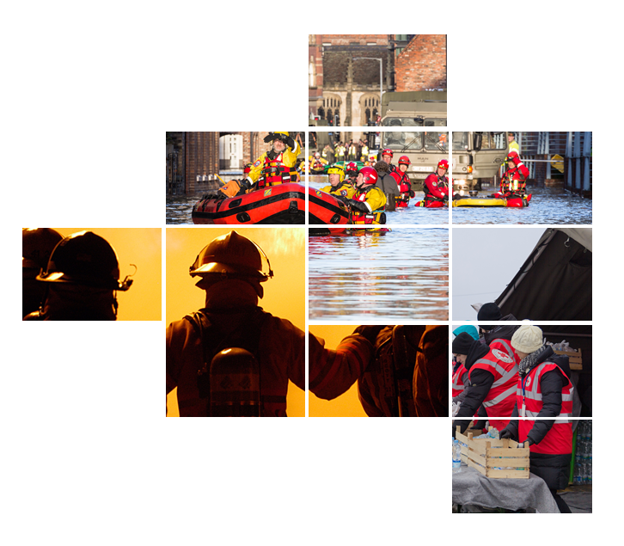

KeepOperational HAndbook
SP94 - Trials
10.04.2019
[Abstract]
[Manager]
[Company]

General

URL to use KeepOperational
https://ts.dlr.de/keep-operational/?locale=en

Log in

E-Mail: tdp@dlr.de  Password: #Tdp# | 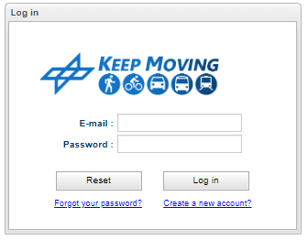

Log out
Just click on the log out button on the right hand side (red circle). A display will pop up, asking you if you really want to log out.

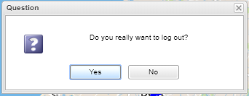

Dashboard
After Log in, the user will see following start screen.

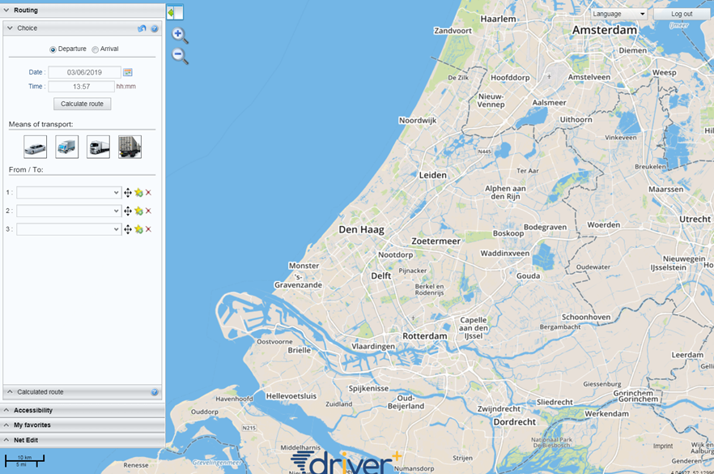
Footer
Visualization
Header
Menu area

The dashboard is divided into four areas.
- Header: The Header allows the user to change the language and to log out. It also contains the control elements for zooming ('+' and '-') on the left side.
- Visualization: The visualization displays the dynamic, georeferenced contents.
- Menu area: This area contains the functionalities (Routing, Accessibility, My favorites, Net edit)
- Footer: The footer is like the header a static content, which contains the logo of the project (middle) and the imprint (bottom right) and shows the current position of the mouse pointer in the map as coordinates (bottom right) and the scale (bottom left).

Header

Change language
On the top right in there is a selection field to change the language. Selectable languages are English, German and Dutch.

Zoom in/out
With the help of the magnifiers on the top left side you can zoom in/out.

Menu area
The menu area shows the functionalities offered. When selecting a functionality element, the respective menu item opens and shows the corresponding contents. If required, the menu area can be completely shown or hidden using the symbol: .
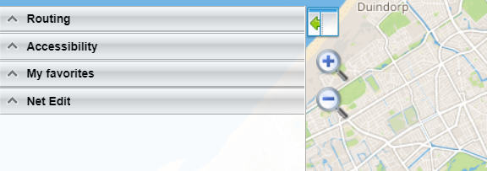

Routing
The routing can be used to query start-destination relationships with intermediate destinations via the desired means of transport at a specific time (typical weekday with time or a specific date with time), taking into account the traffic situation. The result is immediately available with a suggested route and two alternatives. In addition, start-destination relationships can also be added by directly right-clicking on the map ('Route from here' or 'Route here').
The menu item "Routing" contains two sub-items:
- Choice
- Calculated route

Choice
The "Choice" item is used to enter the information relevant for calculating the route (routing according to departure or arrival' (typical) weekday, date and time). In addition, a means of transport class (car, van, truck, truck+trailer; each represented by icons) can be selected as a boundary condition for the routing. If you move the mouse pointer over the icons, information on the respective class such as weight, width, height, length and maximum vehicle speed is displayed.
If several means of transport classes are selected because the convoy consist of different vehicles, a check mark is automatically placed in the "Convoy trip" check box. The subsequent routing then takes into account the maximum values (e.g. weight, maximum vehicle speed, etc.) of all selected means of transport classes, so that it is ensured that the routing results are equally passable for all means of transport.
In the selection area, the start and destination as well as an optional intermediate destination for the routing are offered. The input fields can be moved via the icon. To do this, keep the icon pressed behind the corresponding input field and move it up or down.
When selecting an address, the user is free to enter it via the text field or directly via the map:
A right click on the desired location on the map opens a selection. After clicking on one of the points, a flag is placed in this position and the text field is automatically filled with the correct address. | When entering an address or geo-coordinates in the text field, a selection menu opens and displays the corresponding address suggestions for the characters typed so far. The user can then assign the corresponding address to the field by clicking on the selection. A flag is then automatically set to the corresponding location in the visualization area.
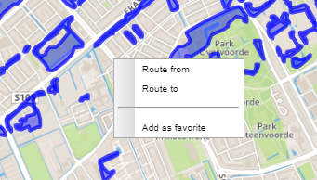 | 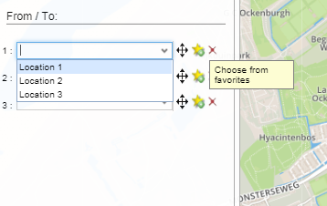
With the help of the star symbol (next to the input field) a favorite can be inserted as a route point. The list of locations saved as favorites is then available for selection. With this symbol it is also possible to save a point of the route as a favorite: After an address or coordinates have been entered in the input field and the symbol has been clicked, the dialog for saving the point as a Favorite opens. Here the user can assign a favorite name, add a comment and adjust the address if necessary.
With the symbol an already selected waypoint can be deleted.

Calculated route
After entering the relevant information for a route calculation, click the "calculate route" button. After a short time the result will be opened.
The corresponding information about the route is displayed in the menu sub-item "routing result” and in the visualization area. The user can move the mouse over the labels of the routes “Option1”, “Option2” or “Option3” to display the route. Further information can be found in the "Overview" section with the buttons "Further information" and "Route description".
If the user wants to print a route, he can do this by clicking the button “Print route”. A PDF document will be generated, which can be printed or send (e.g. to LCMS or specific Action Center).

Accessibility
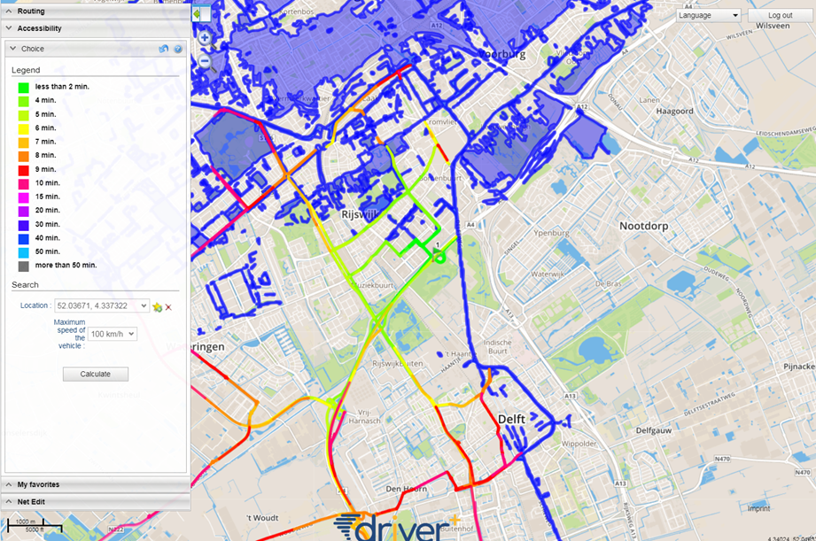
Under the menu item „Accessibility" so-called isochrones are displayed. These are lines of the same travel time which can be interpreted as rings around a point. For example, all locations with the same travel time can be read from a supply point or the travel times can be used as supplementary information for the selection of units. The information is based on current trip times.
The activation of the display of accessibility is done by selecting the location around which the isochrones are to be displayed. For this purpose an address can be entered or selected via a drop-down menu. Places saved as favorites can also be loaded for this purpose. The maximum speed of the vehicles can be specified as a boundary condition. By clicking the 'Calculate' button the isochrones are automatically displayed in the visualization area.

Net adaption
Under the menu item „Net Edit” flood masks and manually added closures (like road closures) can be displayed, created or deleted.

Display/hide flood mask
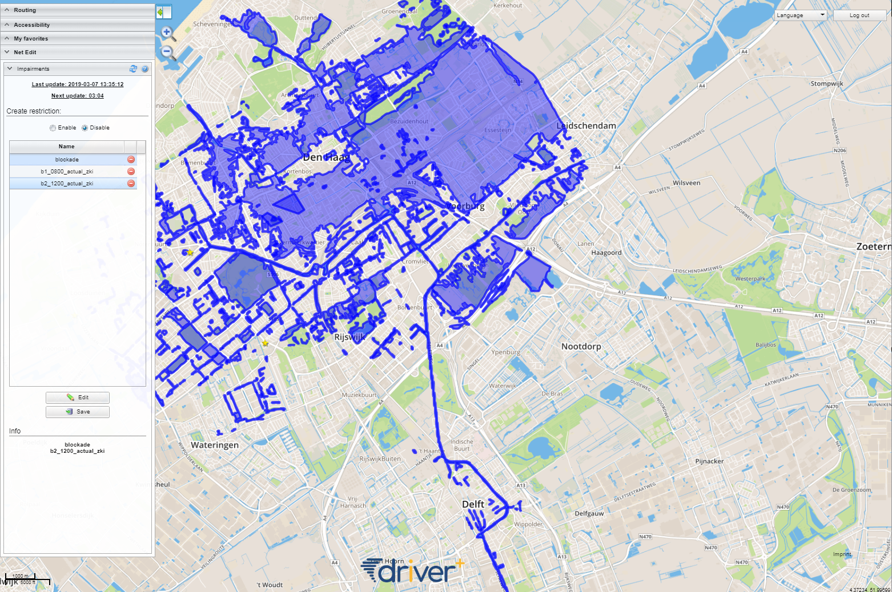
The display of the areas affected by the flood can be called up via the menu item "Net Edit". The available flood masks are displayed in a list. Flood masks following a naming convention in the Trial and can be identified by the Trial Block (b1, b2, b3, b4). Clicking on the respective list entry activates the display in the visualization window. If a flood mask is activated, the underlying information is taken into account during routing. This means, that areas affected by the flood are blocked for the routing. Depending on the size of the flood mask it might takes a few moments to activate.

Manual Closures
Apart from flood masks, manual blockages can be added. These can be road closures, destroyed buildings or others.

The adding of manual closures can be done via the checkbox “Create restriction” by clicking on “enable”. Now the user is able to create closures. For this, the user draw a shape on the map by left-clicking and confirm the shape by double-click. It is possible to draw multiple shapes. When you are finished, click save button. An input window will open and asking for a name of the closure. Again, click on the save button and the closure will appear in the list of closure. | 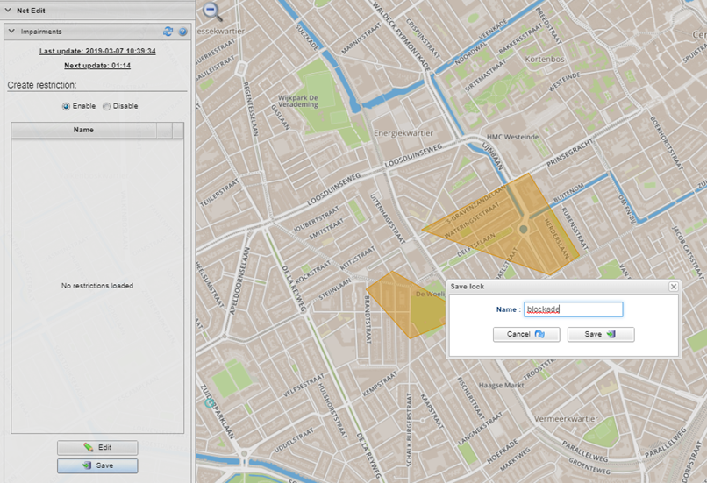
By clicking the “pencil” button you are able to edit the respective closure. Make sure that only one restriction in the list is selected and click on the edit button. By clicking the red icon, you can delete created closures. | 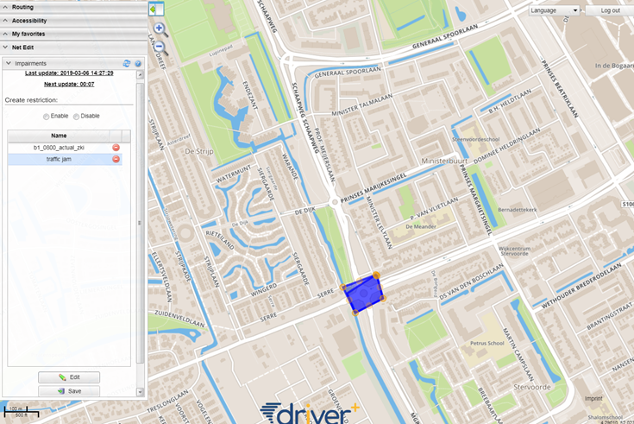

Favorites/My places
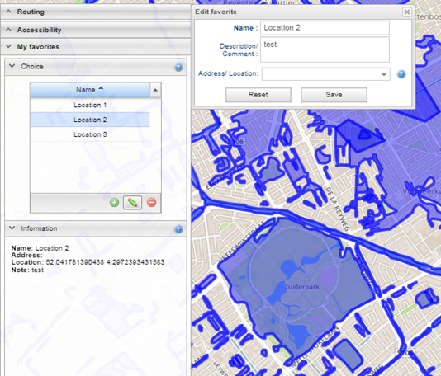
This menu item contains the option of adding, editing or deleting your own favorites such as control centres, deployment centres, supply stations, etc.
In the favorites list, multiple selection (e.g. to delete several favorites at once) is possible by marking them with the mouse while holding down the control key.
“My favorites” is divided into two areas (sub-items):
- Choice: The selection contains the already saved favorites in a selection list. At the bottom right of the list there are three icons that allow the user to create or edit new locations or delete existing locations. The functionality behind the icons can be queried by moving the mouse over them.
- Information: In the information area, the stored data such as location and optional user comment for a selected favorite are displayed. In addition to the selection option in the list, it is also possible to select a favorite via the corresponding star symbol on the map. If the mouse pointer is over the symbol, information such as the name of the favorite is displayed. By clicking on the symbol, the corresponding favorite is marked both in the selection list and on the map. On the map, a selected favorite is indicated by a blue border (). If a favorite is selected in the list, it will also be marked on the map.

Creating favorites
The user has three options to create favorites:
- Right click on the map (visualization area) and select "Add as favorite”:
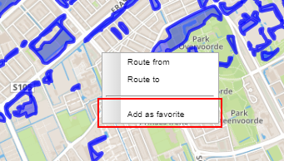 | A favorite is created at the point of the click after filling in the address, name and optionally a comment input window that opens. An address for the location on the map is automatically determined, but can be changed by entering another address or after the favorite has been created by moving the favorite (star on map) with the left mouse button.
- Click on the -Icon below the favorite list:
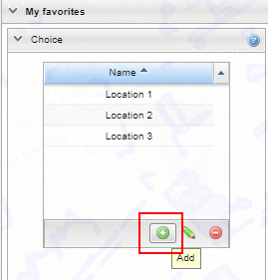 | An input dialog for entering a name, address and comment for the favorite opens. This way of creating a personal location is useful if the address of the location is known. After the favorite place has been created (clicking the "Next" button), the favorite can be moved on the map as desired.

- By clicking the symbol within the menu routing:
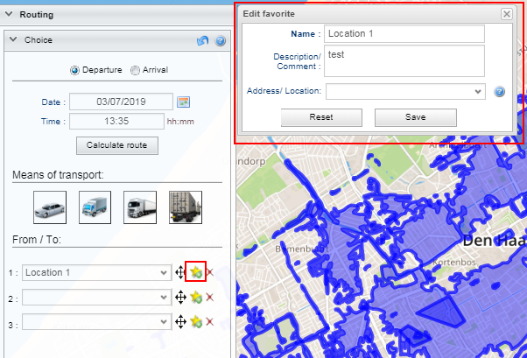 | If an address or coordinates have already been entered, the input window for saving this point opens, otherwise the favorites list below the input field opens for selecting such an address or coordinate.

Edit my favorites
The user has two options to edit his favorites:
- Clicking the „Pencil“ Icon below the favorite list:
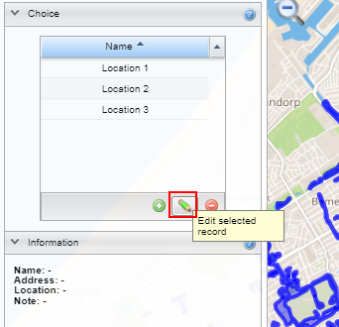
- Moving the favourite address directly in the map (the changed address will be determined automatically!):
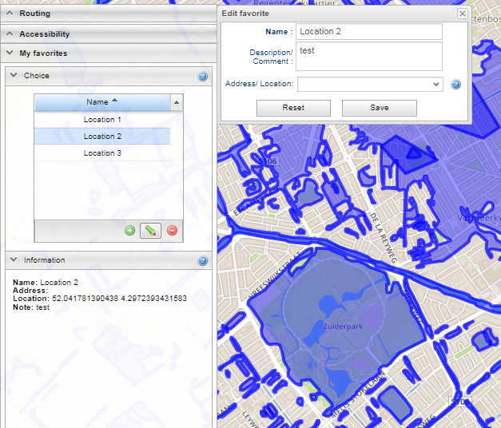
In all cases, an edit box will open with three text fields (Name, Description and Address). Name and address are mandatory fields and have to be filled. Otherwise the favorite won’t be listed.

Delete favorites
By clicking the red icon , below the selection list. This functionality also removes the corresponding star icon from the map and is secured with a confirmation.

