Driving Innovation in Crisis Management for European Resilience

NORWAY
Policy, Legislation, Organisation, Procedures & Capabilities (PLOPC) in crisis management and disaster response
Responsible Partner: MSB (Krister Arnell, Marie Norrby)

  - Scope and limitations
This study serves as supporting information for further work within DRIVER.
Only limited time and budget has been available for this first general survey, which needs to be considered in terms of scope and completeness of the respective studies.
The author/s of this study is/are responsible for its content and quality.
This report was revised at the end of 2015, reviewed internally by CSDM and amended according to reviewer's comments and recommendations upon the decision of the author/s.

Overview
Norway consists of 19 counties (fylker, singular - fylke): Akershus, Aust-Agder, Buskerud, Finnmark, Hedmark, Hordaland, More og Romsdal, Nordland, Nord-Trøndelag, Oppland, Oslo, Østfold, Rogaland, Sogn og Fjordane, Sør-Trøndelag, Telemark, Troms, Vest-Agder and Vestfold.
Each county is administered by a county council (elected by the people) responsible for local affairs, and a county governor, who is the King and Government’s representative in the county to implement the Parliament’s and Government's decisions. The county governor is appointed by the King in Council, and is responsible for the administration of national (central) affairs at the county level. There are, however, only 18 county governors, as two regions (Oslo and Akershus) are organised with a common governor. At the local level, there are 430 municipalities. The capital, Oslo, is both a county and a municipality. The municipalities are led by a popularly elected municipal board, with tax raising powers and a broad range of political responsibilities in providing local services to the population.
In the area of national preparedness, the Norwegian Directorate for Civil Protection and Emergency Planning (DSB) is to support the Ministry of Justice and the Police in its coordinating role, develop and maintain national emergency preparedness and response plans and give advice and report to the Ministry and the Government in connection with national crisis management. The Directorate was established in 2003, and its objective is to maintain a full overview of the risk and vulnerability in society, promote measures which prevent accidents, crises and other undesirable incidents, and ensure sufficient emergency planning and efficient management of accidents and crises.
The DSB provides information and advice and carries out supervision of ministries, county governors and municipalities. Research, studies and documentation related to the development of national vulnerability and the changing threat scenario make up an important part of the Directorate's work, as a basis for planning emergency preparedness, response and priorities. The Directorate plans and conducts exercises in crisis management and crisis communication for strategic management at the national, regional and local levels.
Furthermore, the DSB is the national public authority for municipal and inter-municipal fire services, the local electrical safety inspection authorities and the county governors’ emergency preparedness and response work. The DSB is also responsible for the professional and administrative follow-up of the Norwegian Civil Defence, the Emergency Planning College, the Norwegian Fire Academy and the Civil Defence's three regional schools.
The Civil Defence Organisation is an operative part of the DSB. The DSB is responsible for the education and training of Civil Defence Forces. Its activities are organised around the head office in Tønsberg and Oslo, 20 civil defence districts, five civil defence camps, five schools and five regional inspectorates for inspection and control of electrical safety.
Typical risks include weather related hazards, critical infrastructure e.g. power supplies and some geo related hazards such as landslides.

Table of Contents
NORWAY Policy, Legislation, Organisation, Procedures & Capabilities (PLOPC) in crisis management and disaster response 1788
Overview 1789
Table of Contents 1790
List of Figures 1792
List of Abbreviations 1792
1 Policy 1793
1.1 Risk Assessment 1793
1.2 Policy and Governance 1793
1.2.1 Structure of civil emergency planning 1793
1.2.2 Strategy scope and focus 1794
1.2.3 Civil military cooperation 1798
1.2.4 Monitoring and analytical support to policy making; R&D 1798
1.3 Financing 1798
1.3.1 Investing in preparedness 1798
1.3.2 Investing in consequence management 1799
1.4 Policy review, Evaluation & Organisational Learning 1799
1.4.1 Post-Disaster Assessment 1799
1.4.2 Departmental Lessons Learned systems 1799
1.4.3 Centralised (national) Lessons Learned system 1799
1.4.4 International exchange for Lessons Learned 1799
1.4.5 Regular policy reviews 1800
1.5 Resilience 1800
1.6 Information sharing and data protection 1800
2 Legislation 1801
2.1 Crisis (emergency, disaster) management concept 1801
2.2 General crisis (emergency, disaster) management law 1801
2.3 Emergency rule 1802
2.4 Specific, department/agency-level legal arrangements and regulations on emergency and disaster management 1802
2.5 Specific to the regional and local authorities legal arrangements and regulations on emergency and disaster management 1802
2.6 Legal regulations on the involvement of volunteers and specialised NGOs 1802
2.7 Legal regulations for international co-operations 1802
2.7.1 Nordred agreement 1803
2.7.2 NORDEFCO-Nordic Defence Co-operation 1803
2.7.3 Haga declaration 1803
2.7.4 Haga declaration II – a robust nordic region 1804
2.7.5 Nordic Medical agreement 1804
3 Organisation 1805
3.1 Organisational chart 1805
3.2 Organisational cooperation 1807
4 Procedures 1808
4.1 Standing Operating Procedures (SOPs) and Guidelines 1808
4.2 Operations planning 1808
4.3 Logistics support in crises 1808
4.4 Crisis communication to general public; Alert system; Public Information and Warnings 1808
5 Capabilities 1809
5.1 Human resources 1809
5.2 Materiel (non-financial) resources 1809
5.3 Training 1809
5.4 Procurement 1810
5.4.1 Procurement regulation 1810
5.4.2 Procurement procedures 1810
5.5 Niche capabilities 1810
Resources 1811
Legislative acts 1811
Other normative acts 1811
Official documents (white papers, strategies, etc.) 1811
Online resources (e.g. websites of key CM organizations) 1811
Publications 1812
Expert interviews 1812

List of Figures
Figure 1: Principle lay out of Norway’s international co-operation within crisis management 1803
Figure 2: Organisation of a major rescue operation. 1805
Figure 3: General lay out of how Norway organise its Crisis Management. 1806

List of Abbreviations
CTIF | International Fire and Rescue Service Association
DSB | [Norwegian] Directorate for Civil Protection
SSB | Statistics Norway

Policy

Risk Assessment
Risk assessments are done by all levels in the public sectors.
Local level: 434 municipalities
Regional level: 19 County Boards, 5 Hospital Regions, 27 Regional Police authorities
National level: All governmental agencies

Risk assessments are also done by the private sector that can affect the population and environment like Seveso plats and Energy sector.

Policy and Governance
Norway is a constitutional monarchy. The executive power rests formally with the King, but in practice with the government, and the legislative power rests with the unicameral parliament. The King, with the parliament’s approval, appoints the government, and both the prime minister and each cabinet minister are judicially directly responsible to the parliament. Each minister is normally in charge of a ministry, which is responsible for carrying out public administration in his or her field. The regional level consists of 19 counties, the county governor being the highest representative of the central government. There are however, only 18 county governors as two regions (Oslo and Akershus) are organised with a common
Governor. At the local level there are 430 municipalities. The capital, Oslo, is both a county and a municipality. The municipalities are led by a popularly elected municipal board, with tax raising powers, and a broad range of political responsibilities in providing local services to the population.

Structure of civil emergency planning
The concept of Total Defence is still a guiding doctrine in Norwegian crisis emergency planning (CEP). However, the focus of the concept has changed, from mobilization of all national resources in support of an all-out military struggle, to a focus on societal security. Total Defence is now broader and a two-way street, where civilian resources can provide support in the time of military crises, and the military is operationally prepared to assist civilian society in times of need, regardless of whether this is due to man-made or natural disasters. Societal security is defined as safeguarding the population and key societal functions and infrastructure against attack or damage where the existence of the country is not threatened. The work on safety and security in society is furthermore based upon the principles of liability, decentralisation and conformity. Together these principles are the foundation for establishing efficient crisis prevention and crisis management. Crisis in regard to nuclear accidents are handled by a specific organisation called “atomberedskapsorganisajonen” (nuclear readiness organisation)
- The principle of liability states corresponding responsibility either when dealing with a normal everyday situation or an extraordinary situation. This principle applies to all public and private activities. In addition, each citizen is responsible for his or her own safety. Responsibility for the functions of normal, everyday activities, will presumably improve the ability to handle critical situations. Thus, each ministry is responsible for emergency planning within its own sector. However, the Ministry of Justice and the Police has been given a more distinct responsibility for coordinating the administration of work on safety, security and emergency planning within the civil sector in general.
- The principle of decentralisation states that the responsibility for crisis management should be handled at the lowest possible level.
The principle of conformity states that society must be able to operate in accordance with normal standards no matter what challenges it is exposed to, and that the structures of responsibility are maintained in extraordinary situations.
- Holistic and coordinated crisis management centrally, regionally and locally.

Strategy scope and focus
The politically defined objectives for the work on safety and security of Norwegian society are based on the notion that emergencies should be prevented, and that emergencies that arise should be tackled in the best way possible. Basically, society must be able to meet any threat and handle any situation that may occur. The central objective is ensuring that interruptions to important societal functions and large accidents will not entail large societal losses, to initiate measures preparing society to meet any challenge and securing emergency planning in general. The government has been working on strengthening the following:
- Preventive activities, including health, environment and security work.
- Ensuring that agencies with emergency responsibilities are able to tackle major incidents, including acts of terrorism and/or mass destruction.
- Coordinated and purposeful work with regard to ensuring critical infrastructure protection.
- Increased cooperation, including plans and exercises, between civil and military authorities.
- The ability of intelligence and security services to analyse, warn and prevent different forms of terrorism in Norway.

Crisis emergency planning organisational structure
The executive authorities must at all times be prepared to manage any crisis that may occur. A basis for crisis management is the corresponding responsibility when dealing with a normal everyday situation or a crisis situation or war. This is in accordance with the principles of liability and decentralisation previously mentioned. However, in 2006 the government decided to strengthen the central crisis management by introducing 3 strategic elements. First, a ministerial level council to improve crisis coordination was created in what has been named the Government Crisis Council. Secondly, a clarification of overall responsibility for crisis management at the central level was established through the concept of a Lead Ministry. And thirdly, a support and assist function for the Lead Ministry and the Government Crisis Council is the task of the Crisis Support Unit.
The Government Crisis Council is chaired by the Secretary General in the lead ministry and is the top-level strategic coordinating body during crises in which there is a need for extensive coordination among several ministries. The Government Crisis Council handles coordination of affected ministries and furnishes coordinated information and necessary documentation to the government. All ministries must be prepared to accept the role of the lead ministry. The selection of the lead ministry is based on the principle of “most affected ministry” given the nature of the crisis, and the ministry that has best access to information and policy instruments for managing the crisis. The appointment of the lead ministry does not change constitutional responsibilities. The lead ministry is responsible for the regular coordination of crisis management at the ministerial level. In a crisis situation, the lead ministry shall:
- draw up coordinated situation reports.
- identify and assess the need for measures at the national level.
- handle necessary coordination with other ministries.
- ensure that coordinated information is given to the media and the population.

If there is uncertainty about which ministry is to coordinate crisis management, the prime minister in consultation with the relevant ministers will appoint the lead ministry in accordance with a recommendation from the Government Crisis Council. In such situations, the Ministry of Justice and the Police shall take the necessary initiative until something else is decided. With assistance from the Crisis Support Unit, the lead ministry will assume the secretariat function for the Government Crisis Council.

Ministry of Justice and the Police
The Ministry of Justice and the Police has a particular responsibility for coordinating the administration of work on safety, security and emergency planning in the civil sector in general. This includes responsibility for developing new national guidelines, making principal decisions regarding the Norwegian civil preparedness system, as well as administrative responsibility for the search and rescue service (SAR). However, each ministry is responsible for planning within its own sector. In most cases where central crisis management is necessary, the Ministry of Justice and the Police will be appointed lead ministry.

Directorate for Civil Protection and Emergency Planning (DSB)
In 2003, the government established the Directorate for Civil Protection and Emergency Planning consisting of the former Directorate for Civil Defence and Emergency Planning and the former Directorate for Fire and Electrical safety. The purpose was to create a basis for a wider range of expertise within the field of safety and security, and a common structure of authority from national to local level for the administration of fire, rescue and emergency planning. The directorate is the executive body of the Ministry of Justice and Police with regard to civil emergency preparedness, and its formation is intended to result in more efficient use of resources and give the Ministry of Justice and the Police a more distinct role concerning the collective emergency and rescue services. The directorate’s objective is to maintain a full overview of risk and vulnerability in society, promote measures that prevent accidents, crises and other emergencies, and ensure sufficient emergency planning and efficient management of accidents and crises.

Civil defence
The Civil Defence Organisation is an operative part of the DSB, and divided into 20 regional districts. 50,000 individuals serve in the Civil Defence Organisation, and about one third of these forces are ready to be utilised for peacetime emergencies. The DSB is responsible for the education and training of civil defence forces, which in peacetime are an important supplementary resource to the police and other emergency and rescue services, and regional and local authorities.

County governors
The county governors coordinate and supervise crisis emergency planning in their regions. The regional administration promotes emergency planning at the local level and participates in the planning of support of the military forces, as well as being responsible for environmental issues, agriculture and the inspection of municipal administrations. In a major crisis the county governor may also be responsible for crisis management coordination, and this authority increases greatly in times of war.

Municipalities
The municipalities are responsible for key societal services, and ensuring the continuation of these services during emergencies. This applies to local infrastructure, health services, care for the elderly and information to the public. The municipalities have primary responsibility for dealing with any peacetime emergency. Important tools in this respect are risk and vulnerability assessments and establishing local crisis management plans. All municipalities are required to have a fire service, and this is the municipality’s primary resource for handling both fires and/or other types of emergency. Additionally, the municipalities are required by law to undertake civil emergency preparations for the health sector.

The police
The police are tasked with securing people, property, order, and public safety. It is the responsibility of the police to deal with accidents and incidents where life and health are at risk, and to ensure measures to avert danger and limit consequences. Crime prevention and investigation are also an important part of the societal safety and security work. Police reserve units may be used during major emergencies and disasters. Furthermore, the Police Directorate has an operative staff that may be established during major emergencies or acts of terrorism.

The rescue service
The Norwegian Search and Rescue (SAR) service maintains an integrated coordination structure, which means that each joint rescue coordination centre is prepared to handle land, sea or air operations, rescue operations on offshore oil or gas installations, as well as operations requiring international cooperation. The collective SAR management at the two rescue coordination centres located in Bodø and Stavanger, and the rescue sub-centres lead and coordinate search and rescue operations within their respective areas. These centres consist of representatives from a number of government agencies who (together with the local chief of police who is in overall command) lead and coordinate search and rescue operations within their respective areas.

Military defence
The armed forces have the task, enshrined in the relevant laws and regulations and within the limits of their
competence and available resources, of providing support to society and the civil authorities in the event of major accidents, rescue operations, natural disasters and other situations posing a threat to life or health, or involving the risk of material damage. The armed forces must be capable of helping to prevent and counter possible assaults and attacks on the country’s inhabitants, infrastructure and management functions. For instance, the armed forces conduct border guard activities along the Norwegian-Russian border in Finnmark. Armed forces units take part in search and rescue operations, and the Norwegian Coast Guard conducts maritime surveillance and control of Norwegian territorial waters and in the exclusive economic zone.

Voluntary organisations
Voluntary organisations provide important contributions during accidents at a local level, as well as emergency aid to other countries. Norway have nine voluntary rescue organisations on a national level, they are organised in “Frivillige Organisajoners Redningsfaglige Forum” (FORF) (Voluntary organisations Rescue For a)
Den norska räddningstjänsten är lokalt förankrad och bygger till stor del på frivillighetsorganisationer. Norge har nio frivilliga räddningsorganisationer på nationell nivå som finns samlade i Frivillige Organisasjoners Redningsfaglige Forum (FORF).
These organisations are:
- Norges Røde Kors Hjelpekorps (Red Cross)
- Norsk Folkehjelp Sanitet (Medical assistance)
- Norske Redningshunder (Rescue dogs)
- Sjøredningskorpsene til Redningsselskapet (Sea rescue)
- Rovernes Beredskapsstyrke (Home guard)
- Norske Alpine Redningsgrupper (Alpine rescue=
- Norsk Radio Ræle Liga (Radio support)
- Norsk Aeroklubb (Aeronautical support)
- Norsk Grotteforbund (Cave rescue)
In total these organisations has some 10 000 volunteers and in total some 500 local operative units. The majorities of the Norwegian municipalities (approx 350) host one or several of these organisations.
The local connection makes it possible for these organisations to function effectively in case of disruptions in the infrastructure such as road network and communications. The voluntary organisations has some niche capabilities when come to operating in open terrain with good sustainability. This capability is often used when it comes to save life’s.

Intelligence, counter-intelligence and security services
These services have responsibilities both in preparations against threats to important societal values and in relation to crisis management. Focus is on prevention against a broad spectrum of societal threats, and they consist of the Defence Intelligence Service, the Police Security Service and the National Security Agency.
The National Security Agency reports both to the Ministry of Defence, as its superior authority, in cases concerning military matters and to the Ministry of Justice and the Police, as its superior authority, in cases concerning the civil matters.

Civil military cooperation
Civil military cooperation in Norway is based on the Total Defence concept, which states that there will be a “total mobilisation of all possible civil and military resources to maintain the will to defend oneself, to offer the greatest possible resistance to aggression, to protect life and health, to maintain an organised society and to prevent damage caused by peacetime crises and/or war”. Greater emphasis is now being placed on armed forces support to civil communities. In crisis situations in peacetime, this support will normally take the form of supplementary assistance to the civil authorities when the crisis is of such a nature that the particular authority responsible for that sector is unable to manage the crisis on its own. The concept implies interdependence and close cooperation between civil preparedness and military defence. Civil preparedness measures may be used during peacetime in efforts to avoid or limit serious incidents when sufficient aid cannot be obtained from the ordinary aid organisations. In addition, civilian defence provides assistance to the police, fire brigades, health services and other public bodies and non-governmental organisations. Furthermore, in the case of a full military mobilisation the army will need substantial resources from civilian society, and it is therefore of vital importance that civilian society functions well in order to both supply the military and keep everything else running.

Monitoring and analytical support to policy making; R&D
DSB provides studies’, auditing and guidelines along with the county boards. There is also for example FFI, Norwegian defence research institute.

Financing

Investing in preparedness
No aggregated sums have been identified since it is various authorities at local level that fund different sectors of preparedness. Some statistics at national level can be found at www.ssb.no

Investing in consequence management
For the private sector most have companies have insurance.
For the public sector the state pays when there has been a major rescue operation. All other sectors have to pay their own costs. The “polluter pays” is the fundamental rule.

Policy review, Evaluation & Organisational Learning

Post-Disaster Assessment
Individuals get help from the municipality. POSOM groups (group that consists of representatives from various municipality sectors and other societal functions such as church) and other personal help are organised so that if need you get a temporary shelter. Voluntary organisations, like the Red Cross are also assisting.

Departmental Lessons Learned systems
The municipalities and county boards have a common organisation to share different experience.

Centralised (national) Lessons Learned system
There is no single centralised system. Every sector and agency has their own responsibility. SSB, Statistics Norway, is the national agency that collects statistics from a variety of sectors. Some sectors like Dangerous Goods have several agencies and actors that collect statistics and experiences. Below are some examples.
In the spectra of social and health care there is a national lessons learned system, both for the municipalities and Hospital areas.
To investigate major accidents DSB provides reports and recommendation to improve and provide opportunities for lessons learnt.

International exchange for Lessons Learned
Some examples:
DSB, together with other governmental agencies, arrange observation studies when they identify incidents of interest to learn from.
The Nordic countries have also ongoing cooperation in different areas. Nordred Agreement (www.nordred.org), HAGA declaration (named after castle) and Nordhels (www.nordhels.org) are some of them.
CTIF is an international organisation that has national sub-organisation. The purpose is to learn from each other and incidents that has append, from fire to hazardous materials. http://ctif.org/

Regular policy reviews
After every election there is a review of the Risk and vulnerability analysis. The level of ability is then reviewed and the new policies are set at the local level.

Resilience
Responsible for working with the protection of vital services and critical infrastructure rests in accordance with the principle of responsibility of each sector, as well as the owners and proprietors of businesses.
At the national level a national strategy and action plan for the protection of vital infrastructure as well as guidelines has been produced.

To ensure at structured approach to resilience implementation Norway has adopted standard NS-ISO 22301.

Information sharing and data protection
Personal information Law (PUL) and Inspire directive are implemented.
Each municipality have responsibility to ensure the safety of it citizens. The Social office, in the municipality is always involved when evacuation needs to be done.
Each sector is responsible to comply within the law, and secure that necessary information can be chaired.
Each citizen has the right to know what kind of threats that normally exist within the municipality, like the risks for flooding or Seveso plants.

There is no national register of voluntary personnel. Every Voluntary organisation in itself has its own register of members.
One example is FORF, Non-Profit Organisations’ Rescue Forum, which organizes several voluntary organisations.
Kriseinfo.no is a web site that gathers information on regular bases from different sites, regarding different warnings and information to the public about how to be prepared and find information.

Legislation

Crisis (emergency, disaster) management concept
The foundation of CM manifested in the Norwegian law.
The responsibility principle
The person or organisation that is responsible for an activity under normal conditions is also responsible for such operations in an emergency situation.
The equality principle
Operations should, as far as possible, be organized in the same way during emergency situations as under normal conditions.
The proximity principle
Emergencies should be handled at the lowest possible level in society. On a central level the Government is the body responsible for this area, on the regional level it is the County Administrative Board and on the local level it is the municipalities.

In the different legislation rolling at all levels and sectors, the method to cope with a major incident is based on cooperation.

General crisis (emergency, disaster) management law
Legislation concerning Norwegian civil emergency planning may be divided into two pillars consisting of acts, prepared delegations of powers for law-making, regulations and directives. The first concerns the protection of the population in times of hostile acts and war, and the second relates to peace-time emergencies. The following acts provide the main framework for administrative operations in times of crisis/war:
- The War Act of 15 December 1950
- The Supplies Act of 14 December 1956, made valid for a peacetime crisis in 1974
- The Act on Civilian Defence of 17 July 1953. This act applies both in war and during peacetime, and is currently under revision.
- The Security Act of 20 March 1998
- The Act of Social and Health Preparedness of 23 June 2000
There is no overall legislation concerning civil protection in peacetime. Many government agencies and private organisations do however have civil protection tasks and are responsible for civil emergency planning, and every part of the administration must ensure that the necessary detailed emergency plans are put into effect. This is mainly regulated through laws and regulations concerning specific sectors.
The following legislation is important in this regard:
- Police Act of 4 August 1995,
- Fire Protection Act of 8 December 2000, implemented on 1 January 2001.
- The Fire and Explosion Prevention Act of 14 June 2002
- The Planning of Buildings Act of 14 June 1985, amended 24 November 2000
- Protection Against Pollution Act of 13 March 1981
- Regulation of 4 July 1980 on the main principles for the organisation of the Search and Rescue Services
- A new Act proposed on Municipal Responsibility for Sectorial Risk, Vulnerability Assessment and Emergency Plan, that was implemented 1 January 2010

Emergency rule
Municipalities’ Rescue Services always have to have an incident commander. The incident commander has far reaching powers to engage people and resources that he/she need to handle the incident, but not without paying for it.
The Hospital area´s representative in the health care authorities during a pandemic or for specified dangerous diseases also have far reaching powers, for example to isolate people.

Specific, department/agency-level legal arrangements and regulations on emergency and disaster management
DSB is a national coordinator to help the municipalities and other actors to facilitate the management of the incident. Regarding legal arrangements and regulations see 2.2.

Specific to the regional and local authorities legal arrangements and regulations on emergency and disaster management
None

Legal regulations on the involvement of volunteers and specialised NGOs
There is no specific legislation regarding NGO´s involvement, but is on voluntary base, the “Frivillige Organisasjoners Redningsfaglige” Forum, forming a cooperation with nine major organisations.

Legal regulations for international co-operations
There is a number of different agreements that regulates the international co-operation, especially in the Nordic area. Norway also works actively within UN, NATO and EU. DSB is the focal point that co-ordinates international co-operation. Within EU Norway is a partner of the European Union Civil Protection Mechanism.
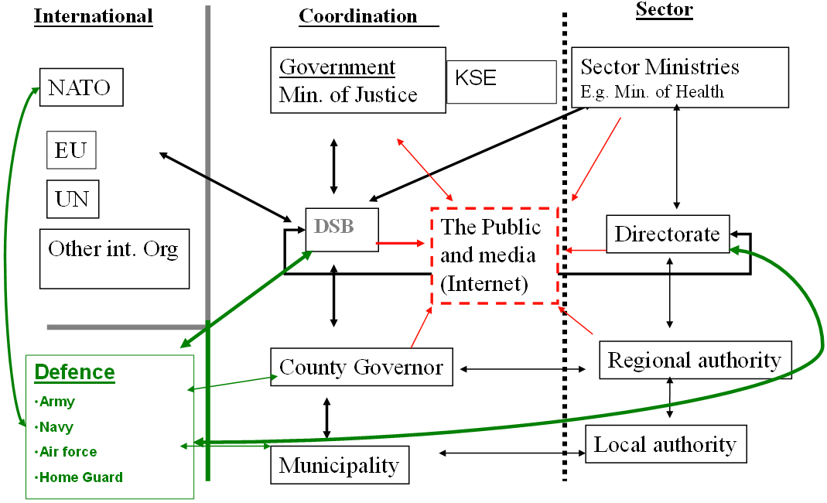
Figure 69: Principle lay out of Norway’s international co-operation within crisis management

Nordred agreement
This is a framework for co-operation regarding rescue operations between the Nordic countries. It is a meant to prevent accidents and reduce injuries to people, property and the environment. Participating countries are Denmark, Finland, Iceland, Sweden and Norway. The agreements article 6 regulates the states obligations:
- Inform on new legislations and organisation within the rescue area
- Contribute to development and co-operation regarding rescue capabilities
- Ensure active contacts with necessary agencies and arrange meeting when necessary.

NORDEFCO-Nordic Defence Co-operation
The NORDEFCO-agreement is aiming at strengthen the countries defence capabilities, identify synergy effects in the defence area and to foster efficient solutions. Members are Sweden, Finland, Denmark, Iceland and Norway.

Haga declaration
Haga Declaration of 2009 aims to enhance the Nordic cooperation to prevent, reduce and manage the consequences of major accidents and disasters. The declaration covers the following areas:
- Rescue services
- Training and education
- CBRN-Develop the capability to handle major accidents in this area
- Crisis communication to the general public
- Exchange experiences regarding volunteer organisations use in crisis management
- Research and development

Haga declaration II – a robust nordic region
This agreement from 2013 aims at even further developing the Nordic countries ability to prepare for and handle societal disruptions.

Nordic Medical agreement
This agreement aims at reinforce the ability to assist each other with medical assistance when the country’s own resources is not enough.

Organisation

Organisational chart
A schematic skis of how a major rescue operation can be organised

Figure 70: Organisation of a major rescue operation.
- National/ IO authority for emergency and disaster management; chain of command and high-level decision-making:
The incident commander is the commander during a rescue operation. The Commander can request more recourses and help. All tactical and operational decisions rest at the local level even when there is a crisis. The politicians may need to make funding available to handle the incident.
- Interdepartmental (inter-ministerial) emergency and disaster management authority:
The ministries have a group to keep them informed. DSB and other affected agencies inform the government on regular base during a major incident. They can make more resources available, if necessary.
- National permanent emergency and disaster management unit(s)/ formations; first responders:
There are no national First responders, except for:
Special police forces, mountain rescue, sea rescue, nuclear accident and maritime environment rescue operation.
- Planned/ anticipated use of specialised military assets:
Civil agencies and rescue service can ask for the recourses the military have. The local first responder’s organisations may also have pre planned cooperation, and then the military, if they agree to help, is under the command of the incident commander.
- Departmental emergency and disaster management arrangements:
Each department need to have their own disaster management arrangement, including pre planned cooperation with others. It is each organisations own responsibility.
- Other national civil service organisations:
DSB is appointed to coordinate and encourage cooperation between national civil service organisations: special police forces, mountain rescue, sea rescue, nuclear accident and maritime environment rescue operation.
- Provincial (regional) authorities and arrangements for emergency and disaster management:
County Boards, Hospital Areas and municipalities are obliging to plan. Local (municipal, town) authorities have arrangements for emergency and disaster management
- Volunteers and volunteer organisations; specialised NGOs:
Frivillige Organisasjoners Redningsfaglige” Forum organises voluntary organisations that have capacity to be engaged in search and rescue operations both on land at sea. They also have flying capacities to conduct visual reconnaissance.
- Private businesses:
Private businesses are obliged to protect themselves and their property. They are also obliged to prevent further damages, if possible.
In some sectors there are more regulations, transport of dangerous goods, Seveso plats, energy sector etc.
Below is a scheme showing key players and their relationships. The support is going towards the incident commander at the local level. The levels are not chain of command or a hierarchy; it is a way of describing local, regional and national agencies and their respective responsibilities.

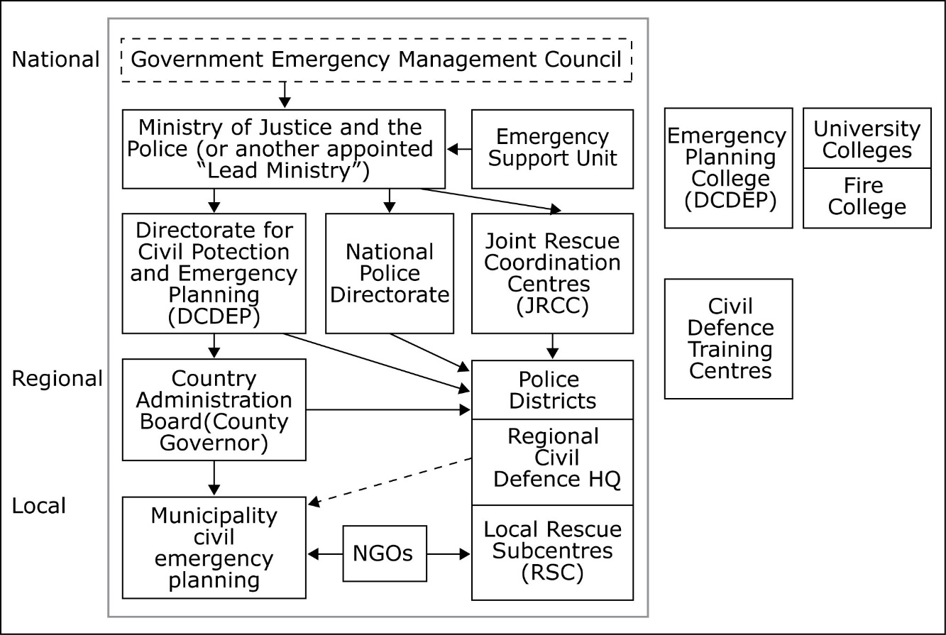
Figure 71: General lay out of how Norway organise its Crisis Management.

Organisational cooperation
- Operational cooperation (e.g., coordinated CM operations planning and response at national level, cross-border operational cooperation, operational cooperation within the EU)
  - How priorities are assigned in the case of simultaneous occurrence of events?
The municipalities prioritise, together with the incident commander, the resources. The County Board can support with prioritization of national and international recourses.
  - How cross-border collaboration is organized?
Under the Nordred agreement, municipalities on both sides of the border have local agreements. They have been authorised by the Nordic countries governments to sign agreements on cooperation in the aim of assisting each other, both in crises and during smaller incidents, like fires and traffic accidents.
- Cooperation and coordination in CM capability development (coordinated departmental CM capability planning, nationally centralized CM capability planning, multi-nation/ EU-level coordination of capability planning and capability development)
Cooperation is vital to handle all incidents. The incident commander is responsible to organise the cooperation and all parties are responsible to cooperate and make resources available for the incident commander. Every sector is responsible to handle their part of the incident.
Cooperation is a vital part of the legislation in the Nordic countries legislation. The Nordred agreement and Haga declaration means that there exists several on gong cooperation, both at local, regional and national level. CM is a challenge due to the decentralised CM system. There is an ongoing exchange of experience and sharing of knowledge.
On EU-level DSB is represented in the Module group discussing mainly HNS, Host Nation Support, and the EU Civil Protection Mechanisms Voluntary Pool.

Procedures

Standing Operating Procedures (SOPs) and Guidelines
Depending on the risk and responsibility each organisation has SOPs or not. There are guidelines and handbooks that DSB produce for the municipalities rescue service to use. Other sectors have their governmental agencies that produce handbooks and guidelines.

Operations planning
Depending on the risk and responsibility each organisation has its own operations planning. The auditing that the County Boards and DSB do of the plans for operation, highlight the organisations that do not meet a minimum level of safety that the public can expect.

Logistics support in crises
Depending on the outcome of the risk assessment and the organisations responsibility each organisation has to plan for their own needs of logistics support.

Crisis communication to general public; Alert system; Public Information and Warnings
There are national procedures how to alert municipalities, county boards and central alarm system.
Kriseinfo.no is a web site that gathers information on regular bases from different sites, regarding different warnings and information to the public about how to be prepared and find information.

Capabilities

Human resources
https://www.politi.no/nord_trondelag/redningstjeneste/Tema_920.xhtml
Civil defence has 8 000 men and women that are educated and exercised divided in to 20 districts.

Materiel (non-financial) resources
- What specific non-financial resources (dedicated equipment etc.) have been allocated to crisis management (central, regional, local preparedness and response)?
-All sectors and levels have their own pre planning to handle an emergency.
-DSB has helicopters that can be used in forest fires.
-The energy sector has their recourses, like personnel on call.
- Permanent reserve stocks (fuel, food, medicines, tents, blankets, etc.)
- Stock of medicines (Nationally funded)
- Municipalities and County Council may have their own.
- Planned /anticipated/ involvement of specific military assets (e.g. reconnaissance assets, search and rescue helicopters, fire-fighting planes/helicopters, CBRN, etc.)
-These assets exist among civil agencies like the Norwegian Coast Gard, Police, and Rescue Services.
- Incident commander during a rescue operation, can if deemed necessary mobilise or commandeer private assets during crises.

Training
- National, local and departmental exercises
-DSB organises a table top cries management exercise every third year for national agencies.
-Every County Board organise on regularly base table top exercise in their respective region.
-Every municipality organise on regularly base table top exercise in their respective region.
http://www.sivilforsvaret.no/Distrikter/Nord-Trondelag/Samvirke/LRS-aktiviteter/Ovingsutvalg-i-lokal-redningssentral-LRS/
- Centralised specialist training
-DSB organise training for UN, EU, Norwegian national, regional and local agencies.
- Training of volunteers and NGO personnel
-FORF among other voluntary organisations organises training, with funding from DSB
- Cross-border and multinational training activities
-Barents Rescue is a major exercise between Sweden, Norway, Finland and Russia every third year. But there are many other exercises done every year.
- Is there a certification system? What standards are used to define specialists' training requirements?
- Norway does not have a certification system for specialists training requirement. The employer may implement ISO standards if they find it appropriate.

Are there specialised training programmes for high-level decision makers?
-Courses are offered in crisis management and crisis information.
- Strategic Crisis Management, 5 meaning
-Civil Protection, Emergency Planning, and Civil and Military Cooperation, 5 ECTS
National training centres
National Emergency Planning College
The college is organised under DSB
Norway’s fire academy http://nbsk.no

Procurement

Procurement regulation
- What needs to be procured? E.g. goods or services, including trainings?
Procurement regulation in the public sector is strict. Best value for many is the basic rule. Cooperation between the different agencies in the public sector is however encouraged
- Which EU directive on procurement is applicable on procurement of CM tools and related? Are all articles of the directive applicable or are some articles not implemented?
-All articles are implemented and needs to be followed. If it is a sudden unexpected crisis you are allowed to buy what you need to handle the situation.

Procurement procedures
The public sector at all levels has their own procurement organisation that deals with procurements. A common web site www.anskaffelser.no is available for national an agency.

Niche capabilities
JRCC has flying capacities for sea rescue operations.
www.hovedredningssentralen.no/english/
Civil defence has resources, organised in to 20 districts.
The Norwegian Coast Guard

Resources

Legislative acts
The Police Act of 4 August 1995
The Fire Protection Act of 8 December 2000
The Fire and Explosion Prevention Act of 14 June 2002
The Planning of Building’s Act of 14 June 1985, amended 24 November 2000
The Protection against Pollution Act of 13 March 1981
The Regulation of 4 July 1980 on the Main Principles of the Organisation of the Search and Rescue Services
The Act on Municipal Responsibility for Sectorial Risk, Vulnerability Assessment and Emergency Plan, 1 January 2010.

Other normative acts

Official documents (white papers, strategies, etc.)
There are a rage of recommendations and handbooks in different areas to support the local and regional levels both private and public sector.
Some of them are collected at the websites below.
www.regelhjelp.no
http://oppslagsverket.dsb.no/
http://www.beredskapsnett.no/

Online resources (e.g. websites of key CM organizations)
www.dsb.no
www.politi.no
www.forf.no
www.nordhels.org
www.sivilforsvaret.no
www.Kriseinfo.no

Publications
There are a range of recommendations and handbooks in different areas to support the local and regional levels both private and public sector.
Some of them are collected at the websites below.
www.regelhjelp.no
http://oppslagsverket.dsb.no/
http://www.beredskapsnett.no/

Some examples:
Veiledning til forskrift om organisering og dimensjonering av brannvesen, DSB
Retningslinjer for varsling og rapportering på samordningskanal, DSB
Systematisk samfunnssikkerhetsog beredskapsarbeid i kommunene, en veileder fra Direktoratet for sivilt beredskap

Expert interviews
Norwegian Directorate for Civil Protection, DSB

https://www.regjeringen.no/globalassets/departementene/fd/dokumenter/rapporter-og-regelverk/fd_stotte-samarbeid_web_april.pdf
https://www.msb.se/RibData/Filer/pdf/24677.pdf
https://www.regjeringen.no/globalassets/departementene/fd/dokumenter/rapporter-og-regelverk/fd_stotte-samarbeid_web_april.pdf
https://www.regjeringen.no/globalassets/departementene/fd/dokumenter/rapporter-og-regelverk/fd_stotte-samarbeid_web_april.pdf
http://ec.europa.eu/echo/files/civil_protection/vademecum/no/2-no-1.html#over
https://www.regjeringen.no/globalassets/departementene/fd/dokumenter/rapporter-og-regelverk/fd_stotte-samarbeid_web_april.pdf

