Driving Innovation in Crisis Management for European Resilience

DENMARK
Policy, Legislation, Organisation, Procedures & Capabilities (PLOPC) in crisis management and disaster response
Responsible Partner: ECORYS (Laura Birkman, Linette de Swart and Rachel Beerman)
  - Scope and limitations
This study serves as supporting information for further work within DRIVER.
Only limited time and budget has been available for this first general survey, which needs to be considered in terms of scope and completeness of the respective studies.
The author/s of this study is/are responsible for its content and quality.
This report was revised at the end of 2015, reviewed internally by AIT and amended according to reviewer's comments and recommendations upon the decision of the author/s.

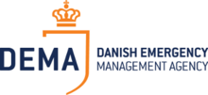

Overview
In 2009, Denmark adopted the Emergency Management Act. This act is detailing all aspects of crisis management. The crisis management approach of Denmark assumes the local level to be better placed to tackle local crisis situations than the national level. Private organisations, volunteers and NGO’s participate in Danish crisis management. In particular, Falck Redningskorps Ltd., a large private Danish rescue and fire company operates on a contractual basis within many of the Danish municipalities.

Danish Civil Protection League is also supporting, as a non-profit organisation, with 5,000 members. Also the Danish Red Cross acts in crisis situations. But the major national organisation, also international contact point, is the Danish Emergency Management Agency or DEMA. DEMA handles different aspects of the crisis management policy cycle.

DEMA is organised in four core areas, each covering a part of the Danish emergency response from prevention (inspection, counselling, supervision and development of national rules and laws preventing fires and explosions, Emergency planning (supervision of other governments and private companies on preparedness planning), Operational (National Division, International Division, Chemical Division and Nuclear Division and training (via the centre for Education and HR Development).

The Danish national accounts do not clearly provide an overview on the costs they make to invest in preparedness. Therefore a rough estimation has been made to provide a general idea. The Danish Parliament (Folketing) decides on the Police budget. The Parliament sets the Police budget for a 4 year period. In the period 2007-2010 the available annual budget was DDK 7.5 billion (1,008 million euros). The fire services are partially provided by public providers and partially by private operators. The only private operator in Denmark is Falck, providing firefighting services for 2/3 of the municipalities in Denmark according to their latest annual report (2013). Besides firefighting services Falck is also responsible for 85% of all ambulance service provided in Denmark. Of the total revenue made in 2013, 46.6% was made in Denmark. The revenue of 2013 amounted to DKK 5.839 million (€ 748 million). DEMA has a staff of 565 employees available divided over 10 different locations (rescue centres and schools). Their annual budget is around DKK 490 million.

The GDP for 2013 was DKK 1,886 billion. The support provided to DEMA is in this case 0.03% of national GDP in 2013. However the costs of DEMA do not cover the entire costs for crisis management as the police forces, the fire brigades as well as the medical assistance play a role in emergency management as well.

Niche capabilities are Private fire and ambulance services (see above). And the international energy preparedness approach. A niche preparedness approach of the Nordic countries is found in the energy supply preparedness. The Nordic countries work closely together to create an integrated electricity supply network.

This report gives an overview of the information retrieved from online published resources. As our attempts to contact DEMA and other local experts failed, and many documents with more details were only published in Danish, the current analysis is more high-level than preferred initially.

Table of Contents
DENMARK Policy, Legislation, Organisation, Procedures & Capabilities (PLOPC) in crisis management and disaster response 538
Overview 539
Table of Contents 541
List of Figures 543
List of Tables 543
List of Abbreviations 544
1 Policy 545
1.1 Risk Assessment 546
1.1.1 Key risks and former disasters 546
1.1.2 Risk assessment methodology 549
1.2 Policy and Governance 550
1.2.1 Strategy scope and focus 550
1.2.2 Monitoring and analytical support to policy making; R&D 551
1.2.3 Policy for Prevention 551
1.2.4 Policy for Preparedness 553
1.2.5 Policy for Response 558
1.2.6 Policy for Relief and Recovery 559
1.3 Financing 560
1.3.1 Investing in preparedness 560
1.3.2 Investing in consequence management 562
1.4 Policy review, Evaluation & Organisational Learning 563
1.4.1 Post-Disaster Assessment 563
1.4.2 Departmental Lessons Learned systems 563
1.4.3 Centralised (national) Lessons Learned system 564
1.4.4 International exchange for Lessons Learned 564
1.4.5 Regular policy reviews 565
1.5 Resilience 565
1.6 Information sharing and data protection 565
2 Legislation 567
2.1 Crisis (emergency, disaster) management concept 567
2.2 General crisis (emergency, disaster) management law 568
2.3 Emergency rule 569
2.4 Specific, department/agency-level legal arrangements and regulations on emergency and disaster management 570
2.5 Specific to the regional and local authorities legal arrangements and regulations on emergency and disaster management 571
2.6 Legal regulations on the involvement of volunteers and specialised NGOs 571
2.7 Legal regulations for international engagements of first responders and crisis managers 573
3 Organisation 576
3.1 Organisational chart 576
3.2 Organisational cooperation 579
4 Procedures 583
4.1 Standing Operating Procedures (SOPs) and Guidelines 583
4.2 Operations planning 583
4.3 Logistics support in crises 584
4.4 Crisis communication to general public; Alert system; Public Information and Warnings 585
5 Capabilities 586
5.1 Human resources 586
5.2 Materiel (non-financial) resources 587
5.3 Training 590
5.4 Procurement 591
5.4.1 (European) procurement regulations 591
5.4.2 Procurement procedures 593
5.4.3 National regulations and procedures 594
5.5 Niche capabilities 595
Resources 597
Legislative acts 597
Other normative acts 598
Official documents (white papers, strategies, etc.) 598
Online resources (e.g. websites of key CM organizations) 598
Publications 598
Expert interviews 599

List of Figures
Figure 1.1: DEMA’s civil preparedness planning process 549
Figure 1.2: Preparedness and crisis management planning 556
Figure 1.3: Cross border energy supply Nordic countries 557
Figure 1.4: Crisis management cordon 559
Figure 1.5: Report on the Danish government’s planning and coordination of the emergency preparedness for major incidents and disaster 563
Figure 3.1: DEMA’s organisation 577
Figure 3.2: DEMA's rescue centres and training institutes 577
Figure 3.3: DEMA's rescue centres 578
Figure 3.4 Crisis management structure in case of an extraordinary crisis 580
Figure 3.5 International crisis management structure 581
Figure 5.1: Screenshot logistics capacity per subdivision on DEMA website 588
Figure 5.2: Screenshot logistics capacity within subdivision on DEMA website 589
Figure 5.3 Air photograph of the Tinglev training ground. 590

List of Tables
Table 1.1: Position Denmark in the world risk index 546
Table 1.2: Former incidents Denmark between 1951 and 2009 547
Table 1.3: Largest natural disasters between 1900-2014, measured in economical impact 548
Table 1.4: Largest natural disasters between 1900-2014, measured in people killed 548
Table 1.5 Largest technological disasters between 1900-2014, measured in number of people killed 548
Table 1.6: Penetration rate and GVA contribution per sector (2011) 562
Table 3.1: Former international engagements 582

List of Abbreviations
CESIS | Common Emergency Communication and Information System
DANATO | Danish NATO mission
DEMA | Danish Emergency Management Agency
DKK | Danske Kronor (Danish Crown)
EU | European Union
IHP | (Nordic) International Humanitarian Partnership
IOS | International operational staff
LGDK | Local Government Denmark
MIC | Monitoring and Information Centre
NATO | North Atlantic Treaty Organisation
NOST | National operative staff
OCHA | Office for the Coordination of Humanitarian Affairs
OECD | Organisation of Economic Cooperation and Development
RVA | Risk and Vulnerability Assessment
SAR | Search and Rescue
SCEPC | Senior Civil Emergency Planning Committee
SOPs | Standard Operating Procedures
UN | United Nations
UNDAC | United Nations Disaster Assessment and Co-ordination
UNHCR | United Nations High Commissioner for Refugees
UNU | United Nations University
USAR | Urban Search and Rescue

Policy
Denmark is situated in Northern Europe, and extends from the Barents Sea and Arctic Ocean on the north to the Baltic Sea on the south and includes Norway and Sweden. Denmark lies south of Norway and to the southwest of Sweden. Denmark’s mainland is Jylland (Jutland), a peninsula that shares a short southern border with Germany and otherwise is surrounded by the North Sea, Skagerrak and Kattegat, and Baltic Sea. Jutland accounts for over two-thirds of Denmark’s area, the rest of Denmark consists of more than 400 islands. Sjaelland (Zealand), the largest and most densely populated of the islands, is home to the country’s capital of Copenhagen. Ferries, bridges, and small planes connect many of the inhabited islands. (Stone Wyman)

Geography and Climate
Denmark is the smallest of the Scandinavian countries in area, at approximately 42,916 square kilometres (Website Denmark, 2014). As the country is an archipelago it gives Denmark a long, irregular coastline of about 7,314 kilometres, characterized by bays and estuaries, sandy beaches with dunes, and some cliffs (Stone Wyman).

As the lowest-lying Scandinavian country, Denmark has the most homogenous terrain, characterized by flat plains, rolling hills, and many lakes, with its highest natural feature topping out at only about 568 feet (173 meters) above sea level. Land cover in Denmark consists of cultivated areas (66%); forests (12%); bogs, meadowland, heath and sand hills, and lakes (10%), with the remainder devoted to built up and traffic areas (CIA World Factbook, 2014 and Stone Wyman).

Denmark’s climate is the most temperate of the three Scandinavian countries. Historically, winters are mild and summers cool due to the Gulf Stream and the westerlies. Average temperatures range from a low of about 0.0 °C in January to a high of just over 16°C in August. Within these averages, however, the actual highs and lows fluctuate considerably (Stone Wyman).

Demographics
With 5,627,235 (2014) inhabitants, Denmark is second to Sweden in total population, but the most densely populated of the three Scandinavian countries. The country is highly urbanized, with 85% of its population residing in cities and towns but has a low population density of 130.50 inhabitants per square kilometre (Statistics Denmark 2014).

Economy
The country’s economy includes a high-tech agricultural sector as well as prominent companies in several sectors such as pharmaceuticals, renewable energy, and maritime shipping. Although a net exporter of food and energy, Denmark’s manufacturing sector relies on imports of raw materials. The Gross domestic product is DKK 466.2 billion (2013) or 253 billion EUR (2013) (DST, 2014; Stone Wyman, 2014).

The next section will detail the risk assessment for Denmark. The risk methodology, former crises and identified risks are discussed.

Risk Assessment

Key risks and former disasters
In the World Risk Report 2014 Denmark is qualified as a rather safe country compared to other (EU) countries. On the world risk index Denmark is ranked 149th out of 171 countries. Neighbouring countries Norway and Sweden score a bit better. Germany scores a little lower, especially on exposition.

Table 1.1: Position Denmark in the world risk index
Rank | Country | World risk index | Exposition | Vulnerability | Susceptibility | Lack of coping capabilities | Lack of adaptive capacities
147 | Germany | 3.01% | 11.41% | 26.37% | 15.41% | 37.73% | 25.97%
149 | Denmark | 2.93% | 10.87% | 27.00% | 15%08 | 39.49% | 26.42%
158 | Norway | 2.31% | 8.58% | 26.86% | 14.41% | 40.05% | 26.13%
162 | Sweden | 2.19% | 7.97% | 27.49% | 15.39% | 40.90% | 26.18%
Source: Alliance Developments Work (2014), edited by authors.

The main natural hazard for Denmark is flooding, as the country consists of a long coastline and many islands. Flooding is mainly a seasonal risk and occurs in some parts of the country. Parts mostly at risk are Jutland (Juelland) and along the southern coast of the island Lolland. Besides these two major parts under threat, other parts of the country are at risk for flooding as well, as the country consists of around 400 islands of which 82 are inhabited with Jutland, Zaelland (Sjaelland) and Funen (Fyn) being the largest ones, both in terms of km² and number of inhabitants. The country as an overall coast line of 7,314 km (IFEH, 2014).

The main threats, in addition to flooding, identified for Denmark are: fires, storms, snow storms, oil spills, man-made and technical disasters. Although the highest risk of the country is flooding, the disasters causing the highest number of causalities and economic damages are storms and transport accidents. The next table provides an overview of the main disasters in Danish history since 1951.

Table 1.2: Former incidents Denmark between 1951 and 2009
October 2009: Waste Disposal Fire in Toelt
January 2007: Kyrill storm
March 2006: Bird flu
January 2005: Winter storm Gudrun in Denmark, Sweden & Baltic countries
November 2004: Fireworks accident at N.P. Johnsen’s fireworks factory in Kolding, Denmark.
March 2001: Collision of the freight ship Tern and the oil tanker Baltic Carrier east of the Danish island of Falster.
December 1999: Violent hurricane.
1988: Railway accident near Soroe (Zealand); 8 dead, 72 injured.
1985: Oil slick from the Jan of Bremen; 20 km of marsh polluted at the island of Laesoe (in the Kattegat).
1984: Oil slick from the Ibn Rochd; pollution at numerous points on the Jutland and Zealand coasts.
1984: Major storms in Jutland causing extensive damage to buildings.
1976: A 1.4 million acres moorland fire at Aabybro (Northern Jutland). Fire action during one month.
1975: Several big forest fires in Jutland lasting weeks.
1975: Fisher trawler loss in the harbour of Hanstholm (Northern Jutland) during a hurricane; 11 dead.
1973: Hotel fire in Copenhagen; 35 dead.
1972: Tank lorry accident in Simmersted (Southern Jutland). Massive phenol pollution in the water supply system and environmental damage to the streams in the area.
1967: Railway accident at Odense (Funen); 11 dead, 30 injured.
1964: Explosion at a gasworks in Copenhagen; 4 dead, 200 injured and extensive damage.
1964: Explosion at a chemical plant in Roenland (Western Jutland); 3 dead.
1959: Fire and explosion on a tourist boat on a lake near Haderslev (Southern Jutland); 53 dead.
1951: Explosion in a mine depot at Naval Base Copenhagen; 16 dead, approx. 50 injured.
Source: EC, 2014

According to the Brussels based Centre for Research of the Epidemiology of Disasters (CRED), the most costly natural disaster in Denmark is a storm that caused a lot of damage in 1999. In terms of damage cause 7 out of the 8 disasters included, were storms. The eight disasters causing high financial damage was the drought of May 1992. The table below shows the top-8 disasters since 1900, measured in their financial impact.

Table 1.3: Largest natural disasters between 1900-2014, measured in economical impact
Disaster | Date | Damage (000 US$)
Storm | 3/12/1999 | 2,604,939
Storm | 7/01/2005 | 1,300,000
Drought | may/92 | 751,700
Storm | 24/11/1981 | 250,000
Storm | 25/01/1990 | 120,000
Storm | 17/01/2007 | 100,000
Storm | 25/02/1990 | 60,000
Storm | 28/02/1990 | 10,000
Source: Emdat, 2014

CRED also reported on the number of people killed. As the following table shows not many Danish citizens died during the eight largest natural disasters, included in the CRED database. All disasters included are storms and the storm created the highest number of casualties was a storm in 1981, which resulted in 9 Danish people killed.

Table 1.4: Largest natural disasters between 1900-2014, measured in people killed
Disaster | Date | No Killed
Storm | 24/11/1981 | 9
Storm | 3/12/1999 | 7
Storm | 7/01/2005 | 4
Storm | 18/01/1983 | 2
Storm | 28/02/1990 | 1
Storm | 27/10/2002 | 1
Storm | 27/10/2013 | 1
Storm | 7/12/2013 | 1
Source: EMDAT, 2014

CRED also collected data on technological disasters. The following table presents the major technological disasters since 1900, measured in the number of people killed. As the table shows only four accidents are included in the CRED database. The largest accident was a transport accident in 1989, in which 55 people lost their lives.

Table 1.5 Largest technological disasters between 1900-2014, measured in number of people killed
Disaster | Date | No Killed
Transport accident | 08/09/1989 | 55
Miscellaneous accident | 00/09/1973 | 35
Transport accident | 21/08/1917 | 18
Industrial accident | 04/11/2004 | 1
Source: EMDAT, 2014

Risk assessment methodology
In order to mitigate the potential impact of the risks described above frequent risk assessments are conducted. Conducting risk assessments was previously mainly done by private companies and local public bodies. Since the Danish National Vulnerability Evaluation (conducted in 2004) also general risk assessments are carried at the central governmental level.

The Danish Emergency Management Agency (DEMA), more specifically its Centre for Resilience and Contingency Planning, developed a methodology to assess the potential risks. The model conducts a risk and vulnerability analysis (RVA model) which forms the basis for all preparedness planning at the central governmental level. As risk and vulnerability planning is rarely required by law, the DEMA model is used on a voluntary basis (DEMA, 2014a).

The RVA model mainly considers potential effects of a crisis on critical functions. These critical functions refer to all activities and services which are indispensable for society. The model assumes a function to be critical if their partial or entire loss will cause grave consequences for life, health, property or the environment. For each of the functions the model assesses what will happen to it in case of simulated large-scale disturbances, accidents or outright catastrophes. The figure below outlines the different model steps. The model itself is not publically available.

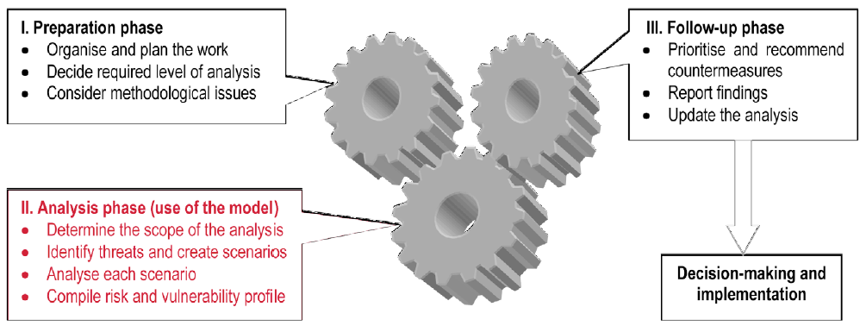
Figure 1.1: DEMA’s civil preparedness planning process

The results of each model run are included in the National Vulnerability report, which is published yearly. However, no reports could be retrieved (DEMA, 2014a).

Policy and Governance

Strategy scope and focus
Danish crisis management is mainly organised on the local. In case of an emergency the municipal fire and rescue service is the first to respond to the emergency together with the local police and ambulance services. If the emergency is too large for the responders in a single municipality to combat, these services can ask assistance from services in neighbouring municipalities. In a situation in which specialised equipment or skills are required to sufficiently combat the emergency, local authorities can turn to the national level for assistance. This assistance will be provided by DEMA (see below). This division of tasks and responsibilities is laid down in the Emergency Management Act, the main crisis management act in Denmark.

Although the Emergency Management Act is the main crisis management act in Denmark is mainly focuses on fires and related emergencies. In addition to the Emergency Management Act other acts are adopted, which focus on more specific disasters and challenges, e.g. acts on oil spills, harmful substances at sea, energy sector contingency planning and IT and telecommunications preparedness (Stone Wyman).

At the national one overarching crisis management authority has been establish which is oversees the prevention and preparedness policies and if needed can support the municipalities in combatting emergencies. This authority is the Danish Emergency Management Author (DEMA). Before its merger in 1993 DEMA consisted of two separate organisations the State Fire Inspectorate (Statens Brandinspektion) and Civil Defence Agency (Civilforsvarsstyrelsen).

DEMA is organised in four core areas, each covering a part of the Danish emergency response:
‘Prevention includes inspection, counselling, supervision and development of national rules and laws related to the technical and behavioural aspects of preventing fires and explosions.
Emergency planning includes supervision of other government, regional or municipal agencies and private companies on preparedness planning.
Operational response (National Division, International Division, Chemical Division and Nuclear Division). The Chemical Division undertakes the following tasks: Analytical chemical investigations of unknown substances, including chemical warfare agents (CWA) and explosives; examinations of dangerous goods and hazardous materials; information on hazardous substances, including the "Guidebook for Emergency Response to Hazardous Materials Incidents" and "Manual for Response to Hazardous Materials Incidents"; and advisory services, including the Emergency Response Centre.
The Centre for Education and HR Development carries out professional educational consultancy services for colleges, centres and the municipal civil protection preparedness system, including training regulations and plans for preparedness staff; training course administration; management and development of both national and internal training courses and exercises; recruitment of staff, staff administration and staff policy; cooperation with national and international universities and civil protection training centres.’

Important feature of the Danish crisis management system is the possibility for municipalities to outsource the fire and rescue services to a privately owned company (article 13 Emergency Management Act). Currently the only private company offering fire and rescue services is Falck Redningskorps Ltd.. According to their annual report 2/3 of all Danish municipalities outsourced the fire and rescue services to them. In addition to providing fire and rescue services Falck also provides around 85% of all the ambulance services in Denmark. This Danish possibility to enter into agreement with a private company to perform basic emergency management functions is rather unique.

Monitoring and analytical support to policy making; R&D
Not many specific examples regarding R&D have been retrieved during this research. Main R&D effort found is the development of the generic risk and vulnerability methodology for civil contingency planning. Based on this methodology a risk and vulnerability model (RVA model) has been development. The development of this tool was partially funded by DEMA. The model serves as the basis for all preparedness planning in Denmark. (RVA is also discussed in section 1.1).

Policy for Prevention
DEMA is responsible for a wide range of tasks relating to prevention, including fire prevention. These include drawing up regulations and directives, providing advice and campaigns directed at the general public, authorities and companies. (Danish emergency management act, 2009)

DEMA works with prevention through rules and regulations in areas such as:
- Rules and regulations concerning fire and explosion hazards in enterprises and storage facilities;
- Operational directives for community centres, hotels, schools, etc.;
- Approval of major stocks of gases and flammable liquids;
- Approval of enterprises covered by the Seveso II Directive due to fire;
- Explosion hazard;
- Regulations for transport of dangerous goods by road and approval of tanks.
(Danish emergency management act, 2009)

DEMA also develops educational material and campaigns aimed at changing behaviour and attitude in respect of fire prevention and emergency management. Each year a number of campaigns are implemented. Examples are:
- Fire prevention campaign aimed at primary school children;
- National warning siren campaign along with full-scale testing of national warning sirens.
(DEMA, 2014c; Danish emergency management act, 2009)

The municipal level is often performing the operational tasks of prevention. The municipal council shall for example carry out inspections of fire prevention arrangements of enterprises, listed buildings, buildings in which many persons are gathered, buildings that are inflammable and stores as well as of floating constructions (Art. 36 of part 7 of the Danish emergency management act, discussed in chapter 2). The reports of the prevention analysis are published on the DEMA website (Danish emergency management act, 2009).

Specific prevention for flooding
Spatial planning in Denmark is rather strict. Main reason for such strict regulation is to prevent and minimise the risks of flooding along the coast line. One specific element of Danish spatial planning is the possibility to give unhabituated land back to the sea. This practise ensures that the effects of flooding become less and populated areas are less at risk. If the practise of giving back the land to sea do not suffice it is possible to undertake preventive measures. These measures are taken by the Danish Coastal authority that mainly opts for beach nourishments or other soft defences.

Three acts of the Danish legislation are important to mention when considering coastal adaptation measures:
- Coastal Protection Act: the municipalities have the right to undertake coastal protection projects when necessary, financed with the money from the local landowners gathered through taxes;
- Nature Protection Act: in the first 300 m zone from the coast no new constructions may be build;
- Planning Act: in the first 3 km from the coast new activities is restricted.

Besides these planning restrictions, most discussion on climate change focus on mitigation. An example of this focus is the publication of the Danish government in March 2008 for a general strategy with regard to climate change adaptation. The main purpose of this strategy is to support coordination and informed decisions about autonomous measures. The policy document, however, does not contain any specific analysis or actions yet. It only sets the strategic agenda.

Coastal zones are mentioned only briefly in this climate strategy. The strategy says the following:
- Climate adaptation may become a necessity due to seal level rise and more intense storms;
- Enforcement of the protection structures may be needed based on risk-analyses;
- An integrated flood warning system could be useful in the future.

Niche prevention: preparing elderly
A well-functioning scheme in Denmark is that municipalities have a legal obligation to organise home visits to all persons aged 75 or more at least twice a year. In a 1999 evaluation of this practice, 80 percent of the responding municipalities reported that the scheme had helped them reach groups of ‘vulnerable’ elderly, which they had not formerly known (OECD, 2006).

If this approach resulted in a better preparedness for crisis situations is not retrieved, however this niche approach in preparedness planning is worth mentioning.

Policy for Preparedness
The preparedness planning in Denmark is based on three principles: total defence, sector responsibility and risk assessment.

- The concept of “total defence” refers to a collaboration and coordination across Denmark’s defence agencies, home guards, police and rescue management units, and all entities engaged in civilian sector readiness (Stone Wyman).

- A fundamental principle of emergency planning in Denmark is the principle of sector responsibility. This means that the authorities or institutions, which are in charge of the day-to-day responsibility of a given area, are also responsible for that area in the event of a major accident or disaster. According to the Danish Emergency Management Act, each Minister is responsible for planning within their respective areas of responsibility. Their tasks are to maintain the functions of the Government and public administration, producing necessary legislation and providing guidance to regional and municipal authorities. This principle of sector responsibility is outlined in paragraph 24.1 of the Emergency Management Act, which reads (Emergency Management Act, 2009):
- The individual ministers shall each within their areas plan the maintenance and continuation of societal functions in the event of accidents and catastrophes, including acts of war, and provide support for the armed forces;
- The Minister of Defence coordinates the planning regarding the civil sector's emergency management, cf. (1) and provides advice to the authorities. The Minister of Defence shall carry out that part of the planning that does not rest with other authorities;
- At the local level, regional and municipal councils are required to prepare contingency plans for their region designed to maintain critical public sector services during emergencies or restore them as quickly as possible (Stone Wyman).

- Since 2005, risk and vulnerability assessment has been an organizing principle for setting emergency management priorities. An annual vulnerability assessment report will describe selected emergencies that occurred during the year and discuss specific initiatives (Stone Wyman).

Preparedness planning
The purpose of Danish preparedness planning and crisis management is to prevent that major accidents affect life, welfare and environment. All authorities – municipalities, regions and central authorities – are required to plan for maintaining their most critical functions in event of major accidents and crises.

The Danish authorities are obliged to plan how operation of vital societal functions may be continued or re-established in the event of accidents or disasters. The authorities comprise departments, agencies, state-owned enterprises, regions, municipalities and other public institutions. Also private enterprises should consider preparing a plan for the continued operation of the company in connection with extraordinary events which cannot be handled by means of ordinary resources and procedures. (Emergency Management Act, 2009)

Each Ministry (20 in total) needs to prepare a crisis management plan and develop policies for all areas that do fall under its responsibility. Everything that is not covered by one of the Ministry is covered by the Ministry of Defence. This Ministry formulates all preparedness policies not falling under the scope of one of the other Ministries. The planning efforts are mainly carried out by DEMA on behalf of the Ministry of Defence. DEMA publishes a planning guide, a yearly vulnerability report and holds ongoing information meeting (DEMA, 2009).

Besides the policies developed by the Ministries municipalities are required to develop contingency plans which need to cover all their municipal functions. Most critical point which needs to have a clear policy is the capability of keeping hospitals function during a disaster. Municipalities also need to be prepared to receive and take care for evacuees and other victims of different types of emergencies, e.g. floods, accidents, terrorist act, and other natural and man-made emergencies.

In addition to the policies developed at a national and municipal level DEMA the main crisis management body develops preparedness polices. This organisation does not only coordinate national preparedness, but also provides guidance to the local levels. The work and tasks of DEMA are outlined in the Emergency Management Act: Consolidation Act no. 660 of 10 June 2009. (Emergency Management Act, 2009) The overall mission of DEMA is:

The mission of the national rescue preparedness has been laid down on the basis of the political intentions for the preparedness – that is, the Preparedness Act and the political preparedness agreements concluded at any time. The mission is worded as follows: "The national rescue preparedness is to safeguard the population and society against accidents and disasters in the best possible way. The rescue preparedness authorities shall thus work to minimise the harmful effects of accidents and disasters and increase their preventive efforts in an attempt to avoid the occurrence of accidents and disaster." (DEMA, (a)).
Each policy and planning needs to fulfil seven criteria laid down in the so-called ‘Comprehensive Preparedness Planning’:
1. Programme management – which should be the central, pivotal point of the planning;
2. Planning assumptions – analyses and ongoing activities that support planning in the remaining areas;
3. Prevention – measures that may prevent incidents or reduce their probability and consequences;
4. Training – for all employees who have a role in the organisation’s emergency preparedness;
5. Exercises – which all organisations in the guide’s target group should conduct and participate in;
6. Evaluations – in order to utilise the learning potential from incidents and exercises;
7. Crisis management plans – which describe how the organisation has prepared to respond to incidents.

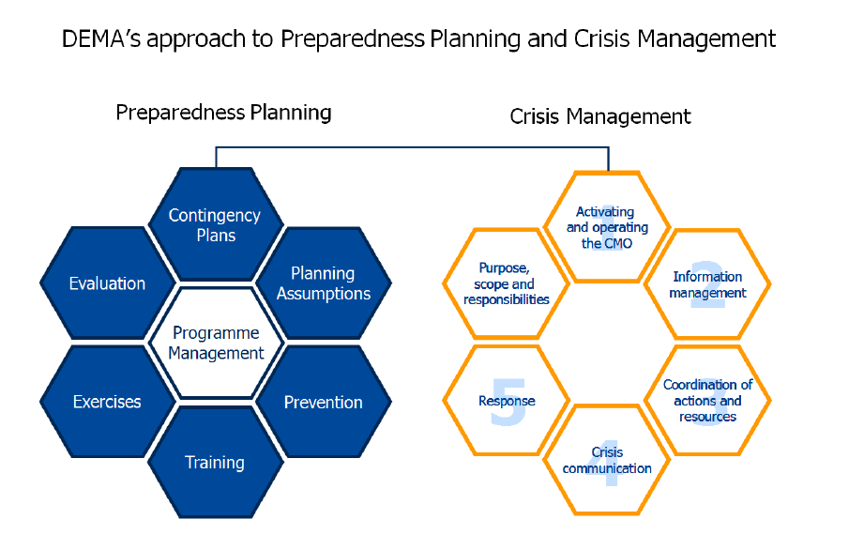
Figure 1.2: Preparedness and crisis management planning

Preparedness planning is a continuous process in Denmark. Therefore preparedness plans are regularly updated to ensure that the most pressing risks and threats are always sufficiently addressed. If possible lessons learned and previous experiences are included in these plans as well. In order to ensure that preparedness planning is done in a similar DEMA has developed the Comprehensive preparedness planning guide which can be downloaded at the DEMA website.

Nuclear preparedness
DEMA also develops the policy for the nuclear emergency preparedness. This policy includes that Denmark has 24-hours surveillance through a nationwide monitoring system and participates in an international warning network. In case something happens abroad that might affect Denmark the National Police Force will be the main point of contact (DEMA, 2014).

Nordic energy preparedness
A niche preparedness approach of the Nordic countries is found in the energy supply preparedness. The Nordic countries (Iceland, Norway, Sweden, Finland and Denmark) work closely together to create an integrated electricity supply network. When one of the states involved is confronted with a power shortage, other countries can, via cross border connections, supply energy. This limits the chance of severe blackouts in crisis situations (The Nordic Forum, 2005).

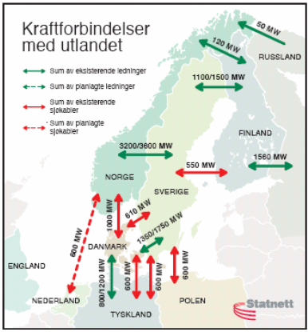
Figure 1.3: Cross border energy supply Nordic countries

However, Denmark in particular has a significant surplus of power generation, and the production is mainly based on fossil fuels with such stocks normally corresponding to at least 3 months’ production. Thus the vulnerability due to energy shortage seems to be low in this sense. This makes Denmark less vulnerable to blackouts than the other Nordic countries. (Nordic Energy Regulators, 2006)

In Denmark the relevant legislation with respect to contingency planning and crisis management for the power sector is:
- Article 24 of the Civil Emergency Procedures Act;
- Article 85 b of the Electricity Supply Act;
- Regulation no. 58 of 17 January 2005 governing contingency planning and crisis management for the power sector;
- Regulation no. 917 of 13 November 2002 governing contingency planning regarding fuel storage in the electricity sector.
(Nordic Energy Regulators, 2006)

Policy for Response
Crisis response is mainly organised on a local level as the municipal fire and rescue services are the main actor in emergency management, supplemented with the local police force and medical services. To ensure that emergency response run smoothly the different local parties need to be aware of their tasks and responsibilities as well as each others roles. In the Emergency Management Act the main responsibilities of each actor are laid down and in addition the lines of commands have been described.

If a major accident happens it is possible to establish an Incident Management Team which consists of representatives of the police force, the municipal fire and rescue service and medical services. If needed representatives of other organisations can be included in the team as well.

The overall coordinating responsibility lies with the police force. The police needs to ensure that the area is sufficiently cordoned off, that both the fire brigade and medical service can provide their services undisturbed and that the public does not interfere.

The technical management of the response is conducted by the municipal fire and rescue service. Their leader needs to ensure that the right measures are chosen to sufficiently combat the emergency and minimise the risks as soon as possible. He is also responsible for the general welfare of the deployed units during the entire period of emergency response.

The leader of the medical assistance is primarily responsible for the medical services provided and for the welfare of his personnel. If other organisations need to provide support as well during the emergency response they are also responsible for their own activities. This is in line with the sector responsibility principle, one of the over-arching principles on which the Danish crisis management is based (Please refer to paragraph 2.1).

The division of tasks also has a physical aspect. As the figure below shows the emergency area is divided into several areas. In the centre is the ‘scene of accident’ – the actual place of the emergency. The scene of accident is surrounded by the inner cordon. Within this cordon is the working area of the municipal fire and rescue services. Between the inner and outer cordon the response area is established. In this area first aid to victims of the emergency is provided. In this are the medical services are active. The outer cordon is guarded by the police. Depending of the involvement of other authorities they will also provided their services ion the response area.

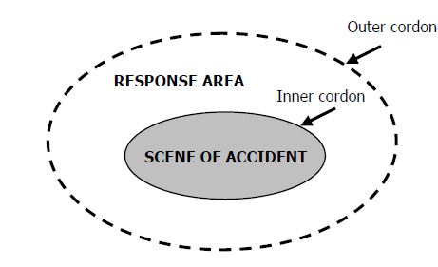
Figure 1.4: Crisis management cordon

DEMA's task
On a national level DEMA issues guidelines for the ‘Incident Command System’. The earlier mentioned Incident Command Team forms the core of this system. The guidelines describe the management conditions and co-operation for all types of emergencies covered by the Emergency Management Act. The guidelines provides details on how to act at specific types of emergencies, e.g. chemical accidents etc. The guidelines are available on the website of DEM (only in Danish).

Policy for Relief and Recovery
In case the emergency is larger than the financial capacity of the local government the national government has the possibility to rapidly make additional funds available in order to support the local government in their response and recovery payments.

For flooding some specific policies have been adopted. The national government has adopted a flood insurance scheme which pays compensation in case of coastal flooding. Compensation is paid to landowners, companies or farms that have suffered flood damage due to severe storm events. Since 2000, the fund is covering compensation payments for forest damages as well. In order to be able to pay the compensation money is collected by an annual tax payment charged through all private fire insurance policies. The decision whether or not and two whom compensation will be paid is made by the Danish Storm Council. This council consists of representatives of the Danish ministries, insurance companies and the Local Government Denmark. If needed other parties can become part of the council as well.

Financing

Investing in preparedness
The Danish national accounts do not clearly provide an overview on the costs they make to invest in preparedness. Therefore a rough estimation has been made to provide a general idea of the costs of investing in preparedness. It should also be noted that crisis management is often organised locally and the local fire brigades and police forces are the first responders to an incident. DEMA is informed, but only become active once the crisis cannot be handled on a local level any more. Below a rough estimation of the preparedness costs is provided.

The police budget
The Danish Parliament (Folketing) decides on the Police budget. The Parliament sets the Police budget for a 4 year period. In the period 2007-2010 the available annual budget was DDK 7.5 billion (1,008 million euros). In the consecutive period (2011-2014) the budget has increased to DKK 8.5 billion per year, which equals around 1,142 million euros. The budget is divided over the national police and the 12 separate police forces. Each force needs to have its own administrative procedures in place to allocate the budget sufficiently. It should be noted that the budget is not used for crisis management only, as the police force also needs to carry out other tasks, i.e. criminal investigation and safeguarding public order.

The fire brigade budget
The fire services are partially provided by public providers and partially by private operators. A municipality can choose to have its own fire brigade, hire the fire brigade of a neighbouring municipality or can have a contract wit a private operator. The only private operator in Denmark is Falck. Currently, Falck provides firefighting services for 2/3 of the municipalities in Denmark according to their latest annual report (2013). Around 65 of the 98 municipalities do have a contract with Falck for firefighting services. The contracts are awarded through public procurement and negotiating. Besides firefighting services Falck is also responsible for 85% of all ambulance service provided in Denmark. Of the total revenue made in 2013, 46.6% was made in Denmark. The revenue of 2013 amounted to DKK 5.839 million (€ 748 million).

The DEMA budget
DEMA, the national emergency management agency, is the main responsible body for developing policies on prevention, preparedness and response. DEMA has a staff of 565 employees available divided over 10 different locations (7 rescue centres and 3 schools). Their annual budget is around DKK 490 million. This more or less equals € 66 million. This budget needs to cover all the costs made by DEMA, so not only the emergency preparedness and response costs, but also their administrative and personnel costs. The costs are paid by the Ministry of Defence of which DEMA is an agency.

The GDP for 2013 was DKK 1,886 billion. The support provided to DEMA is in this case 0.03% of national GDP in 2013. However the costs of DEMA do not cover the entire costs for crisis management as the police forces, the fire brigades as well as the medical assistance play a role in emergency management as well.

Approach to flooding
As indicated in paragraph 1.1 floods are a major risk for Denmark. Therefore investment in flood protection is crucial. Main starting point of the flood prevention policy is that the person benefitting from better protection, should also bear the costs. In practise, this means that private landowners and/or municipalities close to potential flood areas should invest in protective measures. Although the private landowners and municipalities are mainly responsible for flood protection, their actions are overseen by the national government, more specifically by the Danish Coastal Authority (DCA). The DCA is part of the Ministry of Transport. The DCA focuses on policy and strategic issues, such as:
- Supervising the compliance to coastal defence laws;
- Providing advice with regard to coastal defence;
- Approving regional and private plans for coastal protection works;
- Monitoring coastline changes;
- Issuing warnings with regard to storm tide.

The third bullet point indicates that the DCA needs to approve coastal protection plans issued by private landowners or municipalities. DCA will grant permission when the following requirements are fulfilled:
- There is concrete evidence that the landowner will be threatened by violence of the sea within the next 20 to 25 years;
- The project does not harm any nearby Nature 2000 sites;
- The project complies with the coastal planning regulations.

As indicated earlier the starting point of Danish flood protection is that the person benefitting from the protection should pay for it. Therefore private landowners need to seek their own way of financing, e.g. through own means or banks loans. Municipalities have to finance projects with local taxes or through public-private partnerships.
In addition, the Danish government introduced in 1998 a longer term program aiming to yearly investing in dyke maintenance and improvement. For the entire duration of the program (1998-2015) the government reserved a budget of approximately € 315 million, which is on average € 18, 5 million a year.

Investing in consequence management
Several actors are involved in investing in consequence management. If objects belonging to the public domain have been damaged, e.g. buildings and roads, the ‘government’ has to pay. If the objects belong to the national government it will the responsible ministry that needs to pay, if the objects belong to the regional or local government, these governments will bear the costs. If budgets are tight, the national government can provide assistance. Each of the governments have a budget available for un-expected expenses and these budgets can be used to cover the costs to repair, public roads and buildings if needed.

Also most Danish citizens have insurances that cover damages related to property. According to a Lloyd’s report the insurance penetration in 2011 was 2.9% (premiums as a % of GDP). In the list of 42 reviewed countries Denmark was ranked 11th. The list is led by The Netherlands (9.5%), followed by New Zealand (5.2%) and South Korea (4.6%). It should be noted that the penetration rate is note related to the relative risks people are likely to face. The report also calculated if a country is over or under insured by calculating the ‘benchmark insurance coverage’. Denmark is ranked number 10, with a benchmark of 1.36, indicated that the country is moderately insured. Citizens are better insured than they strictly need to be, however margins are small.

The industry compared to citizens is relatively poorly insured. The Lloyd’s report calculated the insurance penetration rated per industrial sector compared to the GVA of this particular sector to the national GDP (see table below). Taking all sectors into account the overall insurance penetration for Danish industry is less than 0.2%, and Denmark is ranked 16th amongst 18 reviewed countries. Frontrunner is the US with a penetration ate of almost 1%, followed by Ireland (0.87%) and the UK (0.75%).

Table 1.6: Penetration rate and GVA contribution per sector (2011)
Sector | Insurance penetration | GVA contribution
Transportation and Storage | 0.48% | 5.70%
Agriculture, forestry and fishing | 0.36% | 1.18%
Construction | 0.29% | 5.66%
Wholesale and retail | 0.25% | 12.84%
Utilities | 0.17% | 1.93%
Manufacturing | 0.14% | 14.09%
Accommodation and food service activities | 0.14% | 1.57%
Professional and administrative services | 0.13% | 9.03%
Public administration and defence | 0.12% | 6.20%
Financial and insurance activities | 0.09% | 4.36%
Information and communication | 0.09% | 2.11%
Arts, entertainment and recreation | 0.07% | 1.78%
Education | 0.06% | 5.35%
Human health and social work activities | 0.05% | 10.70%
Mining and Quarrying | 0.05% | 3.96%
Real estate activities | 0.00% | 9.96%
Source: Lloyd’s (2012)

Policy review, Evaluation & Organisational Learning

Post-Disaster Assessment
No information retrieved. The recent audit on Danish crisis management (see section 1.4.3) however has critique on the post disaster assessment.
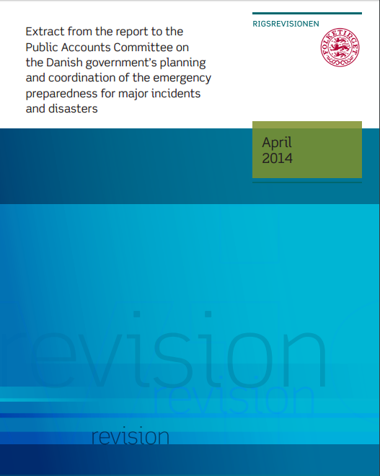
Figure 1.5: Report on the Danish government’s planning and coordination of the emergency preparedness for major incidents and disaster

Departmental Lessons Learned systems
No information retrieved. The recent audit on Danish crisis management (see section 1.4.3 however has critique on the post departmental approach and knowledge of emergency planning (Rigsrevisionen, 2014).

Centralised (national) Lessons Learned system
In April 2014, a National Audit Report on the state's preparedness was published. The Audit Office concludes that the key ministries and agencies in preparedness have prepared themselves to deal with major accidents and disasters. The National Audit Office concludes in addition, the Emergency Management Agency has not solved all tasks concerning the coordination of emergency planning satisfying as the Board does not have a comprehensive overall view of contingency planning in Ministries. Finally, the National Audit Office stated that the authorities' efforts in evaluating major accidents and disasters can be improved and that all authorities prospectively writing should evaluate their crisis management at major events and exercises to ensure that the experience is retained and used to improve preparedness.

Some highlights:
- "The Emergency Management Agency has solved the task of supporting ministries contingency planning by establishing a common guide to good contingency planning and providing advice to ministries but has not solved the problem of assessing the consistency of contingency planning satisfactory since it lacks a comprehensive overall view of contingency planning in the ministries and thus not a sufficient basis for assessing the relationship.”
- "The authorities' efforts in evaluating major accidents and disasters and exercises can be improved."
- "The authorities have [...] followed up on the learning points from the terrorist attacks in Norway in 2011 with a view to improving the Danish preparedness. The Audit office agrees. "
- "The National Audit Office finds that all authorities prospectively writing should evaluate their crisis management at major events and exercises to ensure that the experience is retained and used to improve preparedness."

International exchange for Lessons Learned
Danish crisis management organisations participate in international preparedness and crisis management training. A recent example is the SKAG EX11 exercise. In this exercise crisis management organisation from Norway, Sweden, Finland and Denmark were involved. Around 3,000 people from approximately 55 organisations participated. The exercise was centred around a fire on the passenger ferry MS Bohus. This ferry operates on the route between Strömstad and Sandefjord. As a result of the fire the vessel collided with a smaller bunkering vessel, the Oslo Tank. The involved organisations all had to practise their specific roles. Once the exercise was finished lessons learned were shared and presented to the national crisis management authorities via the ‘SKAG EX11 way forward report’. This report provides details on the exercise as well as the strengths and weaknesses which became apparent during the exercise (DSB, 2012).

Regular policy reviews
No confirmed information was retrieved. Based on the information collected for Paragraph 1.1.1 it seems that a Danish National Vulnerability Evaluation exists. However, it seems no recent report has been published since 2005. Moreover, recently an audit was performed on the organisation of Danish crisis management. Base don this evaluation it might be expected that the current policies were reviewed.

Resilience
The concept of resilience in civil protection, in terms of country’s capacity to withstand shocks due to natural and other disasters, to rebuild itself with efficiency, and to improve on the pre-existing state wherever, has not been explicitly established by law or another normative act. However several public educations campaigns have been organised in which the public has been informed on what to do in case of a crisis situation. Special attention in these campaigns was paid to flooding. Aim was to improve homeowner’s resilience towards storms, storm surges, torrential rain, groundwater flooding etc.

Also several applications for mobile devices have been developed to enable Danish people to be better prepared in case of a crisis. The first application is developed by the Danish Insurance association and gives homeowners instructions on how to better prepare themselves and their homes for extreme weather conditions. The second one is developed by the association of Danish regions. This application provide a quick overview of relevant emergency contacts. In addition the user can quickly retrieve health data, geodata and general advice.

Information sharing and data protection
Crisis communication
Part 6 of the Emergency management act (detailed in chapter 2) deals with radio communication (Emergency management act, 2009).

According to article 29.1, the municipal council and the regional council shall ensure that the national radio communication network is used for the carrying out of own and joint emergency management tasks. The Minister of Defence, after his negotiations with Minister concerned, may lay down rules stating that parties, including individuals, other than the municipal councils and the regional councils shall use the radio communication network (article 29.2). For example in case of a pandemic, the Minister of Health will negotiate with the Minister of Defence on the message to be provided. After this consultation the Minister of Defence will ensure that the message will be communicated. .

Moreover, the Minister of Defence may lay down rules on the use of the national radio communication network, including connection and utilisation. Subsequent to negotiations with the Minister of Finance, the Minister of Defence may furthermore lay down rules on the payment for connection to and use of the network (article 29.3)..

Data protection
Data protection is not mentioned in the Emergency management act. Based on EU data protection law the public authority is, in principal, required to obtain explicit and unambiguous permission to use personal data. Only exemption is the situation in which the public authority needs the personal data in order to fulfil its public duty in a good and sufficient manner, but no time is available to obtain the consent of the public. An example could be providing instant medical assistance to an unconscious person.
Registration of volunteers
Several crisis management related organisations do use volunteers. However, these volunteers are not registered in one national database. Each organisation involving volunteers has its own database with details on the available volunteers. Therefore, databases on volunteers will be available at DEMA, the Red Cross and the Danish Civil Protection League, the three most important organisations involving volunteers in crisis management situations.

Legislation

Crisis (emergency, disaster) management concept
Danish crisis management is based on five over-arching principles. These principles apply to all phases of crisis management, ranging from prevention and preparedness to response and recovery. Some of the principles are laid down in legislation, e.g. in the Emergency Management Act (refer to following paragraph), while others are not. The principles are:
- Sector responsibility: this principle indicates that each department/agency which has a responsibility for a specific sector also remain responsible during a crisis. For example, because the Ministry of Health is responsible for public health in general, the Ministry will also be responsible in case of a pandemic outbreak.

- Similarity: according to this principle the crisis management setup should resemble the daily setup as much as possible in order to minimise the changes needed in case the crisis management system is activated.

- Subsidiarity: refers to a situation where crisis management activities are conducted on the lowest organisational level possible. This principle refers to the decentralised crisis management approach used in Denmark.

- Cooperation: organisations involved in crisis management should cooperate with other relevant organisation when they are planning their crisis management activities. This principle is especially important for maintaining critical infrastructure.

- Precaution: relates to the establishment of a crisis management organisation that may respond in case of an emergency. The organisation needs to be established before something actually happens.
Main act in the field of crisis management is the Emergency Management Act which was adopted in 2009. This act lays down the division between municipal firefighting and rescue services, and national firefighting and rescue services. It also outlines the responsibilities of DEMA and provides, in article 1, the overall task of fire and rescue services. This overall task is the following:
‘The task of the fire and rescue services is to prevent, limit and redress personal injury and damage to property and the environment arising from accidents and disasters, including acts of war, or imminent danger as such’

General crisis (emergency, disaster) management law
As indicated in the previous paragraph the Emergency Management Act was adopted recently (in 2009). As far as the researcher could establish the act is not under review.

The act is divided in 13 different parts, each covering its own aspects of Emergency management. The following parts have been included:
Outline (Table of contents):
- Part 1 Preliminary provisions;
- Part 2 The national fire and rescue service;
- Part 3 The municipal fire and rescue service;
- Part 4 Deployment of the fire and rescue services;
- Part 5 Emergency management planning etc. within the civil sector;
- Part 6 Radio communication;
- Part 7 Preventative measures etc.;
- Part 8 Expropriation;
- Part 9 Injunctions, orders etc.;
- Part 10 Personnel provisions;
- Part 11 Penalties and disciplinary provisions;
- Part 12 Amendments to other legislation;
- Part 13 Commencement and temporary provisions.

The Emergency Management Act is strongly focused on fire and rescue services, which form the backbone of Danish crisis management. Fire and rescue services comprise two levels; the national level (under direct authority of the Minister of Defence) and the municipal level (under direct authority of the municipal council). Although the municipal fire and rescue services fall under the authority of the municipal council, the Minister of Defence is entitled to supervise these services. The Minister of Defence also has the opportunity to authorise DEMA to take over the supervisory of the Ministry of Defence (Article 4.2). In practise, DEMA has taken over the task of the Ministry of Defence and therefore is responsible for the day-to-day supervision of the local fire and rescue services.

In this two-level system the municipal fire and rescue services form the backbone of the Danish crisis management system as they are the first service to warned in case of an emergency. If needed the crisis response can be scaled up and the coordination will shift from a local level to the national level. At this point DEMA becomes involved and will share its response capacity.

In principle, each Danish municipality could have it own public fire and rescue services. However, article 13 of the Emergency management act offers the opportunity for municipalities to either share the obligation with other municipalities or enter into a contract with private-owned companies offering fire and rescue services. Many municipalities have opted for this last option and signed an agreement with Falck, a private company offering fire and ambulance services. The Emergency Management Act also offers the possibility to conclude an agreement with DEMA, in which it is agreed that some of the municipal fire and rescue services will be taken over by the national fire and rescue services.

The main task description of the municipal fire and rescue service is laid down in article 12 which says ‘that the municipal fire and rescue service shall be able to provide a justifiable response to prevent personal injuries, damage to property and the environment arising out of accidents and catastrophes, including acts of war. The fire and rescue services shall moreover be able to receive, accommodate and cater for evacuees and other distressed persons.’

In close connection article 17 of the Emergency Management Act states that the overall crisis response falls under the responsibility of the police commissioner. This commissioner is also responsible for sounding the alerts or warnings, cordoning off, evacuation and other necessary measures (article 17.2). The action needed to combat the fire or the emergency at hand remain with the officer from the fire and rescue service.

The Act also provides the fire and rescue services with the possibility to demand any kind of privately-owned tools and equipment and means of transport if needed. Also the accompanying crew needs to be made available if desired (article 20.1). The individual that provides the goods is entitled to compensation from the municipality for deprivation of material and for any damage to it (article 20.2).

Emergency rule
The Danish legal system does not provide ‘discretionary powers’ which means that in case of an emergency or disaster the authorities do not obtain different responsibilities and powers. During each crisis the authorities must follow the regular principles and procedures as much as possible. This is based on the principle of similarity (one of the five principles playing an important role in Danish crisis management) meaning that the actions undertaken by and the responsibilities of authorities should resemble their normal actions and responsibilities as much as possible under the more extreme circumstances.

Specific, department/agency-level legal arrangements and regulations on emergency and disaster management
Each Ministry is obliged to draw up an emergency plan that indicates what will happen and which procedures have to be followed in case a disaster in its area of expertise occurs (article 24.1 Emergency Management Act). For example, the Ministry of Transport has a legal obligation to draft an emergency plan indicating what will happen when flooding occurs. In addition to indicate the procedures to be followed, the responsible Minister has to ensure that functions normally carried out in society can be continued as well.

In Article 24.2 the Emergency Management Act lays down that the Ministerial plans need to be revised if recent developments make such changes necessary. Irrespective any developments requesting for a revision of the plan, the Ministry is obliged to review its plan(s) at least every four years. Once the plans have been drafted or revised they need to be sent to DEMA, so that DEMA can incorporate the relevant parts in its own emergency response plans.

As already indicated several times, the main focus of Danish disaster response lies at municipal level. To ensure that local response is in line with the emergency response plans drafted at ministerial level, each Ministry has the obligation to draft guidelines, within their own area, on how to incorporate departmental approaches in the regional/municipal emergency plans (article 27 Emergency Management Act). The regions/municipalities have the obligation to follow these guidelines.

Article 28.1 gives the respective Minister the opportunity to involve public authorities as well as public and private enterprises and institution to contribute to the planning or execution of task falling in the area of emergency management. This means that the Minister can opt for stat-of-the-art knowledge and skills. However the Minister needs to negotiate with the enterprises and institutions regarding the scope and possible compensation from state (article 28.3).

In addition The Minister has the possibility to require special measures from public and private enterprises and institutions as long as it concerns goods, services, means of production etc. which fall within their normal operations (article 28.2). Also in this situation the Minister has to negotiate about the scope and possible compensation (article 28.3).

Specific to the regional and local authorities legal arrangements and regulations on emergency and disaster management

Regional/municipal emergency plans
Similar to the ministerial plans each region or municipality has the obligation to prepare a regional/municipal emergency plan. This plan has to be adopted by the municipal council (article 25.1 Emergency Management Act) or the regional council (article 25.2). As indicated in the previous paragraph the plans need to incorporate aspects from the relevant Ministerial emergency plans. Each region/municipality needs assess which aspects it needs to include as not all Ministerial plans will be relevant.

Also the regional/municipal plans need to be revised when certain development makes the revision necessary. Irrespective of such a development, the emergency plan needs to be revised once during each regional and municipal electoral period (Article 25.3). Elections are held at least every four years, so on average also the regional/municipal plans are reviewed once every four years.

Similar to the Ministerial plans also the plans of the regions and the municipalities need to be sent to DEMA, so that DEMA is able to incorporate the necessary information (article 25.4).

Fire prevention
The Emergency Management Act, in article 36.1, lays down the strict obligation for municipalities to ‘carry out inspections of fire prevention arrangements of enterprises, listed buildings, buildings in which many persons are gathered, buildings that are inflammable and stores as well as floating constructions.’ How such inspections need to be carried is harmonized between municipalities as the Ministry of Defence issues detailed rules on how to conduct such inspections and how to remedy and/or punish for any deficiencies detected (article 36.2). Fire inspections can be carried out any moment in time and no court order is needed to access the premises (article 36.3).

Article 36a provides the Minister of Defence with the possibility to lay down rules relating to the publication of the results and sanctions based on the fire prevention inspections of the individual municipalities. Such a publication include the names of inspected natural and legal entities (so all inspections conducted) as well as the names of natural and legal entities who received injunctions or orders, or are subject to sanctions.

Legal regulations on the involvement of volunteers and specialised NGOs

Private sector
As indicated in paragraph 2.2 the Emergency Management Act provides municipalities with the opportunity to enter into an agreement with privately-owned organisations that assists them in carrying out of tasks within the municipal fire and rescue services (article 13). Best known example of a private company hired to provide fire and rescue services is Falck.

Volunteers
The Emergency Management Act only regulates the involvement of ‘non-registered’ volunteers. According to article 40 any individual that is present at an emergency side can upon request of the fire and rescue services take part in fire-fighting and rescue operations. These people are not called-up to help out; they are just present at the scene. Often these people will not be trained, unless they have taken courses themselves, e.g. first aid training. Each individual that took part in the fire-fighting has a right of compensation for substantiated loss of earnings. The municipality has to compensate this loss of earnings.

In addition to the ‘non-registered volunteers’ a group of registered volunteers exists. The volunteers are all member of the Danish Civil Protection League which is a non-profit organisation with 5,000 members.On the website of the Danish Civil Protection League Danish citizens can apply to become a volunteer. Based on their experience, possibilities and the need of the League they will be assigned a dedicated role. With the League many different types of roles can be fulfilled, e.g. becoming part of the voluntary fire brigade or work with search dogs. The volunteers of the League predominantly work in local rescue teams. Although they mainly operate on the local level, if needed the teams can also be involved in national preparedness planning. In addition, the League aims to increase the knowledge of preparedness and prevention among the population and through the education of the population to increase their level of self-preservation and robustness (EC, 2014).

NGOs
The most important NGO involved in Danish crisis management is the Danish Red Cross. The Danish Red Cross provides aid both in Denmark and abroad. In Denmark the Red Cross is mainly involved in establishing and managing refugee centres. In case of an emergency they can provide medical assistance at the incident location by sending a Quick Response Medical Assistance Team, support the municipal government to provide shelter and relief for the evacuated population and to support the municipal government in registering and tracing missing persons. In addition the Red Cross provides services to supply bandages, mattresses, blankets and so on. Abroad the Danish Red Cross is often operating in areas of conflict or areas affect by disease or large disasters.

The researchers were not able to establish whether or not the involvement of the Danish Red Cross in crisis management is regulated by law, as no information in English was available.

Legal regulations for international engagements of first responders and crisis managers
Denmark is active in the field of international humanitarian aid. If an emergency happens some where in the world nations can turn to DEMA for help. DEMA will assess the international request and if Denmark is able to provide help, DEMA will ensure that response capacity becomes available rapidly. Denmark is able to call up a fully equipped operational taskforce for specific disaster within 12 hours. Specific areas of expertise include earthquake disasters, floods, forest fires, refugee crises, etc. The planning of international operations is supported by the formation of a service package concept (flexible manned equipment modules) that can be applied in connection with disaster response and response to complex emergencies (DEMA, 2014).

The European Union
Denmark, as member of the EU, has implemented the EU regulation with respect to crisis management. The Council Decisions do apply in Denmark. These Council Decisions regulate some aspects of cross border assistance and they focus on the procedural side of assistance indicated how requests should be filled, when countries need to respond and how the teams provided are coordinated. The following decisions and treaties have been implemented:
- Council Decision of 8 November 2007 establishing a Community Civil Protection Mechanism;
- Council Decision 2008/617/JHA of 23 June 2008 on the improvement of cooperation between the special intervention units of the Member States of the European Union in crisis situations.

The Council Decision 2007/779/EC/Euratom of 8 November 2007 was issued to set up an effective cooperation mechanism to coordinate rapid exchange of information and arrange assistance through an European network of civil protection resources. The Community Civil Protection Mechanist is based on establishing amongst others: an inventory of possible assistance and intervention teams at an EU level, a common training programme, a Monitoring and Information Centre (MIC) that forwards requests for assistance by affected Member States to a network of national contact points, a Common Emergency Communication and Information System (CECIS) and the provisions for facilitating the sharing of information on the resources available within the network.

The Council Decision 2008/617/JHA of 23 June 2008 aims to set a framework for the cooperation between Member States’ special intervention units in crisis situations. The Decision establishes the general rules and conditions for the provision of assistance by special intervention units to any requesting Member State. According to the provisions of this Decision, the units from countries that provide assistance take up an assisting role and act only within the limits and powers as defined by their own national law. To ensure that experience, expertise and information on managing crisis situations are exchanged joint trainings and exercises between Member States are promoted and may be funded from Community financial programmes.

The United Nations
Denmark is also Member to the United Nations. In the area of civil protection and humanitarian aid, Denmark is involved in the UN Office for the Co-ordination of Humanitarian Affairs, OCHA. In case of a large international disaster requiring specific support Denmark can provide specialised help. During the direct aftermath of a crisis Denmark can send either a, UNDAC or USAR team (Please refer to paragraph 3.2). Besides direct relief operations Denmark is also involved in longer term humanitarian aid. In order to provide this aid sufficient Denmark, together with Sweden, Finland, Norway and the UK is party to the International Humanitarian Partnership (IHP). This partnership lays the foundation for mutual support of equipment models of equipment modules for the purpose of offering manned support and operational packages to the United Nations, including, among others, OCHA and UNHCR (UN High Commissioner for Refugees). In addition this cooperation also includes joint exercises and trainings.
International agreements
Denmark has concluded a series of bilateral and multilateral agreements on early notification of nuclear accidents, the exchange of information relating to nuclear facilities and agreements on mutual disaster aid, etc..

In addition Denmark has concluded bilateral agreements with other Nordic states. These agreements contain obligations regarding early notification of abnormal events or detection of abnormal levels of radiation and exchange of information. Besides these bilateral agreements the Nordic states have ratified the IAEA Early Notification Convention. As Denmark, Finland and Sweden are EU Member States, they have the obligation to implement arrangements regarding crisis management communication. These arrangements regulate crisis communication between the different EU Member States as well as communication between EU and non-EU Member States that have joined the communication system.

Furthermore Denmark is part to several agreements that define different obligations for communication and co-operation. These agreements have been written down in The Nordic Manual (2006, updated in 2008). The following countries have agreed to share information in order to improve nuclear safety:
- •Denmark: Danish Emergency Management Agency (DEMA)
- •National Institute of Radiation Hygiene (SIS)
- •Finland: Radiation and Nuclear Safety Authority (STUK)
- •Iceland: Icelandic Radiation Protection Institute (GR)
- •Norway: Norwegian Radiation Protection Authority (NRPA)
- •Sweden: Swedish Radiation Safety Authority (SSM)

Organisation

Organisational chart
The Danish crisis and emergency management system is decentralised and day-to-day crisis response is organised on a local level, i.e. municipal level. This means that local fire brigades, police and ambulance services are the first to respond in case of an emergency and the mayor of the city is responsible for all actions taken. The municipal level does not have the obligation to consult the national level (the second layer of Danish crisis management) first before starting response operations. In case of larger or more long-term crisis, which are transcend local capabilities, the national level can get involved.

At the municipal level the main first responder to an emergency are the fire brigade services. In Denmark each municipality has the option to have its own (public) fire brigade or to opt for hiring a private company (mostly Falck) or use a voluntary fire brigade. Irrespective the solution chosen the fire brigade needs to be able to leave the fire station within 5 minutes after the alarm. On the emergency site the fire and rescue services are coordinated by the so-called ‘on site commander’ often a firefighter. The overall, wider, response is coordinated by the police.

If the magnitude of the crisis is so large that the local fire brigade is no longer able to sufficiently deal with the crisis on its own, they can ask the support of one of DEMA rescue centres. If DEMA gets involved in crisis management, the coordination is scaled up from local to national level.

DEMA as national crisis organisation
An important organisation for Danish crisis management at national level is DEMA. As described before in case of larger crises DEMA can provide support to municipal response services in case these services can no longer deal with the crisis themselves or special equipment/ additional manpower is needed. In addition to providing response capacity DEMA is also involved in crisis prevention and preparedness. As explained in chapter 1 DEMA is responsible to carry out the yearly vulnerability assessment and needs to implement the policies of the Ministry of Defence.

To support municipalities in crisis response DEMA has six rescue centres from which they can provide additional operative support to municipalities. These centres have staff available 24/7 and the staff should be able to leave within five minutes after a request for assistance comes in.

DEMA also has three trainings centres where emergency personnel can be trained. The graph below shows the internal structure of DEMA.
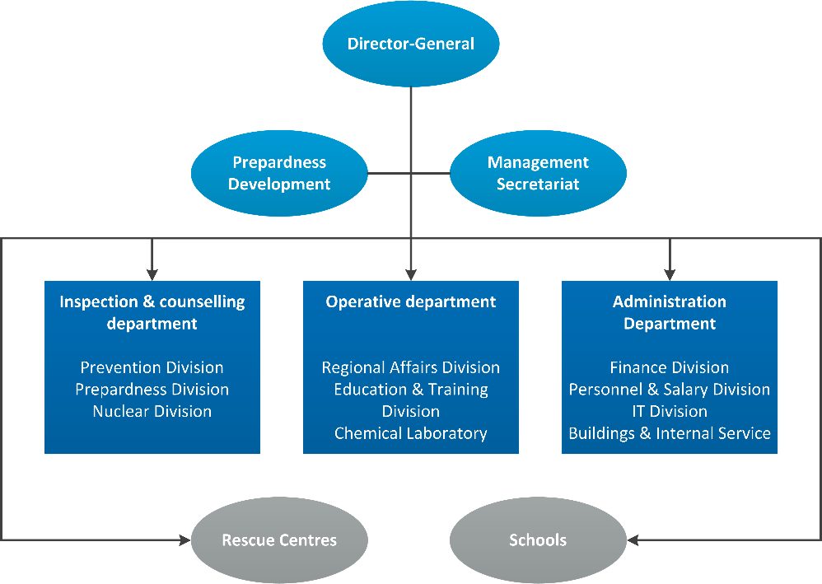
Figure 3.1: DEMA’s organisation

The rescue centres of DEMA are spread over the main islands and are named Nordjylland, Midtlylland, Sudjullayd, Sjælland, Hedehusenen and Bornholm. The locations are chosen in order to ensure that every part of the country can be reached within 2 hours from one of the centres. The training locations are more clustered, located on Tinglev, Snekersten and Birkerød. Following figure shows the locations of the DEMA rescue and training centres (DEMA, 2014).

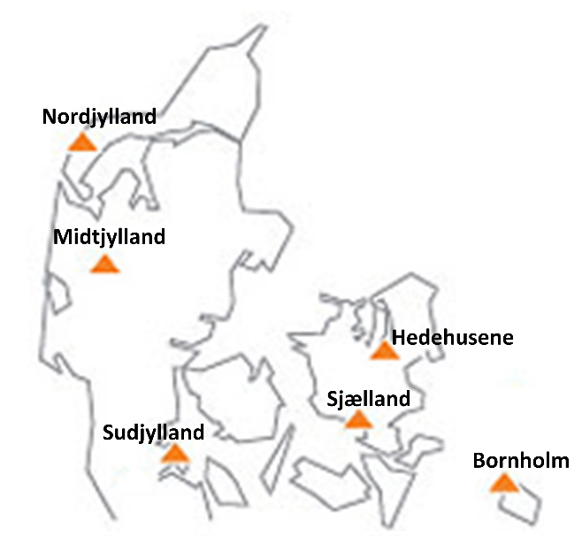 | 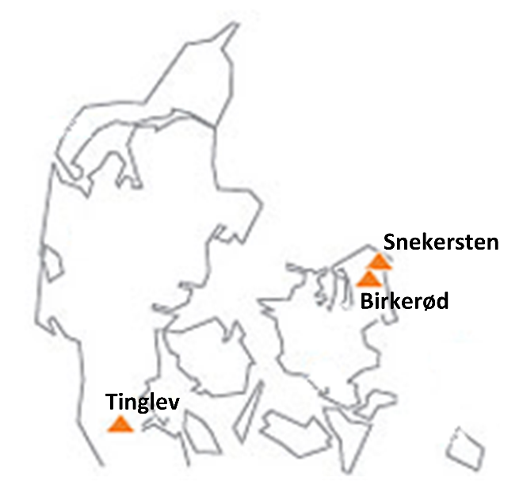
Figure 3.2: DEMA's rescue centres and training institutes

DEMA in the national structure of government
Before 2004, DEMA was part of the Ministry of Health. As the Ministry of Defence is responsible for coordinating the government’s wide civil preparedness planning, implement the taken measures and address all areas not covered by the other Ministries, DEMA became part of the Ministry of Defence in 2004. Within the Ministry of Defence the Office of Emergency Management is responsible for (i) setting the direction of preparedness policy; (ii) negotiating and implementing of political agreements related to crisis management; (iii) leading international cooperation efforts on emergency preparedness; (iv) overseeing both DEMA and the Home Guard and (v) setting the performance requirements for both of them. DEMA is responsible for the day-to-day national coordination of the emergency management and therefore the mission of DEMA is ‘to cushion the effects of accidents and disasters on society and to prevent harm to people, property and the environment’. DEMA has the full responsibility and authority for coordinating the entire spectrum of emergency management, from planning/preparedness to response and recovery. In additional to its overall mission of coordinating crisis management on a national level, DEMA is responsible for operating the rescue centres and training institutes. The figure below presents the embedding of DEMA within the Ministry of Defence.

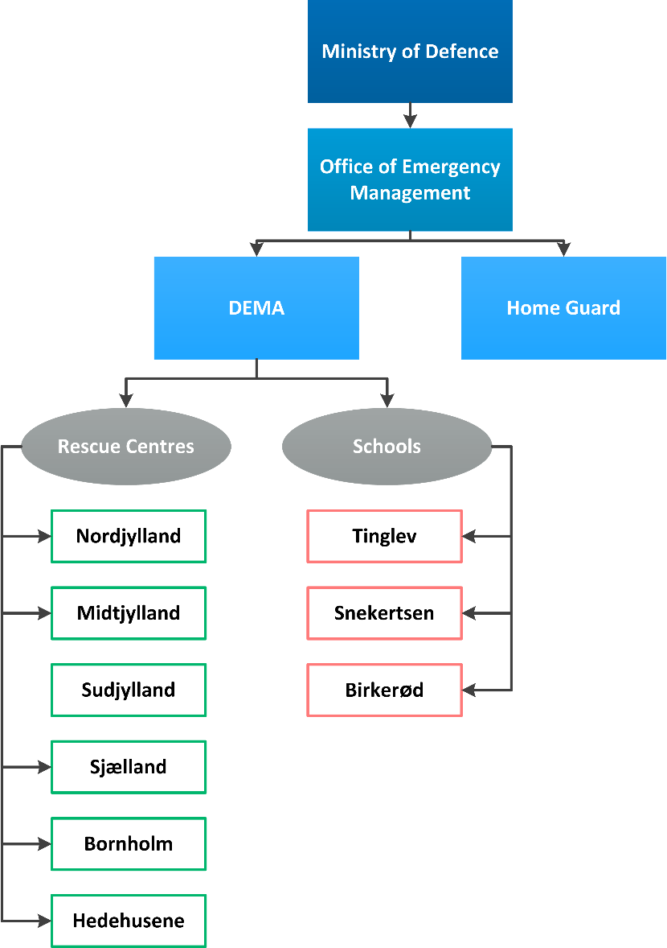
Figure 3.3: DEMA's rescue centres

Organisational cooperation
Organisational cooperation in national crisis situations
The structure shown above presents the general crisis management system at the national level. This system, for example, applies to larger fires that involve more than one municipality or large scale pollution at sea. As a general starting point the local level, i.e. the municipalities, needs to start their response procedures and their police force, fire brigade and medical assistance will be first on the scene. In case the emergency is larger than they can solely manage the local level can ask for assistance of the DEMA rescue centres (DEMA, (b)).

However it might happen that a crisis is more extraordinary (e.g. pandemic or large floods) and to adequately respond to the crisis special skills and decisions are required. In such a situation the special crisis management system, the so-called Danish National Emergency Management Organization, will be activated. At the governmental three committees/groups will become operative. These three groups make the necessary decisions on different levels:
- The Government Security Committee: this is a high level committee consisting of the Danish Prime Minister (chairman of the committee), the Minister of Economic Affairs and Business, the Minister of Foreign Affairs, the Minister of Defence and the Minister of Justice. If needed this group can be expanded by other ministers.
- The Senior Official’s Security Committee: this committee consists of the highest civil servants, i.e. the permanent secretaries, of the above mentioned Ministries. In addition the Head of the Defence Intelligence Service as well as the Head of Security Intelligence Service are member of this committee. If necessary other permanent secretaries or officials may be included. The Committee’s chairman is the Permanent Secretary of the Prime Minister’s Department service.
- The Crisis Management Group: contains representatives of the departmental and undersecretary level of the Ministries mentioned above. Also representatives of the Ministries of Foreign Affairs, Ministry of Health, the Defence Command Denmark, the National Danish Police and DEMA are presented. The group is chaired by representatives of the Prime Minister’s Department.
(DEMA, (b))

Between the three committees/groups a clear hierarchy exists; the government security committee is the highest decision making body, while the other two prepare the decisions taken by the government security meeting and collect the necessary information to do so. The decisions taken are executed by one of the two operational staffs available at national level. In case of a national crisis (only affecting Denmark) the decision will be executed by the National Operational Staff (NOST) and in case of an international crisis affecting Danish people abroad this will be done by the International Operational Staff (IOS). DEMA supports both the NOST and IOS if needed. The graph below presents this structure schematically.

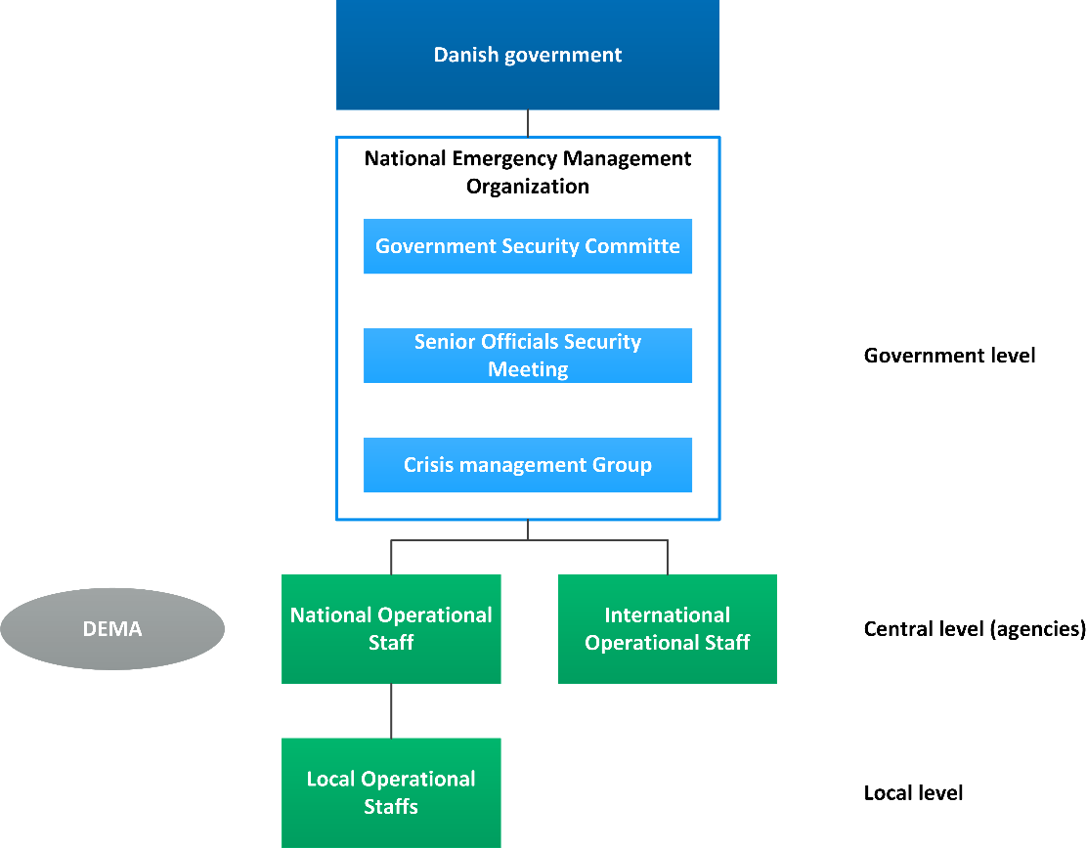
Figure 3.4 Crisis management structure in case of an extraordinary crisis

Organisational cooperation in crisis situations abroad, Danish victims
As indicated in the figure above the IOS is responsible for international crisis management involving Danish people abroad. The IOS is led by the Ministry of Foreign Affairs as this Ministry has all the necessary contacts to retrieve Danish people from abroad. The IOS staff is complemented by representatives of public and private entities. The exact composition of the IOS depends on the crisis itself, e.g. in the recent Ebola pandemic in Africa representatives of the Ministry of Health were involved in the IOS to retrieve Danish people safely, but to ensure quarantine if needed. Often the tourism industry, especially tourism operators, become part of the IOS as they have information on Danish tourists abroad. DEMA can support the IOS if needed, as the figure below shows.

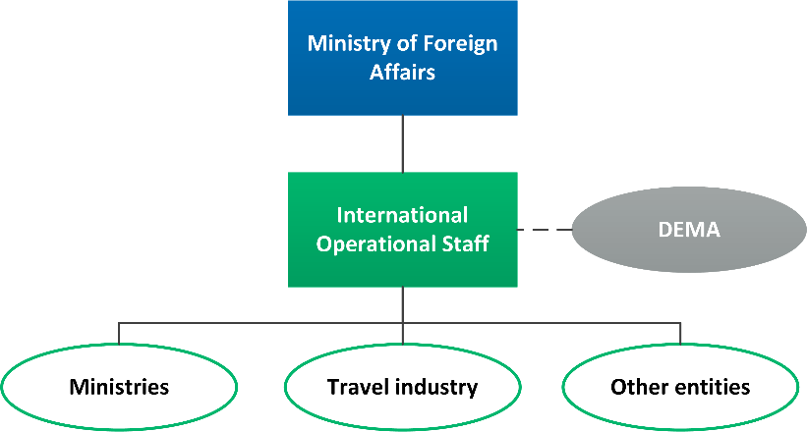
Figure 3.5 International crisis management structure

Organisational cooperation in crisis situations abroad, no Danish victims
DEMA is contact point for international crisis management in case no Danish people are affected by the crisis abroad. In such a crisis DEMA provides humanitarian aid upon request of a foreign governmental body or an international organization. However DEMA cannot take the decision to actually provide humanitarian aid. The decision is made by the Ministry of Defence in concert with the Ministry of Foreign Affairs. The Ministry of Foreign Affairs coordinates and funds the deployment of the Danish governmental humanitarian assistance.

DEMA can provide humanitarian aid in the fields of logistics, transport, management and specialist knowledge alone or in cooperation with other organizations. There is a close cooperation with the EU, UN and NATO as well as with regional partnerships, such as the Nordic International Humanitarian Partnership (IHP).

Dedicated support to the United Nation
The UN can request support from the Denmark in case of disasters happing in other countries. To activate the support the request needs to be addressed to the Ministry of Foreign Affairs and the framework presented in figure 3.5 is followed. The main types of support that can be requested are UNDAC and USAR.

UNDAC
Denmark is Member to UNDAC – United Nations Disaster Assessment and Coordination - since 1993. Experienced emergency managers are available for UNDAC to assist during a crisis. Depending on the type of crisis a manager is appointed. Since 2000 the Denmark has provided assistance 21 times, for example the 2010 flooding in Pakistan, the 2010 flooding in Albania and 2009 typhoon in the Philippines.

USAR
Denmark also has an urban search and rescue team available. The team was added to the USAR list in 1992 and since 2010 the team is qualified as heavy. This means that at least 55 experts are available and the team can carry out complex technical search and rescue operations in collapsed or failed structures, with special attention top steel structures. The team can assists in five fields: management, search, rescue, medical and logistic. The heavy team can assist during national crises, but on request can be deployed abroad as well. Requirements for the team are:

A Heavy USAR Team:
- Is required to have the equipment and manpower to work at a Heavy technical capability at two separate work-sites simultaneously. A separate work-site is defined as: any area of work that requires a USAR team to re-assign staff and equipment to a different location all of which will require separate logistical support. Generally an assignment of this sort would last greater than 24hrs.
- Is required to have both a search dog and technical search capability;
- Is required to have the technical capability to cut structural steel typically used for construction and reinforcement in multi-story structures;
- Must be able to conduct heavy rigging and lifting operations; and
- Must be adequately staffed and logistically sufficient to allow for 24 hour operations at 2 independent sites (not necessarily at the same two sites; the sites may change) for up to 10 days.

The Danish team currently consists of 73 staff members, who are dived between the five required segments. The team has responded to four international disasters since 1992:

Table 3.1: Former international engagements
Emergency | # Personnel | Duration
Iran (Bam) earthquake December 2003 | 39 | 10 days
Turkey earthquake, November 1999 | 42 | 5 days
Turkey Earthquake, August 1999 | 42 | 6 days
Turkey earthquake, March 1992 | 39 | 10 days
Source: UNOCHA

Procedures

Standing Operating Procedures (SOPs) and Guidelines
No information could be retrieved on the SOP’s for DEMA or municipalities. Some operational organisational aspects were retrieved. These are either discussed in chapter 3 or in the next sections.

Operations planning
National /departmental crisis plan
As explained in chapter 2 one of the main principles on which the Danish crisis management system is based is ‘sector responsibility’. This principle means that the authorities or institutions that have the day-to-day responsibility for a given area are also the main responsible actor in times of a crisis. For instance, the Ministry of Health has the day-to-day responsibility for public health, so during a pandemic this Ministry will still be the main responsible actor. The principle of sector responsibility also implies that the responsible organisation or institution has to develop a crisis management plan.

This obligation is laid down in the Emergency Management Act, article 24.1. In order to ensure that each responsible organisation and institution has a sufficient emergency plan in place the Minister of Defence coordinates this planning effort (article 24.2). Commissioned by the Ministry of Defence DEMA has developed guidelines that might help organisations and institutions to develop a comprehensive crisis plan. The guidelines can be downloaded from the DEMA website, but are only available in Danish.

Areas that do not fall under the competence of any organisation or institutions are covered by the Minister of Defence. His ministry will ensure that all relevant areas to have a dedicated emergency plan. Therefore the focus in Denmark lies on the departmental plans and not on a nationwide emergency plan.

Regional / municipal plans
As indicated in chapter 2 each region or municipality has the obligation to prepare a regional/municipal emergency plan. This plan has to be adopted by the municipal council (article 25.1 Emergency Management Act) or the regional council (article 25.2). As indicated in the previous paragraph the plans need to incorporate aspects from the relevant Ministerial emergency plans. Each region/municipality needs assess which aspects it needs to include as not all Ministerial plans will be relevant.

Also the regional/municipal plans need to be revised when certain development makes the revision necessary. Irrespective of such a development, the emergency plan needs to be revised once during each regional and municipal electoral period (Article 25.3). Elections are held at least every four years, so on average also the regional/municipal plans are reviewed once every four years.

Private company plans
In addition to the departmental and regional/municipal plans also private companies need to have an emergency plan in place. They need to ensure they are able to continue their activities as long as possible. This is particularly important for companies that provide vital services, e.g. electricity companies, hospitals etc. In they plans these companies have to consider what they have to do so that they are sufficiently prepared for extraordinary events.

Logistics support in crises
During the desk research no clear indications have been found that private logistical providers are often used in crisis management. They do not form a clear part of the crisis management chain.

Military logistical support
Each couple of years the Danish Government concludes the Danish Defence Agreement, in which the tasks and obligation of the Danish Army, Navy and Air Force are laid down. The latest Defence Agreement was concluded in 2012 and covers the period 2013-2017.

The main focus of this agreement is international security and support. In case of large humanitarian crisis parts of the Danish army, navy and air force can provide support. If needed they can also offer support in armed conflict. Main focus of international actions, however, lies on the protection of Danish civilians currently residing abroad.

In addition, to international security and support the Danish army, navy and air force also conduct several civilian tasks. The tasks are divided into two different groups; the dimensioning tasks and the occasional tasks. The dimensioning tasks consists of a number of regulatory functions, which are conducted on behalf of the Ministry of Defence. Examples are national maritime environmental surveillance and national pollution control at sea. The occasional tasks occur less often and assistance during times of crisis do fall under this task description.

Although the army, navy and air force can provide assistance during times of crisis, they support is additional to the support provided by DEMA. So, if needed they can provide logistics, however no explicit agreements are made on this.

Crisis communication to general public; Alert system; Public Information and Warnings
When a major accident or disaster involves an acute danger of injury or property damage, the Danish police has the possible to warn the Danish population of such risk by means of Denmark’s national electronic siren warning system. The DEMA operates and maintains the siren network of 1,078 sirens covering about 80% of the Danish population. These 1,078 sirens are all fixed sirens and are located at buildings or poles in cities and urban areas with more than 1,000 people. In areas with less than 1,000 no fixed sirens are available; however the police can use mobile sirens to warn people that an emergency has happened. The fixed sirens are equipped with a separate uninterruptible power supply that ensures their operation at all times. In case of a power failure the sirens still operate (DEMA, 2012a).

The siren system can be used nationwide, but can also be operated locally or regionally if this is more appropriate. The system is tested once a year – each first Wednesday in May. On this occasion the sirens are tested out loud. Every night the sirens are silently tested.

If the police decides to use the siren system, two national TV stations, i.e. DR and TV2, will broadcast an emergency message informing the public on the nature of the emergency and providing information on what to do in this specific situation. In addition, both TV stations will use teletext messages to provide relevant information as well.

In crisis situations, a dedicated crisis website kriseinfo.dk will go online. This website was already used for the bird flue crisis. In addition to the website it is possible to follow both DEMA and the Police on Twitter, to obtain relevant crisis related information.

The European SOS number 112 can be dialled to reach emergency services - medical, fire and police.

Capabilities

Human resources
As described in chapters 2 and 3 the main responsible bodies for emergency response activities are the municipal fire and rescue services. During the desk research it was not possible to find information on the number of available municipal firefighters and ambulance personnel.

In additional to the municipal fire and rescue services, DEMA can provide aid as well. In order to provide the aid sufficiently DEMA has five rescue centres which are 24/7 in operation. In case of an emergency each of these centre can depart within 5 minutes. The centres are located in such a way that all parts of Denmark can be reached within two hours. A DEMA response team consists of at least 14 conscripts and non-commissioned officers. If DEMA is asked to provide support in the event of major incidents, they are able to muster up to 1,200 people rapidly (e.g. conscripts, non-commissioned officers and volunteers).

Volunteers
Volunteers are attached to each DEMA rescue centre. Most of the volunteers available are former conscripts. They have signed a contract with DEMA in which they agree to be available on a voluntary basis. Each national rescue centre has 40-100 of these volunteers available. In addition to this group of volunteers, are the two voluntary response forces, which fully consist of volunteers. These two forces are located near the rescue centres of Hedehusene and Herning, but the volunteers can be deployed all around the country. Within these two forces approximately 400 volunteers are available. All DEMA volunteer support the local fire and rescue service and police they are attached to. If needed the volunteers can be sent on missions abroad in response to major incidents, e.g. floods or earthquakes.

Besides volunteers directly contacted to the DEMA rescue centres also the Red Cross and the Danish Civil Protection League can provide volunteers. The Red Cross has around 25,000 volunteers in Denmark. It should be noted that besides crisis management activities in Denmark itself, these volunteers are also active abroad and therefore might not always be available during times of crisis in Denmark. The Danish Civil Protection League has around 5,000 volunteers available.

Involvement of private businesses
Around 2/3 of all Danish municipalities have outsourced the fire and rescue services to Falck, a private firefighting company. Besides firefighting services Falck also offers ambulance services. According to their annual report of 2013, Falck’s ambulance services covered 85% of the market. In Demark Falck has approximately 10,000 employees, divided between the different market segments that are covered by the company. So in case of large emergencies Falck has the possibility to muster up around 10,000 people to provide support.

Materiel (non-financial) resources
Material resources at municipal level
As indicated in previous chapters Danish crisis management is organised on two level; the municipal and national level. The municipalities that have their own fire and rescue service in place also need to ensure that sufficient resources are available to sufficiently carry out firefighting and rescue operations. However, the emergency services themselves will purchase the equipment they need. The equipment they use is not only used in case of large disasters, but can also be used during their daily execution of their tasks. So the fire brigade needs to buy, e.g. the ladder trucks and the fire hoses, while the medical health care needs to purchase the ambulances, stretchers and medicines.

The municipalities that entered into an agreement with Falck have to agree with Falck that Falck ensures sufficient resources are available. Flack will invest and own the resources needed however in the agreement the municipality is entitled to lay down certain requirements. For example, a municipality can ask Falck to guarantee a minimum of fire trucks to be available.

Material resources on national level
If the magnitude of a crisis is such that special equipment and large amounts of personnel are needed, municipalities may call on the assistance of DEMA’s five fire and rescue centres all on 24-hour turn-out duty. DEMA’s centres may dispatch personnel and equipment within five minutes and reach destinations all over the country within approx. two hours.

On the website of DEMA a detailed overview of the available material can be found, detailed per rescue centre. The material is classified in 5 overall categories:
- Firefighting equipment;
- Rescue equipment;
- CBRN equipment:
- Communication equipment;
- Special equipment.
Each of these categories is subdivided in several more specialised categories (see figure 5.1). For instance, the CBRN equipment category is divided in 14 subcategories, ranging from boats and dedicated CBRN vehicles to protective containers and personnel cleaning devices. Again each of these subdivisions is divided in several individual units. In the category boats all different types of boats available within DEMA are described. On the right hand side of the website the number of available units per rescue centre are listed (see figure 5.2). For a complete overview of all material available please visit the website.

Figure 5.1: Screenshot logistics capacity per subdivision on DEMA website

Figure 5.2: Screenshot logistics capacity within subdivision on DEMA website

Possibility to commandeer private goods
Art. 20 of the Emergency Management Act states that the fire and rescue services may demand that any kind of privately-owned tools and equipment and means of transportation together with the necessary crews be made available for the response (Emergency management act, 2009). When article 20 is invoked the owner will, after the rescue operation, regain his property.

The Emergency Management Act also contains an article relating to expropriation. Based on article 38 the Minister of Defence or an individual authorised by this Minister may initiate expropriation of private property for the use of fire and rescue services. The expropriation can include means of transport as well. The Act allows the Minister or the individual authorised by him to seize the goods without a court order in case of a crisis. This implicates that the Minister or the individual authorised by him do not have this right in case of a minor incident, e.g. a small fire.

Training
The main trainings for professionals are organised by DEMA and held on their training schools located in Tinglev, Snekersten and Birkerød (see chapter 3 for the exact locations). At these schools approximately 900 conscripts per year, follow courses to become a qualified fire-fighter. The average duration of their training is 3 months. Also a more elaborate training is offered. On a yearly basis around 500 conscripts follow this course which has a duration of 6 months. Besides fire-fighting courses, these conscripts also follow courses related to hazardous materials (hazmat) and rescue services. After completion of the 6 months training course the conscripts likely start working for the municipal fire and rescue service or the private fire service.

DEMA Emergency Services College
The trainings described above are the primary trainings for conscripts. Besides these more basic training DEMA also offers more advanced trainings. Such trainings can be followed at the DEMA emergency Services College, which is located at the training centre Tinglev. The trainings given here target sub-officers and officers at the municipal fire and rescue services, and representatives from other authorities and the private sector. The trainings deal with operational and tactical decision making and the knowledge obtained can be sued in emergency planning.

The College has a training ground of 13,000 km² available on which incident command situations can be re-enacted. The training ground exists of different types of buildings and ruining in which fire and rescue operations can be conducted. Besides training sub-officers, officers and representatives the grounds are also used to test new emergency response equipment and methods, e.g. new ways to extinct a fire. The figure below shows and air photograph of the training ground.

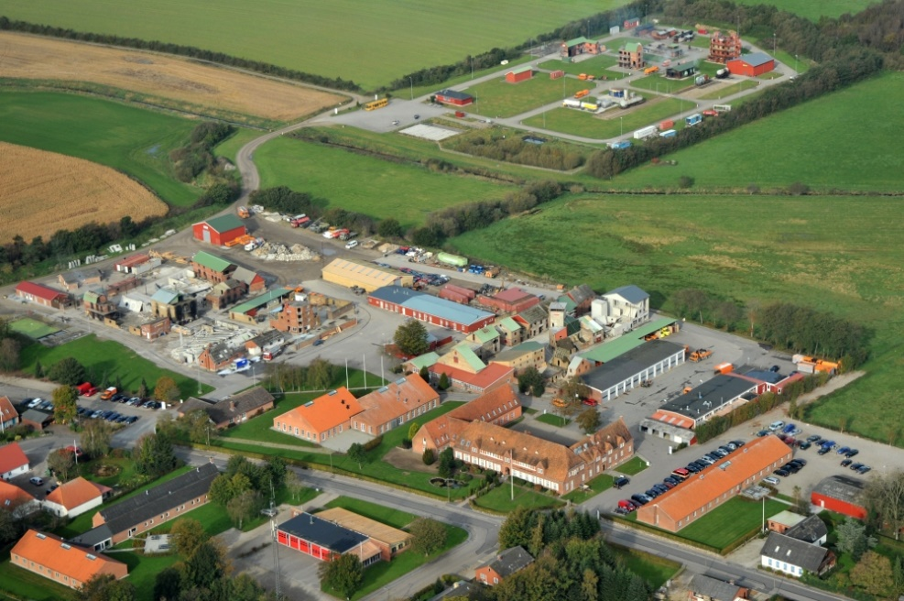
Figure 5.3 Air photograph of the Tinglev training ground.

DEMA Staff College
The DEMA staff college is part of the training school in Snekersten. Main aim of the staff college is to manage the development and implementation of education programs meant for employees of DEMA itself and the municipal fire and rescue service. Contrary to the college in Tinglev, the college in Snekersten mainly focus on trainings in preparedness (the college in Tinglev focuses on response).

DEMA’s international courses
The two above mentioned colleges and the basic trainings focus on Danish first responders. Besides these national oriented trainings, DEMA also organises international trainings. These trainings can be followed by Danish first responders, but also by representatives of international organisations and the foreign fire-fighters. Currently, DEMA is, amongst others, involved in the following international projects:
- Lead partner for European Civil Protection training programme on six annual courses, Information Management Course (IMC), International Coordination Course (ICC), and Security Course (SEC);
- Partner conducting five to six Operational Management Courses (OPM);
- Partner in the European Union’s IPA programme on Civil Protection Cooperation for the candidate countries and potential candidates.

Trainings in volunteer organisations
Also the two largest volunteer organisations, the Danish Red Cross and the Danish Civil protection League to offer trainings for their volunteers. The trainings of the Danish Red cross mainly focus on first aid courses. The training program of the Danish Civil Protection League is more elaborate and consists, amongst others, of trainings concerning food provisioning and temporary housing, fire service, rescue work, use of rescue dogs, communication and SAR-teams (Search and Rescue). They training program is supplemented management trainings in order to better select members for the organisations. Also first aid courses for members and the general public are organised. Focus of these trainings is on the capability to extinguish small fires and handle accidental situations before they become major disasters (EC, 2014).

Procurement

(European) procurement regulations
The procurement of public contracts needs to be in line with the principles of European treaties and especially with the free movement of goods services, capital and people. Furthermore the procurement needs to comply with the principles of equality, proportionality etc. For some types of procurement additional regulations are codified in directives. Within the European legislation, three different procurement directives apply. These directives are mutually exclusive meaning only one of the directives applies to the public procurement. Directive 2014/25/EU (on procurement of utilities) and directive 2009/81/EC (on procurement in the defence and security industry) are topic specific. If these specific directives do not apply, public sector directive 2014/24/EU is applicable, which is the replacement of directive 2004/18/EC. The aim of the new directive is to simply the rules on public procurement; improve the participation of SMEs and stimulate cross border joint procurement.

Stimulation of cross border joint procurement is helpful in case of a major internal crisis or a cross border crisis. The directive states in the preamble that contracting authorities should be able to choose to jointly provide their public services in cooperation with other authorities, without being obliged to use any legal form. These services don’t have to be identical. The cooperation does not require all participating authorities to fulfil the obligations of the contract, as long as there is a commitment to contribute to the cooperative performance. The preamble points out that there are difficulties in cross border joint procurement. Therefore new rules have to be made. In these rules, the conditions for cross border procurement have to be clarified, as well as the applicable regulations. In addition, contracting authorities should be able to set up joint entities established under national or EU law. The new rules are specified in article 39 of the regulations.

If the procurement is executed by a centralised purchasing body located in another MS, the procurement shall be conducted in accordance with the national regulations of the MS where the purchasing body is located. In addition, it may possible that multiple contracting authorities located in different MS jointly award public contracts, conclude framework agreements or operate dynamic purchasing systems. Participating contracting authorities will then conclude an agreement that determines all responsibilities of the parties and the internal organisation of the procedure. As said before, the contracting authorities can set up a joint entity. The parties shall decide on the applicable rules on procurement. They can choose the rules of the MS where the entity has its registered office or where the entity carries out its activities.

This project evolves around the procurement related to crisis management, for example the procurement of ambulances, emergency packs or trainings. The utilities directive applies to gas and heat, electricity, water, transport services, ports and airports and postal services (article 8-13). The directive on defence and security applies to supply of military equipment and sensitive supplies. The majority of procurement in crisis management will be procured by normal NCCs and local authorities like the fire department or police and will not be secret. So in most cases the public sector directive (2014/24/EU) is applicable. This chapter will therefore focus on this directive. Keep in mind that the other directives can also be applicable, for example if the army is used to solve a major crisis. The directive is addressed to Member States and has no direct effect on the national regulations. The directive needs to be implemented first.

Scope of the public sector directive
The public sector directive applies to procurement by contracting authorities with respect to public contracts as well as design contests whose value is estimated to be not less than (article 4):
- € 5.186.000 for public works contracts;
- € 134.000 for public supply and service contracts and design contests, awarded by central government;
- € 207.000 for public supply and service contracts or design contests awarded by sub-central contracting authorities.
- € 750.000 for public service contracts for social and other specific services listed in Annex XIV.

This directive should not apply to certain emergency services where they are performed by non-profit organisations or associations, since the particular nature of those organisations would be difficult to preserve if the service providers had to be chosen in accordance with the procedures of the directive. Furthermore the directive does not apply to public contracts with the purpose of providing public communication networks or electronic communication services; public contracts organised pursuant to international rules; several types of service contracts, e.g. rental, legal services and employment contracts and service contracts based on exclusive rights; and last, public contracts between entities within the public sector (articles 8-12).

Procurement procedures
On a European level, procurement is executed by the European Commission. The public sector directive contains several award procedures:
- open procedure,
- restricted procedure,
- competitive procedure with negotiation,
- competitive dialogue,
- negotiated procedure without prior publication.

The open procedure applies when no other procedure is chosen. In the open procedure, the contracting authority submits a call for tenders. Interested companies may submit a tender. The best offer is chosen, based on the selected award criteria (article 27).

The restricted procedure consists of two phases. In the first phase a call for expression of interests is set out. Interest candidates may submit an invitation to tender. The contracting authority will then invite the most suitable candidates to submit a tender. The contracting authority will award the contract to the best tender, based on the selected award criteria (article 28).

In the competitive procedure with negotiation any interested candidate may submit a request to participate in the negotiations, in response to a call for competition. In this call for competition, the contracting authority has provided a description of their needs and the characteristics of the works or services to be procured. Only the interested candidates that are invited may submit an initial tender, which will be the basis of the negotiations (article 29). In several cases the negotiation procedure can be used without prior publication, for example when the public contract contains a creative achievement; when there is no competition; when intellectual property rights need to be protected, or when there are reasons for extreme urgency (article 32).

In the competitive dialogue any interested candidate can submit a request to participate in response to a contract notice given by the contracting authority. The contract notice provides the information on and the needs and requirements of the contracting authority, as well as the chosen award criteria. The selected interested candidates will join the competitive dialogue, in which the means best suited for satisfying the contract will be defined (article 30).

A new procedure within this directive is the innovation partnership. In the innovative partnership procedure, in response to a contract notice, each economic operator may submit a request to participate in the partnership. The economic operator can do so by providing information requested by the contracting authority. The innovation partnership can be set up with one partner or several partners. Only the economic operators invited by the contracting authority participate in the procedure. After each phase, the contracting authority may decide after each phase to terminate the partnership or reduce the number of partners within the partnership, based on the targets.

According to article 26, the open procedure and restricted procedure are the standard procedures to apply in case of procurement. The other procedures can be used in a limited number of situations, for example when the service is innovative, or when the technical specifications can’t be determined (art. 26, sub 4.).
Contracting authorities can use framework agreements, provided that they apply the procedures in this directive. The agreement can not exceed four years. Contracts within the agreement will be awarded according to the rules in article 33.

In most procedures the candidates are chosen with the use of selection criteria. The selection criteria may relate to suitability to pursue the professional activity; economic and financial standing and technical and professional ability. All criteria need to be related and proportionate to the matter of the contract (article 58).

National regulations and procedures

Scope
In Denmark, the old procurement directives are implemented without any exemptions. The Danish Tender Act is applicable to all procurement outside the scope of the EU directives, because the threshold value isn’t met. In other words, the Danish rules are secondary in relation to the European directives. The Danish act has no threshold value on public works; the value for public services is DKK 500,000

Procurement is executed by the bodies codified in Appendix I of the European directive, which are the state, regional and local authorities and bodies governed by public law. Private entities are only subject to the Danish Tender Act if the public contract is publicly funded.

Procedures
The contracts to which the European directive is applicable all the European procedures are permitted. If the procurement is within the scope of the Danish Tender Act, three different procedures are available: public tenders, restricted tenders or informal bids. There are no restrictions on the use of the procedures, although the contracting authority needs to make sure there is enough competition.

In a public tender the contracting authority announces its intents to contract. This announcement includes technical ability and economical standing of the tenderer. Furthermore the contracting authority should announce if the contract is awarded to the most economically advantageous tender, or the lowest price.

A restricted tender can be performed with or without a prequalification round. The contracting authority In case of a prequalification round, the contracting authority will announce the tender in the press or electronic media. If there is no pre-qualification round, the contracting authority directly invites the chosen participants.
The contracting authority has the authority to negotiate with the tenders, but only with the lowest bidder or with the three most economically advantageous tenderers. This may not result in a substantial change of the project or award criteria.

Informal bids can only be used when the estimated value of the contract is below DKK 3,000,000.

Award criteria
The Danish Tender act prescribes two award criteria: the lowest price or the most economically advantageous offer. If the most economically advantageous offer is used, the contracting authority shall list and explain the sub-criteria, with the relative weight, linked to the public contract. When the lowest price or the most economically advantageous tender has been identified, the tender is awarded to the winner.

Niche capabilities
Private fire and ambulance services
Danish fire and rescue services can be carried out by a privately owned company (according to article 13 emergency Management Act). Currently, around 2/3 of all Danish municipalities has entered into such a contract with a privately owned provided (65 out of the 98 municipalities). The only private operator in Denmark is Falck, who therefore offers its services to 2/3 of all the municipalities. Besides firefighting services Falck is also responsible for 85% of all ambulance service provided in Denmark.

International energy preparedness
A niche preparedness approach of the Nordic countries is found in the energy supply preparedness. The Nordic countries work closely together to create an integrated electricity supply network. When one of the participating countries involved, is confronted with a power shortage, other countries can, via cross border connections, supply energy. This limits the chance of severe blackouts in crisis situations.

Resources

Legislative acts
At national level
Overall, the legislative framework for Danish civil preparedness is mainly based on:
- The Constitutional Act of the Kingdom of Denmark
- Acts (three readings in the Parliament)
- Statuary orders/administrative directives/decrees (depending on the legal authority)
- Circulars
- Guidelines.

The major legislative framework for civil preparedness is the following:
- Emergency Management Act (Consolidated Act No. 660 of 10 June 2009, LBK no. 137 of 01/03/2004 as amended);
- Act on Shelters (Beskyttelsesrumsloven (LBK nr. 732 of 20. August 2003);
- Act on Safety and Environmental Control of Nuclear Installations (Lov om sikkerhedsmæssige og miljømæssige forhold ved atomanlæg (LBK no 244 of 12/05/1976);
- At ministerial level;
- At ministerial level, there is a number of statuary orders governing civil preparedness within the sphere of responsibility of the respective ministry:
- Order of the Ministry of Environment No 1156 of 18 November 2005 on the control of major accidents involving dangerous substances (Miljøministeriets bekendtgørelse nr. 1156 af 18. november 2005 om kontrol med risikoen for større uheld med farlige stoffer);
- Order of the Ministry of Defence no 765 of 3 August 2005 regarding risk-based municipal fire and rescue service as amended by Order no 872 of 6 July 2007 (Forsvarsministeriets bekendtgørelse nr. 765 af 3. august 2005 om risikobaseret kommunalt redningsberedskab som ændret ved bekendtgørelse nr. 872 af 6. juli 2007).

Inter-ministerial cross-cutting co-ordination
- Legal acts such as The Police Act (Law No. 444 of 9 June 2004 as amended) on general co-ordinating powers;
- The Danish Emergency Management Act on co-ordination of efforts at the accident site;
- At international level;
- International intervention is governed by political agreements. Denmark participates in the EU emergency and crisis co-ordination arrangements (CCA), and the Ministry of Foreign Affairs acts as the Danish point of contact in relation to the CCA;
- Military interventions are governed by the Defence Law (Law no 122 of 27 February 2001), while civil interventions are governed by the Civil Preparedness Act (LBK no. 137 of 01/03/2004 as amended);
- Regional agreements.
The Council of the Baltic Sea States (CBSS).

Other normative acts
-

Official documents (white papers, strategies, etc.)
- Danish Defence Agreement 2013 -2017 (20012(
- Danish Government (2008) Danish strategy for adaptation to a changing climate
- Nordic Energy Regulators (2006) ‘Handling extreme situations in the Nordic Countries Report’
- Rigsrevisionen (2013) ‘Report to the Public Accounts Committee on the Danish government’s planning and coordination of the emergency preparedness for major incidents and disasters’
- UNDAC (2011), ‘Emergency response missions’

Online resources (e.g. websites of key CM organizations)
- http://brs.dk
- http://beredskab.dk/bliv-frivillig/opgaver-som-frivillig/#.Vm7A4P5IiUk
- http://www.dr.dk/nyheder/indland/foelg-beredskabsstyrelsen-paa-twitter
- http://elections.sim.dk/local-elections.aspx’
- http://www.emdat.be/result-country-profile?disgroup=natural&country=dnk&period=1900$2014
- http://faolex.fao.org/docs/pdf/den140206.pdf
- http://faolex.fao.org/cgi-bin/faolex.exe?rec_id=114806&database=faolex&search_type=link&table=result&lang=eng&format_name=@ERALL
- http://www.falck.com/en/countries/denmark
- http://www.fmn.dk/eng/allabout/Pages/Defenceexpenditure.aspx
- http://naturstyrelsen.dk/media/nst/Attachments/planlovenpengelsk2007.pdf
- https://www.rodekors.dk/

Publications
- Alliance Developments Work (2014), ‘World risk report 2014’
- CIA World Factbook (2014) Denmark, https://www.cia.gov/library/publications/the-world-factbook/geos/da.html
- DEMA (a) (year of publication unknown) ‘The Danish emergency management agency’
- DEMA (b) (year of publication unknown ‘Preparedness Planning and Crisis Management in Denmark - a short overview’
- DEMA (c) (year of publication unknown, ‘DEMA’s Approach to Risk and Vulnerability Analysis for Civil Contingency Planning’
- DEMA (2012a), ‘Sounding of sirens - Facts’
- DEMA (2012b), ‘Emergency management planning – Facts’
- DEMA (2012c), ‘Emergency response management and co-operation – Facts’
- DEMA (2012d), ‘Assistance form the Danish Emergency Management Agency’

- DEMA (2009) ‘Comprehensive Preparedness Planning’
- DSB (2012) ‘SKAG EX11 Way Forward Report’
- DST (2014) http://www.dst.dk/en/Statistik/emner/aarligt-nationalregnskab/aarligt-nationalregnskab-hele-oekonomien.aspx
- EC (2014) Vademecum Denmark http://ec.europa.eu/echo/files/civil_protection/vademecum/dk/2-dk-6.html
- European Council (year of publication unknown) https://wcd.coe.int/com.instranet.InstraServlet?.
- Falck (2014), ‘Annual report 2013’
- IFEH (2014) ‘’Spotlight on environment and health in Denmark’
- Lloyd’s (2012), ‘Lloyd’s underinsurance report , October 2012’
- OECD (2006,) ‘Denmark assessing societal risks and vulnerabilities’
- Policy research cooperation (year of publication unknown) ‘Denmark – Country overview and assessment‘
- Politi (year of publication unknown), ‘Police in Denmark, the Faroer Islands and Greenland
- Preventionweb (2015), ‘Denmark – National progress report on the implementation of the Hygo Framework for Action (2013-2015)’
- Statistics Denmark (2015), ‘Denmark in figures 2015’Fehler! Hyperlink-Referenz ungültig.).
- Stone Wyman, J. (2012), ‘Emergency management in Denmark: Lessons learned at home and abroad’
- The Nordic Forum (2005), ‘Nordic Contingency Planning and Crisis Management’
- United Nations Office for the Coordination of Humanitarian Affairs (2014), ‘INSARAG External Qualification / Reclassification Manual
- United Nations University (2014), ‘World risk index’
- Website Denmark (2012) http://denmark.dk/en/quick-facts/facts/

Expert interviews
Unfortunately no expert interviews were conducted despite multiple attempts to do so. DEMA did not have the capacity (other urgent priorities) and the Danish Red Cross did not respond either.

Source: https://www.falck.com/en/
Source: www.brs.dk/eng/
Source: Statistics Denmark (2015)
Source: Alliance Developments Work (2014)
Source: EC, 2014
Source: http://emdat.be/
Source: DEMA (c)
Source: DEMA (c)
Source: Stone Wyman
Source: DEMA, 2014
Source: https://www.falck.com/en/
Source: Policy Research Corporation
Text (in Danish only) could be found at: http://faolex.fao.org/cgi-bin/faolex.exe?rec_id=114806&database=faolex&search_type=link&table=result&lang=eng&format_name=@ERALL
Text (in Danish only) could be found at: http://faolex.fao.org/docs/pdf/den140206.pdf
Text could be found at: http://naturstyrelsen.dk/media/nst/Attachments/planlovenpengelsk2007.pdf
Source: DEMA (2009)
Source: DEMA (b)
brs.dk/eng/Documents/Comprehensive_Preparedness_Planning.pdf. (DEMA, 2009)
Source: Nordic Energy Regulators (2006)
Based on: DEMA (2012c)
Source: DEMA (2012c)
Based on: Policy Research Corporation
Source: Policy Research Corporation
Source: Politi
Source: Falck (2014)
Source: http://www.fmn.dk/eng/allabout/Pages/Defenceexpenditure.aspx
Source: Statistics Denmark (2015)
Based on Policy research corporation (2014)
Source: Lloyd’s (2012)
Source: Lloyd’s (2012)
Source: (Rigsrevisionen, 2014)
Based on Preventionweb (2015)
Source: DEMA (b)
Article 1 Emergency Management Act
The Act can be consulted online via: http://brs.dk/eng/legislation/act/Pages/the_emergency_management_act.aspx
Source: DEMA (b)
Article 24.3 Emergency Management Act
Source: http://elections.sim.dk/local-elections.aspx
Source: https://www.falck.com/en/
Source: http://beredskab.dk/bliv-frivillig/opgaver-som-frivillig/#.Vm7A4P5IiUk
Source: https://www.rodekors.dk/
E.g.. Agreement between the Government of the People’s Polish Republic and the Government of the Kingdom of Denmark on Exchange of Information and Cooperation in Nuclear Safety and Protection Against Radiation. Done at Warsaw on 22 December 1987.
E.g. Memorandum of Understanding (The Nordic manual, 2006) on cooperation regarding exchange of information and assistance between Nordic authorities in nuclear or radiological incidents and emergencies. (retrieved via: https://www.stralsakerhetsmyndigheten.se/Global/IRRS/Modules%20summery/Mod%202%20Global%20safety%20regime_FINAL.pdf)
This section is based on: DEMA (b)
Source: DEMA, 2014, edited by authors
Source: brs.dk, edited by authors
Source: DEMA, 2014, edited by authors
Source: DEMA (b), edited by authors
Source: DEMA (b)
Source: DEMA (b), edited by authors
Source: UNDAC (2011), ‘Emergency response missions’
Based on OCHA – INSARAG External classification/reclassification manual 2014
Source: http://vosocc.unocha.org/USAR_Directory/USARTeam.asp
Source: DEMA (b)
Source: Preventionweb (2015)
Source: http://elections.sim.dk/local-elections.aspx
Source: DEMA (b)
Based on: Danish Defence Agreement 2013-2017.
Persons who are hard-at-hearing or hearing-impaired may subscribe to a DEMA warning system to receive text messages
Source: http://www.dr.dk/nyheder/indland/foelg-beredskabsstyrelsen-paa-twitter
Source: DEMA (2012d)
Source: DEMA (b)
Source: DEMA (2012d)
Source: https://www.rodekors.dk/
Source: http://beredskab.dk/bliv-frivillig/opgaver-som-frivillig/#.Vm7A4P5IiUk
Source: http://www.falck.com/en/countries/denmark
Source: DEMA (b)
Please be aware that the information provided on the website is available in Danish only. To visit the website please use the following link: http://brs.dk/beredskab/idk/statsligt_beredskab/resursekatalog/brand/Pages/brand.aspx
Source: brs.dk
Based on: http://brs.dk
Source: http://brs.dk
Source: article 39 public sector directive 2014/24/EU
Source: Falck (2014)
Source: The Nordic Forum (2005)

