

***Driv***ing Innovation in Crisis Management for ***E***uropean ***R***esilience

**BELGIUM**  
Policy, Legislation, Organisation, Procedures & Capabilities (PLOPC) in crisis management and disaster response

*Responsible Partner: ECORYS (Laura Birkman, Linette de Swart, Rachel Beerman)*

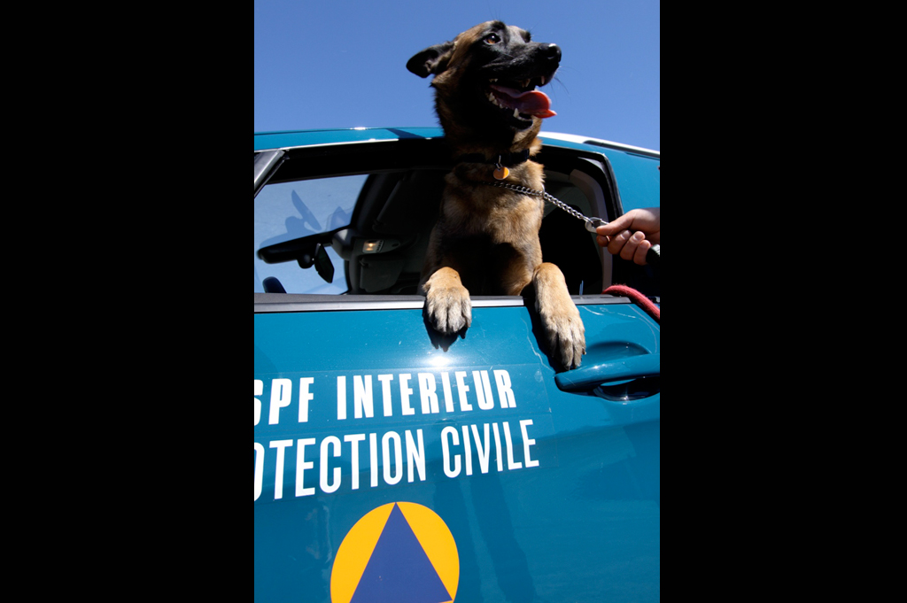

Scope and limitations

This study serves as supporting information for further work within DRIVER.

Only limited time and budget has been available for this first general survey, which needs to be considered in terms of scope and completeness of the respective studies.

The author/s of this study is/are responsible for its content and quality.

This report was revised at the end of 2015, reviewed internally by AIT and amended according to reviewer's comments and recommendations upon the decision of the author/s.

# Overview

In Belgium, a distinction is made between emergency situations that arise as a result of a local/provincial/national crisis and those that arise as a result of an international crisis. A national crisis has its origins and effects on the Belgian national territory, and thus will be managed nationally. Crisis management in Belgium is organised at three levels, the mobilisation of which depends on the magnitude of the incident: These are the (i) municipal level, under the responsibility of the mayor; (ii) provincial level, under the responsibility of the provincial governor; and (iii) federal level, under the responsibility of the Ministry of the Interior.

A Belgian national crisis is first tackled at a local municipal or provincial level, before it is coordinated at the national level. If the magnitude exceeds the provinces’ abilities, the national crisis organisations step in and act as crisis coordinator (operationally managed via numerous departments and operational units, falling under control of the Minister of Interior Affairs). Fire services and the civil protection services of the DG Civil Security together form the emergency intervention services on the operational response side, organised into 32 emergency rescue zones as per 1 January 2015. Civil protection forces are organised on the Federal level and act on federal, provincial and municipal requests.

Key stakeholders are the municipal level (Mayors), the Provincial level (Governors) and the Federal level (Minister of Interior Affairs and supporting DGs, namely DG Crisis Centre, DG Civil Security, DG Security and Prevention; Federal Knowledge Centre; Red Cross; B-FAST, etc).

International crises in Belgium are generally managed within the framework of multilateral organisations. The Belgian civil protection agency has a unique structure for international emergency assistance in the interdepartmental B-FAST teams, comprised of civil protection services from the Federal Public Services (FPS) Interior Ministry, as well as FPS Public Health, FPS Foreign Affairs and the Ministry of Defense. B-FAST is also deployed in the case of emergencies originating in Belgium but having effects outside its borders.

# Table of Contents

BELGIUM Policy, Legislation, Organisation, Procedures & Capabilities (PLOPC) in crisis management and disaster response 271

Overview 272

Table of Contents 273

List of Figures 276

List of Tables 276

List of Abbreviations 277

1 Policy 278

1.1 Risk Assessment 279

1.2 Policy and Governance 280

1.2.1 Strategy scope and focus 281

1.2.2 Monitoring and analytical support to policy making; R&D 281

1.2.3 Policy for Prevention 282

1.2.4 Policy for Preparedness 284

1.2.5 Policy for Response 284

1.2.6 Policy for Relief and Recovery 285

1.3 Financing 286

1.3.1 Investing in preparedness and prevention 286

1.3.2 Investing in consequence management 288

1.4 Policy review, Evaluation &Organisational Learning 289

1.4.1 Post-Disaster Assessment 289

1.4.2 Departmental Lessons Learned systems 289

1.4.3 Centralised (national) Lessons Learned system 289

1.4.4 International exchange for Lessons Learned 289

1.4.5 Regular policy reviews 290

1.5 Resilience 290

1.6 Information sharing and data protection 291

2 Legislation 292

2.1 Crisis (emergency, disaster) management concept 292

2.2 General crisis (emergency, disaster) management law 292

2.3 Emergency rule 294

2.4 Specific, department/agency-level legal arrangements and regulations on emergency and disaster management 294

2.5 Specific to the regional and local authorities legal arrangements and regulations on emergency and disaster management 294

2.6 Legal regulations on the involvement of volunteers and specialised NGOs 296

2.7 Legal regulations for international engagements of first responders and crisis managers 297

3 Organisation 298

3.1 Organisational chart 299

3.2 Organisational cooperation 310

4 Procedures 312

4.1 Standing Operating Procedures (SOPs) and Guidelines 312

4.2 Operations planning 313

4.3 Logistics support in crises 314

4.4 Crisis communication to general public; Alert system; Public Information and Warnings 314

4.4.1 Internal communication 314

4.4.2 External communication 315

5 Capabilities 317

5.1 Human resources 317

5.2 Materiel (non-financial) resources 318

5.3 Training 319

5.4 Procurement 322

5.4.1 Procurement regulation 322

European regulations 322

5.4.1.1 Scope of the public sector directive 323

5.4.1.2 Award procedures 323

*National* regulations 325

*5.4.1.3* *Scope* 325

*5.4.1.4* *Procedures* 325

*5.4.1.5* *Award criteria* 325

5.5 Niche capabilities 325

Resources 327

Legislative acts 327

Other normative acts 327

Official documents (white papers, strategies, etc.) 328

Online resources (e.g. websites of key CM organizations) 328

Publications 331

Expert interviews 332

## List of Figures

Figure 1: Map of communities and regions of Belgium 278

Figure 2: Flowchart on the procedure for recognizing payments under the calamity funds 286

Figure 3: Example of a recent campaign targeted at young Belgians. Financed by the Seveso fund 290

Figure 4: Map of new emergency rescue zones in Belgium 296

Figure 5: Belgian’s Federal crisis coordination 299

Figure 6: Main Belgian federal civil protection organizations 301

Figure 7: DG Civil security of the Federal Public Service of the Interior Affairs 303

Figure 8: Organisation of the Directorate of Operations under DG Civil Security 304

Figure 9: Map of operational civil protection services units 304

Figure 10: Federal crisis management bodies 308

Figure 11: Crisis management plans 314

Figure 12: BASF's new fire truck, co-financed by the Ministry of Interior affairs 318

Figure 13: Training in the new Diabolo tunnel under Brussels Airport 320

## List of Tables

Table 1: Summary of Natural Disasters, human impact and economic damage (1980-2015). 279

Table 2: Budget Expenditures of MoI on crisis management, 2011-2012 (in ,000€) 287

Table 3: Five disciplines operational crisis management 305

Table 4: Staff of most relevant crisis institutes (as per 1 September 2014) 317

## List of Abbreviations

|  |  |
| --- | --- |
| B-FAST | Belgian First Aid and Support |
| BELINTRA | Belgian Intervention System for Transport Accidents |
| CIC-C101 | Communications and Information Centres |
| CGCCR | Coordination and Crisis Centre of the Government |
| CPND | Commission of National Defence Matters |
| DICa-DIR | Contingent for Relief Operations Abroad |
| DG | Directorate General |
| EC112/100 | 112/100 Emergency Centres |
| FPS | Federal Public Services |
| FRISK | Federal Risk Inventory, Survey and Knowledge Building |
| GRIMP | Group for rescue and intervention at difficult places |
| HNS | Host Nation State |
| IBZ | Ministry of the Interior |
| INSARAG | International Search and Rescue Group of the UN |
| IPSU | Higher Institute for Emergency Planning |
| KCCE | Federal Centre of Expertise for Civil Protection |
| MIC | Maritime Information Node |
| MRCC | Maritime Safety and Coordination centre |
| OCAD/ OCAM | Organ for Coordination and Analysis of Threats (in Flemish / in French) |
| PGUI | General emergency and response plans (In French, Le plan général d’urgence et d’intervention) |
| PPUI | Specific emergency and response plans (in French, Le plan particulier d’urgence et d’intervention) |
| PUI | Multidisciplinary emergency and intervention plans (in French) |
| RD | Royal Decree |
| Regetel | Réseau gouvernemental de Télécommunications, or Governmental Telecommunications Network |
| SOP | Standard/Standing Operating Procedure |
| TETRA | "TErrestrial Trunked RAdio |

# Policy

Belgium operates under a federal parliamentary democracy under a constitutional monarch. The key actors in the federal government are the Prime Minister and the Ministers. Through a series of constitutional revisions from 1970 to 1993, Belgium devolved into a federal state comprised of federal, regional and community institutions, entailing a complex division of responsibilities.[1]

Belgium has three region (i.e., Walloon, Flanders and Brussels, the capital) and three linguistic communities (i.e. French, Flemish and German). The regional areas are administrated on, e.g. economic, industrial and environmental issues, while the linguistic communities administer in areas mainly related to their respective language, e.g. education and media.

Belgium has 10 provinces, each of which is led by a governor that presides over a provincial council. The local government level is made up of 589 municipalities, each of which is led by a mayor presiding over a municipal council.[2]

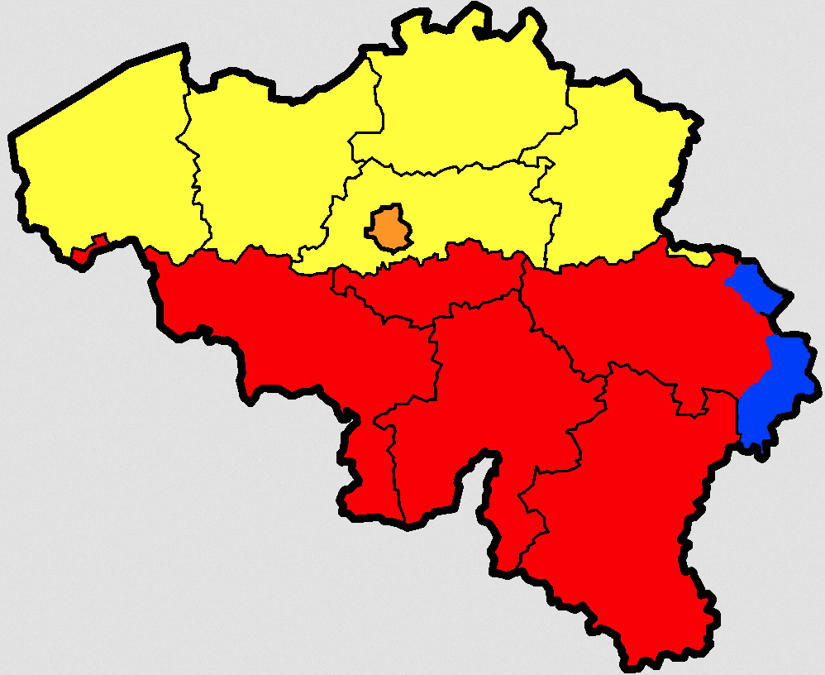

\

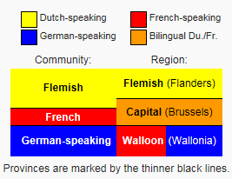

Figure 41: Map of communities and regions of Belgium[3]

## Risk Assessment

Due to the geographical terrain of the country, the main natural disaster risk in Belgium is flooding, particularly along rivers and in areas of reclaimed coastal land, which are protected from the sea by concrete dikes. Nuclear risks are another important threat, given that the Belgium’s energy supply depends on nuclear power for more than 50% of the country’s energy resources.[4] Other threats include Seveso and contagious animal diseases. [5]

The Ministry of Interior Crisis Centre of Belgium and its partners identify the following priority risks:

* Flooding
* Nuclear risks
* Seveso risks
* Contagious animal diseases
* Vital Interests of the country
* Pipelines
* Terrorist threats[6]

The relevance of the risks being designated as “priorities” is that annual planning focuses first on these risks when drawing up plans.

Table 10 summarises the record of natural disasters over the last 35 years (1980 to 2015), including their human and economic impact in Belgium.

Table 10: Summary of Natural Disasters, human impact and economic damage (1980-2015).[7]

|  |  |  |  |  |
| --- | --- | --- | --- | --- |
| **Type of disaster** | **No. Events** | **No. Killed** | **Total affected (1)** | **Damage (000 USD)** |
| Earthquake (ground movement) | 2 | 2 | 1030 | $150,000 |
| Extreme temperature (2) | 6 | 2121 | - | - |
| Flood | 21 | 28 | 4975 | $1,345,146 |
| Storm | 15 | 15 | 978 | $ 764,986 |
| (1) Refers to Sum of injured, homeless, and affected (People requiring immediate assistance during a period of emergency; it can also include displaced or evacuated people).  (2) Includes cold waves and heat waves | | | | |

The DG Crisis Centre under the Ministry of the Interior (described in 3.1) has developed a risk inventory through which it can continuously monitor and analyse risks as objectively as possible. This inventory is called the Federal Risk Inventory, Survey and Knowledge Building (FRISK).[8] The data and information collected is based on inputs of different sources of information and warnings from civilians and professionals (Mayor, Governor, DG Civil Security and Police).

## Policy and Governance

In Belgium, a distinction is made between emergency situations that arise as a result of a local/provincial/national crisis and those that arise from an international crisis. A national crisis has its origins and effects on the Belgian national territory, and thus will be managed nationally, whereas an international crisis tend to find their roots beyond Belgium’s borders and are generally managed via a political and/or military framework, such as the Belgian First Aid and Support (B-FAST).[9]

Crisis management in Belgium is organised at three levels, the mobilisation of which depends on the magnitude of the incident: These are the (i) municipal level, under the responsibility of the mayor; (ii) provincial level, under the responsibility of the provincial governor; and (iii) federal level, under the responsibility of the Ministry of Home Affairs.

A Belgian national crisis is first tackled at a local municipal or provincial level, before it is coordinated at the national level. If the magnitude exceeds the provinces’ abilities, the national crisis organisations step in and act as crisis coordinator (operationally managed via numerous departments and operational units, falling under control of the Minister of Interior Affairs).

**Municipal phase**

If the crisis does not exceed the municipal level, the major is in charge of the crisis emergency planning. He reports to the governor of the concerned province.

**Provincial phase**

If the crisis’ magnitude exceeds the boundaries of one municipality, then the governor of the province is in charge. He reports to the Minister of Internal Affairs.

**Federal/National phase**

When the magnitude exceeds two or more provincial boundaries and the means available to the provincial governor within his/her competence of coordination are insufficient, the Minister becomes responsible for implementing the phase.

All levels are responsible for emergency planning in their respective territories.[10]

### Strategy scope and focus

The strategic approach to crisis management in Belgium covers all necessary activities for prevention, preparedness, response (including resilience) and relief and recovery. Article 11(2) of the Law on Civil Security of 15 May 2007 states that prediction, prevention, preparedness, execution and evaluation are all integral to the tasks of the operational civil security emergency services (comprised of the Civil Protection intervention services and the fire departments).

### Monitoring and analytical support to policy making; R&D

Analytical support is provided to the civil protection services via two institutes: (i) the Higher Institute for Emergency Planning (IPSU), which is embedded within the Coordination and Crisis Centre of the Government (CGCCR) and (ii) the Federal Centre of Expertise for Civil Protection (KCCE), a separate service within the DG Civil Security of the Ministry of the Interior.

The **Higher Institute for Emergency Planning (IPSU)** was first established in 1991 by the Royal Decree of 29 July 1991. In 2003, IPSU was integrated into the CGCCR. This institute is responsible for sharing information on the multidisciplinary and strategic aspects of crisis emergency planning and to support the evolution of the CGCCR into a “knowledge centre of emergency planning for all crisis managers,” including “at the federal and local levels, in the private and public sectors, and in the military, policing and civilian fields”.[11] It is tasked with maintaining a close link with academic experts in crisis management.

The main activities of the Institute are:

(i) [to spread] information via the organisation of specific trainings, brochures and participating at other initiatives;

(ii) [to stimulate] the exchange of ideas for internal and external emergency planning among the diverse authorities and industry;

(iii) [to inform] workers on necessary precautions with respect to health risks regarding interventions. This takes place in close cooperation with the Directorate General for Civil Security.[12]

Examples of research projects organised by IPSU include[13]:

* “The role of the mayor during the Emergency Management ” (2011) to clarify the specific role of the mayor in an emergency situation. The output was a publication which contains a collection of experiences and best practices on planning and emergency situations.
* “Research on monitoring disaster victims” (2011)
* “The practice of evacuations” (2009) to analyse both legal and practical aspects of evacuation. The output included the development of practical tools to facilitate a rapid and effective response during actual events.

IPSU also participates in European research projects, such as[14]:

* ERGO (2009), Evacuation Responsiveness by Government Organisations
* Disaster 2.0 (2012), a research project on the use of web 2.0 and web 3.0 applications in the field of crisis management.

The Federal Centre of Expertise for Civil Protection (KCCE) was established on 28 March 2007 and is embedded within the Federal Public Service (FPS) Interior Affairs. The centre is tasked with collecting information on civil security with the aim to improve the quality of their services and to stay up to date on the latest standards. In terms of specific support to policy-making, the centre plays a key role in the development of Standard Operating Procedures (SOPs), discussed in section 4.1.[15]

### Policy for Prevention

Prevention is institutionalised via the DG Security and Prevention falling under the Ministry of Interior Affairs. The main task of DG Safety and Prevention is to contribute to the safety of Belgian civilians, via intense cooperation with a network of partners, enforcing specific safety and security legislation including the responsibility of giving sanctions in case of non compliance and last prevention (fire and burglary for example) specifically aimed at civilians.

The DG consists of eight units[16]:

1. Fire safety[17]
2. Control of private security
3. Litigation and legal support
4. Comprehensive local safety / security
5. Police management[18]
6. Private security
7. Footbal unit
8. Radicalism unit.

The DG supports the Ministry of Interior affairs and prepares measures and plans to limit damage in case of an emergency. Therefore the Department also invests in research on preventions. The Department specifically organises prevention via three funds targeted at risk prevention (IBZ, 2014):

* Seveso Fund[19]
* Nuclear Fund
* The fund/council for protection against fire and explosions

These funds are discussed under 1.3.1.

The Royal Decree of 19 December 2014 “determining the organization of the fire prevention in the emergency rescue zones” sets out the main tasks of fire prevention, namely to sensitize, provide advice and control.

First the zones need to inform and sensitize the citizen regarding the possible dangers. They do this amongst other things through prevention campaigns, information sessions and open days. Besides sensitizing, the zones also need to provide fire prevention advice. That advice is always without obligations. Citizens, architects, authorities, …, can ask for specific information. Fire prevention controls only take place in the framework of a potential action of the authorities or in preparation to a decision of an authority such as granting a permit or closing down a building. The emergency rescue zones also have to draw up an action plan in which they mention their future fire prevention initiatives and determine their policy.  The action plan is tuned to the framework policy document of the FPS Home Affairs.[20]

The importance of such campaigns is evidenced by the 2010 National Fire Prevention Plan campaign of the DG Security and Prevention. This plan was identified as a best practice in prevention due to the large approach to the general public and communication via social media. (IBZ, 2014)

* Civilians were made aware of the fire risks and fire prevention measures via a website <http://www.ismijnwoningbrandveilig.be> and via social media. These prevention measures focus on installing a smoke detector, investing in fire equipment (blankets and extinguishers), avoiding the use of stand-buy mode for electronic equipment etc.
* The government made available funds to train fire prevention advisors. These are equipped with a trolley to support them in giving lectures. The trolley contains smoke detectors, fire blankets, fire proof building materials etc. In November 2010, 87 advisors were active in 28 operational zones (steered via the local fire fighters).

### Policy for Preparedness

The key actor is the DG Crisis Centre of the FPS Interior Ministry. Ministers are responsible for emergency planning in their area of competence, and all levels of government (i.e. municipal, provincial, national) are responsible for emergency planning in their respective territories. The CGCCR is tasked with organising proactive emergency planning. Contingency plans for emergency protection, rescue and relief are drafted on the basis of input from IPSU. The knowledge on crisis management is also updated by the KCCE. The process for drafting emergency plans is discussed in section 4.1.

In an official statement at the Third UN World Conference on Disaster Risk Reduction (WCDRR) in Sendai, Japan (March 2014), the First Counsellor of the Permanent Mission of Belgium, Mr. Christophe de Bassompierre states, as evidence of Belgium’s commitment to preparedness:

During its Presidency of the Council of the EU, Belgium has developed the principle of “Host Nation Support”(HNS), with regard to receiving assistance during a major emergency. It principally consists in preparing, on the territory of States which have experienced a disaster and asked for international assistance, the on-the-spot integration of international teams mobilized in order to support them. In the same way, Belgium is very active in the organization of large-scale European civil protection exercises.[21]

### Policy for Response

A crisis is managed at the municipal, provincial or national level depending on a number of criteria, i.e. geographical scope, number of victims, environmental and/or economic impact, etc. At the national level, three bodies can be summoned at the DG Crisis Centre: an assessment, a management, and an information cell. Each one contributes to the overall decision process within their respective competences (described in section 3.1). The Directorate of Operations under the DG for Civil Security is responsible for national coordination in the event of an emergency. An emergency is to be coordinated at this level if:

* A minimum of two provinces are affected
* The means available to the provincial governor within his/her competence of coordination are exceeded.

In terms of operational organisation, DG Civil Security is responsible for deploying the civil protection services upon request and is also indirectly responsible for fire services. The civil protection services are comprised of 6 operational units, divided across the Belgian territory. The operational tasks of each unit are divided between 5 disciplines, which are described in section 3.1.

Mobilization of the emergency civil protection services at the provincial level occurs when:

* The scope of the emergency requires management by the government
* The immediate effects of the emergency exceed the municipality.

Mobilisation of the emergency civil protection services at the municipal level occurs when the scope of the emergency requires management at municipal level.

In international scenarios:

Belgian government has a unique mechanism called B-FAST (Belgian First Aid and Support Team) which provides emergency response capacities to other countries whose own resources are insufficient to face a disaster. These capacities include humanitarian goods, dispatching of experts in assessment or for coordination, or sending of teams (modules).[22]

### Policy for Relief and Recovery

The Belgian policy approach to relief and recovery is based around the Calamity Funds system (“Rampenfonds” in Flemish; or “Fonds des Calamités” in French), which is aimed at assisting civilians when recovering from a natural disaster. The main actors and tasks are:

* the **local administration** is involved for collecting detailed information in the damage.
* the **provincial level** bundles the local information to a report, which is submitted to the Calamities Directorate of the FPS Interior;
* the **Minister of Interior Affairs** declares the damage to be falling under the fund, the report is discussed at the Federal Minister council. If approved by the council, the Calamities Directorate transfers the responsibility for covering the damages caused to civilians to the ‘National Calamities Fund’. The Ministry of Interior affairs communicates with the civilians.

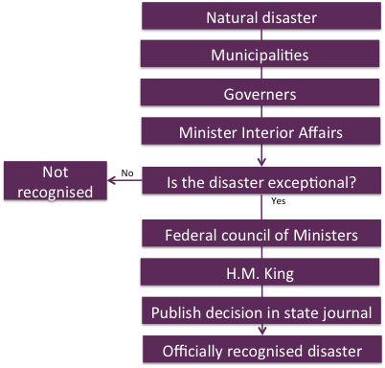

Figure 42: Flowchart on the procedure for recognizing payments under the calamity funds[23]

For more on the calamity funds, see section 1.3.2.

Regarding international relief and recovery efforts,

The actions related to emergency relief are as much as possible multilaterally framed both at European (EU Civil Protection Mechanism) and global levels (United Nations OCHA Emergency Services Branch: UNDAC and INSARAG). Among the foreign disasters which have left their mark on the past decade, B-FAST was prominently present and active in the aftermath of typhoon Haiyan (Philippines, November 2013), Port-au-Prince earthquake (Haiti, January 2010), Aceh tsunami (Indonesia and Thailand, December 2004 – January 2005), and Al Hoceima earthquake (Morocco, February 2004).[24]

## Financing

### Investing in preparedness and prevention

The DG Civil Security invests in preparedness for and prevention against fire and explosions, nuclear-, chemical- and biological incidents via three funds:

* Seveso Fund
* Nuclear Fund
* The fund/council for protection against fire and explosions

**The Seveso Fund.** The Seveso fund is financed by the companies falling under Seveso legislation. The revenues collected are gathered in two funds: One ‘Fund for the risks of major accidents’ and one ‘For the prevention of major accidents’. The first falls under the Ministry of Home Affairs, the second falls under the Ministry of employment. The funds support related prevention like for example, the realization of information campaigns, the purchase and the maintenance of specific material of intervention, the management of the network of sirens, the provision of a databank of a dangerous goods to the fire protection organizations are financed thanks to the funds.

**The Nuclear Fund.** The development of Belgian CEP Nuclear plans are supported by the funding foreseen by the Belgian Nuclear sector itself. The sector contributes to the Belgian Nuclear funds. This fund supports the coordination of protection measures in case of emergencies.

**The Fund/Council for Protection Against Fire and Explosions.** Belgian’s Federal level is responsible for the basic norms of fire protection and fire prevention. This council sets up these regulations, which can be complemented with local legislation or legislation of the regional level. The council for protection against fire and explosions has an advising and guiding role. The fund also supports professional training, funds research and is taking care of information sharing.

The department additionally supports local policy makers and police departments in developing crisis management measures, supports the process of settlements if civilians were to incur damage as a result of police actions and also evaluates the compliance of private security organisations with regulation.

Overall budget expenditures on relevant crisis management activities is shown in Table 11.

Table 11: Budget Expenditures of MoI on crisis management, 2011-2012 (in ,000€)[25]

|  |  |  |
| --- | --- | --- |
| Departments and Programmes | 2011 | 2012 |
| Strategic Coordination | 2.164 | 3.853 |
| Management | 9.935 | 10.562 |
| Logistics and Coordination | 159.664 | 238.276 |
| DG Crisis Centre | 15.374 | 13.563 |
| DG Civil Security | 94.402 | 89.222 |
| DG Security and Prevention | 55.283 | 86.598 |
| Provincial governments | 19.404 | 20.613 |
| Calltakers, 112 Emergency Centre and ASTRID | 72.620 | 87.562 |
| OCAM | 1.597 | 1.547 |
| **Total Crisis Management Expenditures** | **430.443** | **551.796** |

### Investing in consequence management

Since 1 March 2007, the financing of recovery from most “ordinary” disaster risks, i.e. floods, earthquakes, overflows or backups at public sewers and landslides/subsidence, is organised via insurance companies, specifically fire insurance. This covers damages to houses and their contents by the aforementioned disaster risks.

When the civilian’s fire insurance does not cover the damage incurred[26], and the Minister declares the damage to be originating from an unforeseeable natural disaster, the Calamity Funds system can be activated. According the Calamity Funds User Manual, the funds provide only for:

* Assets that do not constitute ordinary risks
* Agricultural goods in principle excluded from insurance coverage, i.e. no-harvested crops, livestock alive outside buildings, soil, crops, etc.
* Cars that are not safely parked in a garage or under a carport
* Goods that are not insured because of poverty of the household involved
* Property in the public domain of legal entities.

The ‘Calamity Funds’ also cover the costs of removal of explosives of World War II and damage to Belgian private property incurred in Congo, from the moment on the country Congo declared itself independent. Both represent a minor part of their tasks. [27]

When the “Calamity Fund” is activated, the damages are paid ad-hoc by the National Treasuries. [28] Costs of the civil protection are paid from their assigned budget, and are seldom reclaimed from the civilians relying on the services.

In the year 2012, the most recent data retrieved, the Federal government decided on the acceptance of incurred costs as a result of unforeseeable natural disasters of 2012, € 25.144.592, of which € 24.642.671. A total of 20 events were recognized by the Council of Ministers under the required criteria. [29]

As of 1 January 2015, this fund has been regionalised, meaning that for all damages from events occurring since 1 July 2014, the regional department is responsible (previously FPS Interior):

* Walloon Public Services – “Service régional des Calamités”
* Flemish Government Administrative Affairs “Vlaams Rampenfonds”
* Regional Public Services of Brussels – “Direction des Investissements”[30]

## Policy review, Evaluation &Organisational Learning

### Post-Disaster Assessment

See sections 1.4.2 – 1.4.5.

### Departmental Lessons Learned systems

While it could not be verified for each single organisation (see chapter 3.1), in general, knowledge gained from past experiences is built at the KCCE.

### Centralised (national) Lessons Learned system

While a specific mandate with regards to a centralised lessons learned system count not be verified, the KCCE is tasked with collecting information on civil security activities with the objective to improve the quality of services provided and to maintain the latest standards in service provision. The findings of these activities then provide inputs to the development of SOPs, a key responsibility of the KCCE. See also chapter 1.2.2 and 4.1.

### International exchange for Lessons Learned

Belgium participates in international trainings and exercises, however no specific information on international exchanges for lessons learned could be identified in the frame of the study. Knowledge is built at the Federal Knowledge Centre Civil Security and the Higher Institute of Emergency Planning.

### Regular policy reviews

Belgium conducts reviews for its civil protection policy and system, it could not be verified if these reviews take place regularly or if they occur ad-hoc. The latest review was conducted as part of the preparation of the New Framework Law of 15 May 2007 (i.e. Law on Civil Protection) (discussed in Chapter 2).

## Resilience

Belgium’s approach to the concept of resilience is based on increasing disaster awareness through education, trainings and awareness campaigns. For example, an awareness campaign was launched to inform citizens of the procedures applied when one finds him/herself in a Seveso crisis situation. The brochures were distributed to 400.000 Belgians civilians living in Seveso risk areas and via municipalities. The budget for the campaign was 1 million EUR.

In 2012, the Seveso campaign was complemented with an online campaign targeted at young Belgians. The website was shaped as a game: Seveso The Game: Be The Ultimate Survivor. In the game the young people experience the Seveso risks and procedures in a less formal way.[31]

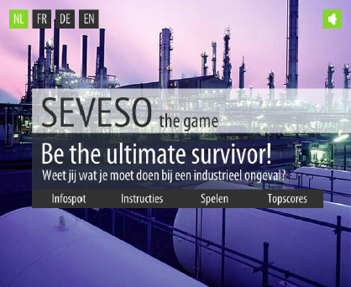

Figure 43: Example of a recent campaign targeted at young Belgians. Financed by the Seveso fund[32]

The trainings organised by the federal and provincial training institutes are discussed in section 5.3.

## Information sharing and data protection

The Royal Decree of 2 June 2015 creating the Strategic Intelligence Committee and the Coordination Committee outlines the responsibilities of these two bodies in the area of intelligence and security services, including the exchange of information between the two fields. Specifically, the Strategy Committee is responsible for reviewing each proposal in the context of the intelligence and security policy determined by the National Security Council and the proposed resolutions to be submitted to the National Security Council by the Coordination Committee. The Coordination Committee is responsible for submitting to the National Security Council proposals for the general policy of the intelligence and security services, including policy on the protection of sensitive information.

In addition, several Euroepan Directives and Regulations apply to Belgium, as all other Member States.

* Directive 95/46/EC is the legislation on the protection of personal data in Europe and it requires that one independent supervisory authority be established in each Member State to monitor its implementation.
* Directive 2002/58/EC on privacy and electronic communications, covering confidentiality, billing and traffic data, rules on spam and so forth, and establishing the EDPS as an independent supervisory authority with responsibility to monitor the processing of personal data by EC institutions and bodies.[33]

# Legislation

## Crisis (emergency, disaster) management concept

The Belgian crisis management concept has its roots in the inter-World War era, to the “Liga voor Passieve Luchtbescherming van de Bevolking en de Burgerlijke instellingen”, founded in 1934. At that time, Liga was made up of volunteers, whose main activities were to warn the civilians in case of air strikes, to provide first aid care and to clean rubble following air strikes. Over time, the name changed to the ‘Belgian Civil Protection’, housed within the Ministry of the Interior. In 1963 the concept was defined as

The civil protection encompasses all civil measures and tools needed in order to guarantee the preservation of Belgian population, guarding the country’s patrimonial in times of armed conflicts. The civil service also has to goal to intervene in crisis situations, catastrophes and damages of all kind and should then at all times aid civilians and protect goods.[34]

The concept of Civil protection has continued to evolve overtime, no longer focused on warning against air strikes but rather organising to support fire fighters and civilian in case of larger crisis situations where expertise, technical aid and specific equipment is needed.

## General crisis (emergency, disaster) management law

Key provisions of the legal framework for crisis (emergency, disaster) management in Belgium are identified below.

**Legal framework for Civil Security (the fire departments and the Civil Protection services)**

The Law of 15 May 2007 on the Civil Security determines the principles governing the organisation and functioning of the fire departments and the Civil Protection. According the DG Civil Security website, the basic principles underlying the execution of the reform of the civil security structure are the following:

* a uniform method of working, by means of which all fire brigades (emergency rescue zones) intervene in the same efficient and safe manner during interventions,
* a thorough cooperation and more efficient division of tasks between emergency rescue zones, and between zones and units of the Civil Protection,
* innovation, with the examination of the best means, trainings, procedures and regulations, and with the exchange of best practices,
* a uniformization and revaluation of the administrative and pecuniary statute of the professional and voluntary firemen,
* increase in scale, with a more efficient spending of the budget as a consequence.[35]

Art 11. Of the second chapter defines clearly the tasks and organisation of the Belgian civil protection services’ operations. First, their tasks are officially:

* To rescue and assist civilians in case of treat and also to protect their belongings
* To provide emergency medical assistance according to Art. 1 of the law of 8 July 1964
* The fight fire and explosions and their consequences
* To fight pollution and dangerous goods; including radioactive and ionised goods
* To provide logistical support,

Secondly, they have the task to:

* Preparedness: Proactively analyse and map the risks
* Prevention: All measures to prevent an minimise occurrence of risks and to minimise the likely effects
* Preparation: All measures to prepare the services on the likely threads
* Execution: To take the measures in case of emergency
* Evaluation: All measures to improve the preparedness, prevention, preparation and execution after incidents have took place.

Art. 153 defines that, for the civil emergency tasks mentioned in Art. 11, the Belgian Civil service is the only competent institute. Following Art. 48 of the law of 12 January 1989, mayors and governors can call on the Civil service’ services when needed. Art. 154 defines the Minister of Interior affairs to be in charge of the Civil service. Art. 155 defines that the teams can consist of professional and voluntary staff.

The Civil Security Law additionally reforms the organisation of roles and responsibilities between the emergency services (see chapter 2.4) and the arrangements pertaining to local and provincial authorities (see chapter 2.5). The new organisation is operationalised on the 1 January 2015.[36]

**Legal framework for managing crises at the national level**

The Royal Decree (RD) of 31 January 2003 shapes the legal framework for crisis management at the national level (i.e. the federal phase of emergency planning). The European Commission *Civil Protection Vademecum* states,

This piece of legislation enables activation of immediate coordination at the national level. The RD confirms the role of the CGCCR in events that demand coordination at the federal level. Thus, it meets the overall goal of protecting the population against all types of risk that might affect it, and the lack of a general emergency plan on a national level.[37]

**Legal arrangements concerning emergency planning and response**

A **Circular of 11 July 1990** states that the obligation of all public administrators, municipalities, provinces, hospitals and enterprises is to develop individual emergency plans in relation to their own particular risk possibilities. The **Royal Decree of 16 February 2006** on emergency planning and response updates the 1990 Decree, assigning to Civil Protection the role of supporting the plans and executing/coordinating the operational tasks. This RD effectively established the current, three-levelled approach to crisis management planning and response in Belgium, which is undertaken at the municipal, provincial and federal/national levels (see section 1.2).

## Emergency rule

Legal provisions concerning emergency rule in the event of disaster or emergency situation could not be identified.

## Specific, department/agency-level legal arrangements and regulations on emergency and disaster management

Building on the Reforms to the civil security structure outlined in 2.2, a **draft Royal Decree of 14 October 2013** “modifying the RD of 25 April 2007 determining the missions of the emergency services that can be recovered and the missions that are free” sets out the division of tasks between the fire departments and the Civil Protection Services, taking into account their respective complementarities. The division of roles is discussed in section 3.1. [38]

## Specific to the regional and local authorities legal arrangements and regulations on emergency and disaster management

The current legal arrangements and regulations specific to regional and local authorities are set out in the following:

* RD of 28 March 2003 on municipal and provincial emergency planning
* RD of 16 February 2006 on emergency planning and response
* Law of 15 May 2007 on Civil Protection

The **Royal Decree of 28 March 2003** assigns emergency tasks to the municipal and provincial level and develops general and specific emergency plans, while the **Royal Decree of 16 February 2006** updates the plans and terminology. This RD is followed by 4 explanatory circulars which further outline the procedures and roles for emergency planning.[39]

**Art. 11 of the Law on Civil Protection** defines explicitly the need of the Civil protection service to cooperate with the local emergency services (Fire fighters). To improve the cooperation, the federal level is obliged to sign cooperative agreements. The new organisation was officially operationalised on 1 January 2015. The major change of this law, however, is the integration of the municipal fire services into a structure of zones. The **Royal Decree of 2 February 2009** regarding the territorial delineation of the emergency rescue zones groups the former 250 local firefighters into 34 rescue zones. As of the 1 January 2016, the organization of the fire departments entirely passes from a municipal organization system to a zonal system. [40]

Figure 44 shows the new configuration of the 34 emergency rescue zones for the whole of Belgium.

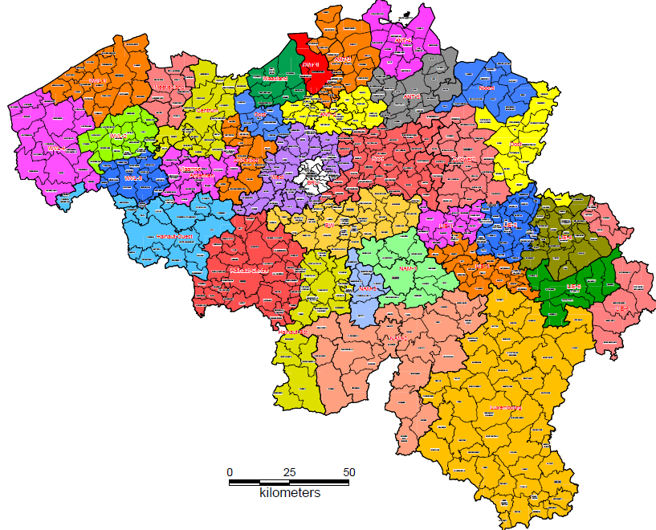

Figure 44: Map of new emergency rescue zones in Belgium[41]

## Legal regulations on the involvement of volunteers and specialised NGOs

The legislation (RD 15 May 2007) allows volunteers in both the organizations of fire fighters and the operational civil protection services. Art. 67 defines the financing structure for all 34 zones, all with a mixed staff of professional fire fighters, voluntary fire fighters, professional ambulance non-fire fighter staff and/or voluntary ambulance non-fire fighter staff (Art. 103). Art. 155 of the same RD defines that the civil protection staff can exist out of professional members or volunteers.

Regarding their accountability, detailed rules are applied via Art. 159 till 166 of the former mentioned RD. The volunteer or professional is only accountable personally in case s/he committed a serious failure or failure on purpose. Also small failures can be incurred by the member of staff, if these occur more than average. Other damages are incurred by the organisation of civil protection. The services as well take up the costs of legal advice for staff members, or the relatives in case the staff member passes away, except when committed a failure on purpose or an serious failure.

## Legal regulations for international engagements of first responders and crisis managers

The **Royal Decree of 28 February 2003** established B-F.A.S.T (Belgian First Aid and Support Team), an emergency relief structure for the purpose of providing assistance to a country or countries affected by natural and man-made disasters. The Decree defines the underlying strategic framework of BFAST and its supporting structures, as well as the criteria for their use. These are described below:

Before a B-FAST operation can be deployed by the Belgian government, the following intervention conditions must be met:

(i) The size of the disaster, natural or man-made, must exceed the capabilities of the country hit by the disaster to such extent that it poses a threat to the health or the lives of the population in the disaster zone.

(ii) The country hit by the disaster must launch a request for relief to the international community.[42]

(iii) In case of an armed conflict in the disaster zone, an intervention by B-FAST is excluded.[43]

Once deployed, a B-FAST operation must comply with the following application criteria:

(i) B-FAST operations cannot exceed 10 days

(ii) B-FAST operations solely include immediate emergency relief.[44]

Regarding the “intervention radius” of B-FAST operations, “[f]or practical and logistic reasons and according to the proportionality principle concerning the use of the available means, an intervention radius of maximum 6,000 km from Belgium is the limit for B-FAST operations abroad.”[45] This criteria is not, however considered to be an absolute standard.

Finally, B-FAST operations abroad should be executed in coordination with the various international partners (UN, EU, NATO) and should be deployed on the basis of the added value of B-FAST. That is, the participation of B-FAST should be limited to the domains in which it can provide expertise based on Belgian capacities.

# Organisation

Figure 45 shows the Belgian disaster management structure, including government bodies, emergency services and warning dissemination structures.

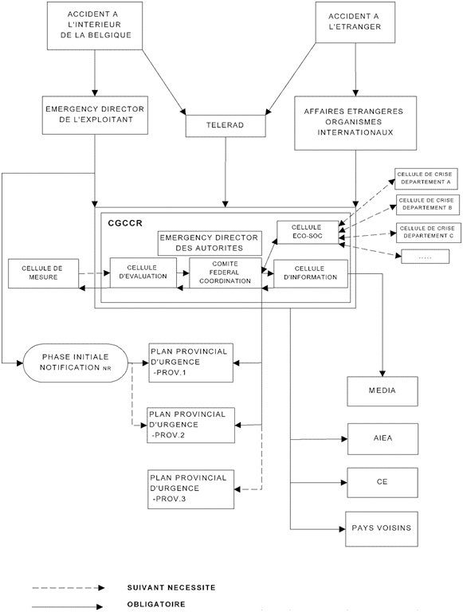

Figure 45: Belgian’s Federal crisis coordination[46]

## Organisational chart

The following organisations have a crucial role in the Belgian disaster and crisis management:

* Government ministries, in particular
  + Interior Affairs
  + Ministry of Public Health
  + Foreign Affairs
  + Defense
* Public security bodies
  + Police and rescue
  + Fire services
  + Civil protection services (part of the DG Civil Security)
* Coordination and Crisis Center of the Government (CGCCR)
* CNPD
* B-FAST
* Ministerial Council / Prime Minister
* Institute of Higher.. (IPSU)
* KCCE

The range of actors that may be involved in a disaster or crisis situation in Belgium are many and wide-ranging, and may include institutions not dedicated to crisis management services, e.g. DG Employment, Labour and Social Dialogue in the execution of a related Seveso Fund (see 1.3.1).

The institutes are largely based at the Federal level, rather than at the provincial or municipal level, and the overall responsibility for crisis management in Belgium rests with the federal government and the ministries.

In the event of a disaster or emergency, the Minster of Interior Affairs is the highest executive agent. The Minister is supported by several DGs, all under his or her control. Figure 46shows the key DGs involved in crisis and emergency management.



Figure 46: Main Belgian federal civil protection organizations[47]

DG Coordination and Crisis Centre of the Government (CGCCR), is responsible for overall coordination at the national level under the supervision of the Minister of Interior Affairs. It is through the CGCCR that the Minister manages national emergencies and engages the integrated police and rescue services. The DG for Civil Security is directly responsible for the civil protection services, which are federal services, comprised of six permanent operational units distributed across the Belgium territory. DG Civil Security is also indirectly responsible for fire services, which are operationally organised by emergency zones (34 in total). In a national level crisis, the CGCCR is responsible for coordination, while the Operations Directorate under DG Civil Security is responsible for managing the intervention. In the event of an international crisis, B-FAST is activated.[48]

In terms of preparedness and prevention, the CGCCR is tasked with initiating and organisning pro-active emergency planning, supported by the ISPU, while the responsibility for developing and implementing disaster preparedness plans in Belgium lies at all levels of government (i.e. municipal, provincial, national are responsible for emergency planning in their respective territories).

In the following sub-sections, the tasks and responsibilities of the Ministry of Interior Affairs (via DG Civil Security, DG Safety and Prevention, DG Crisis Centre), civil protection services of DG Civil Security, the fire brigade, police and rescue teams will be described in detail.

**DG CGCCR**

The CGCCR (also known as DG Crisis Centre) is responsible for steering crisis management at the national level under the supervision of the Minister of Interior Affairs. The Crisis Centre has the assignment to organise the pro-active emergency planning. The centre is supported in this task by the IPSU (described in section 1.2.2.).

The main tasks of the Crisis Centre include:

* Collects and analyses on a permanent base relevant information for policy making and for operational organisations
* The centre offers expertise for crisis management at the Federal level
* The centre acts as the contact point for international crises
* After office hours, the centre acts as steering organisation for several federal institutions
* The crisis centre also is involved in public order management. The planning coordination and follow up of large events are tasks of the centre.
* The centre is actively involved in the security of high ranked officials visiting the country (kings etc.)
* Emergency plans on federal level are assigned to the centre
* The centre has a state of the art infrastructure for meeting and coordinating in times of crisis[49]

In the event of a national crisis, three bodies can be summoned at the Crisis Centre, each one contributing to the decision process within their respective competences: (i) an assessment cell, (ii) a management, and (iii) an information cell.

The **assessment cell** evaluates the situation. It comprises experts and scientists from different competent authorities or services. It is presided by the department, which is most involved in the crisis, which is designated by the management cell.

The **management cell** (alias the Federal Coordinating Committee) takes the necessary measures and is the policymaking organ. It comprises the competent (federal) ministers or their representatives, and it is presided, in principle, by the Minister of Home Affairs or his/her representative.

The **information cell** communicates regularly about the measures taken to inform the population about the latest state of affairs and decisions taken by the management cell. The information cell comprises those responsible for communication or spokespersons from the departments concerned.[50]

**DG Civil Security**

DG Civil Security is the hub for the non-police emergency services in Belgium, covering the 6 federal civil protection intervention service units (directly) and the municipal (now zonally organized) fire services (indirectly). It is responsible for operational coordination in the event of an emergency, directly managing and controlling the Civil Protection Intervention Services (discussed below). The DG is comprised of 4 operational directorates, 3 staff services and five supporting cells. The operational directorates are:

* **Directorate 112**, a separate service coordinating the communication between the civilians in need of assistance in crisis situations and the professionally organised emergency services (police, medical aid, civil security etc.);
* **Centre of Expertise for the Civil Security** (KCCE), responsible for training fire services and operational civil protection intervention services (see section 1.2.2.);
* **Directorate of Operations**, responsible for managing the interventions;
* **Directorate Equipment and New Technologies**, which supports the procurement of materials and equipment for the fire service and the operational civil protection intervention services (discussed under 5.4)

The DG is additionally charged with legal issues, prevention and public relations. The following figure shows the structure of the DG Civil Security. The purple dots are the main units within the department.

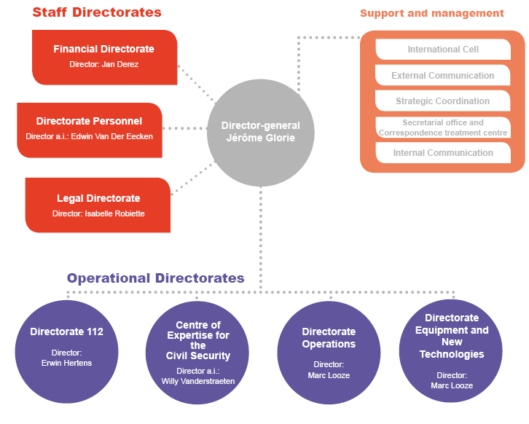

Figure 47: DG Civil security of the Federal Public Service of the Interior Affairs [51]

Each emergency is handled by **civil protection intervention services**, which are managed and controlled by the DG Civil Security, providing the population with assistance in the event of both small or big disasters. Figure 48shows the organizational structure in which the civil protection services operate.

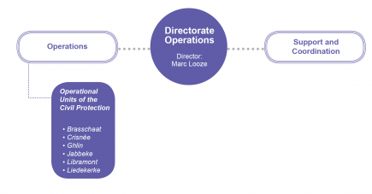

Figure 48: Organisation of the Directorate of Operations under DG Civil Security [52]

There are six operational units, distributed across the Belgian territory:

• Brasschaat (near Antwerp)

• Crisnée (near Liège)

• Ghlin (near Mons)

• Jabbeke (near Brugge)

• Libramont (province of Luxembourg)

• Liedekerke (near Brussels).

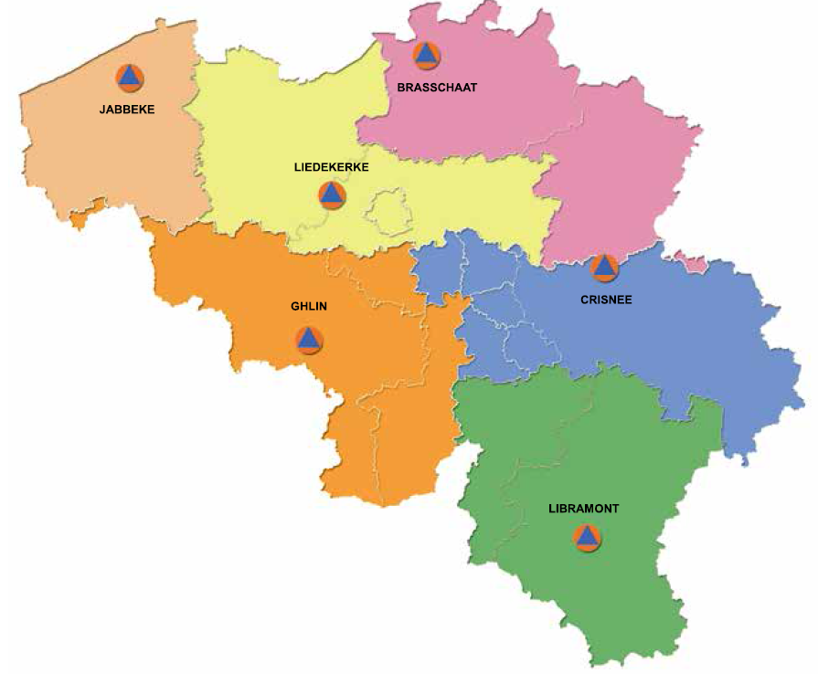

Figure 49: Map of operational civil protection services units[53]

The operational tasks of the civil protection services are divided into five disciplines, each of which must draw up an intervention plan that outlines operating procedures.

Table 12: Five disciplines operational crisis management[54]

|  |
| --- |
| **Discipline 1: Assistance operations** |
| * Controlling the emergency and eliminating associated risks, tracking persons, setting them free, rescuing and placing them in safety, protecting their goods. |
| * Claiming goods and persons. |
| **Discipline 2: Medical, sanitary and psychosocial assistance** |
| * Starting the medical chain |
| * Applying medical and psychosocial care to victims and persons involved in the emergency |
| * Organising transport of victims |
| * Taking measures to protect public health. |
| **Discipline 3: Police local to the area of the emergency situation** |
| * Restoring and maintaining public order |
| * Clearing entry and evacuation roads (if need be, escorting intervening services and means to the area of occurrence) |
| * Setting up the perimeter, physical demarcation, signalling and guarding, ensuring entry control to the operational theatre |
| * Executing public evacuation and supervising shelter |
| * Identifying victims |
| * Supporting judicial inquiry. |
| **Discipline 4: Logistical support** |
| * Ensuring reinforcements of personnel and materials, as well as specialised rescue and assistance means |
| * Organising technical means for communication between disciplines, the operational command post and the coordinating committee(s) |
| * Organising foodstuffs and drinking water for the intervening services and stricken population. |
| **Discipline 5: Information** |
| * Providing information and guidelines to the population (e.g. through the media) |
| * Providing information about measures for returning to normal conditions. |

A few examples of the interventions of the Civil Protection are:

* Reinforcement of the water and foam supply, or heavy, specialized equipment in case of fire
* Shore up, apply canvasses, track and rescue victims of disasters or major accidents
* Deployment of specialized teams such as diving teams or dog teams during interventions or judicial missions of long duration
* Cleaning and transport of large-scale pollution such as petrol, asphalt, …
* Decontamination and reception of the population in case of chemical or nuclear pollution
* Sealing of dikes and pumping in case of large-scale floods
* Distribution of potable water
* Support with means of telecommunication[55]

**National coordination**

The CGCCR (DG Crisis Centre) is the hub in crisis management, and steers the cooperation with the operational civil protection forces under DG Civil Security. This DG intervenes at the request of the minister of Internal Affairs, the governors, the mayors, the fire departments or the police and provides reinforcement to emergency services with heavy and specialized equipment. The DG additionally coordinates with the Belgian fire fighters (operationally organised via emergency zones. The national approach for managing crises at national level, and the organisational cooperation between the relevant bodies, is sketched below.

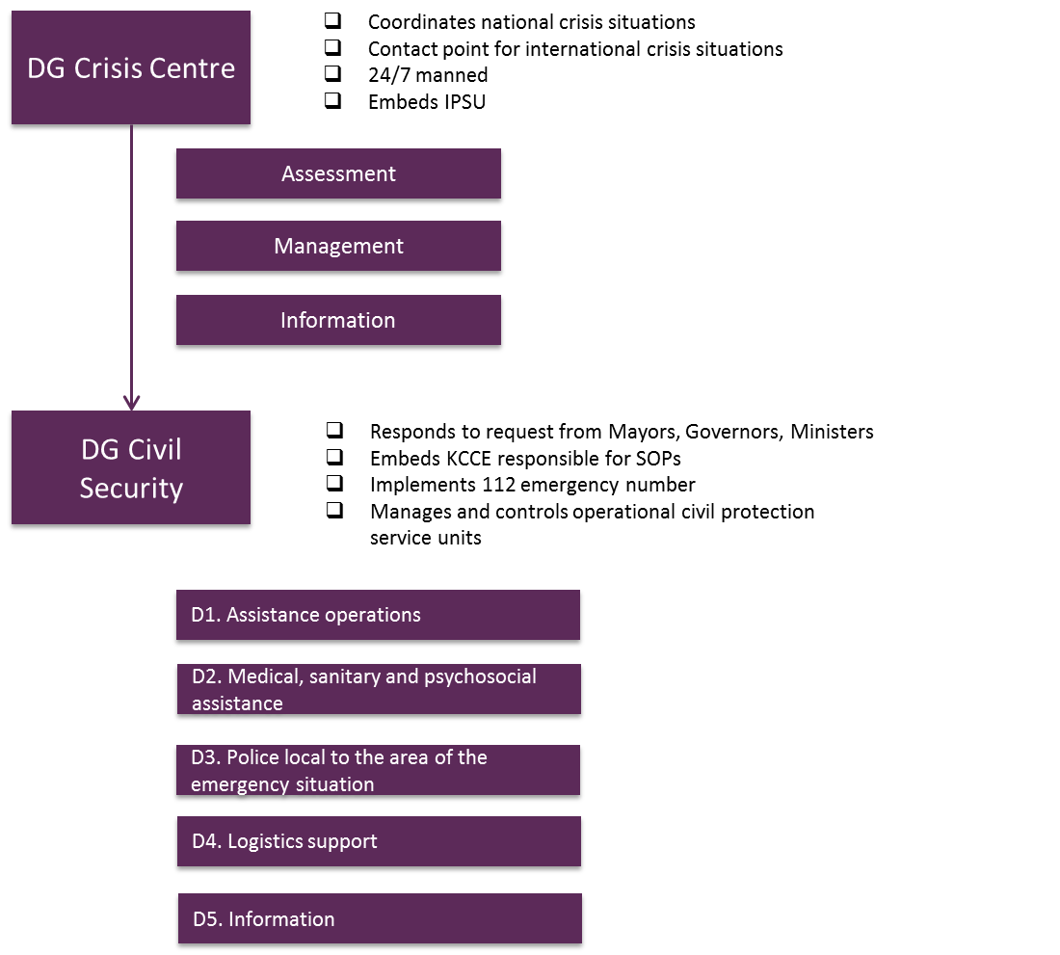

Figure 50: Federal crisis management bodies[56]

**Fire services**

The **Royal Decree of 2 February 2009** sets out a new system for organizing fire services in the Belgium. With the Decree, the 250 fire services were replaced by 34 zones. The website of the DG Civil Security states that, as of 1 January 2015, “The organization of the fire departments entirely passes […] from a municipal organization to a zonal system. The royal decree regarding the emergency rescue zones divides Belgium into 34 emergency rescue zones.”[57] A map of the new zonal structure is shown in section 2.5.

Regarding the division of tasks and missions of the emergency services:

A draft of royal decree modifies the division of tasks between the fire departments and the Civil Protection. It optimally takes into account the complementarity of these two emergency services. The fire departments take care of the basic missions regarding civil security, while the Civil Protection takes charge of the lengthy and specialized interventions. The possibility is given to the emergency rescue zones, by means of a cooperation agreement, to also appeal to another emergency rescue zone or to the operational units of the Civil Protection for certain  basic missions when other means than the minimal means mentioned in attachment 1 of the royal decree regarding the determination of the minimal conditions of the fastest adequate assistance and the adequate means, are needed.[58]

Fire services are mobilized based on the principle of fastest adequate assistance:

This principle means that the fire department that can get to the place of a loss fastest will intervene. Before, it was the territorially competent fire department that intervened, regardless of whether another fire department actually could get to the place of the incident faster. The principle of the fastest adequate assistance is applied in practice since 2007.

In 2012 a royal decree regarding the determination of the minimal conditions of the fastest adequate help and the adequate means, was passed. The prezones and the emergency rescue zones now have time until 31 December 2017 to take the necessary measures to meet the conditions provided in this decree.[59]

**Specialised teams**

In addition to the roles that have been described relating to the various actors so far, the civil protection and fire departments have organized a number of specialized Civil Protection teams. These teams consist of personnel of the fire departments and the Civil Protection:

* Assistance teams with dogs
* B-FAST (discussed below)
* Dangerous goods safety advisors
* Divers of the civil protection
* High capacity pumping
* IBIS, specialized in tracking diseased persons, mainly in cooperation with the Disaster Victim Identification team (DVI) of the federal police
* Rescue with ropes
* Speleo
* USAR. [60]

**Civil military-cooperation**

In the event of a national emergency, the following arrangement applies in accordance with the Ministerial Circular NPU-1: “Whenever civilian means are exhausted, military support can be considered and requested through the competent authority. In case of a municipal phase, agreement by the governor is compulsory.”[61]

Regarding international assistance, “the Ministry of Defense is part of the B-FAST structure, and it will provide available means and expertise to such missions, in accordance with international practices, e.g. the Oslo Guidelines”.[62]

**International assistance**

The interdepartmental B-FAST is the framework for Belgian international assistance, comprised of civil protection services from Federal Public Service (FPS) Interior Ministry as well as FPS Public Health, Ministry of Defence and FPS Foreign Affairs. It was created by the Royal Decree of 28 February 2003 as a permanent emergency relief structure that could be mobilized at any time to assist a country or countries affected by a man-made or natural disaster. B-FAST consists of three committees and a permanent secretariat:

The **B-FAST Secretariat** is the competent body for coordinating, preparing decisions, possible execution of and follow-up on all measures in the framework of emergency assistance.

The **coordination council** is presided by the Minister of Foreign Affairs or his/her representative. It consists of the representatives of the ministers involved and the director of the B-FAST Secretariat. In case of a request for assistance, the coordination council president submits a proposal for possible assistance to the Council of Ministers.

The **planning committee** ensures strategic support and prepares files for treatment in the coordination council. It consists of administration representatives from the above-mentioned departments and focuses on technical- strategic aspects, e.g. investments, training, exercises and operations.

An **advisory committee** can be consulted consisting of representatives from NGOs and experts, designated by the coordination council[63].

The decision process regarding the deployment of B-FAST services is discussed in the next section.

Regarding operational activities of B-FAST, including the deployment of relief actions abroad, the organisation of exercises and trainings,

B-FAST has at its disposal the Contingent for Relief Operations Abroad (DICa-DIR), which is comprised of about 150 professionals and volunteers of the public emergency services (Fire Brigade and Civil Protection) from the FPS of the Interior, “supplemented if necessary with staff from Defence (logistics, communication, commando) and with volunteers (paramedical staff and doctors) from the FPS Public Health.” The detachment also engages in the aforementioned organisation of trainings abroad. [64]

## Organisational cooperation

As has been described already in chapter 1, in terms of internal organizational cooperation of among the relevant crisis management organisations, three levels of government are central depending on the magnitude and scope of the incident.

The strategic framework of B-FAST (see Chapter 2.7) states that B-FAST should participate in the international coordination mechanisms for dealing with disasters. To that end, operations should be deployed in coordination with the various international partners (ie. EU, UN, NATO).

Regarding the mobilisation of B-FAST forces for international assistance,

As soon as a request for assistance reaches B-FAST, the Secretariat summons the planning committee and, if necessary, the advisory committee, to be able to submit a proposal to the coordination council. In practice, however, both the planning committee and coordination council will be summoned at the same time. At the moment of the convocation, so as to gain time, all relevant departments will start operational preparations.

As for the acceptance of international assistance, there is no specific national plan.[65]

# Procedures

## Standing Operating Procedures (SOPs) and Guidelines

The Belgian KCCE is assigned to collect, analyse, develop and spread knowhow and expertise on civil security. The development of Standing Operating Procedures (SOP) is part of their tasks. The SOP’s are designed in order to have a prewritten procedure in case of a certain crisis, however given that each incident is different SOPs are to be considered as a best practice against which commanders can deviate following a proper assessment of the individual incident.

On its website, the DG Civil Security outlines the different phases of development of SOPs:

**1. Development**

The existing Standard Operation Procedures are developed by fire experts who work for the Centre of Expertise for the Civil Security. These fire experts act as the pilot and draw up an action plan in this framework, they appoint a working group of minimum six experts in this theme and they develop certain SOPs in co-operation and consensus with this working group.

**2. Test phase**

After a temporary approval of a Standard Operation Procedure by the Validation Committee, it passes through a test phase. After all, the most important thing is that a SOP corresponds to the reality of the field, that is meets the most recent intervention techniques and that it is sufficiently flexible for the application of the SOP in both a rural and an urban environment in the entire country.

After the publication of a SOP on this website, it is tested by different emergency rescue zones in Belgium. Testing and assessing a SOP in a realistic situation by at least two emergency rescue zones is the strict minimum. They can transfer their remarks on the basis of their findings to the Centre of Expertise for the Civil Security after which the pilot of the project can adapt the SOP with the help of his working group.

**3. Best practice**

After a test phase in at least two emergency rescue zones, a Standard Operation Procedure can be “definitively” validated by the Validation Committee and then the SOP is considered to be a best practice. Emergency rescue zones can use it if they want to. Nonetheless, SOPs are not a regulation and therefore don’t need to be applied obligatory.

When it proves, after acquiring new insights on the subject or evolutions in the domain, that the SOP can still be improved after the test phase, this can off course be done by contacting the Centre of Expertise for the Civil Security.

**4. Training, practice and exercise**

As soon as a Standard Operation Procedure has become a best practice, trainings and exercise cards can be linked to it to prepare the relief workers even better for certain interventions. If needed, the necessary specialized equipment can be bought as well, to be able to optimally execute certain interventions.

In case of emergency, the Belgian Directorate-General Civil Security is responsible for executing the SOP. The Directorate is part of the Federal Public Service Home Affairs. [66]

## Operations planning

The approach to dealing with emergencies by the authorities are set out by the numerous emergency plans for handling incidents at the different governing levels. At the first level, there are the multidisciplinary emergency and intervention plans (PUI in French, NIP in Flemish). These are developed by local authorities and cover (i) the General Emergency and Intervention Plans (PGUI in French, ANIP in Flemish), which are supported by the specific emergency and intervention plans (PPUI in French, BNIP in Flemish). The latter pertain to specific risk types and magnitude, allowing case specific planning (e.g. for airplane crashes).

The second level covers the Mono-disciplinary Intervention Plans, which are linked to are linked to the specific intervention plans of the different emergency services, detailing their functions and duties during incidents. For instance, a medical intervention plan or a psychosocial intervention plan. The third level covers the internal emergency plans of private companies.[67]

Thus, a “phased approach” to emergency planning exists in that, depending on the nature of the incident, assistance is structured for the local, provincial and national levels. This is show in Figure 51.



Figure 51: Crisis management plans[68]

## Logistics support in crises

Within the DG for Civil Security, the Directorate Logistics is in charge of organizing logistics support. A full reference of logistical support intervention modules is available in the catalogue of intervention modules.[69] Directorate Logistics (Dir-log) of the civil protection agency is in charge.

## Crisis communication to general public; Alert system; Public Information and Warnings

The coordination of the Civil Security is organised twofold. The first type of communication is organised for supporting the operational activities. The second coordinates and communicates externally.

### Internal communication

There are several communication systems in place for supporting operational activities among Belgian authorities and/or crisis management actors. The Regetel network (Réseau gouvernemental de Télécommunications, or Governmental Telecommunications Network) is an independent network of the government, “with own servers, 410 telephone nodes, 90 fax nodes, own technical support and an own network in the centre of Brussels. It ensures that all partners of the DG Crisis Centre of the FPS Interior are reachable in the event of a disaster. The network is split into a part dedicated to crisis situations (Crisis Network) and a second part dedicated to federal services (Federal Network).

The Crisis network allows contact between:

* Provincial crisis centres
* Permanent units of the Civil Protection intervention services
* 112/100 Emergency Centres (EC112/100)
* Communication and information centres (CIC-C101)
* Federal organisation responsible for the analysis of threads (OCAM, in FR or OCAD in NL)
* Crisis centers at Fluxys and Eandis, gas and electricity infrastructure providers
* Dispatch centres of the Belgian Red Cross
* Maritime Safety and Coordination centre (MRCC) in Ostend and the Maritime Information Node (MIC).

The Federal Network connects higher level government actors, e.g. federal ministers and their chiefs of staff; DGs of the FPS’s; the Royal Palaces; and the Speakers of the House of Representatives and the Senate.[70]

In addition, Belgium is equipped with a TETRA communication network, operated by ASTRID. TETRA, or "TErrestrial Trunked RAdio", is a European-developed standard for digital voice and data communications (i.e. national radio communications, paging and dispatching network) designed for emergency and security services.[71]

### External communication

DG Crisis Centre is responsible for informing the media and general public in the event of an emergency.The services are day and night available to give support in crisis situations with GIS tools, videoconferences, electric generators, sirens etc. The Crisis Centremanages the network of around 570 sirens to rapidly warn the population in the event of an incident near nuclear sites and factories with significant industrial risks (i.e. Seveso high threshold risks) and nuclear areas. [72]

The use of alternative means of early warning (e.g. SMS warnings) are currently being tested as part of the BE-Alert project. Civilians can register their mobile phone number to be alerted in case of emergency. Civilians need to register and can be informed via[73]:

* Spoken messages on fixed and mobile phones
* SMS alerts on mobile phones
* Text messages via email
* Text messages via fax.

Civilians may contact the government via the common European emergency number: 112. The line is operated by the 112 Directorate of the DG Civil Security of the FPS Interior and the Ministry of Public Health. – Minister of Home Affairs & Minister Public Health. A federal multi-linguistic project is planned in the near future.

Other emergency numbers include

* Police: 101
* Emergency Medical Services: 100
* Fire Brigade: 100
* Child focus: 116.[74]

# Capabilities

## Human resources

The number of staff employed at the main crisis management organisations of the federal government amounts to around 3.024 persons. The Federal level also has on its payroll 373 persons working in the provinces. It is unclear, however, the proportion of the federal staff located in the provinces that are working in the area of crisis management. The staff statistics as per 1 September 2014 are shown in Table 13.

Table 13: Staff of most relevant crisis institutes (as per 1 September 2014)[75]

|  |  |
| --- | --- |
| Institute | Number of staff |
| DG Civil Security | 1366 |
| - Central directorate in Brussels | 131 |
| - Knowledge Centre | 12 |
| - Operational units | 571 |
| - Call takers 112/100 and Operators 101 | 652 |
| DG Security and Prevention | 195 |
| DG Crisis Centre | 80 |
| Direction des calamates | 17 |
| Fire fighters | 18.000 (2/3th is volunteer) |

Additional resources are available from other civil protection service providers, e.g. fire services (amounting to approximately 18.000 in 2014, of which around two-thirds are volunteers), emergency medical services and from NGOs such as the Belgian Red Cross.

Private sector stakeholders include:

* Belintra for chemical transport incidents
* SCK – The Belgian Nuclear Research Centre
* IRE – The National Institute for Radioelements
* Belgoprocess for nuclear incidents. [76]

## Materiel (non-financial) resources

The Civil Protection has access to heavy, specialized equipment that can be deployed for her own interventions, as well as for the reinforcement of the interventions of other emergency services. A few example of this equipment are:

* super cannon: to extinguish heavy fires in chemical companies.
* goliath pump: can pump away very large amounts of water with a speed of 66,000 litres per minute, for instance in case of floods.
* decontamination units: to decontaminate people that became contaminated during a nuclear or chemical accident.
* vacuum tank: to quickly drain off and transport dangerous substances after for instance oil pollution in a river or ditch.
* waterline: can create up to 600 water bags per hour. [77]

The protection agency can additionally rely on the equipment of the fire protection agencies, the specialized private protection services and the army. Fire fighters from the Industrial Chemical plants can be called for support in crisis situations. The new Turbo-Löscher fire truck of the Antwerp plant of the Chemical company BASF is even co-financed by the Belgian Civil protection agency. The Ministry of Interior Affairs pays BASF a fee of 110.000 EUR per year for the next 10 years. The highly powerful fire hoses can spray a distance of up to 100 to 150 meters and up to 70 m high and 45 m in width; it can spray up to 25.000 liters of water per min. The Turbo can be used for Belgian interventions, and regional cross border interventions. When in operation, the fire truck is supplied with water via equipment of the Belgian Civil protection forces.[78]

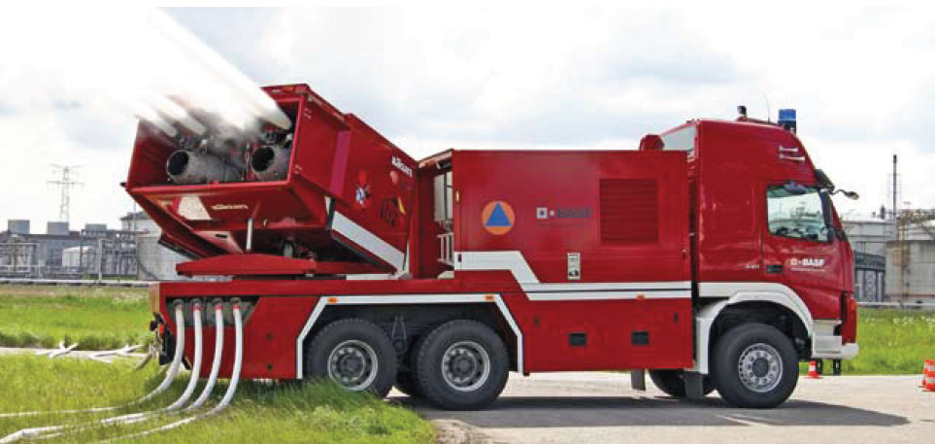

Figure 52: BASF's new fire truck, co-financed by the Ministry of Interior affairs[79]

The civil protection organisation has a catalogue of 120 pages detailing their material resources, ranging from equipment to reinforce the fire departments and emergency rescue zones in case of big fires to equipment for logistics support to resources to support the police services.[80]

## Training

Within the Civil Protection structure, advisory boards are installed. These advise the operational zones, units, operators and call takers. The structure knows three advisory boards: personnel, material and training.

Within the training advisory board, four units exist.

* The trainings for public fire fighters is organised and continuously reviewed at the ‘*Hoge Raad voor de opleiding voor de openbare brandweerdiensten*‘. The council advises the Minister of Interior Affairs directly on the trainings, reglementation and reports on the quality of the trainings organised at the local/provincial training centres.
* The *programming commission* is active in the needs mapping for trainings, advising on the syllabi, making proposals to the Minister on courses and exams and controlling the redaction committee.
* The third unit ‘*Commission on Equalisation and exemption’* advises the Minister on the levelling of diploma standards, courses and brevets and the exemption of courses and exams.
* In 2003, a ‘*supra-provincial training council’* for the French speaking and German speaking public fire fighters and a ‘*supra-provincial training council’* for the Dutch speaking public fire man were founded. The councils are grouping the presidents of the regional federations, technical and operational representatives of the General Council. An official of the Brussels department of fire fighters is added. These councils coordinate and level provincial trainings. [81]

The training locations are spread around the provinces.

* The Federal Training centre is located in Archennes.
* The training centre for the province of Antwerp is located in Emblem.
* The training centre for Brussels is located in Brussel centre.
* The training centre for the province of Henegouwen is located in Jurbise.
* The training centre for the province Limburg is located in Genk.
* The training centre for the province Liege is located in Seraign.
* The training centre for the province Luxemburg is located in Bastogne.
* The training centre for the province Namen is located in Namen.
* The training centre for the province East-Flanders is located in Gent.
* The training centre for the province West-Flanders is lcoated in Brugges.
* The training centre for the province Flemish-Brabant is located in Asse.
* The training centre for the province Wallonian-Brabant is located in Wavre. [82]

The training centres organise mono-disciplinary and multi-disciplinary trainings at location as well. A recent multidisciplinary training was organised in a new railway tunnel under Brussels Airport. The team tested the new SOP, under guidance of the Federal Expertise Centre.

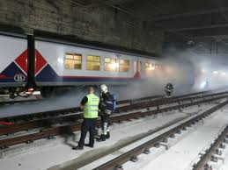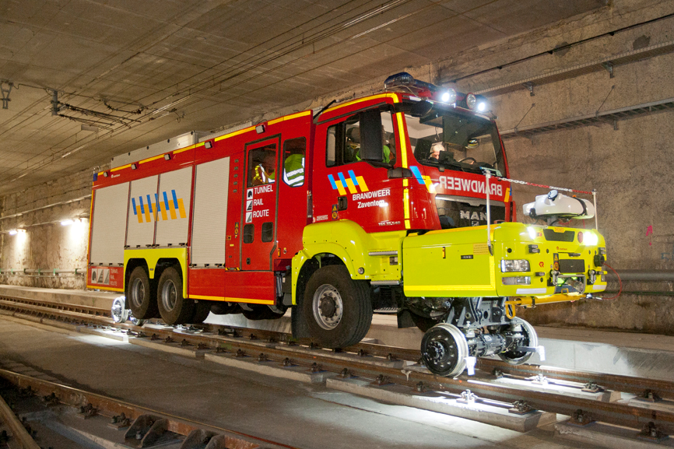

Figure 53: Training in the new Diabolo tunnel under Brussels Airport[83]

**Certification**

The trainings are organised at the provincial level. The trainings consist out of a bachelor type of training structure, split also in modules which can be followed separately. As of 1 January 2016, trainings follow the regulation of the RD of 18 November 2015 “Concerning the training of members of public emergency services and amending various Royal Decrees.” [84]

The trainings consist of seperate courses for :

* Adjudanct
* Fire man
* Unit chef
* Korporal
* Officier
* Sergant
* Technical expert fire prevention
* Trainings outside Belgium

A seperate training *crisis management* is organised at the provincial centres. This training is structured in 4 disciplines and totals to 50 hours of training.

* Regulation
* Severe accidents: risk analysis and risk management
* Emergency planning
* Telecommunication and procedures, information management in collective emergencies

Also short courses are added. For example on gas protecting suits and diving.

After a successful participation in the courses, the students receive a certificate useful to promote within the civil protection or fire fighters organisations.

Annex I to the RD of 18 November 2015 on training defines that staff, meeting the requirements to participate in the training, are supported by subsidies covering the registration costs. The total subsidies allotted per training are listed in this Annex.

[85]

**Exercises**

Belgium participates in the European Civil Protection Modules Exercises (EU Modex) to prepare for international operations in the framework of the EU CPM. In March 2015, Belgium took part in the European exercise EUBelmodex held in Antwerp. The scenario of the exercise stated: “impressive floods have had an enormous impact on Belgium, the Netherlands and the north of France, bringing about dangerous situations in the surroundings of certain companies in the Port of Antwerp and in a hospital. To be able to face this large-scale situation, the Belgian authorities have requested the European assistance as reinforcement.”[86]

Intervention teams and coordination experts from multiple countries participated to the event, including from During the exercise, intervention teams and coordination experts from multiple countries came into action: Belgium, Austria, Portugal, Germany, Italy, Latvia, Lithuania, Sweden, Bulgariaand Slovakia. In total, 300 individuals participated, spread across 5 sites in Antwerp. On the Belgian side, the following are said to have participated: DG for Civil Protection and DG Crisis Centre (FPS Home Affairs), the operational units of the Civil Protection, the Emergency Planning Service of the federal services of the governor of Antwerp, the Emergency Planning Service of the city of Antwerp, the emergency rescue zone Antwerp, the emergency rescue zone ‘Rand’, the municipality of Edegem, Defence, the Havenbedrijf Antwerpen, the FPS Public Health, the (local and federal) police, different communication specialists and the university of Antwerp.[87]

## Procurement

### Procurement regulation

European regulations

The procurement of public contracts needs to be in line with the principles of European treaties and especially with the free movement of goods services, capital and people. Furthermore the procurement needs to comply with the principles of equality, proportionality etc. For some types of procurement additional regulations are codified in directives. Within the European legislation, three different procurement directives apply. These directives are mutually exclusive meaning only one of the directives applies to the public procurement. Directive 2014/25/EU (on procurement of utilities) and directive 2009/81/EC (on procurement in the defence and security industry) are topic specific. If these specific directives do not apply, public sector directive 2014/24/EU is applicable, which is the replacement of directive 2004/18/EC. The aim of the new directive is to simply the rules on public procurement; improve the participation of SMEs and stimulate cross border joint procurement.

Stimulation of cross border joint procurement is helpful in case of a major internal crisis or a cross border crisis. The directive states in the preamble that contracting authorities should be able to choose to jointly provide their public services in cooperation with other authorities, without being obliged to use any legal form. These services don’t have to be identical. The cooperation does not require all participating authorities to fulfil the obligations of the contract, as long as there is a commitment to contribute to the cooperative performance. The preamble points out that there are difficulties in cross border joint procurement. Therefore new rules have to be made. In these rules, the conditions for cross border procurement have to be clarified, as well as the applicable regulations. In addition, contracting authorities should be able to set up joint entities established under national or EU law. The new rules are specified in article 39 of the regulations.

If the procurement is executed by a centralised purchasing body located in another Member State (MS), the procurement shall be conducted in accordance with the national regulations of the MS where the purchasing body is located. In addition, several contracting authorities from different MS may jointly award a public contract, conclude a framework agreement or operate a dynamic purchasing system. Participating contracting authorities will then conclude an agreement that determines all responsibilities of the parties and the internal organisation of the procedure. As said before, the contracting authorities can set up a joint entity. The parties shall decide on the applicable rules on procurement. They can choose the rules of the MS where the entity has its registered office or where the entity carries out its activities.

This project evolves around the procurement related to crisis management, for example the procurement of ambulances, emergency packs or trainings. The utilities directive applies to gas and heat, electricity, water, transport services, ports and airports and postal services (article 8-13). The directive on defence and security applies to supply of military equipment and sensitive supplies. The majority of procurement in crisis management will be procured by normal NCCs and local authorities like the fire department or police and will not be secret. So in most cases the public sector directive (2014/24/EU) is applicable. This chapter will therefore focus on this directive. Keep in mind that the other directives can also be applicable, for example if the army is used to solve a major crisis. The directive is addressed to Member States and has no direct effect on the national regulations. The directive needs to be implemented first.

#### Scope of the public sector directive

The public sector directive applies to procurement by contracting authorities with respect to public contracts as well as design contests whose value is estimated to be not less than (article 4):

* € 5.186.000 for public works contracts;
* € 134.000 for public supply and service contracts and design contests, awarded by central government;
* € 207.000 for public supply and service contracts or design contests awarded by sub-central contracting authorities.
* € 750.000 for public service contracts for social and other specific services listed in Annex XIV.

This directive should not apply to certain emergency services where they are performed by non-profit organisations or associations, since the particular nature of those organisations would be difficult to preserve if the service providers had to be chosen in accordance with the procedures of the directive. Furthermore the directive does not apply to public contracts with the purpose of providing public communication networks or electronic communication services; public contracts organised pursuant to international rules; several types of service contracts, e.g. rental, legal services and employment contracts and service contracts based on exclusive rights; and last, public contracts between entities within the public sector (articles 8-12).

#### Award procedures

On a European level, procurement is executed by the European Commission. The public sector directive contains several award procedures:

* open procedure,
* restricted procedure,
* competitive procedure with negotiation,
* competitive dialogue,
* negotiated procedure without prior publication.

The *open procedure* applies when no other procedure is chosen. In the open procedure, the contracting authority submits a call for tenders. Interested companies may submit a tender. The best offer is chosen, based on the selected award criteria (article 27).

The *restricted procedure* consist of two phases. In the first phase a call for expression of interests is set out. Interest candidates may submit an invitation to tender. The contracting authority will then invite the most suitable candidates to submit a tender. The contracting authority will award the contract to the best tender, based on the selected award criteria (article 28).

In the competitive procedure with negotiation any interested candidate may submit a request to participate in the negotiations, in response to a call for competition. In this call for competition, the contracting authority has provided a description of their needs and the characteristics of the works or services to be procured. Only the interested candidates that are invited may submit an initial tender, which will be the basis of the negotiations (article 29). In several cases the negotiation procedure can be used without prior publication, for example when the public contract contains a creative achievement; when there is no competition; when intellectual property rights need to be protected, or when there are reasons for extreme urgency (article 32).

In the *competitive dialogue* any interested candidate can submit a request to participate in response to a contract notice given by the contracting authority. The contract notice provides the information on and the needs and requirements of the contracting authority, as well as the chosen award criteria. The selected interested candidates will join the competitive dialogue, in which the means best suited for satisfying the contract will be defined (article 30).

A new procedure within this directive is the *innovation partnership*. In this procedure, any economic operator may submit a request to participate in response to a contract notice, by providing information for qualitative selection that is requested by the contracting authority. The innovation partnership can be set up with one partner or several partners. Only the economic operators invited by the contracting authority participate in the procedure. After each phase, the contracting authority may decide after each phase to terminate the partnership or reduce the number of partners within the partnership, based on the targets.

According to article 26, the open procedure and restricted procedure are the standard procedures to apply in case of procurement. The other procedures can be used in a limited number of situations, for example when the service is innovative, or when the technical specifications can’t be determined (art. 26, sub 4.).

Contracting authorities can use framework agreements, provided that they apply the procedures in this directive. The agreement cannot exceed four years. Contracts within the agreement will be awarded according to the rules in article 33.

In most procedures the candidates are chosen with the use of selection criteria. The selection criteria may relate to suitability to pursue the professional activity; economic and financial standing and technical and professional ability. All criteria need to be related and proportionate to the matter of the contract (article 58).

*National* regulations

Member States need to implement directive 2014/24/EU before 18 April 2016. In Belgium, procurement is codified in the Law on procurement and orders on works, services and supplies (In Flemish: De wet overheidsopdrachten en bepaalde opdrachten voor werken, leveringen en diensten).

#### Scope

The law on procurement applies to public contracts between a public contracting authority and one or more suppliers with respect to carrying out works, supplies or services on the market. The contracting authorities can be the Federal State, territorial agencies, and public institutions (article 2). The value of the contract is not a factor in the definition of the scope.

Some types of public contracts are excluded from the scope from the law. For example, when other rules apply according to international law, or if the procurement takes place between to public entities (article 17).

#### Procedures

In all types of procurement, the contracting authorities need to make sure that candidates are treated equally, without discrimination and that the procedures are transparent. The Belgium law has the same procedures as the European directive, with the open and restricted procedures as the standard and the procedure with negotiation and the competitive dialogue in a limited number of situations (article 26 and 27). One difference is that Belgium has a distinction between a tender procedure and the procurement. In a call for tenders, the candidates will be evaluated according to more criteria, while the procurement is only evaluated according to one criteria, in most cases the price.

#### Award criteria

The award criteria are stated in article 25 of the procurement law. According to the law, the criteria have to be line with the subject of the public contract and have to make sure that tenders can be compared objectively. The law provides some examples like price, quality, technical value and functional characteristics. These criteria are comparable to the criteria in the EU directive.

## Niche capabilities

The B-FAST structure (described in chapter 2.7 and 3.1) enables Belgium to send a range of intervention services in the case of large-scale disaster abroad. What makes the B-FAST teams unique is the combination of experts from Public Health, Defense, fire departments and the Civil Protection emergency services. Specific intervention modules that can be deployed abroad in the framework of B-FAST are:

* Urban Search And Rescue (USAR), amongst which relief teams with dogs
* High Capacity Pumping (HCP)
* Advanced Medical Post
* Field Hospital
* CBRN Detection and Sampling
* Emergency Temporary Shelter
* Water Purification[88]

One of Belgium’s particular niche capabilities pertains to flood disasters. As mentioned in the list above, BFAST can provide High Capacity Pumping in the event of extensive flood disasters.

The staff has received a specific training for that purpose, which will be completed by the generic functions and means required for the modules to be deployable fully autonomously in foreign countries (in particular concerning accommodation, food supply, etc.).

These flood disaster modules meet the European standards with regard to capacity (e.g. at least 1000 m³/hour), interoperability with other European intervention teams – e.g. where coupling devices are concerned  – availability and autonomy.[89]

More information on all of the intervention module capabilities can be found on DG Civil Security website.

# Resources

## Legislative acts

Law of 31 December 1963 on Civil Protection. Accessed (in French) <http://www.securitecivile.be/fr/regulation/loi-du-31-decembre-1963-sur-la-protection-civile>.

Law of 22 January 2007 concerning the establishment of the Federal Agency for Civil Security Knowledge. Accessed (in French) <http://www.securitecivile.be/fr/regulation/loi-du-22-janvier-2007-concernant-la-creation-du-centre-federal-de-connaissances-pour-la->

Law of 15 May 2007 on Civil Security. Accessed (in French) <http://www.securitecivile.be/fr/regulation/loi-du-15-mai-2007-relative-la-securite-civile>.

## Other normative acts

Ministry of the Interior. Ministerial Circular C-2006/00885 NPU-1 Emergency Planning and Response. 26 October 2006. Accessed (in French) <http://crisiscentrum.be/sites/5052.fedimbo.belgium.be/files/cm-mo_npu-1_26_10_2006_plans_durgence-noodplannen.pdf>.

Royal Decree of 29 July 1991 establishing the Higher Institute of Emergency Planning. Accessed (in French) <http://crisiscentrum.be/sites/5052.fedimbo.belgium.be/files/ar-kb-ispu_29_juillet_1991_fr-nl.pdf>.

Royal Decree of 31 January 2003establishing the emergency plan for crisis events and situations that require coordination or management at national level. Accessed (in French) <http://crisiscentrum.be/fr/legislation/ar-31012003-gestion-de-crise-lechelon-national>.

Royal Decree of 28 February 2003 establishing the Belgian First Aid and Support Team (B-FAST). Accessed (in French) <http://www.ejustice.just.fgov.be/cgi_loi/change_lg.pl?language=fr&la=F&cn=2003022850&table_name=loi>.

Royal Decree of 16 February 2006 on emergency planning and response. Accessed (in French) <http://crisiscentrum.be/nl/legislation/kb-16022006-nood-en-interventieplannen>.

Royal Decree of 28 March 2007 relating to a Federal Centre of Expertise for Civil Protection. Accessed (in French) <http://www.ibz.be/download/centre_connaissance/2007-03-28M_centre_de_connaissance_-_2007.pdf>.

Royal Decree of 2 February 2009 determining the territorial delineation of the emergency rescue zones. Accessed (in French) <http://www.securitecivile.be/fr/regulation/arrete-royal-du-2-fevrier-2009-determinant-la-delimitation-territoriale-des-zones-de-seco>

Royal Decree of 19 December 2014 establishing the organization of fire prevention in emergency zones. Accessed (in French) <http://www.securitecivile.be/fr/regulation/arrete-royal-du-19-avril-2014-portant-la-determination-de-la-cle-de-repartition-de-la-dot>.

Royal Decree of 2 June 2015 creating the Strategic Intelligence Committee and the Coordination Committee. Accessed (in French) <http://www.ejustice.just.fgov.be/cgi/article_body.pl?language=fr&pub_date=2015-06-05&numac=2015202642&caller=list#top>.

Royal Decree of 18 November 2015 Concerning the training of members of public emergency services and amending various Royal Decrees. Accessed (in French) <http://www.securitecivile.be/fr/regulation/arrete-royal-du-18-novembre-2015-relatif-la-formation-des-membres-des-services-publics-de> .

## Official documents (white papers, strategies, etc.)

Christophe de Bassompierre, First Counsellor at the Permanent Mission of Belgium, “Belgium: Statement made at the Third UN World Conference on Disaster Risk Reduction (WCDRR)”, Sendai, Japan, March 2015. <http://www.preventionweb.net/english/professional/policies/v.php?id=44100>

## Online resources (e.g. websites of key CM organizations)

ASTRID. “The TETRA Standard.” Accessed 20 December 2015 <http://www.astrid.be/templates/content.aspx?id=3866&LangType=1033>.

B-FAST. “History.” B-FAST, accessed <http://b-fast.be/en/content/history>.

B-FAST, “FPS Interior andB-FAST,” accessed 20 December 2015, <http://b-fast.be/en/content/fps-home-affairs>.

EM-DAT: The OFDA/CRED International Disaster Database, www.emdat.be - Université catholique de Louvain - Brussels – Belgium.

European Commission, DG ECHO. “Country Profile – Belgium” *Vadmecum - Civil Protection* . Accessed 20 December 2015, <http://ec.europa.eu/echo/files/civil_protection/vademecum/be/2-be.html>.

European Commission, DG ECHO. “Belgium - Disaster management structure.” *Vadmecum - Civil Protection* . Accessed 20 December 2015, <http://ec.europa.eu/echo/files/civil_protection/vademecum/be/2-be-1.html>.

European Commission, DG ECHO. “Belgium – Emergency planning.” *Vadmecum - Civil Protection* . Accessed 20 December 2015, <http://ec.europa.eu/echo/files/civil_protection/vademecum/be/2-be-2.html>.

European Commission, DG ECHO. “Belgium – Prevention and Preparedness.” *Vadmecum - Civil Protection* . Accessed 20 December 2015, <http://ec.europa.eu/echo/files/civil_protection/vademecum/be/2-be-3.html>.

European Data Protection Supervisor, “Legislation”, accessed 11 January 2016, <https://secure.edps.europa.eu/EDPSWEB/edps/EDPS/Dataprotection/Legislation>.

Kerremans, I. (2012) *Brandweermannen BASF rukken uit over hele land,* <http://www.gva.be/cnt/aid1197670/brandweermannen-basf-rukken-uit-over-hele-land>

Ministry of the Interior. “Calamités naturelles – Fonds des Calamités”, accessed 20 December 2015, <http://www.ibz.be/code/fr/loc/calamites.shtml>.

Ministry of the Interior, DG Civil Security. “About Civil Security,” accessed 20 December 2015 <http://www.securitecivile.be/en/content/about-civil-security>.

_______. “B-FAST,”, http://www.civieleveiligheid.be/en/specialized-team/b-fast

_______. “High capacity pumping,” Accessed <http://www.civieleveiligheid.be/en/specialized-team/high-capacity-pumping>.

_______. “How comes a Standard Operation Procedure about?” <http://www.securitecivile.be/en/content/how-comes-standard-operation-procedure-about>.

_______. “Maps of the 34 Emergency Rescue Zones,” accessed <http://www.civieleveiligheid.be/sites/5043.stg.fedimbo.be/files/explorer/34hulpverleningszones_34zonesdesecours.pdf>.

_______. “Reform,” DG Civil Security of FPS Interior, accessed 20 December 2015, <http://www.civieleveiligheid.be/en/content/reform>.

_______. “Organisation Chart,” accessed 20 December 2015, <http://www.securitecivile.be/en/content/organization-chart>.

_______. “Specialised Civil Protection Teams,” accessed 20 December 2015, <http://www.securitecivile.be/en/content/specialized-civil-protection-teams>.

_______. “The European Civil Protection Modules Exercises,” <http://www.civieleveiligheid.be/en/content/european-civil-protection-modules-exercises>.

_______. “What does Civil Protection Do?” accessed 20 December 2015, <http://www.securitecivile.be/en/content/what-does-civil-protection-do>.

Ministry of the Interior, DG Crisis Centre. “Be-Alert: soyez alerté en situation d'urgence,” <http://centredecrise.be/fr/content/be-alert-soyez-alerte-en-situation-durgence>.

_______. “Alerte à la population,” accessed 20 December 2015, <https://5052.fedimbo.belgium.be/fr/content/alerte-la-population>.

_______. “Analyse du risque,” FPS Interior - DG Crisis Centre, accessed 20 December 2015, <http://centredecrise.be/fr/content/analyse-du-risque>.

_______. “Planification d'urgence et gestion de crise en Belgique,” accessed 20 December 2015, <https://5052.fedimbo.belgium.be/sites/5052.fedimbo.belgium.be/files/planification_durgence_et_gestion_de_crise_fr_def.pdf>.

_______. “Regetel,” DG Crisis Centre, accessed 20 December 2015, <http://crisiscentrum.be/fr/content/regetel>.

_______. “Research and Networks,” FPS Interior - DG Crisis Centre, accessed 20 December 2015, <http://centredecrise.be/fr/content/recherches-et-reseaux>.

_______. “Sur le Centre de Crise,” DG Centre de Crise, <http://centredecrise.be/fr/content/sur-le-centre-de-crise>.

Ministry of the Interior, DG Security and Prevention. “National Fire Prevention Survey.” Accessed <http://www.ismijnwoningbrandveilig.be>.

_______. “Seveso: Campaign 2012,” accessed 20 December 2015, <http://www.seveso.be/content/campaign-2012>.

_______. “Seveso Funds,” accessed 20 December 2015, <http://www.seveso.be/content/seveso-funds>.

_______. “Qui Sommes nous?”. Accessed 20 December 2015 <https://www.besafe.be/fr/qui-sommes-nous>.

OCAD (2014) *Wat is het Coördinatieorgaan voor de dreigingsanalyse?,* <http://www.comiteri.be/index.php?option=com_content&task=view&id=54&phpMyAdmin=97d9ae9d92818b6f252c014a4a05bdfb&Itemid=56&lang=NL>

Preventionweb (2014) “Disaster & Risk Profile - Belgium.” Accessed [*http://www.preventionweb.net/english/countries/statistics/?cid=17*](http://www.preventionweb.net/english/countries/statistics/?cid=17)

Wikipedia, “Communities, regions and language areas of Belgium,” accessed 20 December 2015.

## Publications

Activiteitenverslag Binnenlandse Zaken 2010 (2011)

Activiteitenverslag Binnenlandse Zaken 2012 (2013)

Essenscia (2013) *Naar aanleiding van het treinincident in Wetteren heeft het provinciale crisiscentrum het advies en de operationele steun van de chemische industrie gevraagd*, <http://www.essenscia.be/nl/Document/Download/12967>

Federal administration social security (2014), *Hulpverleningszones*, <http://5043.fedimbo.belgium.be/sites/5043.fedimbo.belgium.be/files/explorer/34hulpverleningszones_34zonesdesecours.pdf>

Ministry of the Interior. “Rapport d’activités 2012,” accessed 20 December 2015, <http://www.ibz.be/download/RA-JV-2012/jaarverslag%202012%20FR_intranet.pdf>.

Ministry of the Interior. “Rapport d’activités 2014,” 2014. accessed <http://ibz.be/download/activiteitenverslag-2014/jaarverslag-2014_FR.pdf>.

Ministry of the Interior. “Tableau d’évolution du budget par division organique et par programme (en kEUR),” accessed <http://www.ibz.be/download/RA-JV-2012/Budget-original-2013-01-17.pdf>.

Ministry of the Interior, Calamities Directorate. “Guide - Calamites: Mode d’emploi, janvier 2015,” September 2014, <http://www.ibz.be/download/natuurramp/vademecum_09-2014_Fr.pdf>.

Ministry of the Interior, DG Centre de crise (2012). Campagne d’information sur le risqué Seveso. Available <http://centredecrise.be/sites/5052.fedimbo.belgium.be/files/retour_sur_la_campagne_seveso.pdf>.

Mazzara, Isabelle. “Plan de management de la président du comité de direction du SPF Intérieur 2014-2020,” accessed <http://www.ibz.be/download/plandemanagement-2014.pdf>.

Steamexfire (2014) “De Turbo-jet van BASF Antwerpen.” *een-een-twee*, <http://www.steamexfire.nl/image/109.112turbopdf.pdf>

Swedish Civil Contingencies Agency (MSB), “Belgium.” In International CEP Handbook. Civil Emergency Planning in the NATO/EAPC Countries. Edited by FN LN,..., 33-37. City: Publisher, 2009.

## Expert interviews

Several departments of the Ministry of Interior affairs, the Belgian Knowledge Centre on Civil Security and experts of the Civil Security organisation were contacted by phone and by e-mail. We did not manage to arrange a telephonic interview or review of our analysis.

1. “Belgium - Disaster management structure,” European Commission - DG ECHO Civil Protection Vademecum, accessed 20 December 2015, <http://ec.europa.eu/echo/files/civil_protection/vademecum/be/2-be-1.html>.
2. Swedish Civil Contingencies Agency (MSB), “Belgium,” in *International CEP Handbook. Civil Emergency Planning in the NATO/EAPC Countries,* ed. FN LN et al. (City: Publisher, 2009), 33-34.
3. Wikipedia, “Communities, regions and language areas of Belgium,” accessed 20 December 2015.
4. Belgium has seven nuclear reactors generating jointly about half of its electricity needs.
5. “Country Profile – Belgium” European Commission - DG ECHO Civil Protection Vademecum, accessed 20 December 2015, <http://ec.europa.eu/echo/files/civil_protection/vademecum/be/2-be.html>.
6. “Belgium – Emergency planning,” European Commission - DG ECHO Civil Protection Vademecum, accessed 20 December 2015, <http://ec.europa.eu/echo/files/civil_protection/vademecum/be/2-be-2.html>.
7. EM-DAT: The OFDA/CRED International Disaster Database, www.emdat.be - Université catholique de Louvain - Brussels – Belgium.
8. “Analyse du risque,” Belgium Ministry of the Interior, DG Crisis Centre, accessed 20 December 2015, <http://centredecrise.be/fr/content/analyse-du-risque>.
9. MSB, “Belgium”.
10. “Disaster management structure,” DG ECHO.
11. “Emergency Planning,” DG ECHO.
12. Ibid.
13. “Research and Networks,” Ministry of the Interior, DG Crisis Centre, accessed 20 December 2015, <http://centredecrise.be/fr/content/recherches-et-reseaux>.
14. Ibid.
15. “About Civil Security,” Ministry of the Interior, DG Civil Security, accessed 20 December 2015 <http://www.securitecivile.be/en/content/about-civil-security>.
16. DG Security and Prevention, accessed 20 December 2015, <https://www.besafe.be/fr/public-cible>.
17. The unit supports the regulatory framework development for all buildings, including structures, building materials and equipment, for all buildings except single family dwellings, and ensures its implementation.
18. According the DG Security and Prevention website, the Directorate Police Management “supports the management of 195 police zones. It ensures the management of different materials for the operation of areas such as legislation on finance and accounting, appointment procedures and evaluation of the commanding officer, the appointment and revocation proceedings superior officers and disciplinary procedures with regard to unit commanders and senior officers. In addition, police Management Department acts on behalf of the Minister of the Interior, the specific supervision of the decisions taken by the police boards and local councils on the policy plan.”
19. “Seveso Funds,” accessed 20 December 2015, <http://www.seveso.be/content/seveso-funds>.
20. “Reform,” Ministry of the Interior, DG Civil Security, accessed 20 December 2015, <http://www.civieleveiligheid.be/en/content/reform>.
21. Christophe de Bassompierre, First Counsellor at the Permanent Mission of Belgium, “Belgium: Statement made at the Third UN World Conference on Disaster Risk Reduction (WCDRR)”, Sendai, Japan, March 2015.
22. Ibid.
23. Adapted from the Ministry of the Interior Directorate of Calamities, “Calamités naturelles – Fonds des Calamités”, accessed 20 December 2015, <http://www.ibz.be/code/fr/loc/calamites.shtml>.
24. Bassompierre, “Statement WCDRR”.
25. Ministry of the Interior, “Tableau d’évolution du budget par division organique et par programme (en kEUR),” accessed <http://www.ibz.be/download/RA-JV-2012/Budget-original-2013-01-17.pdf>.
26. Damage already insured by the voluntarily fire insurance is never covered by the fund. If the damage was not insured due to poverty of the household involved, a contribution might be paid by the fund. All other goods, not insurable, are covered by the fund (with restrictions on budgets and involving own contributions).
27. Belgium Ministry of the Interior, Calamities Directorate, “Guide - Calamites: Mode d’emploi, janvier 2015,” September 2014, <http://www.ibz.be/download/natuurramp/vademecum_09-2014_Fr.pdf>.
28. The mayor is responsible for collecting as much as possible information on the magnitude of the damage (all households make pictures of the damage and estimate the costs). The mayors give the gathered information to the governer of the Provice, which asks the Federal Minster of Inetrior Affairs to declare the “Rampenfonds” tob e applicable.
29. Belgium Ministry of the Interior, “Rapport d’activités 2012,” accessed 20 December 2015, <http://www.ibz.be/download/RA-JV-2012/jaarverslag%202012%20FR_intranet.pdf>.
30. “Fonds des Calamités,” Ministry of the Interior.
31. “Seveso: Campaign 2012,” Belgium Ministry of the Interior, DG Crisis Centre, accessed 20 December 2015, <http://www.seveso.be/content/campaign-2012>.
32. “Seveso The Game: Be the Ultimate Survivor,” Belgium Ministry of the Interior, DG Civil Security.
33. European Data Protection Supervisor, “Legislation”, accessed 11 January 2016, <https://secure.edps.europa.eu/EDPSWEB/edps/EDPS/Dataprotection/Legislation>,
34. Law of 31 December 1963 on Civil Protection, available (in French) <http://www.securitecivile.be/fr/regulation/loi-du-31-decembre-1963-sur-la-protection-civile>.
35. “Reform,” DG Civil Security.
36. Law of 15 May 2007 on Civil Security <http://www.securitecivile.be/fr/regulation/loi-du-15-mai-2007-relative-la-securite-civile> .
37. “Disaster management structure,” European Commission DG ECHO.
38. “Reforms”, DG Civil Security.
39. NPU-1, explains more details; NPU-2 defines emergency plans for the provincial governor; NPU-3 defines the procedure for adopting provincial emergency plans and NPU-4 details the 5 operational disciplines for the emergency services.
40. “Reform.” DG Civil Security.
41. “Maps of the 34 Emergency Rescue Zones,” Belgium Ministry of the Interior, DG Civil Security, accessed <http://www.civieleveiligheid.be/sites/5043.stg.fedimbo.be/files/explorer/34hulpverleningszones_34zonesdesecours.pdf>.
42. These are usually coordinated at the European level, i.e. via the EU Civil Protection Mechanism. Once the EU CPM receives a request for assistance, it passes on the request to its Member State organisations, which then mobilized in coordination with the EU CPM.
43. “History,” B-FAST, accessed <http://b-fast.be/en/content/history>.
44. Ibid.
45. Ibid.
46. “Disaster Management Structure,” European Commission DG ECHO.
47. Ecorys Nederland.
48. “Disaster management structure,” Commission DG ECHO.
49. “Sur le Centre de Crise,” Ministry of the Interior, DG Crisis Center, accessed 20 December 2015, <http://centredecrise.be/fr/content/sur-le-centre-de-crise>.
50. “Disaster Management Structure,” Commission DG ECHO.
51. “Organisation Chart,” Belgium Ministry of the Interior, DG Civil Security, accessed 20 December 2015, <http://www.securitecivile.be/en/content/organization-chart>.
52. “Organisation Chart,” DG Civil Security.
53. “What does Civil Protection Do?”, Ministry of the Interior, DG Civil Security, accessed 20 December 2015, <http://www.securitecivile.be/en/content/what-does-civil-protection-do>.
54. “Disaster Management Structure,” DG ECHO.
55. DG Civil Security, “What does Civil Protection Do?” accessed 20 December 2015, <http://www.securitecivile.be/en/content/what-does-civil-protection-do>.
56. Based on DG Civil Security.
57. “Reform,” DG Civil Security.
58. Ibid.
59. Ibid.
60. “Specialised Civil Protection Teams,” Belgium Ministry of the Interior, DG Civil Security, accessed 20 December 2015, <http://www.securitecivile.be/en/content/specialized-civil-protection-teams>.
61. “Emergency Planning,” Commission DG ECHO.
62. Ibid.
63. Ibid.
64. “FPS Interior and B-FAST,” B-FAST, accessed 20 December 2015, <http://b-fast.be/en/content/fps-home-affairs>.
65. “Emergency Planning,” Commission DG ECHO.
66. “How comes a Standard Operation Procedure about?” DG Civil Security, <http://www.securitecivile.be/en/content/how-comes-standard-operation-procedure-about>.
67. “Emergency planning,” DG ECHO.
68. “Planification d'urgence et gestion de crise en Belgique,” Belgium Ministry of the Interior, DG Crisis Center, 21 January 2013, accessed 20 December 2015, <https://5052.fedimbo.belgium.be/sites/5052.fedimbo.belgium.be/files/planification_durgence_et_gestion_de_crise_fr_def.pdf>.
69. The full catalogue of intervention support modules is available at http://www.protectioncivile.be/sites/5043.fedimbo.belgium.be/files/explorer/catalogue_modules/Catalogus_interventiemodules_CB_03-2014_NL.pdf.
70. “Regetel,” Belgium Ministry of the Interior, DG Crisis Centre, accessed 20 December 2015, <http://crisiscentrum.be/fr/content/regetel>.
71. “The TETRA Standard,” ASTRID, accessed 20 December 2015 <http://www.astrid.be/templates/content.aspx?id=3866&LangType=1033>.
72. “Alerte à la population,” Belgium Ministry of the Interior, DG Crisis Center, accessed 20 December 2015, <https://5052.fedimbo.belgium.be/fr/content/alerte-la-population>.
73. “Be-Alert: soyez alerté en situation d'urgence,” Ministry of the Interior, DG Crisis Centre, <http://centredecrise.be/fr/content/be-alert-soyez-alerte-en-situation-durgence>.
74. “Emergency Planning,” Commission, DG ECHO.
75. Isabelle Mazzara, “Plan de management de la président du comité de direction du SPF Intérieur 2014-2020,” accessed <http://www.ibz.be/download/plandemanagement-2014.pdf>.
76. “Disaster management structure,” Commission DG ECHO.
77. “What does Civil Protection Do?”, DG Civil Security.
78. Steamexfire, “De turbo-jet van BASF Antwerpen,” *Een-een-twee*, <http://www.steamexfire.nl/image/109.112turbopdf.pdf>.
79. Ibid.
80. The full catalogue of intervention support modules is available at http://www.protectioncivile.be/sites/5043.fedimbo.belgium.be/files/explorer/catalogue_modules/Catalogus_interventiemodules_CB_03-2014_NL.pdf
81. “About Civil Security,” DG Civil Security.
82. “Belgium – Prevention and Preparedness,” European Commission Civil Protection Vademecum, accessed <http://ec.europa.eu/echo/files/civil_protection/vademecum/be/2-be-3.html>.
83. Activiteitenverslag Binnenlandse Zaken 2012 (2013)
84. Royal Decree of 18 November 2015 Concerning the training of members of public emergency services and amending various Royal Decrees, accessed <http://www.securitecivile.be/fr/regulation/arrete-royal-du-18-novembre-2015-relatif-la-formation-des-membres-des-services-publics-de>.
85. Royal Decree of 18 November 2015.
86. “The European Civil Protection Modules Exercises,” DG Civil Security, <http://www.civieleveiligheid.be/en/content/european-civil-protection-modules-exercises>.
87. Ibid.
88. “B-FAST,” DG Civil Security, <http://www.civieleveiligheid.be/en/specialized-team/b-fast>
89. “High capacity pumping,” DG Civil Security, <http://www.civieleveiligheid.be/en/specialized-team/high-capacity-pumping>.